**SR UNIVERSITY**

**AI CODING**

**ASSIGNMENT NO:03**

**NAME : Gobbilla Manoghna**

**ENROLLMENT NO: 2403A54078**

**BATCH NO : 03**

**3.1:**

**PROMPT: Write program to calculate compound interest using functions**

**CODE:** 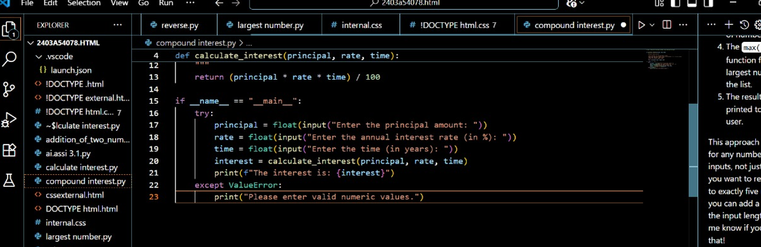

**OUTPUT:** 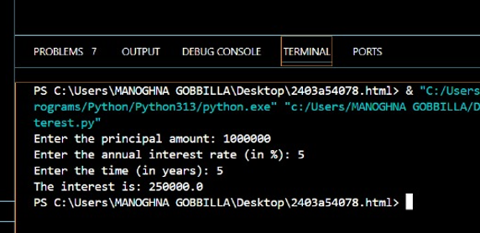

**EXPLANATION:**

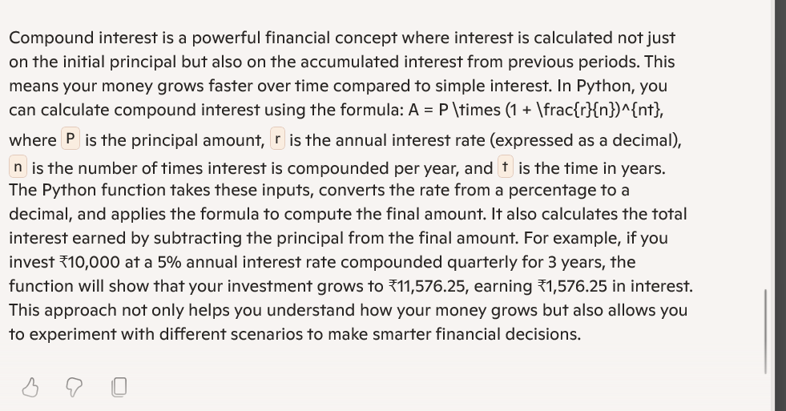

**3.2:**

**PROMPT:Write a python code to calculate average ,median,and mode of a given list of numbers**

**CODE:**

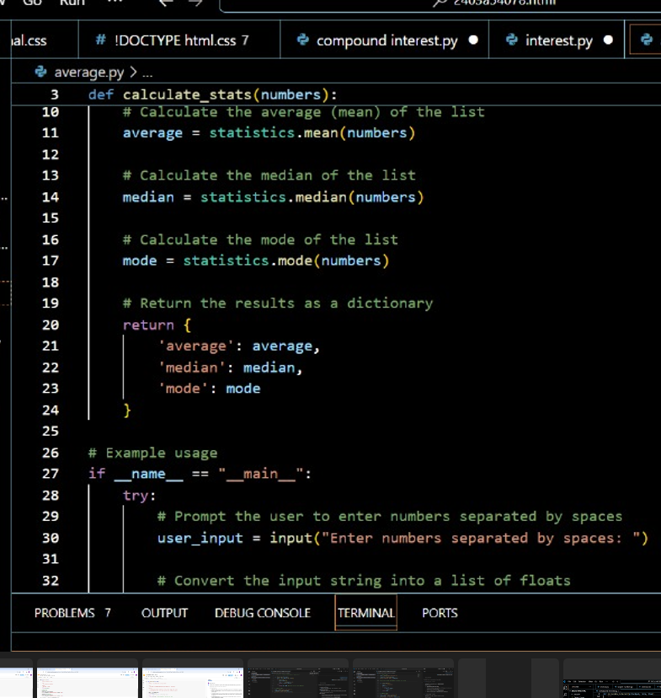

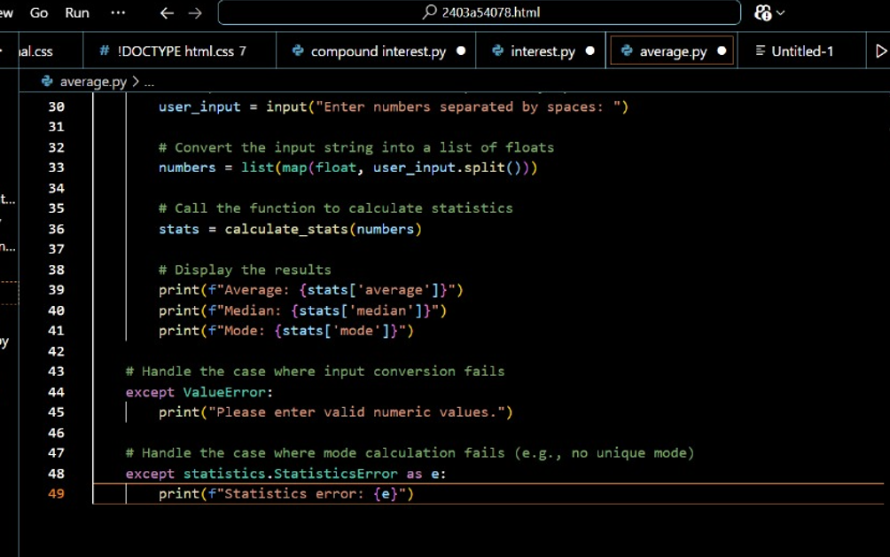

**OUTPUT:**



**EXPLANATION:**

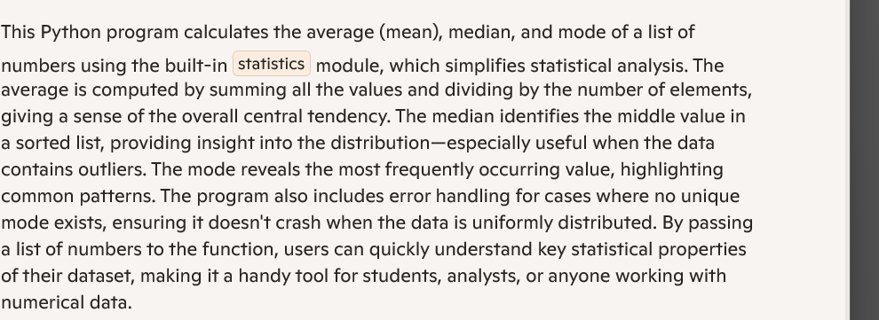

**3.3:**

**PROMPT:Write a python code to convert given number into binary format**

**CODE:**

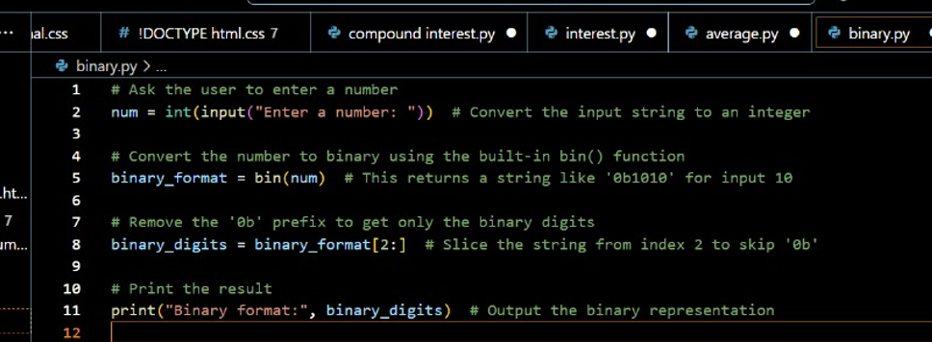

OUTPUT:

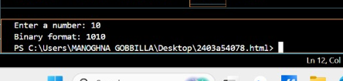

EXPLANATION:

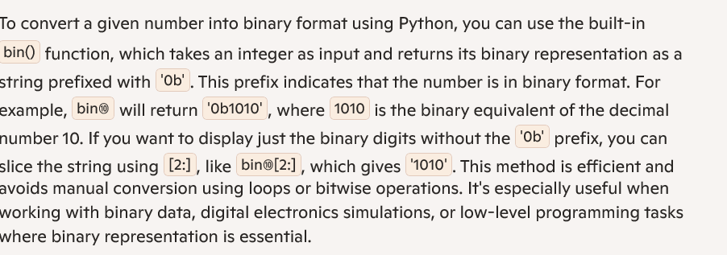

3.4:

PROMPT:Generate global user interface for an hotel based on customer requirements

CODE:

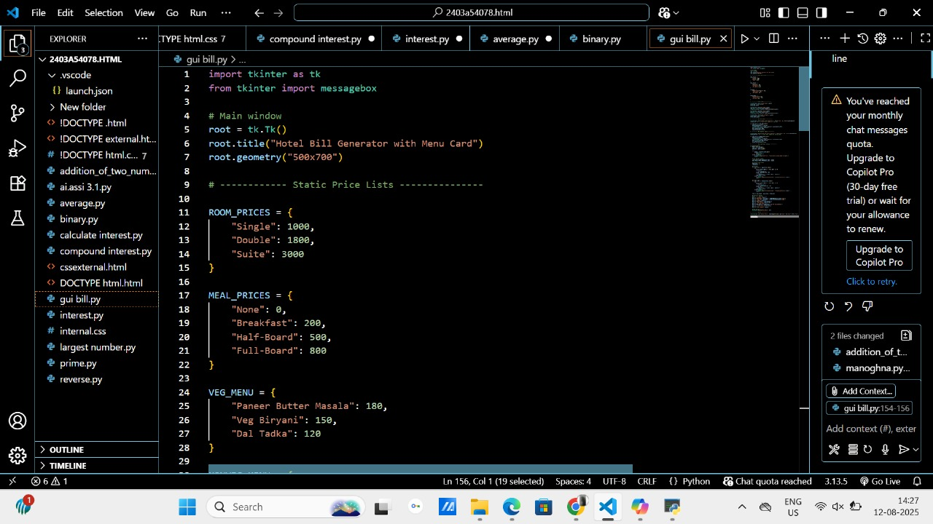

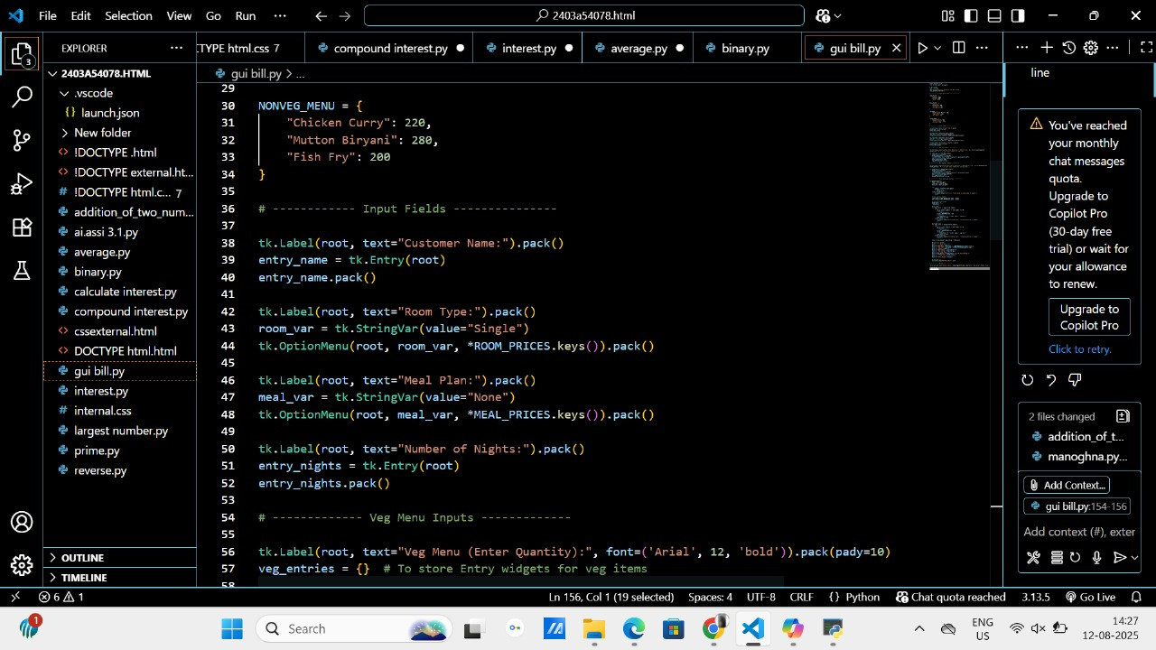

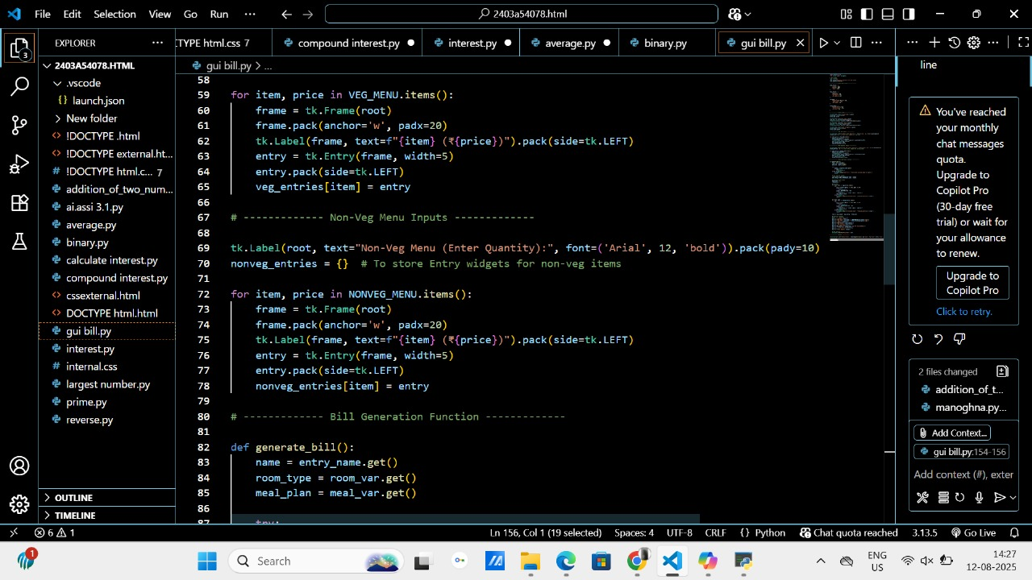

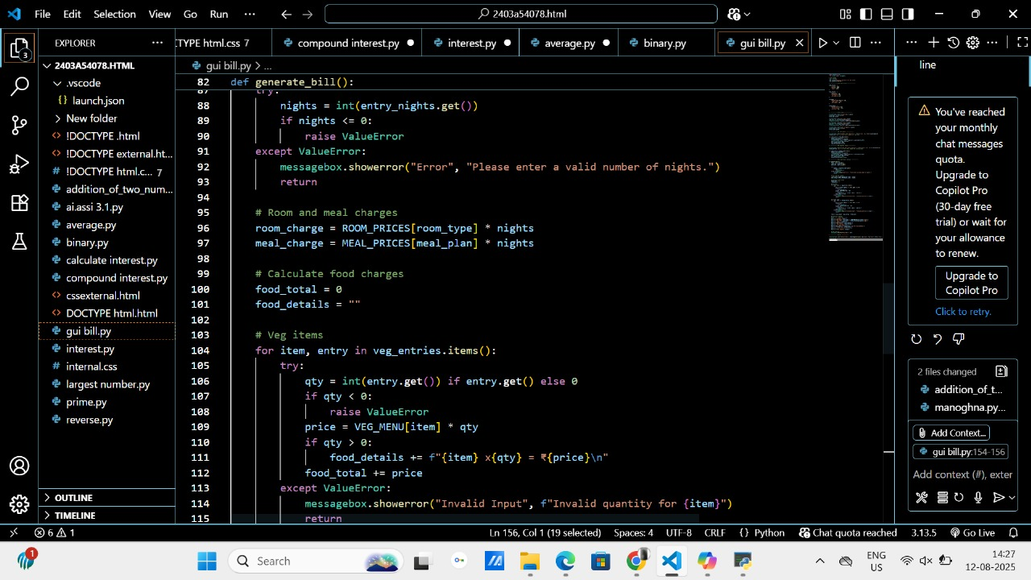

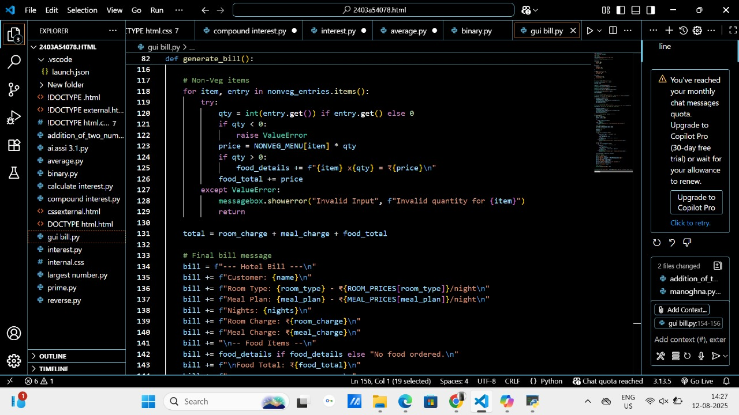

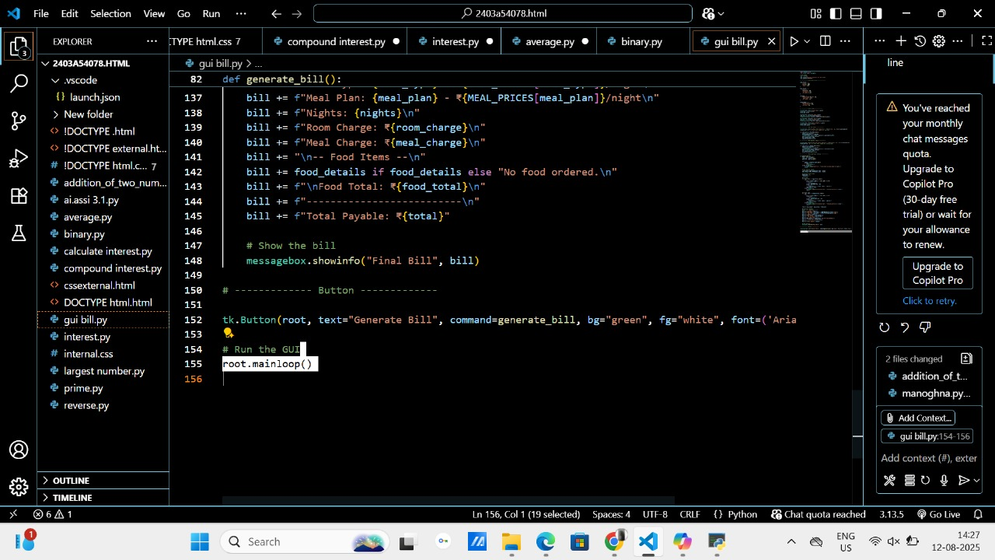

OUTPUT:

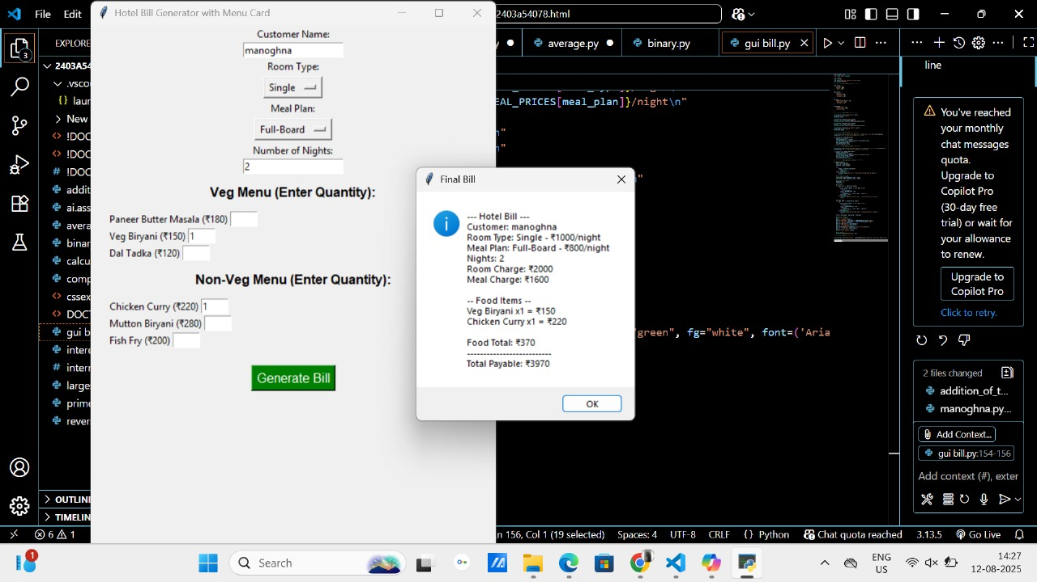

**EXPLANATION:**

