**SR UNIVERSITY**

**AI CODING**

**ASSIGNMENT NO:04**

**NAME :Gobbilla Manoghna**

**ENROLLMENT NO: 2403A54078**

**BATCH NO : 03**

**TASK:01**

**Zero-shot: Prompt AI to write a function that checks whether a given year is a leap year.**

**CODE:**

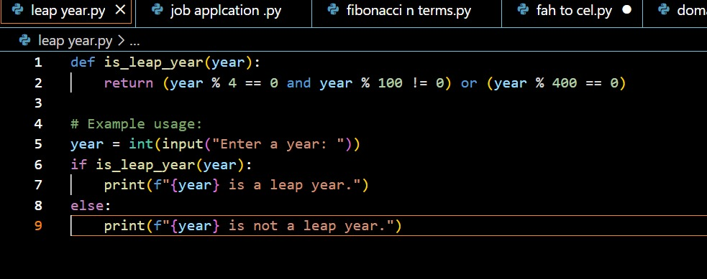

**OUTPUT:**

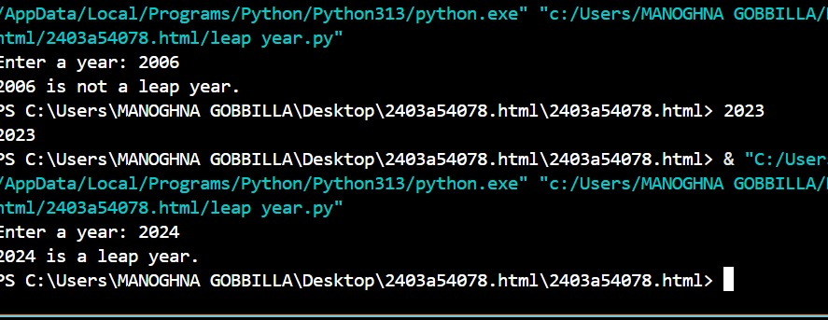

EXPLANATION:

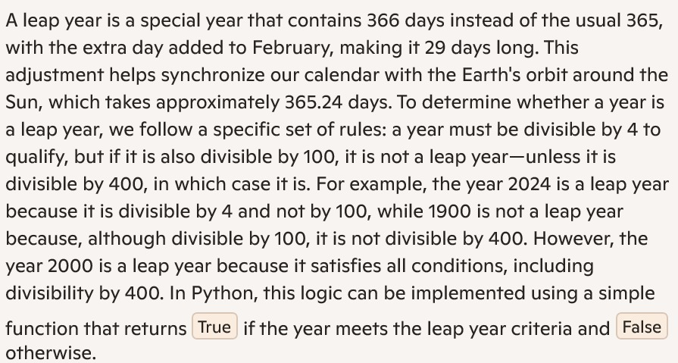

TASK:02

One-shot: Give one input-output example to guide AI in writing a function that converts centimeters to inches.

CODE:

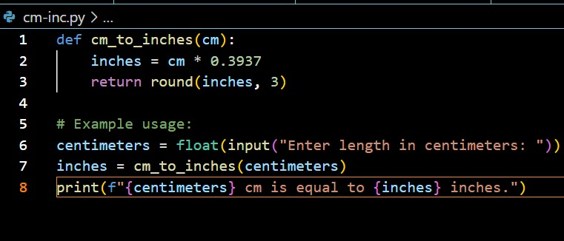

OUTPUT: 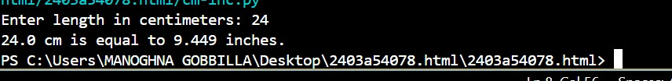

EXPLANATION:

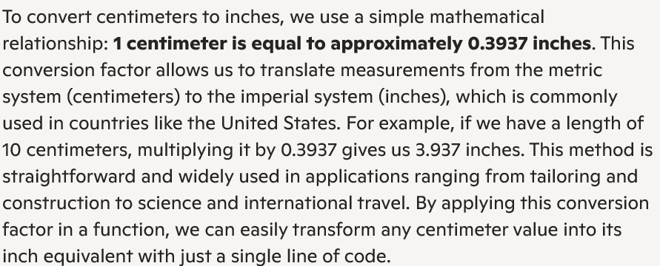

TASK:03

Few-shot: Provide 2–3 examples to generate a function that formats full names as “Last, First”

CODE:

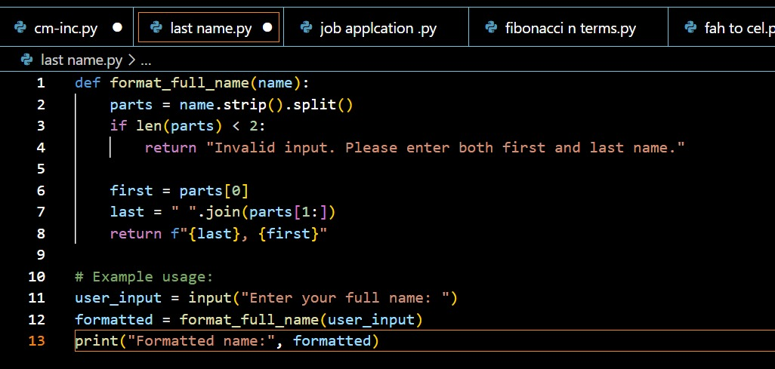

OUTPUT:

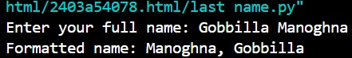

EXPLANATION:

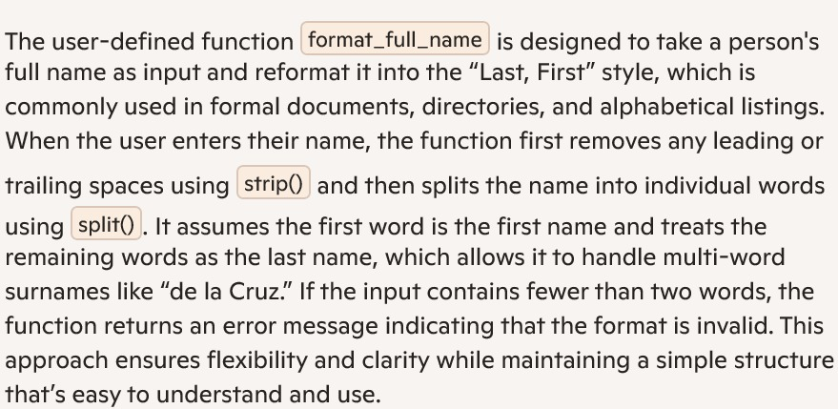

TASK:04

Compare zero-shot and few-shot prompts for writing a function that counts the number of vowels in a string.

CODE:

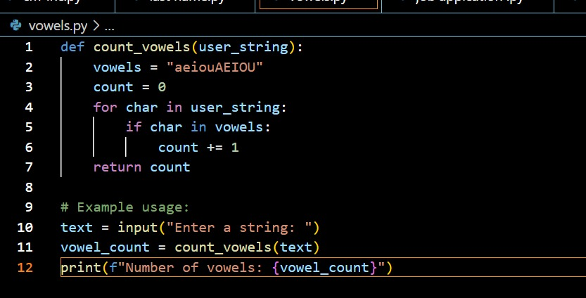

OUTPUT:

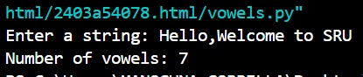

EXPLANATION:



TASK:05

Use few-shot prompting to generate a function that reads a .txt file and returns the number of lines

CODE:

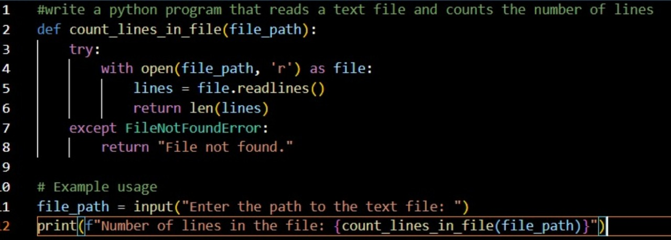

OUTPUT:

EXPLANATION:

