**Sudoku Solver and Generator – ABAP program**

**By: Manohar Potnuru**

Github link: https://github.com/manogithub/SAP-ABAP-Sudoku-Solver-Generator

We have 3 options available here:

1. To generate a Random Sudoku
2. To download a Random Sudoku
3. To upload a Sudoku of your choice, Program then solves and Print the same.

Selection Screen:

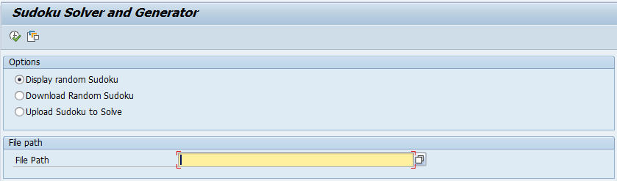

Option1: (Radio button 1 selected) – A Random Sudoku got generated

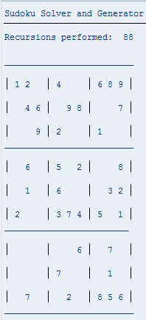

Option 2: A random Sudoku gotdownloaded:

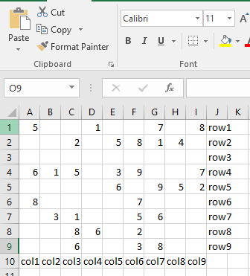

Option 3: If the above Sudoku was uploaded or any other Sudoku can be uploaded via an excel file

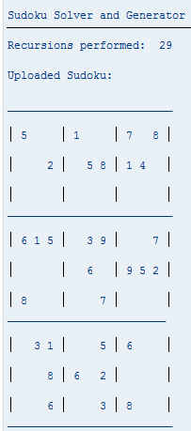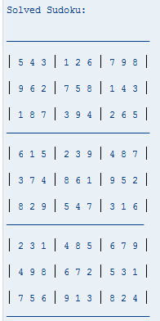

In addition, Sudoku Solver will return with ‘Not Possible’ if the uploaded one is unsolvable.

