**Cloud Application Development**

**Image Recognition with IBM Cloud Visual Recognition**

**Phase-3**

* Start building the image recognition system using IBM Cloud Visual Recognition.
* Create an IBM Cloud account, set up the Visual Recognition service, and obtain API keys.
* Design a simple web interface where users can upload images and view the AI-generated captions.

**Create an IBM Cloud account, set up the Visual Recognition service, and obtain API keys.**

IBM Cloud Account:

After creating the IBM Cloud Account, login with the IBMid.

Enter your IBMid then click continue.

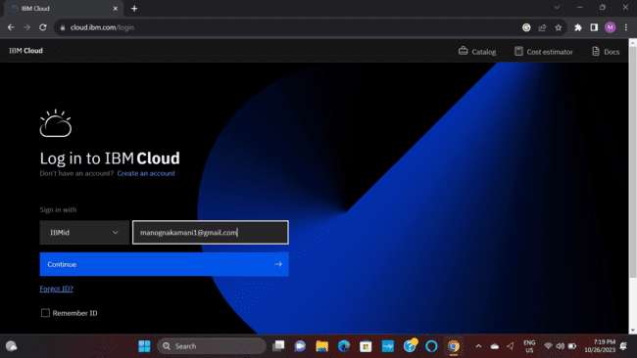

Enter your password, then click login.

The homepage of the IBM account as follows:

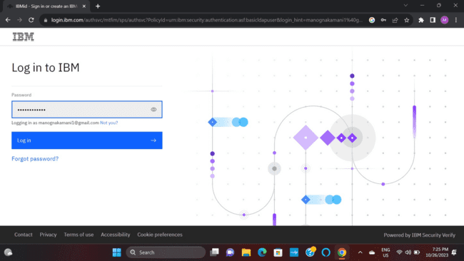

The homepage of the IBM account as follows:

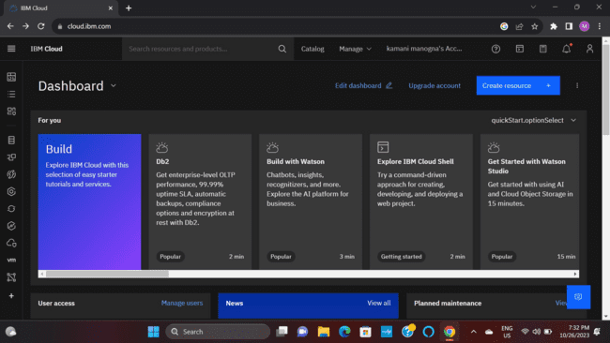

**Set up the Visual Recognition service, and obtain API keys.**

**Set up the Visual Recognition service:**

Open the homepage of your IBM account.

Click on the manage.

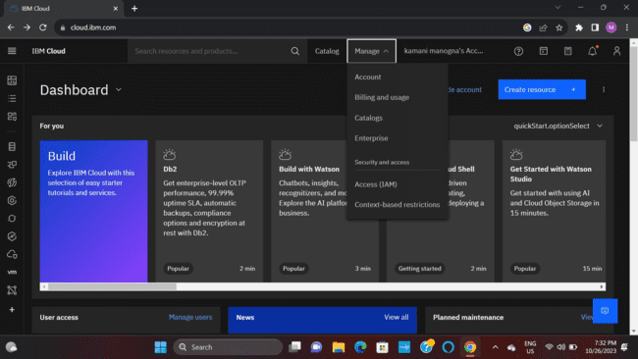

Click on the Access(IAM).

Then click on the Service IDs.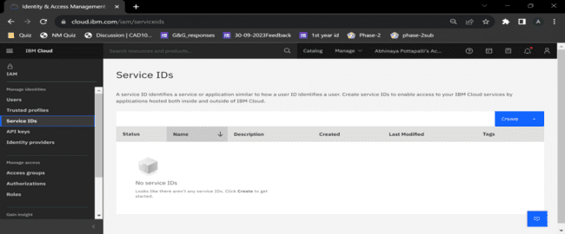

Click on Create button, to create the service.

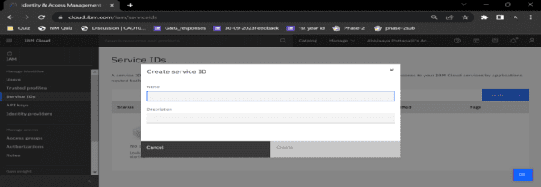

Enter the name and the description for the service, then click on Create button to create the service.

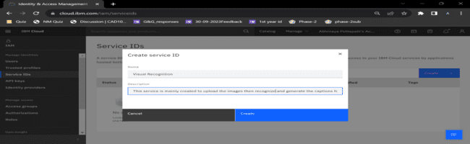

Visual Recognition service has been created.

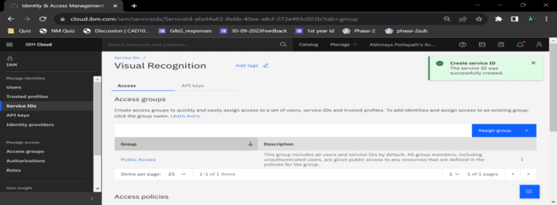

Then click on the API keys, to obtain the API key for the Visual Recognition Service.

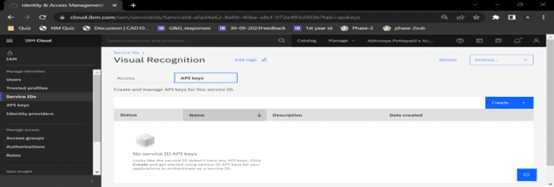

Then enter the name and the description to create the API key and click on the Create button.

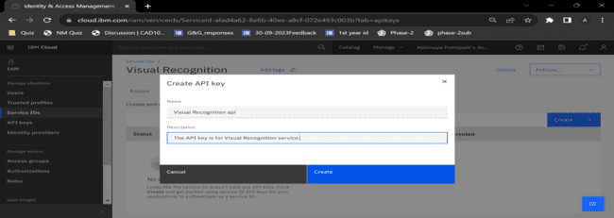

The API key has been successfully created for the Visual Recognition Service.

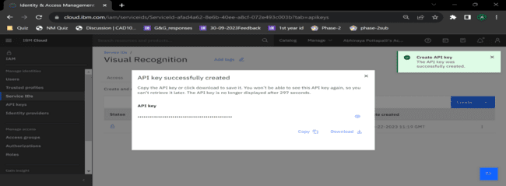

The API key has obtained.

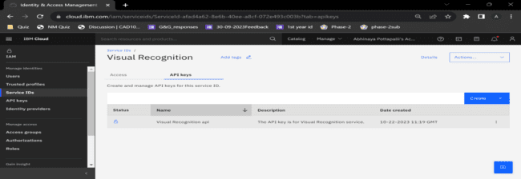

**Visual Recognition Service document.**

Open the home page of your IBM account, click on the help.

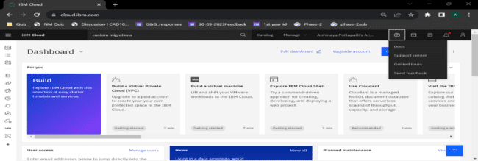

Then click on the Docs to open the document of the Visual Recognition

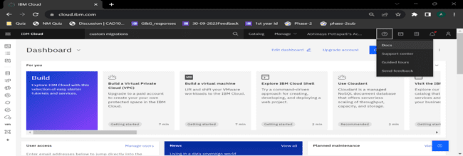Click on the search button at the drop-down menu, near the user account.

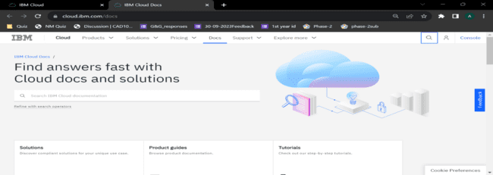

Then search for the Visual Recognition.

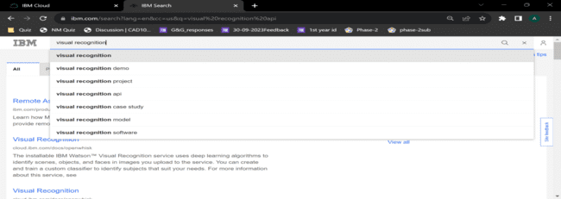Open the DocumentAnalytics.VisualRecognitionClassifier actions

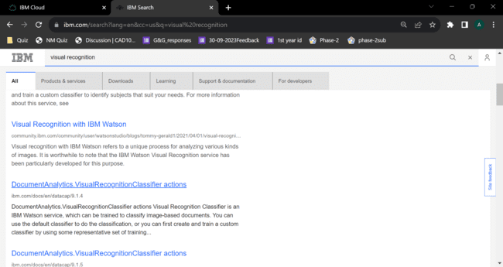

The main page of the document as follows.

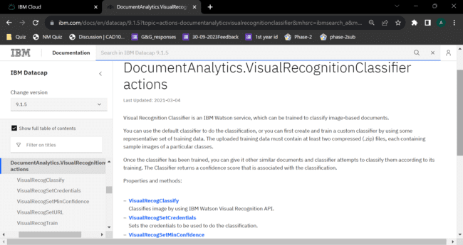

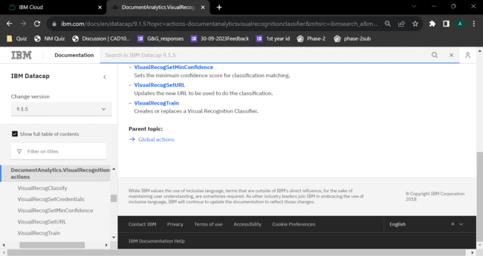

VisualRecogClassify:

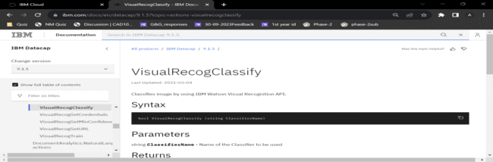

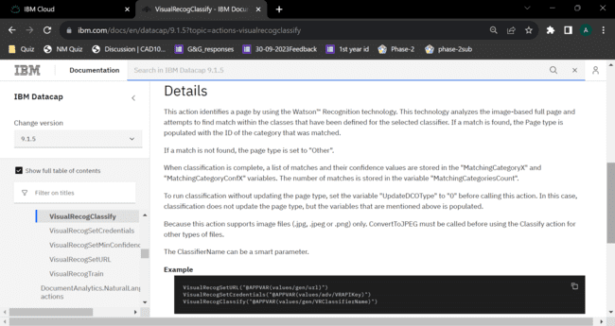

VisualRecogSetCredentials:

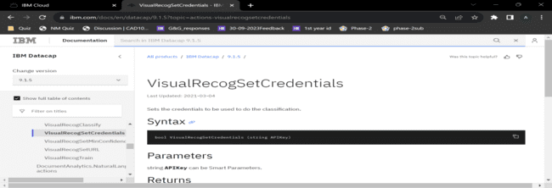

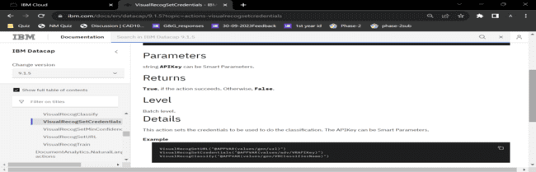

VisualRecogSetMinConfidence:

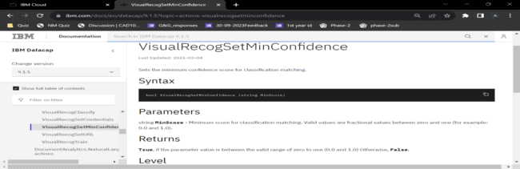

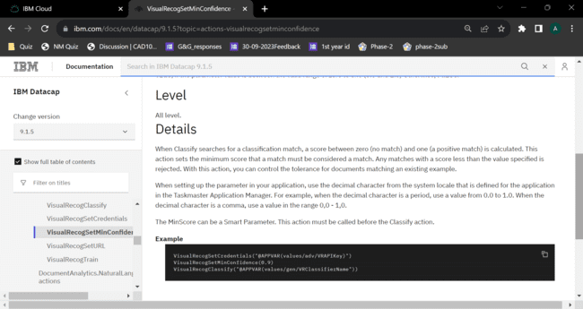

VisualRecogSetURL:

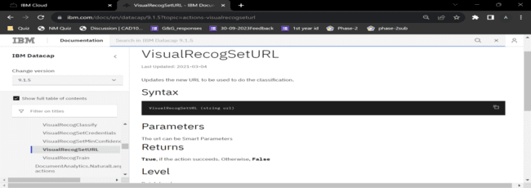

VisualRecogTrain:

