2.1 Login Page
- Role Selector Tabs — Three toggle buttons (Patient, Doctor, Admin) to select account type; one role must always be selected before submission.
- Email Textbox — Text input for registered email; must not be empty and must follow valid email format (user@domain.com).
- Password Textbox — Masked input for password; must not be empty and must be at least 8 characters.
- Forgot Password Link — Redirects to password reset flow; no validation needed but must be keyboard-accessible.
- Login Button — Submits the form; displays inline error messages under each invalid field before proceeding.
- Register Link — Navigates new users to sign-up page; must be visually distinct and clickable.
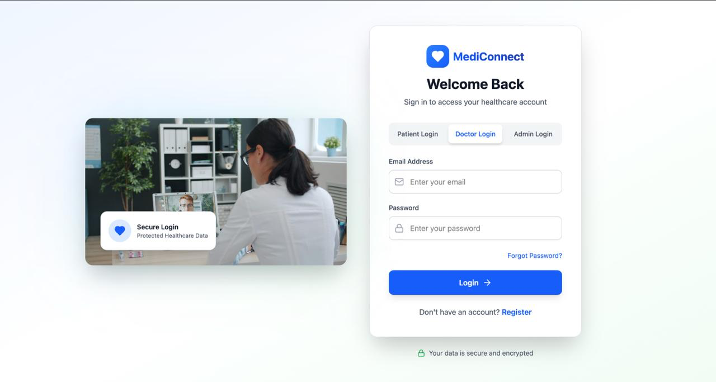
2.2 Doctors Dashboard

• Hospital Selector Dropdown — Switches between hospital branches; a hospital must always be selected and cannot be left blank.
• Global Search Textbox — Searches patients and appointments; requires minimum 2–3 characters and blocks empty or whitespace-only input.
• Stats Summary Cards — Four read-only cards (Total Patients, Appointments, Diagnostics, Revenue); data must refresh dynamically with correct green/red percentage indicators.
• Recent Appointments List — Shows patient name, time, visit type, and status; three-dot menu allows reschedule/cancel and status badges must only show valid states.
• Upcoming Consultations Panel — Lists video consultations with a Join button; Join is only active near the scheduled time and past consultations are greyed out.
• Notification Bell & Profile Dropdown — Bell shows unread alerts and clears on view; profile dropdown closes when clicking outside.
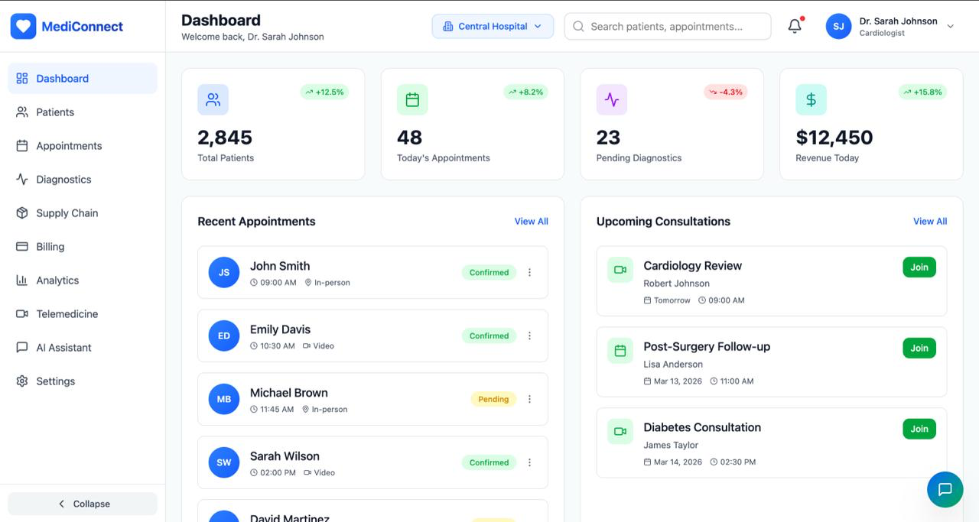

2.3 Hospital Selection Dropdown

• Dropdown Trigger — Opens the hospital panel on click; closes on outside click or Escape key.
• Hospital List Selection — Each row shows hospital name, location, and bed count; only one can be selected and the active one is visually highlighted.
• Bed Count Display — Read-only live numeric badge per hospital; always a positive integer, not editable.
• Scroll Behavior — List is vertically scrollable when entries exceed panel height, ensuring all options are reachable.
• Default Selection Persistence — Always has one hospital pre-selected; cannot be reset to empty or null.
• Dashboard Sync — On selection, dropdown closes and all dashboard data refreshes to reflect the chosen hospital only.

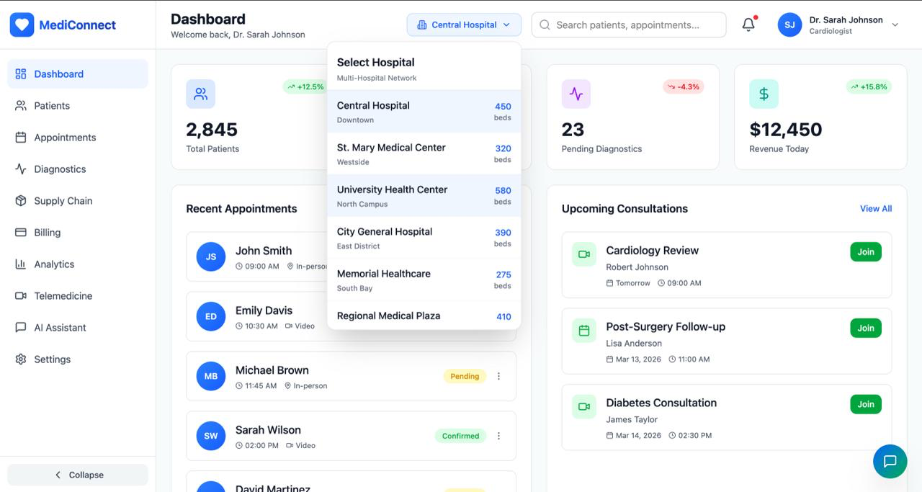

2.4 Search button
• Search Textbox — Free-text input; triggers only after 2–3 characters and blocks empty or whitespace searches.
• Live Auto-suggest — Results appear in real time on each keystroke with a debounce delay to limit API calls.
• Result Count Label — Displays "X result found" dynamically; shows "No results found" when there are zero matches.
• Result Card Display — Each card shows avatar, name, patient ID, age, gender, condition, last visit, and assigned doctor — all read-only from backend.
• Status Badge — Color-coded in real time (green = Active, grey/red = Inactive); never hardcoded.
• Click & Close Behavior — Clicking a card navigates to the patient profile; dropdown closes on result click, outside click, or Escape.
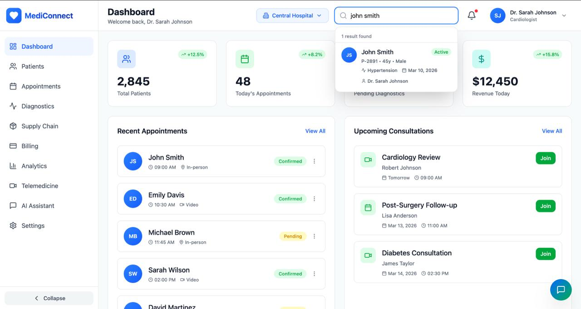

2.5 Notification Button
• Bell Icon — Opens/closes the notification panel; shows a red badge dot for unread alerts that clears once viewed.
• Panel Header — Read-only "Notifications" title; panel opens as an overlay without shifting the dashboard layout.
• Notification Items — Each item shows a message and relative timestamp (e.g. "5 min ago"); timestamps auto-update and never show future or negative values.
• Notification Priority — Emergency alerts (e.g. "Emergency case assigned") must be visually distinguished from routine notifications.
• Read/Unread State — Unread items are visually highlighted; marked as read on click and remain read on re-open.
• View All Link — Blue link at the bottom navigates to the full notifications page; always visible and marks all current items as read on click.
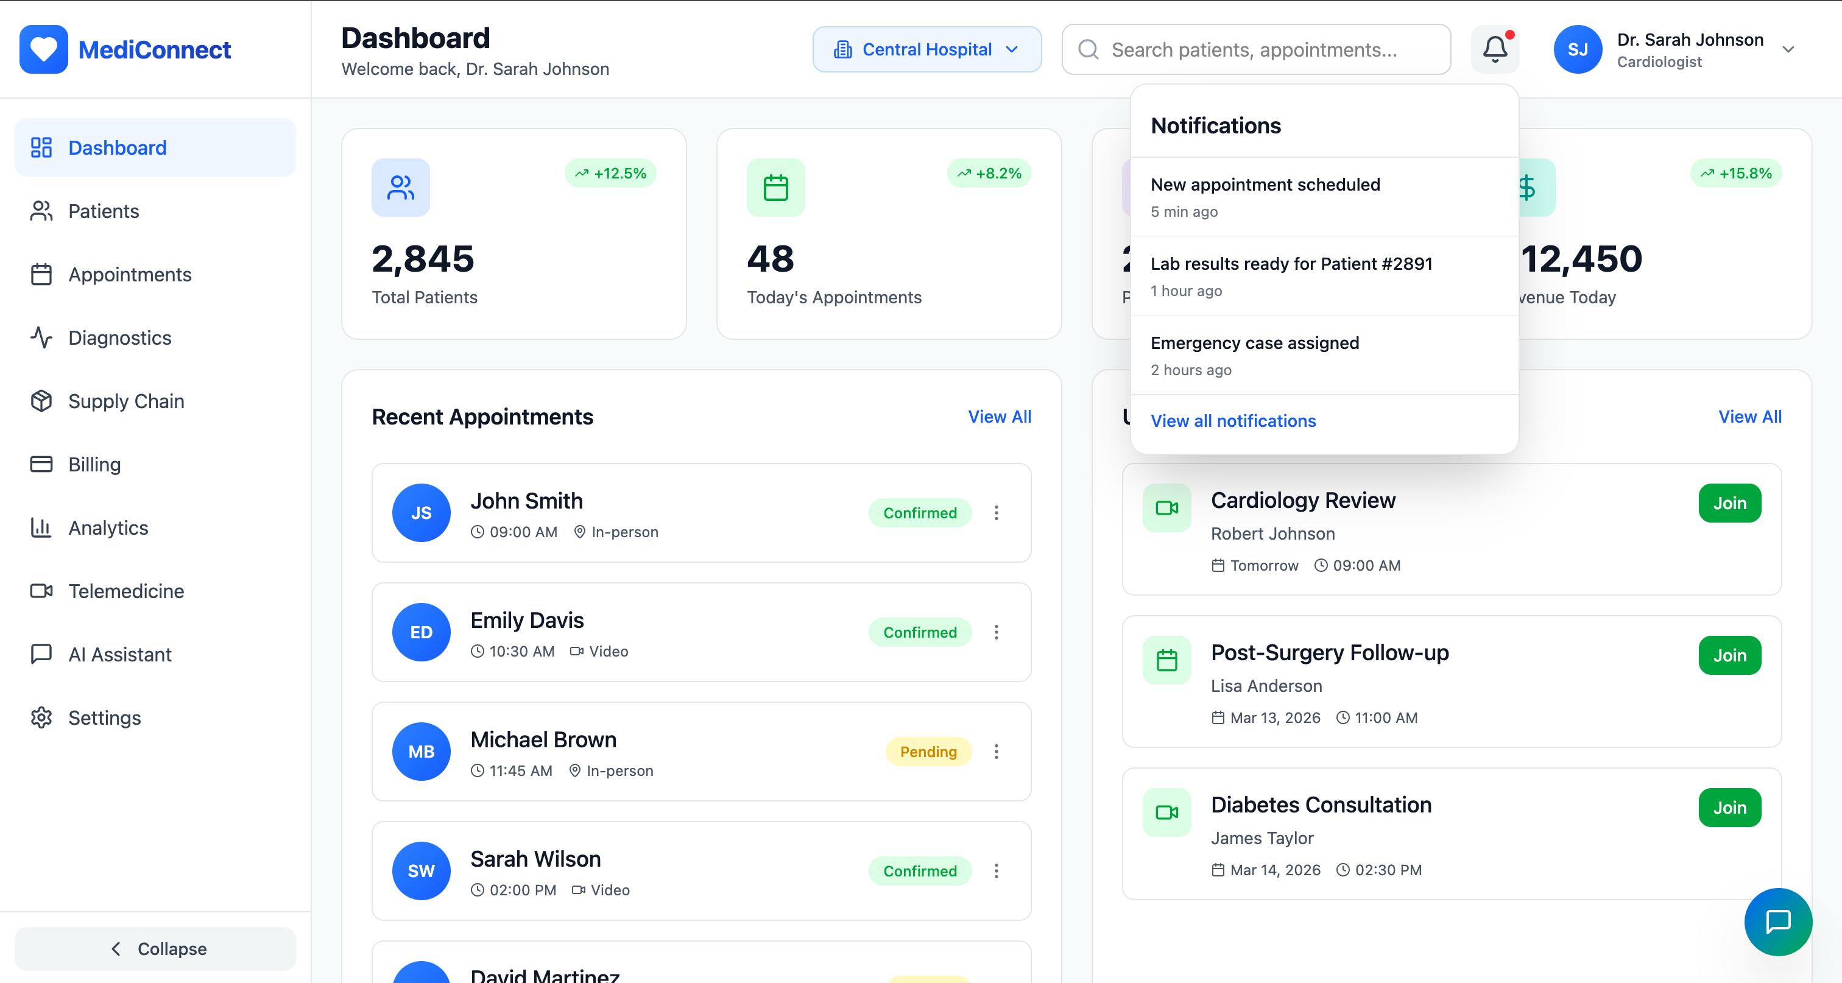

2.6 Profile Button Functionality
• Profile Trigger — Opens dropdown showing avatar initials, name, and role; closes on outside click or Escape key.
• Profile Header — Displays logged-in user's name and email as read-only; always pulled from the active session.
• My Profile Link — Navigates to the user's profile page; loads only the authenticated user's data.
• Settings Link — Opens app settings for the logged-in user only; must not expose other users' configurations.
• Help & Support Link — Redirects to help center; must always be functional and open consistently in-app or new tab.
• Sign Out Button — Ends session, clears auth tokens, and redirects to login; browser back button must not allow return to dashboard.
