**Linux:**

**File & Directory Operations:**

ls -al # List all files with details

cd /path/to/dir # Change directory

pwd # Show current directory

cp src dest # Copy files or folders

mv old new # Move/rename files or folders

rm file.txt # Delete file

rm -rf folder/ # Force delete a folder

mkdir dir_name # Create new directory

touch file.txt # Create an empty file

tree # Visualize directory structure (if installed)

stat file.txt # View file metadata

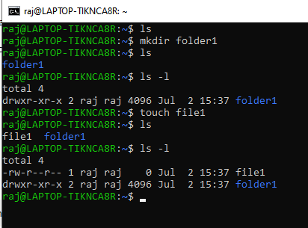

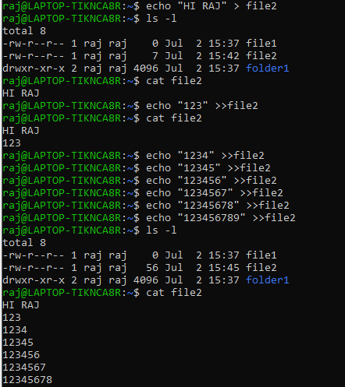

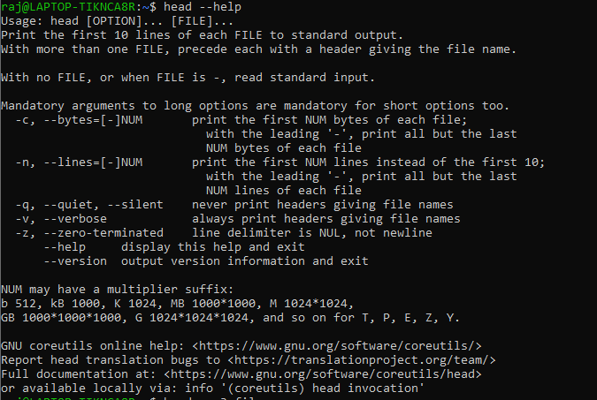

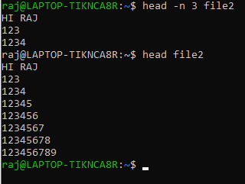

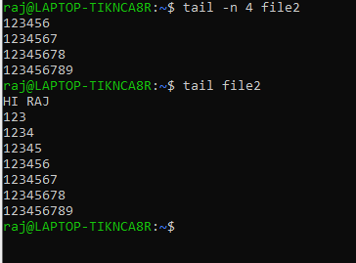

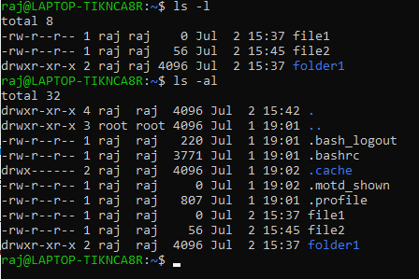

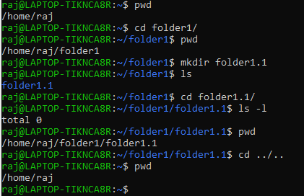

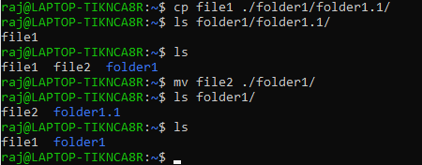

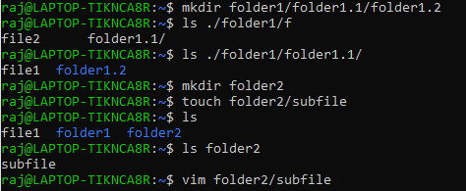

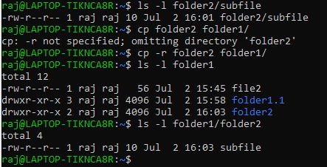

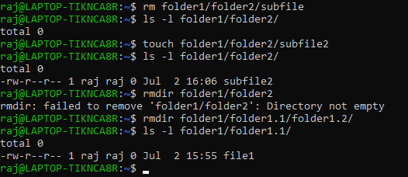

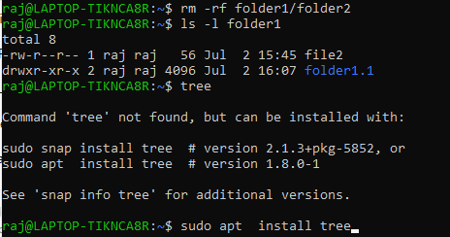

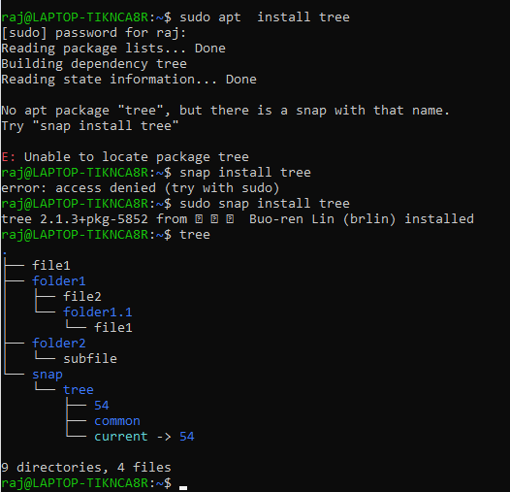

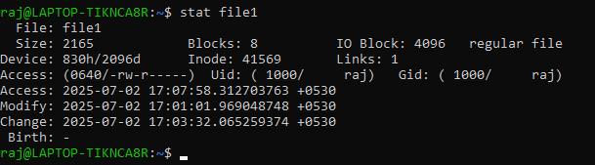

Viewing and Searching Files:

cat file.txt # View entire file

less file.txt # Scroll through file

head -n 20 file # First 20 lines

tail -n 50 file # Last 50 lines

tail -f log.txt # Monitor log in real-time

grep "error" file # Search for "error" in file

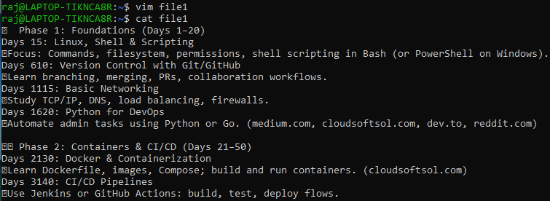

**less filename.txt**

The less command in Linux is perfect for **viewing files line by line or page by page** without loading the entire file into memory.

**Navigation Shortcuts inside less:**

| Key | Action |
| --- | --- |
| ↓ / j | Scroll down one line |
| ↑ / k | Scroll up one line |
| SPACE | Scroll down one page |
| b | Scroll up one page |
| /word | Search forward for “word” |
| n | Go to next match in search |
| N | Go to previous match |
| g | Go to start of file |
| G | Go to end of file |
| q | Quit less |

Use less instead of cat for **long files**.

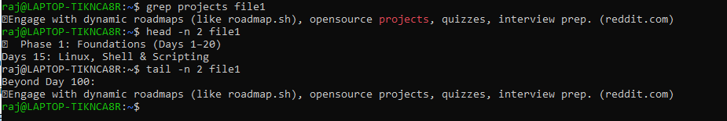

User & Permission Management:

whoami # Current user

id # User ID and groups

chmod 755 file.sh # Set permissions

chown user:grp file # Change ownership

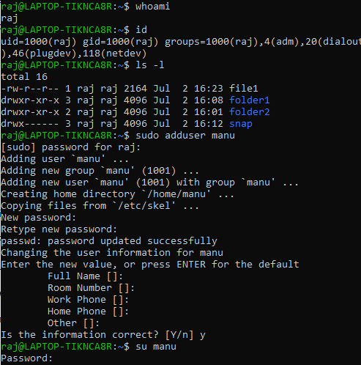

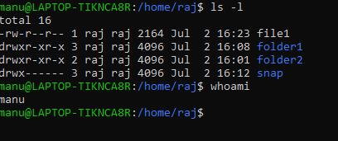

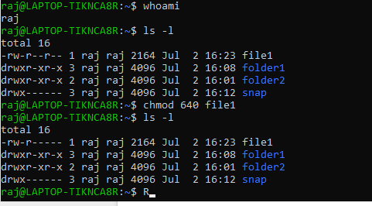

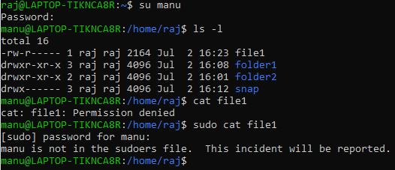

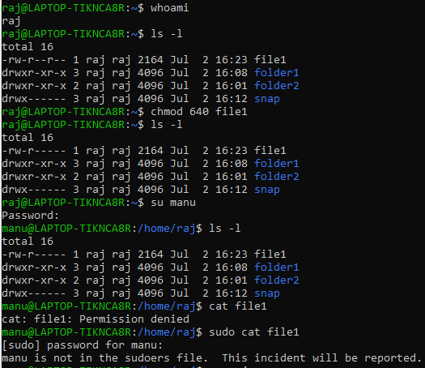

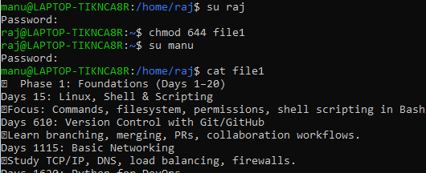

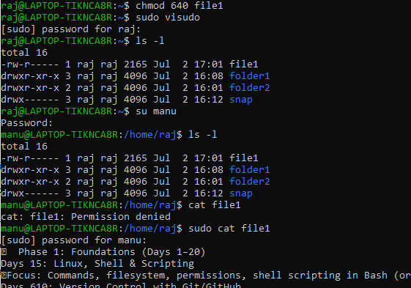

To allow a user to perform commands with sudo, you need to add them to the **sudoers file** properly

sudo visudo

username ALL=(ALL:ALL) ALL

**Save and exit** (Ctrl+X, then Y

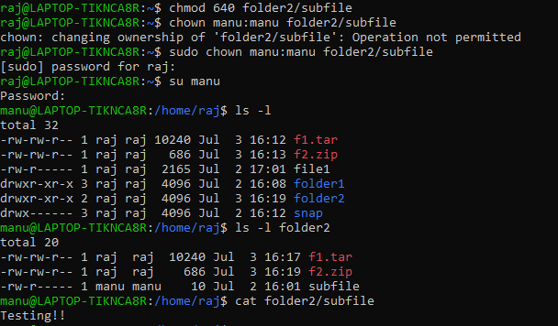

System Monitoring:

top # Live system usage

htop # Better version of top (if installed)

free -m # RAM usage in MB

df -h # Disk usage

du -sh * # Folder sizes

uptime # System uptime

vmstat # Memory, CPU stats(CPU + Memory + Process + Paging + IO)

iostat # Disk I/O (Disk I/O + CPU Overview)

netstat -tulnp # Listening ports

ss -tuln # Faster netstat alternative

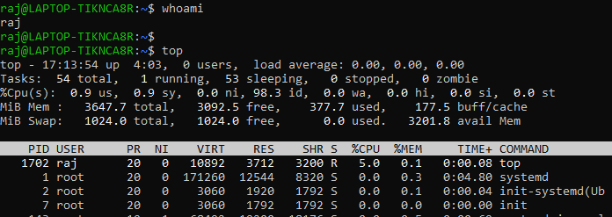

htop

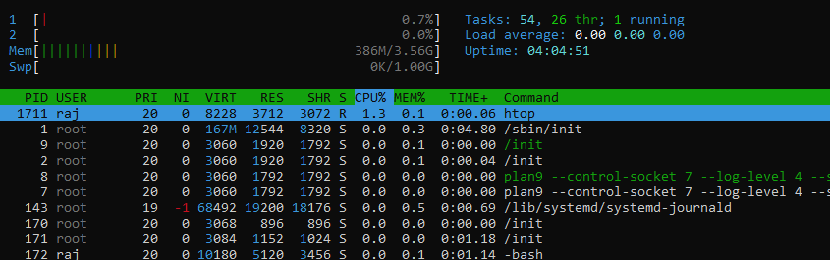

top:

· CPU and memory usage **per process**

· System-wide summary (CPU, memory, load avg)

free -m :

· **Memory usage only**

· Summary of:

* Total RAM
* Used, free
* Buffers/cache
* Swap usage

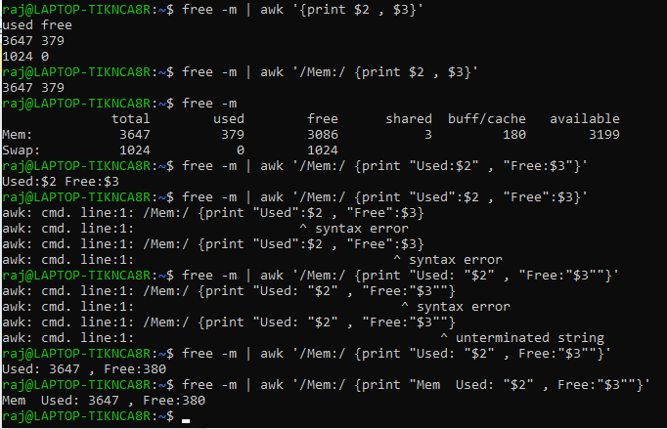

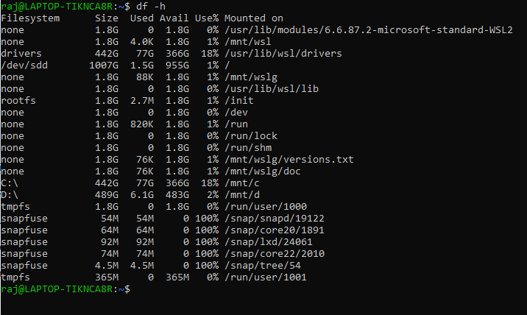

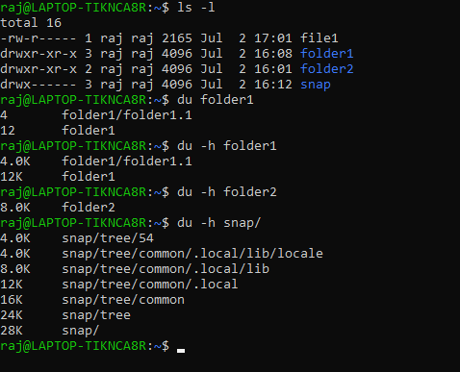

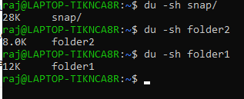



| **Part** | **Meaning** |
| --- | --- |
| 17:39:27 | Current system time |
| up 4:29 | The system has been running (uptime) for **4 hours and 29 minutes** |
| 0 users | Currently **no users logged in** to the shell (e.g., no open terminals) |
| load average: 0.00, 0.00, 0.00 | **System load** over 1, 5, and 15 minutes |

### Load Average (0.00, 0.00, 0.00)

Represents **CPU demand**: the average number of processes **waiting** to run.

Lower is better — 0.00 means your system is **completely idle**.

On a 1-core system:

· 1.00 = fully used

· >1.00 = overloaded

On a multi-core system (e.g., 4 cores):

4.00 = full usage

>4.00 = overloaded

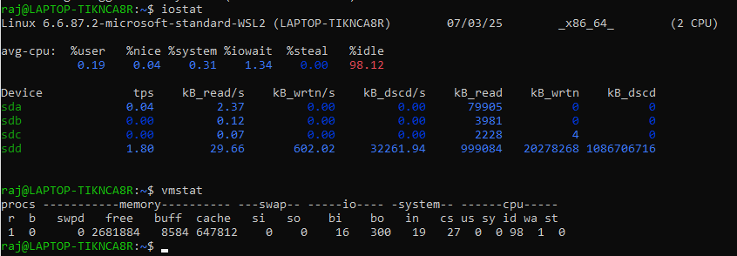

netstat stands for **Network Statistics**.  
It displays information about:

Active **network connections**

* **Listening ports**
* **Routing tables**
* **Network interface**
* **statistics**

netstat -tuln

· t = TCP

· u = UDP

· l = Listening

· n = Numeric (don’t resolve hostnames)

|  |
| --- |
| ss |

|  |
| --- |
| Faster, better alternative to netstat for sockets |

Process Management:

ps aux # List all running processes

ps -ef | grep xyz # Find a specific process

kill <PID> # Terminate process

kill -9 <PID> # Force kill process

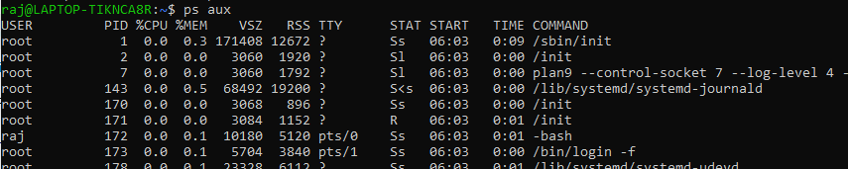

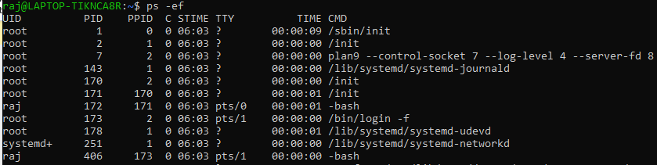

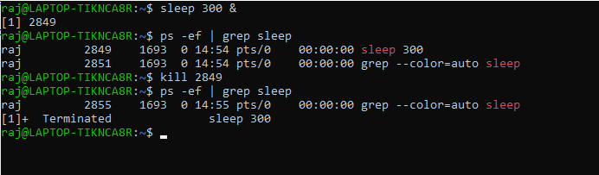

Networking:

ping 8.8.8.8 # Test network

curl ifconfig.me # Show public IP

curl -I url # Check website headers

netstat -tuln # Show listening ports

ss -tuln # Modern replacement for netstat

ip a # Show IP addresses

telnet host port # Test port connectivity (if installed)

nc -zv host port # Quick port test (netcat)

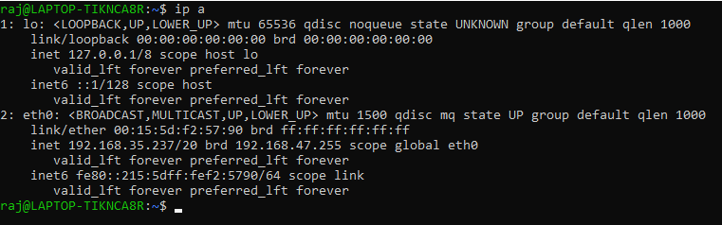

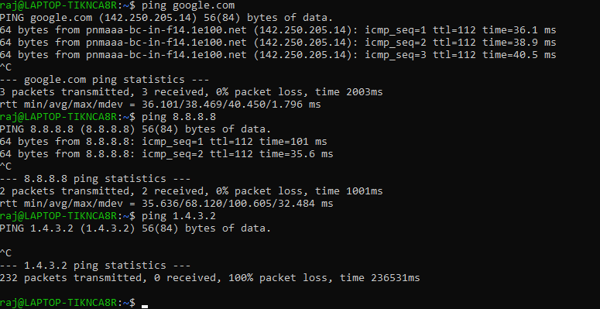

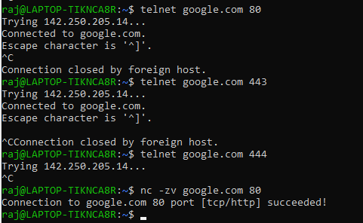

File Archiving & Compression:

tar -cvf file.tar folder/ # Create tar

tar -xvf file.tar # Extract tar

tar -czvf file.tar.gz folder/ # Create tar.gz

tar -xzvf file.tar.gz # Extract tar.gz

zip -r file.zip folder/ # Create zip

unzip file.zip # Extract zip

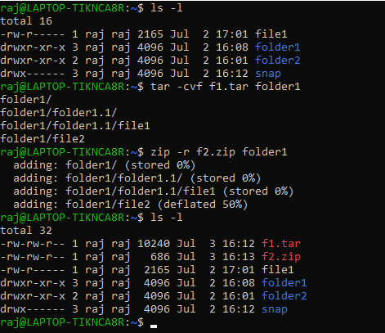

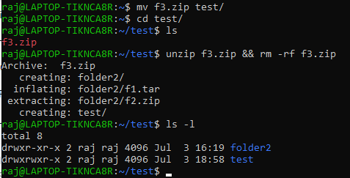

Cron & Scheduling:

* * * * * command

│ │ │ │ │

│ │ │ │ └─ Day of week (0-6, Sunday=0)

│ │ │ └─── Month (1-12)

│ │ └───── Day of month (1-31)

│ └─────── Hour (0-23)

└───────── Minute (0-59)

crontab -e # Edit cron jobs

crontab -l # List user cron jobs

crontab -r # Remove cron jobs

**Check System-Wide Cron Jobs**

cat /etc/crontab

ls /etc/cron.d/

ls /etc/cron.daily/

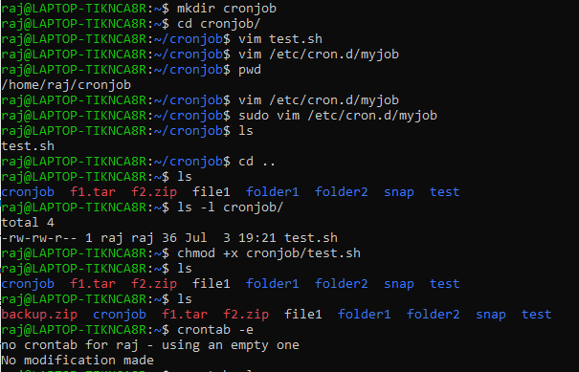

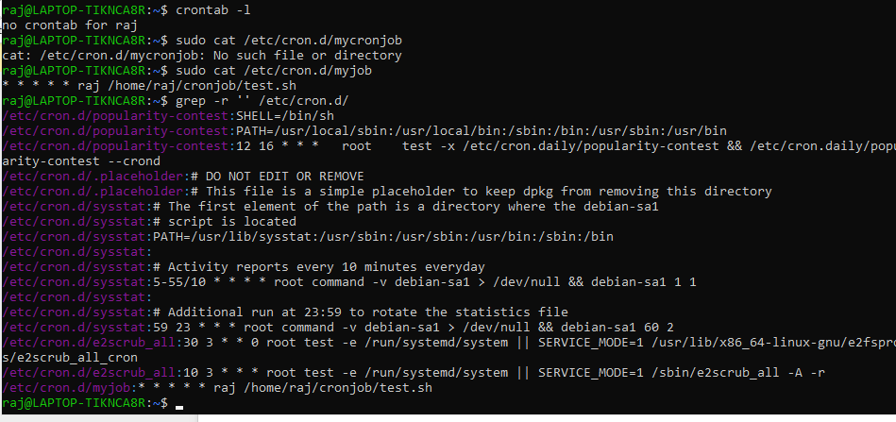

Package Management:

**Ubuntu/Debian**

sudo apt update && sudo apt upgrade

sudo apt install <pkg>

**RedHat/CentOS**

sudo yum update

sudo yum install <pkg>