**12 . factorial number**

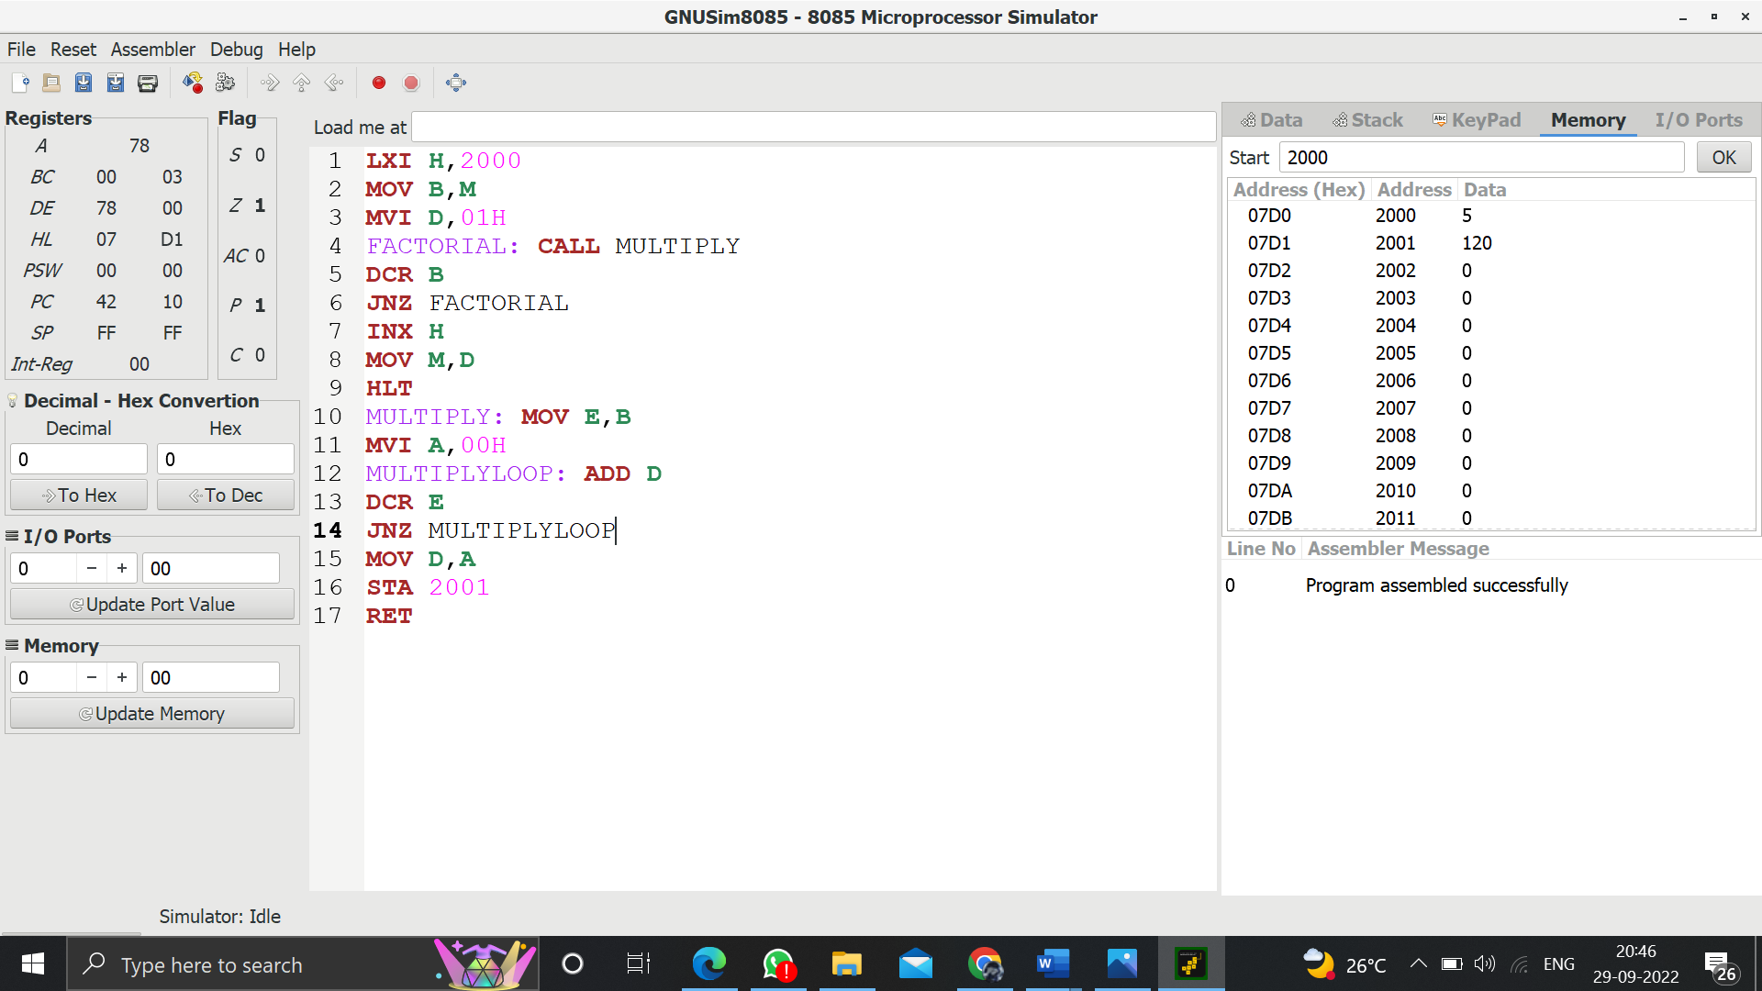

**LXI H,2000**

**MOV B,M**

**MVI D,01H**

**FACTORIAL: CALL MULTIPLY**

**DCR B**

**JNZ FACTORIAL**

**INX H**

**MOV M,D**

**HLT**

**MULTIPLY: MOV E,B**

**MVI A,00H**

**MULTIPLYLOOP: ADD D**

**DCR E**

**JNZ MULTIPLYLOOP**

**MOV D,A**

**STA 2001**

**HLT**