**Maven:**

**Step1 :** download frm the url <https://maven.apache.org/download.cgi>

**Step2 :**Update environment variable.

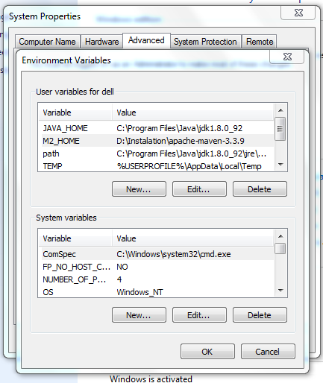

Maven dependency URL : https://mvnrepository.com/

**Maven project creation :**

mvn archetype:generate -DgroupId=com.cf.test -DartifactId=Spring_IOC -DarchetypeArtifactId=maven-archetype-quickstart -DinteractiveMode=false

**Sample XML :**

<?xml version=*"1.0"* encoding=*"UTF-8"*?>

<!DOCTYPE beans PUBLIC "-//SPRING//DTD BEAN 2.0//EN" "http://www.springframework.org/dtd/spring-beans-2.0.dtd">

<beans>

</beans>

**IOC Spring depency :**

<https://mvnrepository.com/artifact/org.springframework>

<dependency>

<groupId>org.springframework</groupId>

<artifactId>spring-context</artifactId>

<version>2.5.5</version>

</dependency>

<dependency>

<groupId>org.springframework</groupId>

<artifactId>spring-core</artifactId>

<version>2.5.5</version>

</dependency>

<dependency>

<groupId>org.springframework</groupId>

<artifactId>spring-beans</artifactId>

<version>2.5.5</version>

</dependency>

**SCOPE TYPES :**

|  |  |
| --- | --- |
| **Scope** | **Description** |
| singleton | This scopes the bean definition to a single instance per Spring IoC container (default). |
| prototype | This scopes a single bean definition to have any number of object instances. |
| request | This scopes a bean definition to an HTTP request. Only valid in the context of a web-aware Spring ApplicationContext. |
| session | This scopes a bean definition to an HTTP session. Only valid in the context of a web-aware Spring ApplicationContext. |
| global-session | This scopes a bean definition to a global HTTP session. Only valid in the context of a web-aware Spring ApplicationContext. |

**MVC project architect type :**

mvn archetype:generate -DgroupId=com.cf.test -DartifactId=Spring_IOC -DarchetypeArtifactId=maven-archetype-webapp -DinteractiveMode=false

Sample pom with decencies :



**AOP :-**

AOP Concepts and Terminology

AOP concepts and terminologies are as follows:

1. Join point
2. Advice
3. Pointcut
4. Introduction
5. Target Object
6. Aspect
7. Interceptor
8. AOP Proxy
9. Weaving

#### Join point

Join point is any point in your program such as method execution, exception handling, field access etc. Spring supports only method execution join point.

#### Advice

Advice represents an action taken by an aspect at a particular join point. There are different types of advices:

* **Before Advice**: it executes before a join point.
* **After Returning Advice**: it executes after a joint point completes normally.
* **After Throwing Advice**: it executes if method exits by throwing an exception.
* **After (finally) Advice**: it executes after a join point regardless of join point exit whether normally or exceptional return.
* **Around Advice**: It executes before and after a join point.

#### Pointcut

It is an expression language of AOP that matches join points.

#### Introduction

It means introduction of additional method and fields for a type. It allows you to introduce new interface to any advised object.

#### Target Object

It is the object i.e. being advised by one or more aspects. It is also known as proxied object in spring because Spring AOP is implemented using runtime proxies.

#### Aspect

It is a class that contains advices, joinpoints etc.

#### Interceptor

It is an aspect that contains only one advice.

#### AOP Proxy

It is used to implement aspect contracts, created by AOP framework. It will be a JDK dynamic proxy or CGLIB proxy in spring framework.

#### Weaving

It is the process of linking aspect with other application types or objects to create an advised object. Weaving can be done at compile time, load time or runtime. Spring AOP performs weaving at runtime.

**MVC Pom.xml dependencies :-**

<dependency>

<groupId>org.springframework</groupId>

<artifactId>spring-core</artifactId>

<version>${spring.version}</version>

</dependency>

<dependency>

<groupId>org.springframework</groupId>

<artifactId>spring-web</artifactId>

<version>${spring.version}</version>

</dependency>

<dependency>

<groupId>org.springframework</groupId>

<artifactId>spring-webmvc</artifactId>

<version>${spring.version}</version>

</dependency>

<!-- jstl -->

<dependency>

<groupId>jstl</groupId>

<artifactId>jstl</artifactId>

<version>${jstl.version}</version>

</dependency>

<dependency>

<groupId>javax.servlet</groupId>

<artifactId>servlet-api</artifactId>

<version>2.5</version>

</dependency>