URL:

<http://spark.apache.org/docs/latest/quick-start.html>

Video Url’s:-

<https://www.youtube.com/watch?v=cvkUkNYlk7U&index=3&list=PLlL9SaZVnVgizWn2Gr_ssHExaQUYik2vp>

https://www.supergloo.com/fieldnotes/apache-spark-examples-of-transformations/

SparkHome:

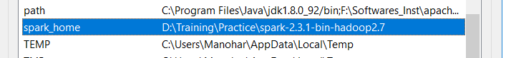

HaddopHome:-

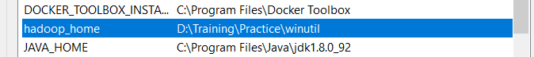

Spark_Path:-

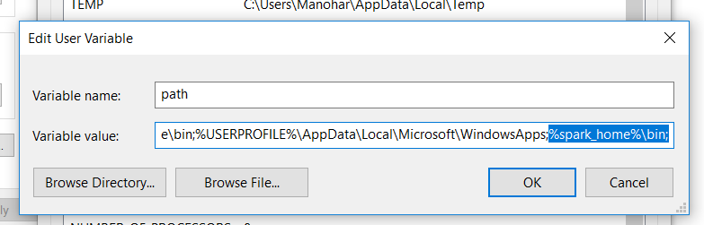

**HADOOP Data URLS:-**

<https://data.sfgov.org/Public-Safety/Fire-Department-Calls-for-Service/nuek-vuh3/data>