# Step 1 – Basic shapes

Start the application by running the “**ShapesController.java**” file. This is where the main function is located.

The following window appears:

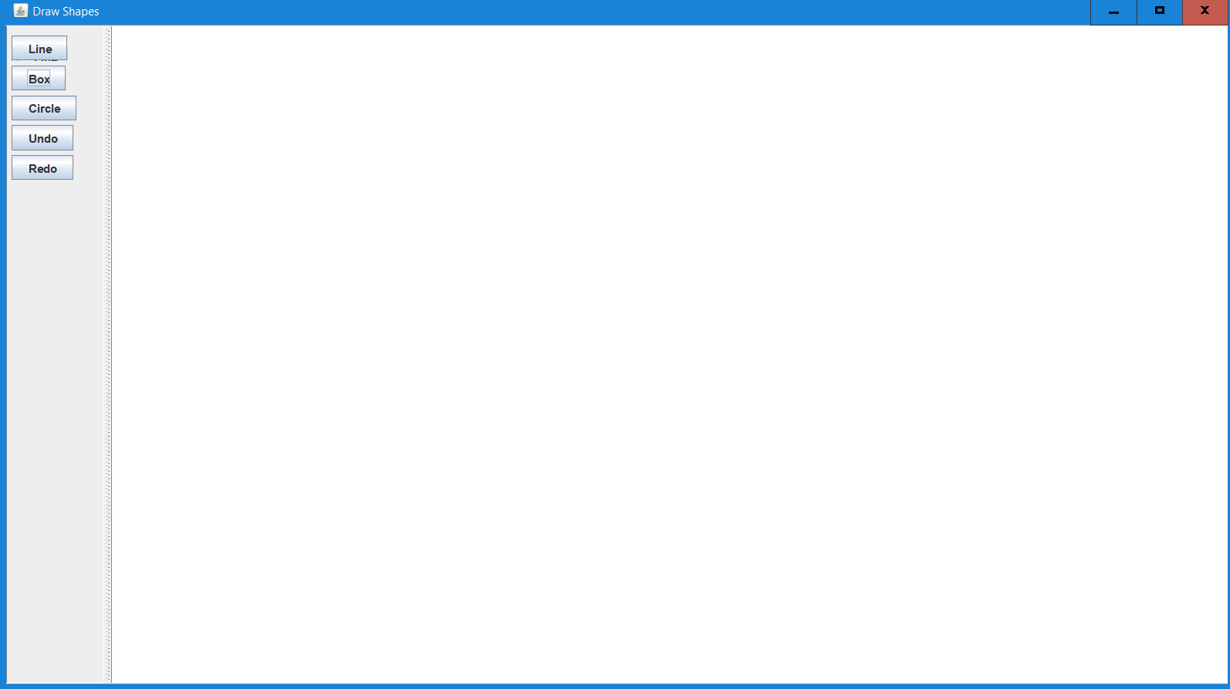

# Step 2

Click on any of shapes buttons – Box, Circle, Line.

The cursor changes to the following sign  as shown

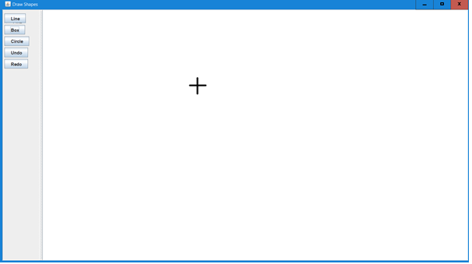

# Step 3

Click on anywhere on the canvas area

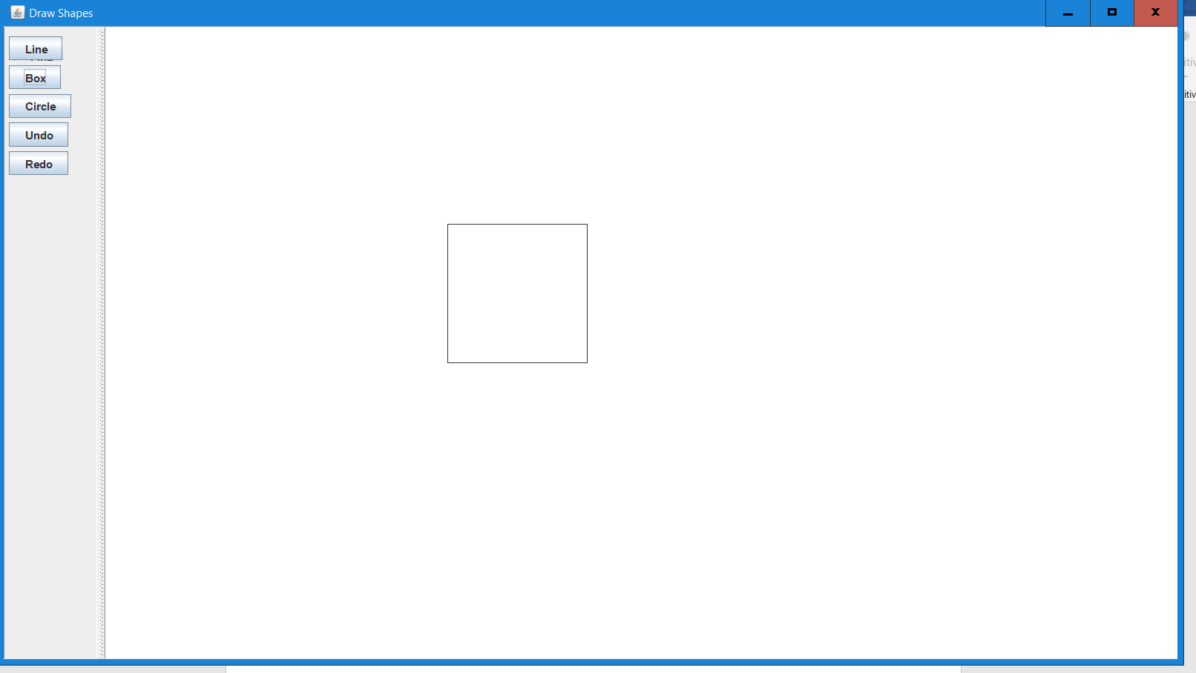

# Step 4

Similarly add other shapes.

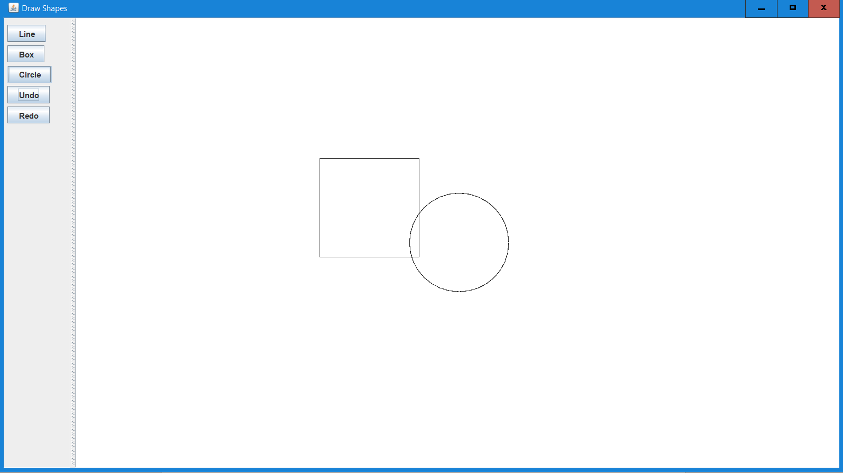

# Step 5

Add a Line shape.

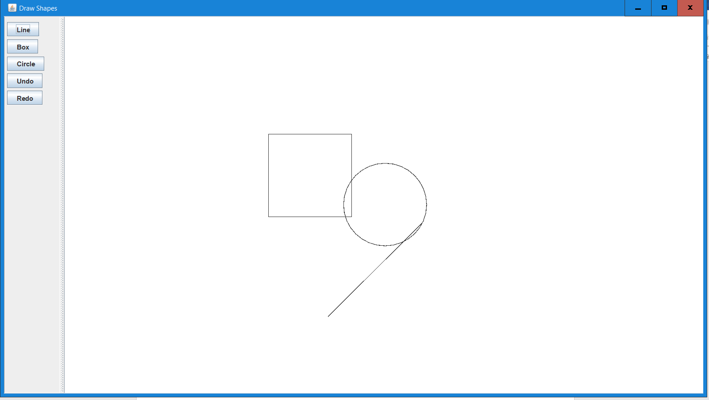

# Step 6

Similarly, after adding three more shapes, the following is the result.

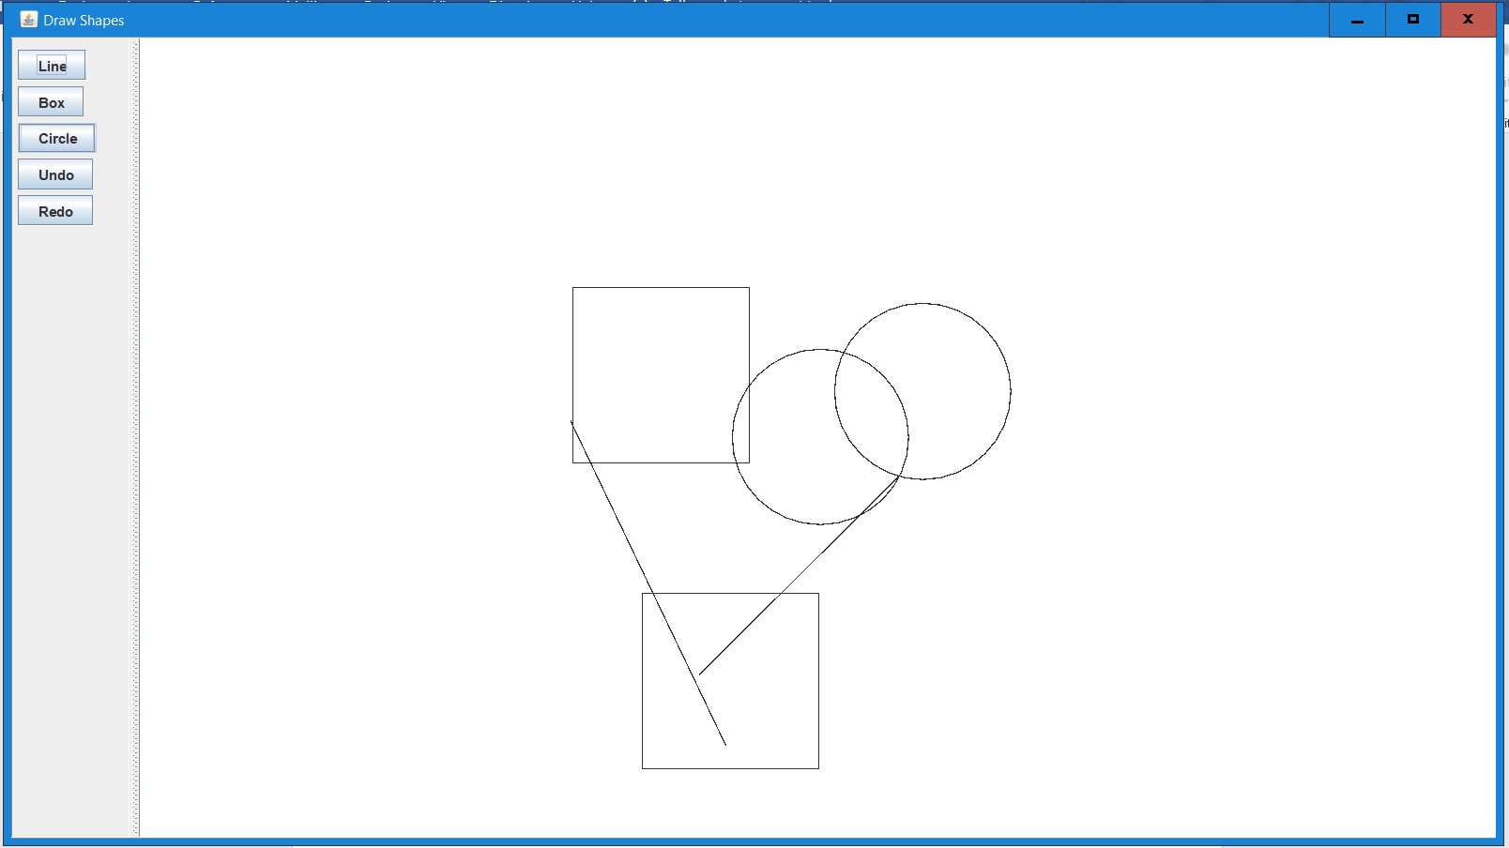

# Step 7 - Undo

Now to test *Undo.*

So, clicking on undo once, results in the following:

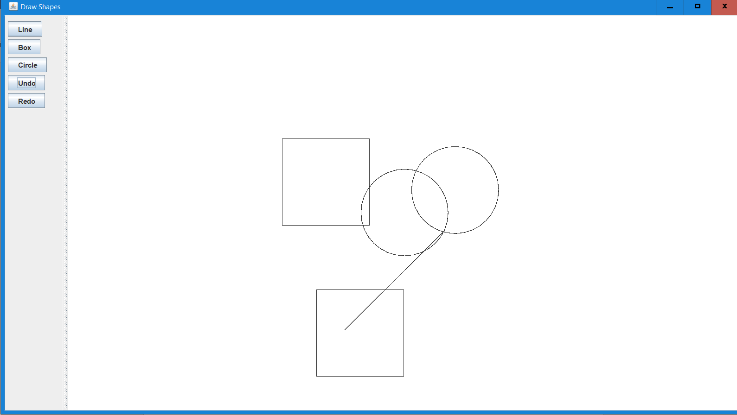

# Step 8

Click on Undo again:

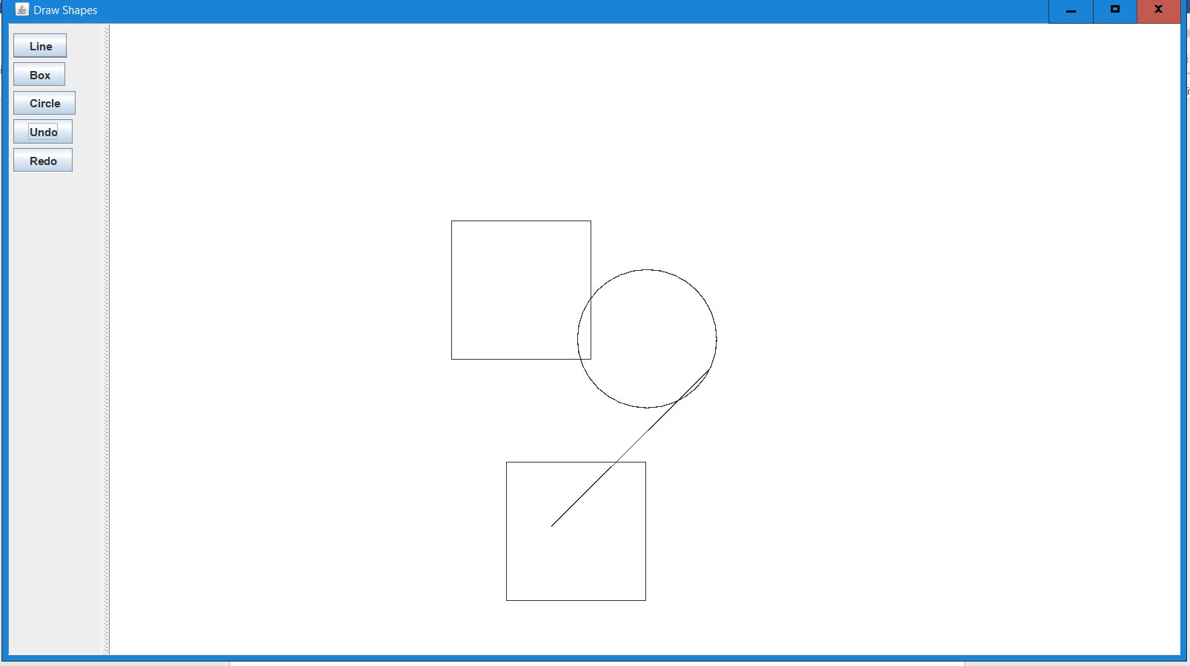

# Step 9

Click on Undo again. It results in the following which is same as Step 5

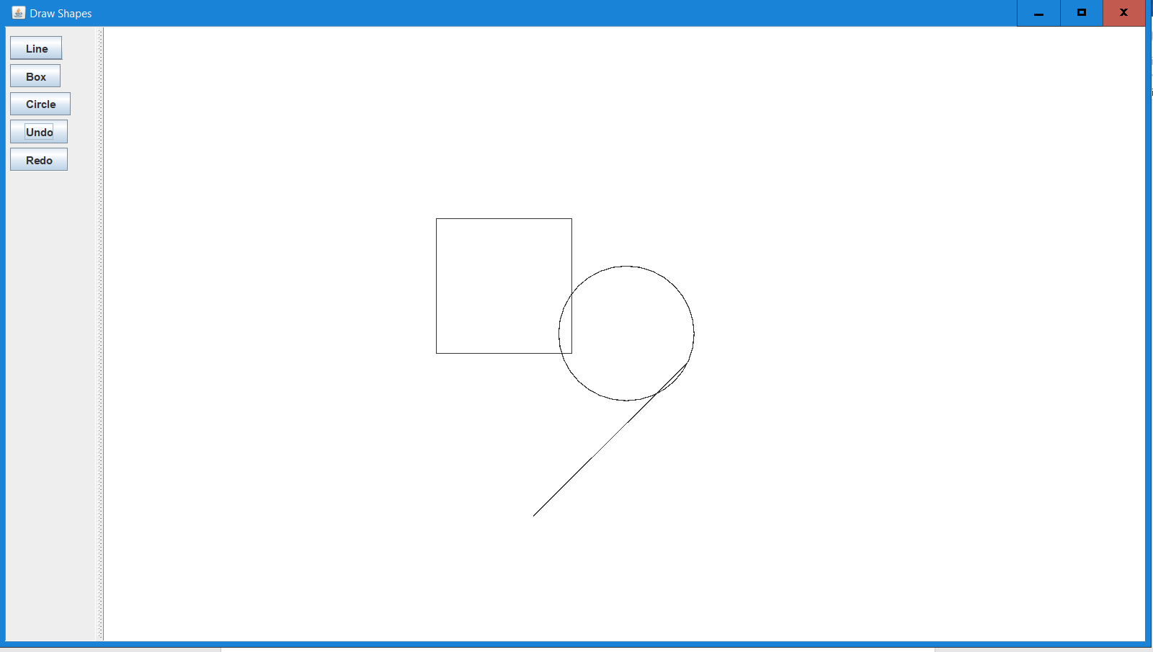

# Step 10

Clicking on Undo 3 or more times results in an empty canvas without causing any problems.

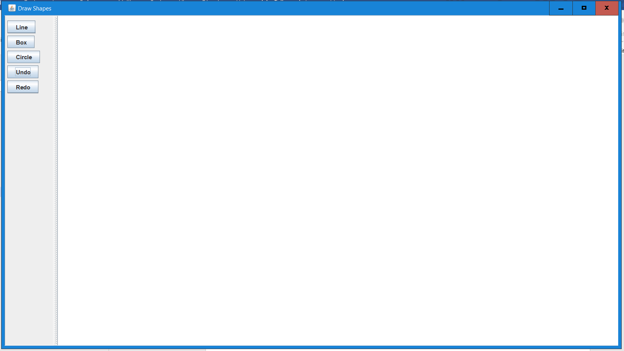

# Step 11 – Redo

Now click on Redo button. The shapes start appearing back on the canvas.

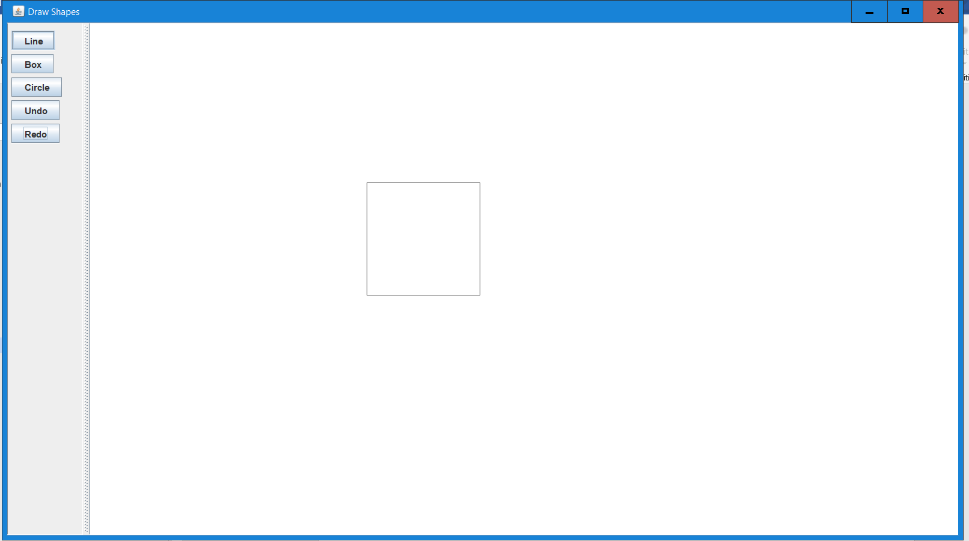

Click on Redo again.

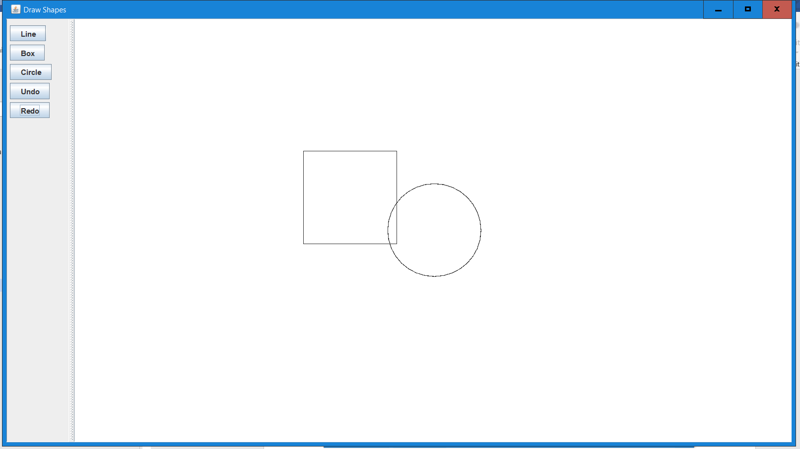

Now as you can see its same as Step 5

