Big query database

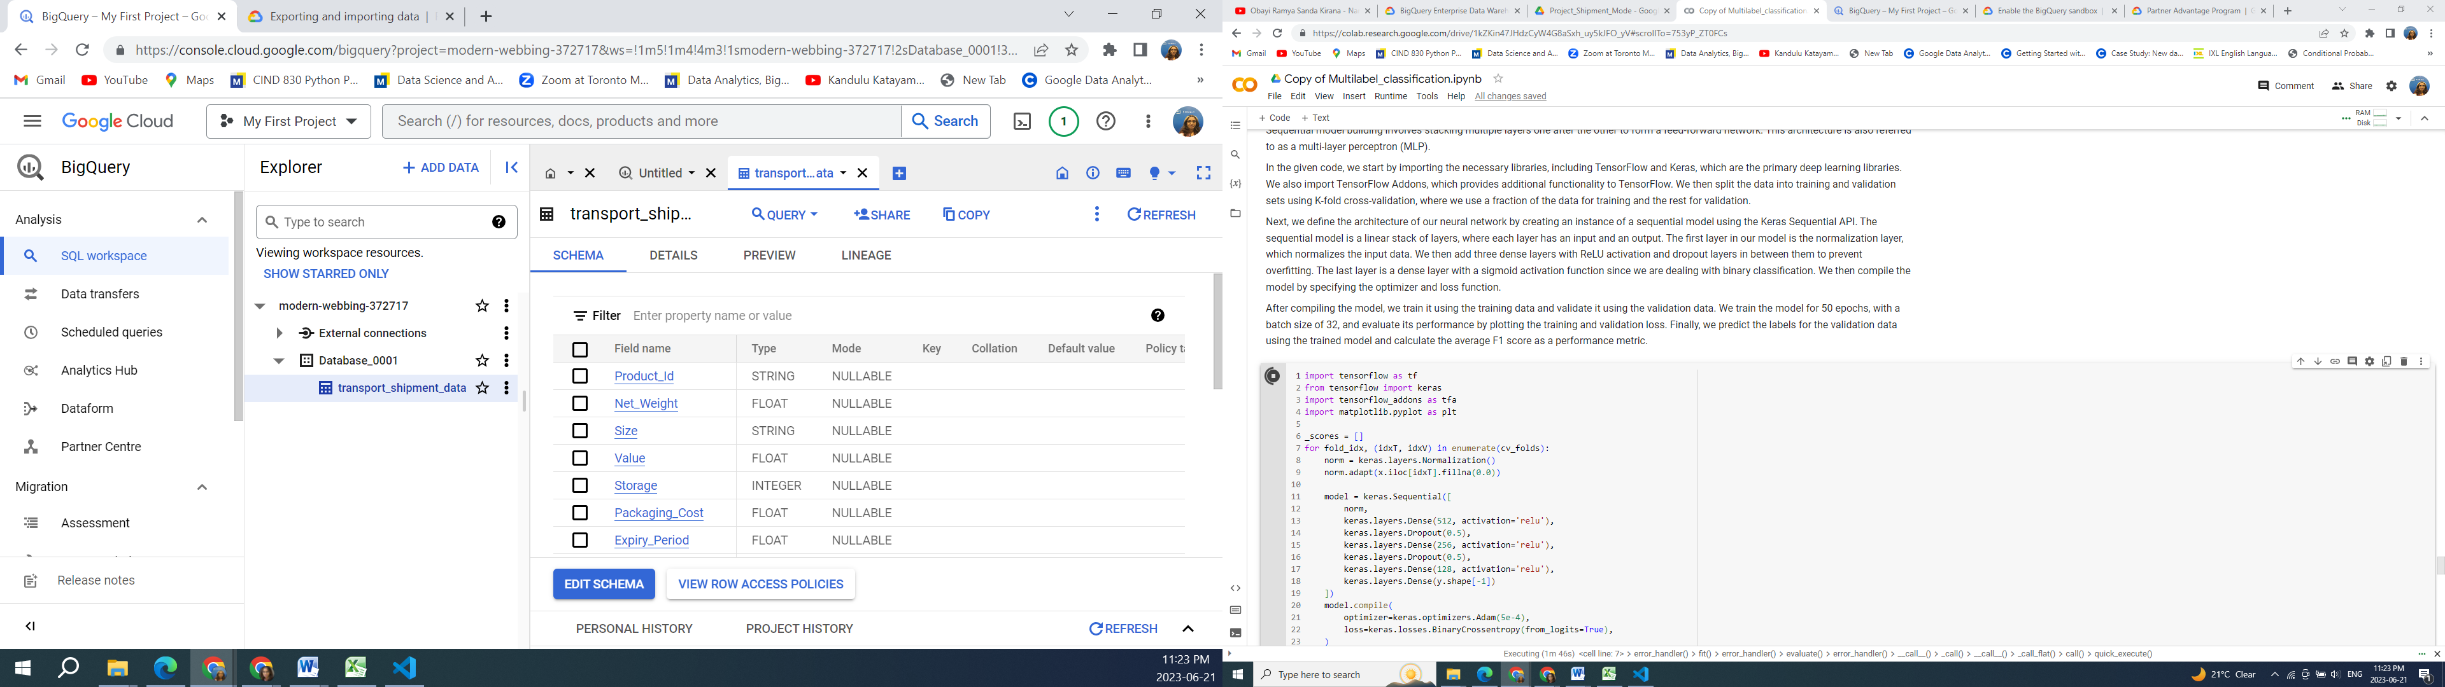

console.cloud.google.com/bigquery?ws=!1m5!1m4!4m3!1smodern-webbing-372717!2sDatabase_0001!3stransport_shipment_data

Multi label Classification for Predicting Shipment Modes