|  |
| --- |
|  |
| February 2022 Newsletter |
|  |

ISKCON Dwarka Dham

# Upcoming Events

## [Date]

Gaura Purnima

## [Date]

[Event Name]

## [Date]

[Event Name]

|  |
| --- |
|  |
| Darshan of the Month No photo description available.  Lord Dwarkadhish at Dwarka main temple |

Sri Sri Rukminidevi Dwarkadhish Mandir

Bharatiya Bhavan,Devi Bhuvan Road,

Dwarka - 361335

https://iskcondwarkadham.com T: E: [iskcondwarka108@gmail.com](mailto:iskcondwarka108@gmail.com)

T +91 9773440880 (Aniketan Prabhu) +91 9898550185 (Vaishnavseva Prabhu)

|  |
| --- |
|  |
| Hare Krishna  Please accept my humble regards.  All Glories to Srila Prabhupada and Gurudeva  Welcome to the first newsletter from ISKCON Dwarka Dham. We are excited to keep you informed about the activities and events at the ISKCON temple and enlighten and inspire you with words of wisdom from sadhus and sastras.  Please stay tuned to our monthly newsletter and feel free to visit the temple and contribute to services at the temple in person or remotely.  Your servant  Vaishnava Seva prabhu |
|  |

## History of Dwarka: the home of Lord Krishna

The modern city of Dwarka (meaning ‘Gateway to Heaven’ in Sanskrit) is located in the north-western Indian state of Gujarat. This city is regarded as one of the most prominent Chardham (the four sacred pilgrimage sites of Hinduism), and one of the seven most ancient religious sites in the country (the other six being Ayodhya, Mathura, Haridwar, Banaras, Kanchi and Ujjain.)

According to Hindu mythology, Dvārakā was a city where Krishna, the eighth avatar of Vishnu, once lived. It is believed that Krishna was born in Mathura, just south of Delhi in the modern state of Uttar Pradesh. His uncle, Kansa, was the tyrannical ruler of this city and was eventually killed by Krishna. Kansa’s father-in-law, who was Jarasandh, the king of Magadha, was furious when he heard of Kansa’s murder, and tried to avenge his death.

Although Mathura was attacked 17 times, it did not fall to Jarasandh. Nevertheless, his clan, the Yadavs, suffered heavy losses over the course of the lengthy conflict. As Krishna realized that his people would not be able to withstand another war with Jarasandh, he decided to leave Mathura with the Yadavs.

[to be continued…]

# More Important News

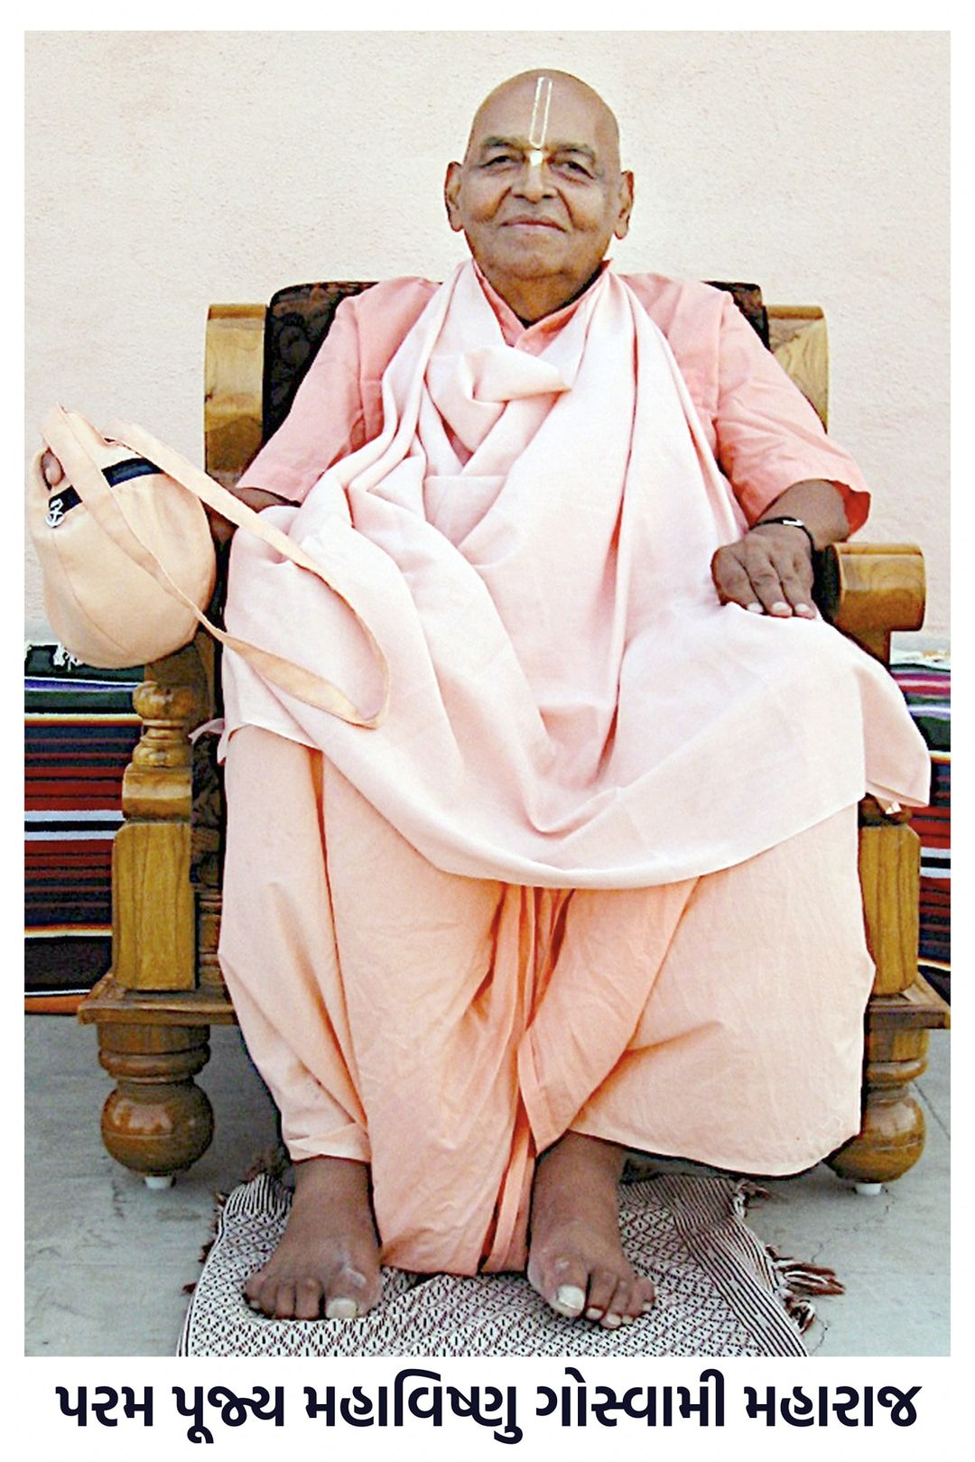

|  |
| --- |
|  |
| Community ActivitiesFood For Life We have started distributing prasadam to poor and needy people in and around Dwarka. Serving Sadhus We have been distributing prasad to visiting sadhus at the holy Dham of Dwarka  Feel contribute generously towards these activities  BANK NAME: HDFC BANK  ACCOUNT NAME: ISKCON DWARKA  ACCOUNT NUMBER: 22521450000137  IFSC CODE: HDFC0002252 |

## History of ISKCON Dwarka

In1996, His Holiness Srila Mahavishnu Gosvami Maharaj, at the advanced age of 78 years, arrived in the Holy Dham of Dwaraka with the one pointed intention of establishing Srila Prabhupada's missionary activities there and spreading Krishna consciousness to one and all.

Maharaj had no well-wishers, friends or supporters in Dwaraka. But he had complete faith in the purity of devotional service and Srimad Bhagavatam.

When some of his disciples who were travelling with him expressed concern about what could be done for preaching in Dwaraka, Maharaj simply reminded them that our first, and only, business was to chant Krishna’s names and study Bhagavatam seriously. And that is what he did – remarkably staying on an open piece of dry desert-like land on the outskirts of the city of Dwaraka and reading and studying Bhagavatam and chanting the Holy Names of the Lord. He would go for a bath at one of the nearer dharmasalas, and soon, many residents of Dwaraka began conversing about a highly renounced sadhu who was attached to nothing except Bhagavatam!

[to be continued ….]