PROJECT KEYSTONE
Field Service Management Platform
Project Report — Java Full-Stack Engineering Internship
Client: Meridian Facilities Management
Delivered by: Zidio Development — Java Full-Stack Practice
Stack: Spring Boot 3 (Java 21) · React + TypeScript · PostgreSQL

1. Overview
Project KEYSTONE is a full-stack field service management platform built for Meridian Facilities Management, a commercial facilities maintenance company. It replaces spreadsheets, phone calls, and messaging apps with a single system of record covering the full journey of a maintenance job: from the moment a customer reports a problem, through dispatch and technician fieldwork, to close-out and reporting.
The platform serves four kinds of user through one application, each seeing only what their role needs:
- Dispatcher — raises and assigns work orders, and watches the dispatch board.
- Technician — sees only their assigned jobs, updates status from the field, and logs parts and time.
- Manager — everything a dispatcher can do, plus closing jobs, managing inventory, and viewing live dashboards.
- Customer — raises requests for their own sites and tracks status without phoning in.

2. Objectives
- Give Meridian one system of record for every work order, from request to close-out.
- Let dispatchers assign and track jobs, with technicians updating them from the field in real time.
- Enforce a clear, guarded work-order lifecycle so jobs cannot skip steps or be silently dropped.
- Track response and resolution against SLAs, and surface breaches automatically.
- Give managers a live operational dashboard and give customers self-service visibility.

3. Technology Stack
Layer | Technology | Why
Language | Java 21 | Modern LTS; records, pattern matching
Backend framework | Spring Boot 3 (Web, Validation) | Industry-standard layered services
Security | Spring Security + JWT | Stateless auth and role enforcement
Persistence | Spring Data JPA / Hibernate | Mapping and repositories
Database | PostgreSQL | Reliable relational store (free/open-source)
Migrations | Flyway | Versioned, reviewable schema changes
Frontend | React 18 + TypeScript (Vite) | Typed, component-based SPA
API docs | springdoc-openapi (Swagger UI) | Live, browsable API reference
Build / deploy | Maven · Docker · Render (free tier) | Reproducible builds, no paid services

No paid or third-party commercial APIs are used anywhere in this project. Postgres, JWT-based authentication, and optional email notifications (via any free SMTP account) are all free and open-source.

4. System Architecture
KEYSTONE is a classic layered Spring Boot application behind a React single-page application. Requests flow from the browser to thin controllers, into services that hold all business rules, down to JPA repositories and PostgreSQL. Business entities are never serialized directly to the client — every response is mapped to a DTO.
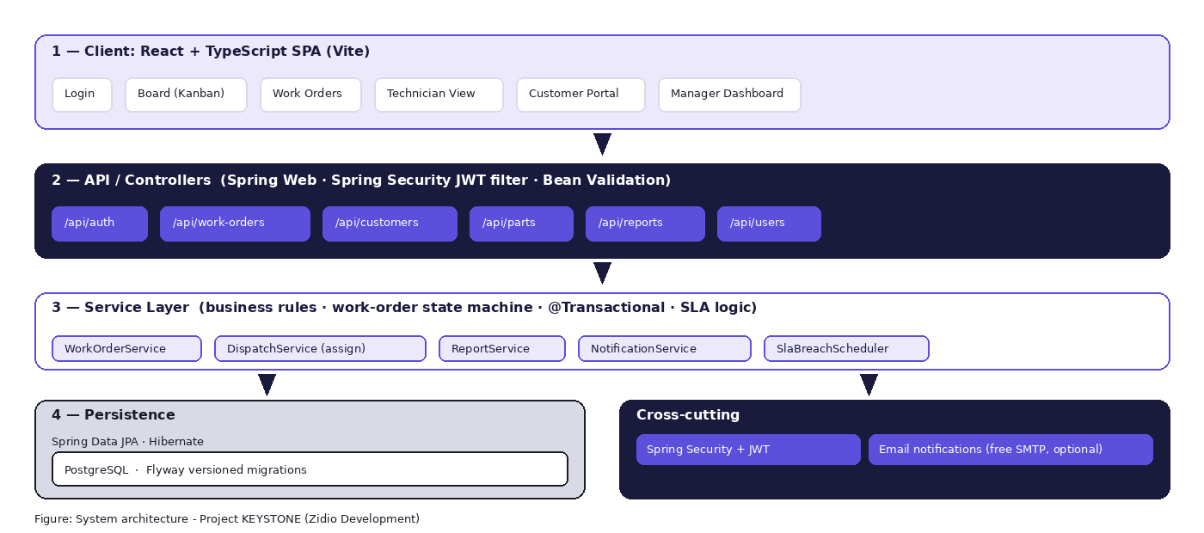
Layer responsibilities:
Layer | Responsibility
Controllers | HTTP only: validate input, enforce auth, map DTOs, delegate to services. No business logic.
Services | Business rules, the work-order state machine, SLA logic; transactional boundaries.
Repositories | Spring Data JPA data access; queries scoped so customers only read their own data.
Persistence | PostgreSQL with Flyway-managed migrations; no schema changes by hand.

5. Domain Model
The core entities are Customer, Site, User, WorkOrder, WorkOrderStatusHistory, Part, PartUsage, and TimeLog. A customer owns one or more sites; sites raise work orders; work orders are assigned to technicians and accumulate an append-only status history, parts used, and time logged. Using parts on a job and decrementing stock happen inside a single database transaction, so partial updates are never possible.

6. Work-Order Lifecycle
The work-order lifecycle is the core business rule of the platform. A work order moves through a fixed set of states — NEW, ASSIGNED, IN_PROGRESS, ON_HOLD, COMPLETED, CLOSED, CANCELLED — and only the transitions defined in the state machine are permitted. This is enforced in the service layer (never just in the UI), and every transition writes an audit row recording who changed what, when, and why.
- Only a manager can transition a work order to CLOSED.
- Only a dispatcher or manager can CANCEL a work order.
- Only the assigned technician (or a manager) can start, hold, resume, or complete a job.
- Terminal states (CLOSED, CANCELLED) cannot transition further.

7. Security & Authentication
KEYSTONE uses stateless JWT authentication with Spring Security. Users log in once and receive a signed token, which is presented on every subsequent request — the server holds no session. Passwords are stored only as BCrypt hashes. Every protected endpoint enforces its role requirement on the server using method-level authorization (@PreAuthorize), and row-level checks in the service layer ensure, for example, that a customer can never view another customer's work orders and a technician can never act on a job that isn't assigned to them.

8. Key Features Delivered
- F1 — Authentication & roles: JWT login, four distinct roles, BCrypt password hashing, server-enforced role checks.
- F2 — Customers & sites: searchable, paginated management; customers see only their own data.
- F3 — Work-order management: full CRUD with server-side validation, unique human-readable codes, immutable once closed/cancelled.
- F4 — Dispatch & assignment: assign/reassign technicians, a Kanban board of all open work grouped by status.
- F5 — Technician field view: mobile-friendly view of assigned jobs, with start/hold/resume/complete actions.
- F6 — Parts & time logging: transactional stock decrements, rolled-up cost and labour totals, stock can never go negative.
- F7 — SLA tracking & notifications: priority-based SLA due dates, a scheduled job flagging breaches, and (optional, free) email notifications.
- F8 — Dashboard & reporting: status counts, overdue work, SLA compliance, and a per-technician breakdown.
- F9 — Customer portal: self-service request raising and status tracking scoped strictly to the customer's own organisation.

9. Deployment
The backend is packaged as a Docker image and deployed as a free Render.com Web Service, backed by a free Render PostgreSQL database. The frontend is deployed as a free Render Static Site (or an equivalent free static host). No paid infrastructure or APIs are required to run the full platform. Local development is supported via Docker Compose (Postgres + backend) alongside `npm run dev` for the frontend.
Live URLs, seed login credentials, and the GitHub repository link are provided in the project submission and in this repository's README.md.

10. Conclusion
Project KEYSTONE delivers a complete, professionally structured field service management platform: a governed work-order lifecycle enforced end-to-end, role-based security that holds even against direct API calls, transactionally correct parts and time tracking, and a live dashboard that gives Meridian's managers real operational visibility. The result replaces Meridian's spreadsheet-and-phone-call workflow with a single, auditable system of record — meeting every deliverable in the engineering brief using entirely free and open-source technology.

