SCHOOL EVENTS LOCATION-BASED PROJECT

CSci 515 – Data Engineering & Management

Department of Computer Science

University of North Dakota

Project Developer :

Name : Manohar Kumar Reddy Dasannagari

Project Instructor :

Name : Dr. Wen-Chen Hu

**Table of Contents**

1. INTRODUCTION ………………………………………………… 1
2. SYSTEM STRUCTURE ………………………………………….. 2
3. APPLICATION FUNCTIONING ………………………………… 3 - 7
4. REFERENCES …………………………………………………….. 8
5. INTRODUCTION
   1. PURPOSE :

This project uses the Google Android platform to build an application where users needing a partner to go for some events in school can request his/her friends to come for requested event. Once his/her friends receive the invitation, they accept if they are interested to come, else they reject if they are not interested in the event. Once the receiver who received the request accepts the invitation, then the status of invitation gets updated at sender’s end acknowledging him that his/her friend accepted the invitation. The sender gets acknowledged even when the invitation is rejected by the receiver. Now, when the invitation got accepted, both sender and receiver can track the location of each of other. This application uses Google maps to plot the locations of users i.e. sender, receiver and events.

* 1. SCOPE :

School events location-based project can be used by users of any school. The invitations can be sent to any number of friends, but this project can only track the locations of only two users at a time i.e. sender and receiver. Tracking locations of more than two people is not yet addressed. The application benefits users of school in checking the school events on map and the event information, other users on the map, sending the invitations to hangout with friends, receiving the invitations to hangout with friends, tracking locations of users once the invitation is accepted by recipient. The application allows the admin to enter the event related information, to manage the database.

1.3 MODULES :

This project has three main modules.

* Authentication Module
* Admin Module
* User Module

1

1. SYSTEM STRUCTURE

The system structure of school events location-based application consists of three tiers:

* Presentation Tier
* Logic Tier
* Data Tier

Double arrow in the below figure represents data flow.

Single line in the below figure represents connection.

Mobile Application User Interface Page

Presentation Tier

System logic

Authentication module

Logic

User

module

Admin module

tier

Data access layer

Data Tier

DBMS

(MySQL)

Fig 1. System Structure of School Events Location-Based Project

2

1. APPLICATION FUNCTIONING
   1. Registration Page:

Users register in this page by entering their name, email id and password.

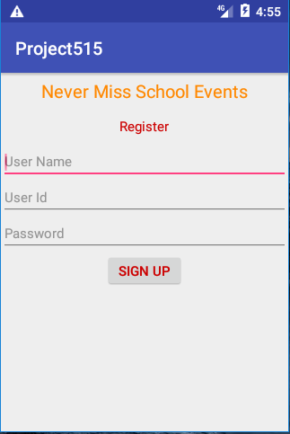

* 1. Login Page :

All the registered users i.e. either admin or normal users can access the application by entering their email id and password with which they have registered.

3

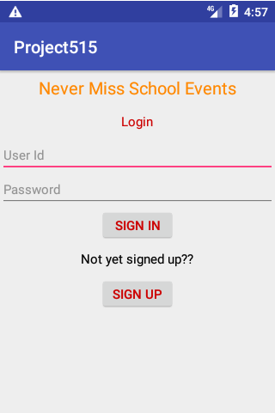

* 1. Admin Page :

Admin enters all the information related to events and maintains the database.

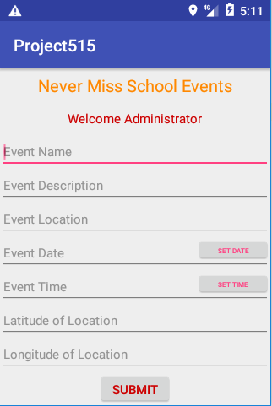

* 1. Events on User Page :

All the events created by admin will appear on the map of user page. Blue Markers represent the events which are on some day from tomorrow, purple markers represent the events that are today. If any event has been completed, then that marker won’t appear on the map. The information related to each event will appear when you click on the marker.

4

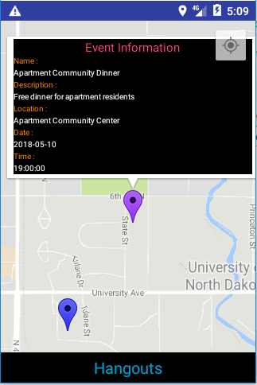

* 1. Users on User Page :

All the users who registered will be there on the map. The current user will be represented by red marker and all the other users are represented by green markers.

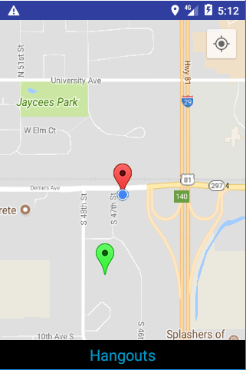

* 1. Sending Invitations on User Page :

A dialog box appears when current user clicks on any other user’s marker. The dialog contains names of the user and drop-down list of events on which the request has not been sent already. The user selects event and hit invite to send the invitation to another user.

5

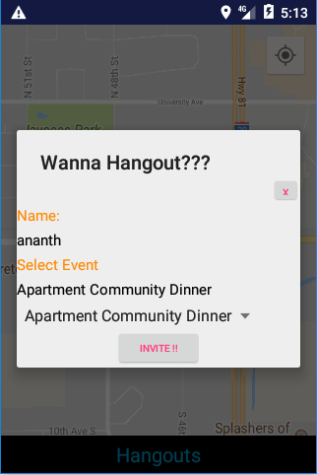

* 1. Invitations Data Page :

When user hits Hangouts button on previous page, he/she will be redirected to Invitations data page which contains invitations sent data and invitations received data.

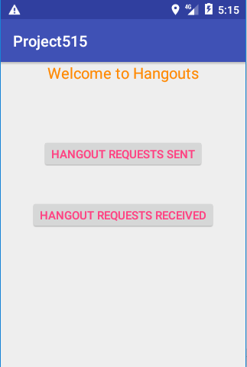

* 1. Invitations Sent Page :

This page shows all the information regarding all the requests that user has sent. This contains information such as name of the user to whom the invitation was sent, event name on which the request was sent, status of the request. The Status of the request will be pending when the request gets initiated, if the other user accepts request the status changes to accepted else rejected. If status changes to accepted, then an option to get the direction is enabled by hitting on which he/she can track both the user’s locations to the event.

6

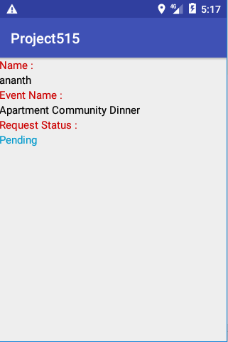

* 1. Invitations Received Page :

This page shows all the information regarding all the requests received by that user. This page contains information about the name of user the request was sent from, event details on which the request was received, options to accept the request or reject the request. If user accepts the request, then an option to get the direction is enabled by hitting on which he/she can track both the user’s locations to the event.

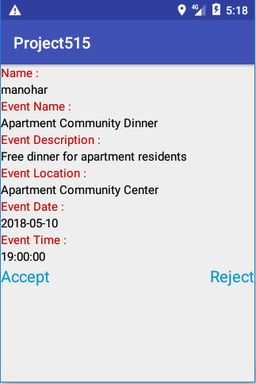

* 1. Get Directions Page :

This page gives the direction from both user’s location to the event location.

7

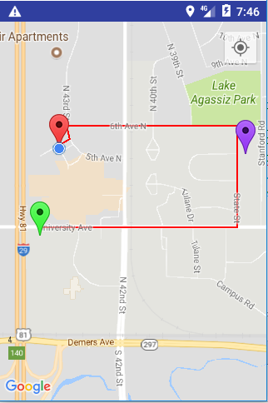

1. REFERENCES

* Class Notes of Data Engineering and Management by Dr. Wen-Chen Hu.
* Stack Over Flow.
* Android Studio Manuals.

8