Welcome to Smallpdf

Ready to take document management to the next level?



# Digital Documents—All In One Place

With the new Smallpdf experience, you can freely upload, organize, and share digital documents. When you enable the [‘Storage’](https://bit.ly/smallpdf-preferences-en) [option](https://bit.ly/smallpdf-preferences-en), we’ll also store all processed files here.



# Enhance Documents in One Click



When you right-click on a file, we’ll present you with an array of options to convert, compress, or modify it.

# Access Files Anytime, Anywhere

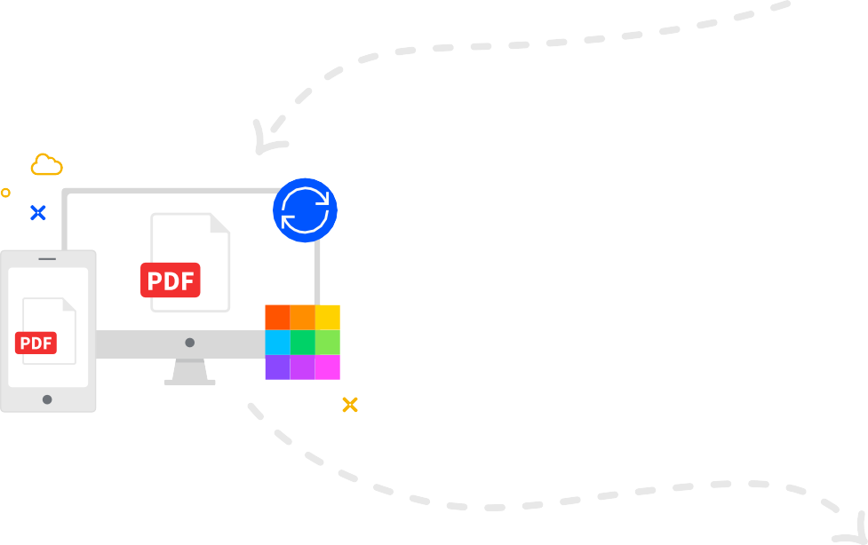

You can access files stored on Smallpdf from your computer, phone, or tablet. We’ll also sync files from the [Smallpdf Mobile App](https://bit.ly/smallpdf-download-en) to our online portal

# Collaborate With Others

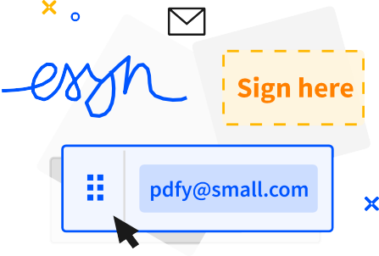

Forget mundane administrative tasks. With Smallpdf, you can request e-signatures, send large files, or even enable the [Smallpdf G Suite](https://bit.ly/smallpdf-chrome-extension) [App](https://bit.ly/smallpdf-chrome-extension) for your entire organization.