Nexora: AI-Powered Platform for Campus Placement and Research Paper Management
Mr. Hari Battana | Palle Pavithra | Nunna Sathvika
Assistant professor,  Dept. of Computer Science and Engineering  Malla Reddy University  Hyderabad,India. | Dept. of Computer Science and Engineering  Malla Reddy University Hyderabad,India. | Dept. of Computer Science and Engineering  Malla Reddy University Hyderabad,India
battana_hari@mallareddyuniversityac.in | pallepavithra2004@gmail.com | sathvikachowdary67@gmail.com
Molugu Sairam | Parne Manohar Reddy
Dept. of Computer Science and Engineering | Dept. of Computer Science and Engineering
Malla Reddy University Hyderabad,India | Malla Reddy University Hyderabad,India
molugusairam521@gmail.com | parnemanoharreddy19@gmail.com

ABSTRACT:
Campus placement management and academic research handling are frequently handled by different systems in contemporary educational institutions, which results in inefficiencies, poor communication, and little stakeholder collaboration. This paper introduces Nexora, an AI-powered integrated platform that supports research paper management in a single digital environment while streamlining campus recruitment efforts. Placement drives, student databases, and academic research workflows can be efficiently coordinated thanks to the platform's role-based access for faculty, students, and institutional administrators. Nexora includes intelligent features that help Training and Placement Officers monitor recruitment performance and student readiness, including AI-assisted resume evaluation, automated placement notifications, mock test modules, and analytics tools.The platform also has a dedicated research hub where students and faculty can manage academic collaborations, track research activities within the institution, and submit manuscripts. Interaction between students, teachers, and recruiters is further improved by professional networking tools and communication modules. To guarantee dependability and institutional control, the system architecture places a strong emphasis on scalable data handling, device management, and secure authentication. Nexora lowers administrative complexity and increases transparency in academic and recruitment procedures by combining artificial intelligence with centralized placement and research management capabilities. By offering a structured and easily accessible platform for academic collaboration and placement management within higher education institutions, the proposed system seeks to improve student career preparedness, support institutional decision-making through analytics, and promote research productivity.
KEYWORDS: Artificial Intelligence, Campus Placement System, Research Management System, Resume Analysis, Academic Collaboration, Recruitment Automation, Educational Technology.
INTRODUCTION:
Higher education institutions have been using digital technologies more and more in recent years to handle research, campus recruitment, and academic administration. Universities and placement cells face enormous challenges in managing massive amounts of student data, planning recruitment drives, and guaranteeing efficient communication between students, faculty, and recruiters as the number of graduating students keeps rising. Conventional placement management techniques frequently depend on manual procedures like keeping spreadsheets up to date, manually reviewing resumes, and sending out emails or notices about job openings. Institutions find it challenging to effectively monitor student progress and placement activities because these approaches are laborious, prone to human error, and frequently result in inconsistent data management.
Furthermore, recruiters often receive a lot of applications for a single job, which makes manual resume screening unfeasible and ineffective. Recruitment processes like skill extraction, resume analysis, and candidate ranking can now be automated with the help of artificial intelligence (AI) and machine learning technologies. AI-based resume screening systems reduce the workload of recruiters while increasing the speed and accuracy of hiring decisions by evaluating resumes and identifying qualified candidates using methods like machine learning and natural language processing.
In order to help students and placement officers improve recruitment outcomes, recent studies have also investigated AI-driven placement platforms that incorporate resume analysis, job recommendations, and placement dashboards. However, the majority of current systems lack integration with research management and are primarily focused on placement automation. This paper suggests Nexora, an AI-powered platform that combines academic collaboration, research paper submission, and campus placement management into a single system, as a solution to this problem.
LITERATURE SURVEY:
In recent years, the application of Artificial Intelligence (AI) in recruitment and campus placement systems has gained significant attention. To increase hiring efficiency, automate resume screening, and facilitate better decision-making in placement management systems, researchers have investigated a variety of technologies, including machine learning, natural language processing (NLP), and data analytics.
An intelligent AI-based resume screening and ranking framework that uses deep learning and natural language processing to automate the candidate shortlisting process was proposed by Sabarirajan et al. Instead of depending only on keyword matching, the system assesses resumes using contextual understanding of skills, experience, and job relevance. The framework maintains fairness and transparency in automated decision-making while reducing recruiter workload and increasing recruitment efficiency by creating ranked candidate lists [1]. In a similar vein, Pawar et al. created an AI-driven placement management system that offers recruiters, placement officers, and students an integrated platform. Features like resume analysis, job recommendations, interview preparation modules, and training and placement officer dashboards are all included in their system. The system increases student readiness and boosts the general effectiveness of hiring procedures by utilising generative AI and machine learning techniques [2].
The shortcomings of conventional placement management systems, which mainly rely on manual data handling and communication procedures, were brought to light by Pandit et al. According to their research, manual placement management results in ineffective data storage, a higher risk of mistakes, and challenges in monitoring student eligibility for various employers. To handle student records and placement notifications, the authors advise creating automated web-based platforms. [3] An AI-based smart placement system that matches student profiles with appropriate job opportunities using machine learning algorithms was presented in another study by Tambe et al. In order to provide tailored career recommendations, the system evaluates student data and resumes, assisting institutions and students in making better placement decisions [4].
A college placement management system combined with an AI-powered resume analyser was proposed by Gurlhosur et al. Students can upload resumes on their platform and get feedback on the quality of the resume, skill gaps, and possible career paths. In order to increase the effectiveness of the placement process, recruiters can also view candidate profiles and shortlist candidates based on job requirements [5].
By creating an AI-driven placement prediction and recommendation system, Khodaskar et al. further investigated predictive analytics in placement systems. In order to forecast placement outcomes and offer tailored suggestions for enhancing employability, their model examines academic performance and skill profiles [6]. An AI-based internship and placement system that incorporates recommendation engines, automated tests, and skill extraction was presented by Madhan et al. By identifying skill gaps and offering individualised learning paths, the system helps students become more prepared for the workforce [8]. In a similar vein, Chaudhari et al. created an AI-based resume screening and prediction system that uses machine learning techniques to categorise resumes into job roles, decreasing the need for manual screening and increasing the effectiveness of candidate selection [9].
Even though these studies show how effective AI-based placement and recruitment systems are, the majority of current solutions mainly concentrate on candidate screening and recruitment automation. The combination of academic research activities and placement management on a single platform has not been extensively studied. Thus, by combining AI-powered placement management, resume analysis, communication modules, and research paper management into a single platform for higher education institutions, the proposed system Nexora seeks to close this gap.
Related work
Intelligent recruitment and placement management systems have been made possible by recent developments in machine learning and artificial intelligence (AI). In order to increase recruitment efficiency, early research concentrated on resume classification and candidate recommendation systems that automatically rank applicants based on job descriptions. AI-based resume screening systems that use machine learning and natural language processing (NLP) to extract candidate skills and create automated shortlists were introduced by later research. Candidate-job matching was further enhanced by AI-powered campus placement portals and job recommendation systems that used classification algorithms and predictive analytics. However, the majority of current systems lack integration with academic research management and primarily concentrate on recruitment automation. By combining placement management, AI-based resume analysis, communication modules, and research paper management into a single system, the proposed Nexora platform overcomes this constraint.
Table 1: Gap Analysis of Existing Systems
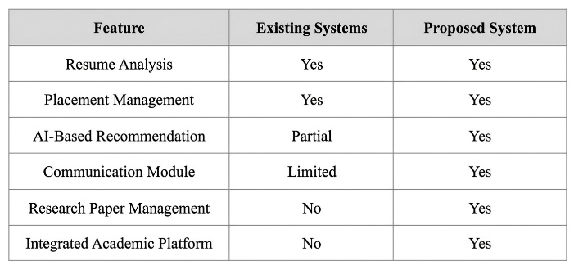
PROPOSED METHODOLOGY:
NEXORA: A Governance-Brain Driven, Multi-Tenant, AI-Integrated University Placement Operating System is a proposed system that uses modular architecture, secure multi-tenant infrastructure, and artificial intelligence to automate and optimize academic collaboration and campus placement management. Within a single platform, the methodology combines data collection, intelligent processing, automated placement management, and AI-assisted decision-making.
- Approach to System Development
NEXORA is being developed using the Agile Scrum methodology, which uses iterative development cycles to implement system features. Delivering particular modules, such as identity management, placement workflow automation, intelligence services, and communication systems, is the main goal of each sprint. Continuous improvement, quick testing, and incremental feature deployment are made possible by this iterative process. Identity and access management, placement management, governance, brain intelligence services, social communication modules, and analytics dashboards are among the essential elements created throughout the process.
B. Institutional Architecture with Multiple Tenants
Multiple universities can function within a single application instance while maintaining total data isolation thanks to the system's schema-per-tenant architecture, which uses PostgreSQL and django-tenants. Academic records, placement drives, and communication data are stored separately in a specific database schema assigned to each institution. Shared services like tenant registration, global configuration, analytics, and authentication are maintained by the public schema. Based on the JSON Web Token (JWT) claims of the authenticated user, middleware automatically determines the correct tenant schema.
C. Management of Identity and Access
The RS256 asymmetric cryptographic algorithm is used by the platform to implement a secure authentication framework based on JWT tokens. Short-lived access tokens are distributed in conjunction with refresh tokens that are kept in secure HTTP-only cookies. Session fingerprinting, IP monitoring, password history validation, and progressive login lockout are further security measures. Tenant resolution, certificate validation, authentication checks, and governance policy enforcement are all carried out by a layered middleware pipeline that processes each request.
D. Engine for Placement Management
The placement module uses a dynamic eligibility rule engine to automate recruitment processes. By defining criteria like minimum CGPA, academic performance, branch eligibility, and backlog restrictions, Training and Placement Officers (TPOs) establish placement drives. The eligibility engine automatically creates a list of qualified applicants after comparing these requirements to the academic profiles of the students. Additionally, the system has an Applicant Tracking System (ATS) that oversees the screening, testing, interview, and offer confirmation phases of the hiring process.
E. The Intelligence Layer and Governance Brain
The central intelligence engine that keeps an eye on students' activities is called the Governance Brain. Each student's intelligence profile is updated based on behavioral events, such as creating a resume, taking quizzes, or breaking rules. Governance policies use the behavior score and risk factor calculated by a scoring algorithm to dynamically enable or limit specific platform features. This system upholds institutional rules and promotes student participation.
F. Intelligence through Retrieval-Augmented Generation (RAG)
The system incorporates a Retrieval-Augmented Generation (RAG) framework to offer individualized academic and career guidance. Resumes, project descriptions, and student profile information are kept in contextual knowledge chunks. When a student submits a query, a large language model (LLM) prompt is combined with pertinent context to produce precise, customized answers. The system ensures dependability through automatic provider fallback mechanisms and supports a variety of AI providers, such as Gemini and LLaMA-based models.
G. Automation and Real-Time Communication
NEXORA uses Django Channels and Redis to integrate WebSocket-based real-time communication. Live chat, notifications, placement updates, and institutional announcements are all made possible by this. Celery distributed task queues improve scalability and system responsiveness by handling asynchronous operations like certificate generation, placement reminders, and large data processing tasks.
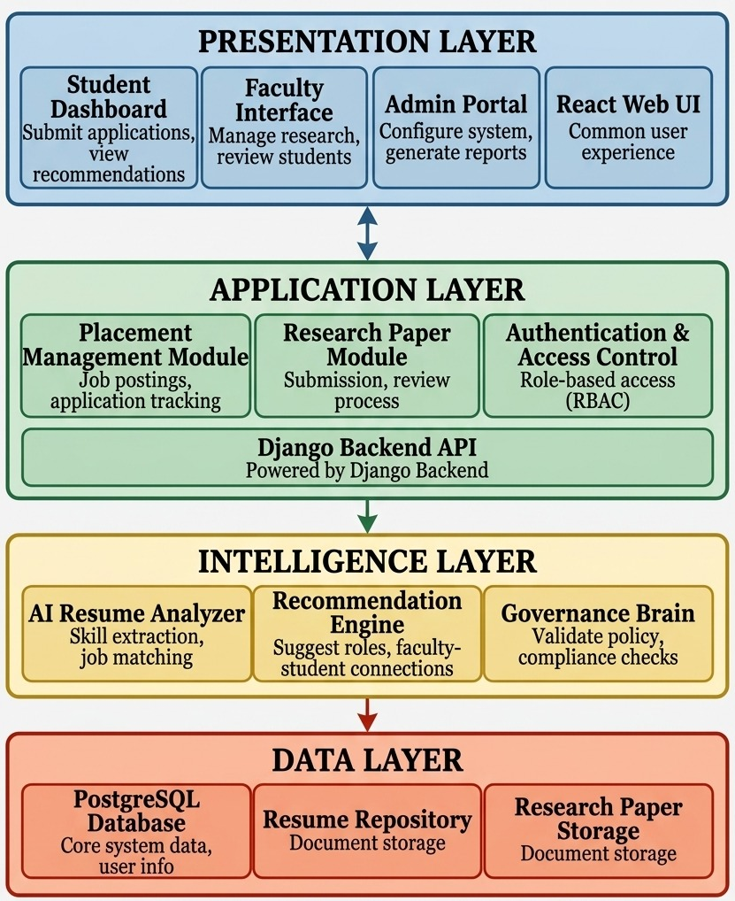
Figure-1: System Architecture

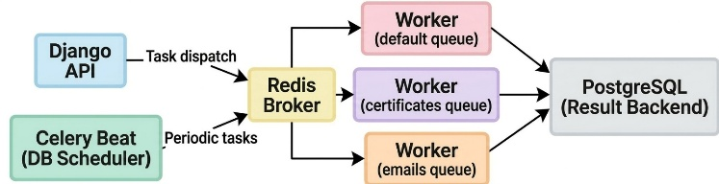
Figure-2: Celery Architecture
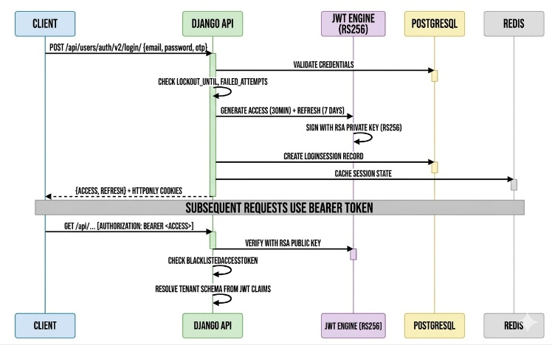
Figure-3: Authentication Flow
RESULT ANALYSIS:
System performance, scalability, and functional efficacy in automating university placement processes were taken into consideration when evaluating the NEXORA platform. A containerized environment with PostgreSQL, Redis, and Django-based backend services was used for the experimental evaluation. The findings show that, in comparison to conventional manual workflows, the suggested system greatly increases placement management efficiency.
According to performance benchmarking, placement drive queries were completed in less than 100 ms, while the authentication procedure utilizing RS256-based JWT tokens achieved an average response time of less than 50 ms. Real-time candidate shortlisting during placement drives was made possible by the automated eligibility evaluation engine, which completed student eligibility calculations in 200 milliseconds. While Gemini-based multimodal responses took about five seconds because of additional contextual processing, AI-assisted guidance using the Groq LLaMA 3.1 model produced personalized responses in about two seconds. With a message delivery latency of less than 30 ms, real-time communication via WebSocket channels ensured effective live notifications and messaging between administrators and students.
The outcomes also validate that the multi-tenant schema-based architecture supports concurrent operations across several universities while guaranteeing total institutional data isolation. Additionally, by offloading laborious tasks like certificate generation and placement broadcasts, Celery's asynchronous task processing greatly increased system responsiveness.
Overall, the experimental evaluation shows that the suggested NEXORA system successfully integrates AI-driven intelligence with automated administrative workflows, offering a scalable, secure, and high-performance solution for university placement management.
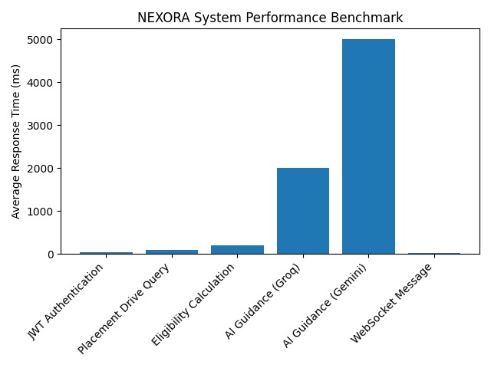
Figure-4: Performance benchmark of major system operations in the NEXORA platform.
DISCUSSION:
The success of incorporating automated workflow management, multi-tenant architecture, and artificial intelligence into university placement systems is demonstrated by the deployment of NEXORA. The efficiency of the placement process, data organization, and student-placement officer communication have all significantly improved, according to the results. Institutions can keep an eye on student engagement and preparedness for recruitment efforts thanks to the Governance Brain mechanism's adaptive behavioral analysis. Strong data isolation between institutions is also ensured by the use of schema-based multi-tenancy. System responsiveness and scalability are further improved by asynchronous task processing with Celery and real-time communication via WebSockets. All things considered, the suggested platform effectively overcomes the drawbacks of conventional manual placement management systems.
CONCLUSION:
This study introduces NEXORA, a multi-tenant university placement operating system that is governance-driven, AI-integrated, and intended to improve and automate placement management procedures. The system uses intelligent automation, dynamic eligibility evaluation, and AI-assisted student guidance to replace manual workflows. The platform guarantees scalability, security, and real-time collaboration by utilizing technologies like Django, PostgreSQL multi-tenancy, WebSocket communication, and retrieval-augmented generation. Improved performance, quicker hiring processes, and effective institutional data management are all demonstrated by experimental evaluation. The suggested system offers contemporary educational institutions a scalable digital solution and lays the groundwork for upcoming improvements like sophisticated AI-driven career counseling systems and predictive placement analytics.
REFERENCES:
[1] A. Sabarirajan, “Intelligent AI-Based Resume Screening and Ranking Framework for Unbiased and Scalable Recruitment Automation,” Proceedings of the International Conference on Agents and Artificial Intelligence, 2025
[2] “AI Powered Placement Management System,” Journal of Emerging Technologies and Innovative Research (JETIR), 2025.
[3] “AI-Based Smart Placement System,” International Journal of Scientific Research in Engineering and Management (IJSREM), 2023
[4] “AI-Based Placement Management System,” International Journal of Research in Engineering and Science, 2022.
[5] “AI-Based Resume Screening Systems,” International Journal of Research and Technology Innovations, 2025.

[6] “College Placement Management System with AI Based Resume Analysis,” International Journal of Novel Research and Development, 2024.
[7] “AI-Driven Placement Prediction and Recommendation System,” International Research Journal of Engineering and Technology (IRJET), 2025.
[8] “AI-Driven Resume Parsing and Ranking System Using Machine Learning,” International Journal of Creative Research Thoughts, 2025.
[9] “AI-Based Internship and Placement System,” International Journal of Research Publication and Reviews, 2025.
[10] O. N. Chaudhari and L. Patil, “AI-Based Resume Screening and Prediction System,” International Journal of Advanced Research in Science, Communication and Technology, 2025.

