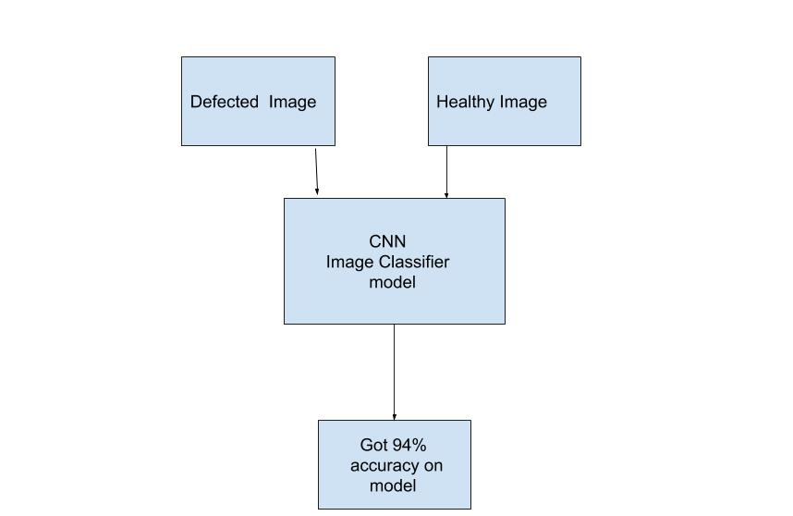

I have solved this assignment by using a convolution neural network (CNN), image classification method. Following are my approach

1. The problem statement was to detect the healthy and defected image, which means the outcome will be binary either 0 or 1.

2. Since the images have a standard background so 100 images for each class were sufficient to get a good prediction result.

3. Used 25% images in test set and 75% images in training set

4. Size of the image was large so input size of image for the model was 64\*64

5. Got accuracy 94% model

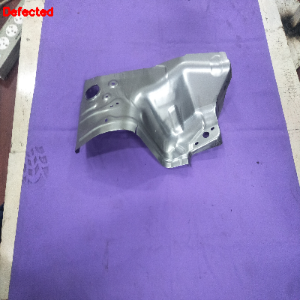 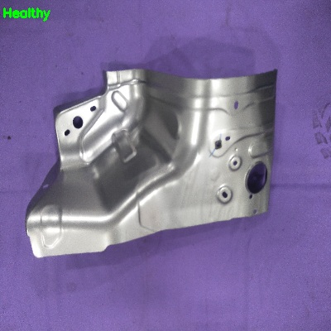

Fig. Defected image Fig. Healthy Image