

VARDHAMAN COLLEGE OF ENGINEERING
(AUTONOMOUS)
Industry Oriented Training Program
in Collaboration with MASS MUTUAL

General Details:
Case Study Name : Real-Time Market Analytics and Investor Insights Dashboard
Team members : K.Manoj Kumar, E.Manvith Reddy, B.Sai Ritheesh, P.Shivendra, Sai Dharahas
Trainers : Chintam Sumati, Expert at Data Engineering, Mass Mutual
Mr. Prasada Reddy, Faculty Trainer of DE domain, VCE
SPOC : Dr. Vasantha V, Head of Mass Mutual

Contents
1 Introduction
1.1 Importance and Relevance to Engineering and Society
1.2 Objectives of the Case Study Analysis
2 Case Study Background
2.1 Description of the Case Scenario
2.2 Key Facts, Figures, and Stakeholders Involved
2.3 Background Information
3 Problem Identification and Analysis
3.1 Main Challenge
3.2 Engineering Principles and Theories Applied
3.3 Analysis of the Identified Problem
4 Application of Program Outcomes
5 Sustainable Development Goals relevant to case study (SDGs)
6 Proposed Solution and Recommendations
6.1 Proposed Solution
6.2 Recommendations
6.3 Implementation Steps
6.4 Implementation screenshots
7 Conclusion and possible outcomes
7.1 Conclusion
8 Response Of The Jury
9 Completion certificates

- INTRODUCTION

  - Importance and Relevance to Engineering and Society
In the modern digital era, financial institutions continuously generate large volumes of complex data related to markets, investments, and macroeconomic indicators. Managing and analyzing this data efficiently has become a critical engineering challenge. Traditional manual methods are no longer sufficient due to the increasing scale, speed, and variety of financial data.
From an engineering standpoint, this case study highlights the importance of designing automated, scalable, and fault-tolerant systems using modern data engineering tools. It demonstrates how concepts such as distributed computing, workflow orchestration, data modeling, and system integration are applied in a real-world financial scenario.
From a societal perspective, accurate and timely financial insights contribute to economic stability, informed investment decisions, and long-term financial planning. Organizations like MassMutual rely on such systems to manage risk responsibly, protect investor interests, and support sustainable economic growth.

  - Objectives of the Case Study Analysis

- To design an automated financial data pipel
- To apply data engineering tools for large-scale data processing
- To demonstrate workflow orchestration using Apache Airflow
- To store and manage analytical data efficiently
- To present insights using professional dashboards

2 . CASE STUDY BACKGROUND

2.1 Description of the Case Scenario

The case scenario focuses on a financial analytics requirement for MassMutual, where daily financial market data must be processed and analyzed efficiently. The organization deals with time-series data such as stock prices, trading volumes, and macroeconomic indicators including GDP growth, inflation, and interest rates.

The challenge is to design a system that automatically processes this data, computes meaningful indicators, and presents insights without manual intervention. The solution must be reliable, scalable, and capable of supporting business-level analysis.

2.2 Key Facts, Figures, and Stakeholders Involved

- Data Sources: Financial market datasets including stock prices, trading volume, market indices, and macroeconomic indicators such as GDP growth, inflation rate, and interest rates, sourced from publicly available financial and economic data repositories in Excel and CSV formats.
- Users: Financial analysts, investment managers, data engineers, business analysts, and senior management involved in financial planning and market analysis.
- Key Metrics: Daily and monthly returns, average trading volume, volatility index, moving averages, market growth trends, top gainers and losers, and key performance indicators (KPIs) for financial decision-making.
- Tools Used: Apache Spark (PySpark), Apache Airflow, PostgreSQL, Docker, Microsoft Power BI, Power Query, DAX, Angular.
- Stakeholders:
  - Internal departments (Finance, Investment, Data Engineering, Business Intelligence)
  - Financial analysts and portfolio managers
  - Senior management and strategic decision-making teams

2.3 Background Information

Historically, financial analysis relied on spreadsheet-based tools and manual reporting systems. While suitable for small datasets, these systems struggle with large-scale data processing and real-time updates. They also introduce human error and inefficiencies.

With advancements in data engineering, organizations now adopt automated pipelines that ensure consistency, faster processing, and scalability. This project is designed to reflect such modern enterprise-level data architectures.

- PROBLEM IDENTIFICATION AND ANALYSIS

3.1 Main Challenge

The main challenge identified in this case study is the absence of an automated and scalable financial data processing system. Manual workflows are slow, error-prone, and incapable of handling growing data volumes efficiently.

Additional challenges include:

- Lack of centralized data storage

- Inconsistent data formats

- Delayed reporting and analytics

- Limited support for advanced risk analysis

3.2 Engineering Principles and Theories Applied

- Data Engineering: ETL processes using Power Query for extraction, cleaning, and transformation.
- Automation: Eliminating manual intervention through scheduled workflows
- Scalability: Using distributed processing to handle increasing data size
- Reliability: Ensuring fault tolerance and retry mechanisms
- Modularity: Separating processing, storage, and visualization layers
- Data Modeling: Applying dimensional modeling for analytical efficiency

3.3 Analysis of the Identified Problem

Manual financial data processing systems are not sustainable in modern environments. As data volume and complexity increase, these systems fail to deliver timely insights. The lack of automation also increases operational risk and limits analytical depth.

A systematic engineering approach is required to address these issues, emphasizing automation, consistency, and scalability.

4. APPLICATION OF PROGRAM OUTCOMES

This project demonstrates the effective application of engineering program outcomes:
- PO1: Application of engineering knowledge to financial data systems
- PO2: Problem analysis and requirement identification
- PO3: Design and implementation of automated solutions
- PO5: Use of modern tools such as Spark, Airflow, and Docker
- PO9: Team coordination and system integration
- PO10: Clear communication through dashboards and reports

5. SUSTAINABLE DEVELOPMENT GOALS (SDGS) RELEVANT TO THE CASE
STUDY

- SDG 8: Decent Work and Economic Growth
Enhances business efficiency, productivity, and financial governance.
- SDG 9: Industry, Innovation, and Infrastructure
Encourages adoption of digital, data-driven analytics solutions.
- SDG 12: Responsible Consumption & Production
Reduces wasteful manual processes and promotes automation.

6. PROPOSED SOLUTION AND RECOMMENDATIONS
6.1 Proposed Solution
The proposed solution is a centralized analytics platform that integrates financial market and investment datasets into a unified reporting system. It provides near real-time insights into market trends, price movements, volatility, trading activity, and investor performance. The system uses PySpark for preprocessing, PostgreSQL for storage, Power BI for analytics, and Angular for frontend access.
Architecture Overview:
- Data Sources: Excel/CSV files containing financial market data such as stock prices, trading volume, market indices, and macroeconomic indicators (GDP, inflation, interest rates).
- ETL Layer: PySpark-based ETL pipeline for data cleaning, transformation, aggregation, and feature engineering. Apache Airflow schedules and orchestrates the ETL workflow.
- Data Model Layer: PostgreSQL analytical schema consisting of fact tables and dimension tables (daily prices, monthly summaries, volatility metrics, stock metadata, date dimensions).
- Visualization Layer: Power BI dashboards with KPIs, charts, trend lines, volatility indicators, rankings, and filters.
- Deployment Layer: Docker-based deployment with Airflow, Spark, PostgreSQL containers and Power BI Service for report sharing and refresh.

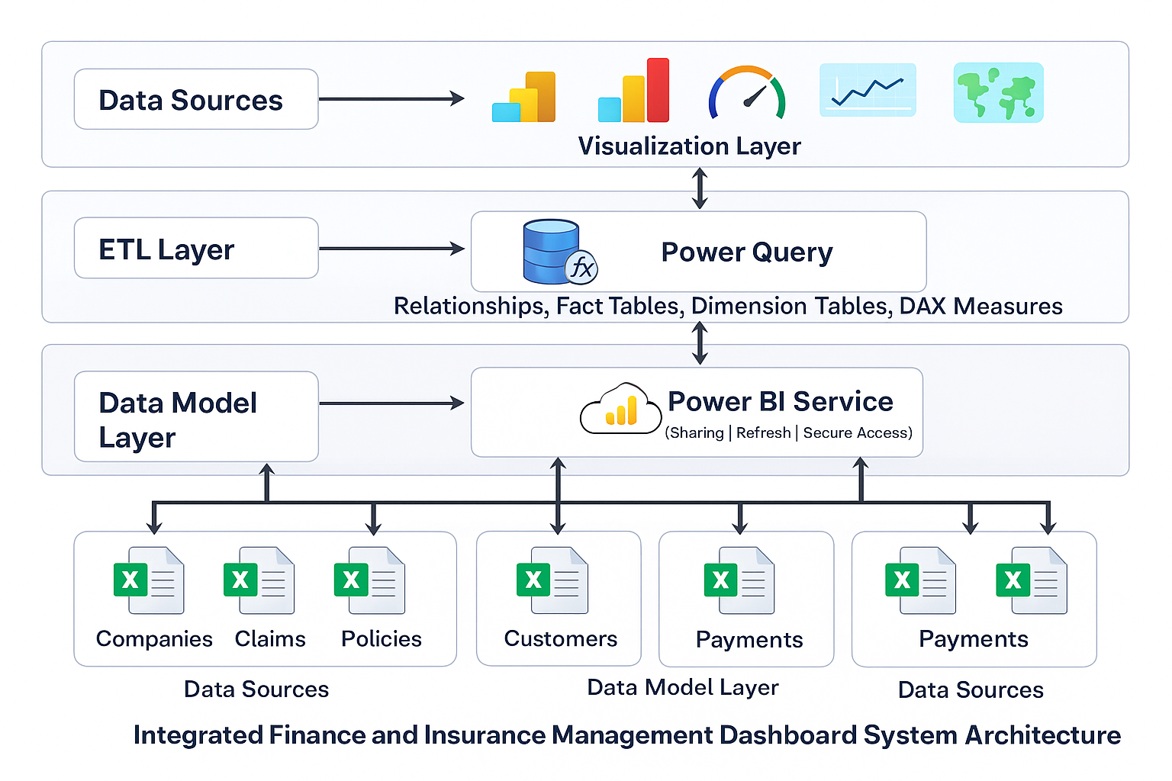
Core Features of the Solution
- Centralized and Data Integration
All data related to companies, policies, customers, claims, payments, and employees are consolidated into one unified Power BI model. This eliminates fragmented reporting across branches and ensures a single source of truth.
- Automated Data Preprocessing
Power Query is used to automatically clean, transform, and validate incoming data. This includes:
  - Removing duplicates
  - Handling missing values
  - Standardizing formats (dates, currency, IDs)
  - Validating relationships between datasets
- Dynamic Analytics Using DAX
In this step, DAX (Data Analysis Expressions) is used to create dynamic measures and calculated columns. These calculations include total claims, average claim amount, profit margin, policy renewal rate, and claim trends over time. DAX enables real-time updates of KPIs whenever users apply filters or slicers, making the dashboard fully
interactive DAX (Data Analysis Expressions) is used to create real-time calculations such as:
  - Total Claims
  - Average Claim Amount
  - Active vs Expired Policies
  - Profit Margin
  - Policy Renewal Rate
- Interactive Visual Dashboard
The processed and analyzed data is then presented through an interactive Power BI dashboard. Various visual elements such as maps, bar charts, line charts, donut charts, gauge charts, and scatter plots are used to represent different performance indicators. Users can filter data by branch, policy type, time period, and claim category. Drill-down and cross-filtering features allow deeper exploration of the data.
The dashboard includes:
  - Maps for branch-wise performance
  - Bar & Line Charts for trends
  - Donut & Pie Charts for distribution analysis
  - Gauge Charts for Profit Margin and Claim Payout
  - Scatter Charts for Revenue vs Claim Risk
  - Slicers & Filters for real-time user interaction
- Real-Time Monitoring & Alerts
This step focuses on enabling real-time operational monitoring. The dashboard continuously tracks critical factors such as expiring policies, high claim payouts, and revenue fluctuations. Threshold-based alerts can be configured to notify decision-makers when unusual trends or risk conditions occur. This allows organizations to take proactive actions rather than reacting after losses occur.
The system enables continuous monitoring of:
  - Expiring policies
  - Sudden spikes in claims
  - Revenue fluctuations
This allows management to take proactive action instead of reactive decisions.
- Secure Cloud Deployment
Finally, the completed dashboard is deployed on the Power BI Service, which provides secure, cloud-based access to users across departments. Role-based access control ensures that sensitive financial and insurance data is visible only to authorized users. Scheduled data refresh keeps the dashboard updated automatically. The dashboard is deployed on Power BI Service, ensuring:
  - Secure online access
  - Role-based user permissions
  - Scheduled automatic data refresh
  - Easy sharing across departments
Outcome of the Proposed Solution:
This solution:
- Eliminates manual report preparation
- Improves data accuracy and consistency
- Enables faster and smarter decisions
- Enhances risk assessment and financial control
  - Recommendations

Based on the analysis and implementation of the proposed system, the following recommendations are suggested to improve operational efficiency and analytical capabilities:
• Organizations should transition from manual, spreadsheet-based financial analysis to automated data engineering pipelines to ensure accuracy and timeliness.
• Centralized storage of processed financial data in a relational database should be adopted to maintain consistency across analytics and reporting tools.
• Workflow orchestration tools such as Apache Airflow should be used to automate recurring data processing tasks and reduce manual dependency.
• Containerization using Docker is recommended for consistent deployment across development, testing, and production environments.
• Business users should be provided with intuitive dashboards and web interfaces to access insights without requiring technical expertise.

6.3 Implementation Steps
The implementation of the proposed solution was carried out in a systematic and phased manner to ensure reliability and scalability.
- Data Collection and Ingestion
Financial market datasets in Excel and CSV formats were collected, containing stock prices, trading volumes, and macroeconomic indicators.
- Data Transformation and Processing
PySpark was used to clean, transform, and aggregate the raw datasets. Feature engineering was performed to compute returns, volatility metrics, and trend indicators.
- Workflow Automation
Data processing jobs were scheduled and monitored using Apache Airflow, ensuring automated daily execution and failure handling.
- Data Storage
The transformed data was stored in PostgreSQL, organized into fact and dimension tables for analytical querying.
- Visualization and Analytics
Processed data was connected to Power BI to create interactive dashboards and key performance indicators.
- Frontend Integration
A web interface was developed using Angular to provide unified access to summaries and embedded analytics.
- Deployment and Execution
All services were containerized using Docker and executed through a unified deployment setup.

6.4 Implementation Screenshots
The following screenshots are included to demonstrate the successful implementation of the proposed solution:
- Docker containers running Spark, Airflow, PostgreSQL, and Redis
- Airflow DAG execution showing scheduled ETL workflow
- Power BI dashboard displaying financial trends and KPIs
- Angular frontend interface integrating analytics and summaries
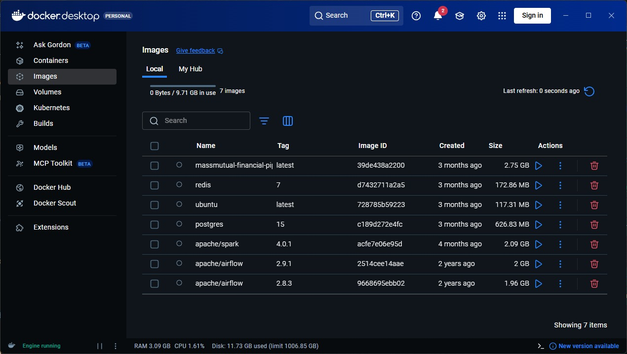

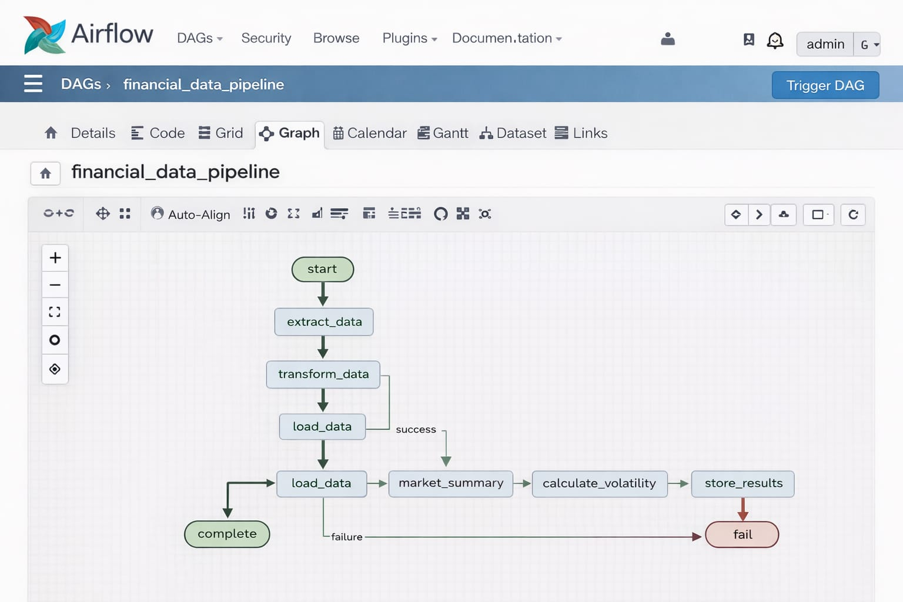
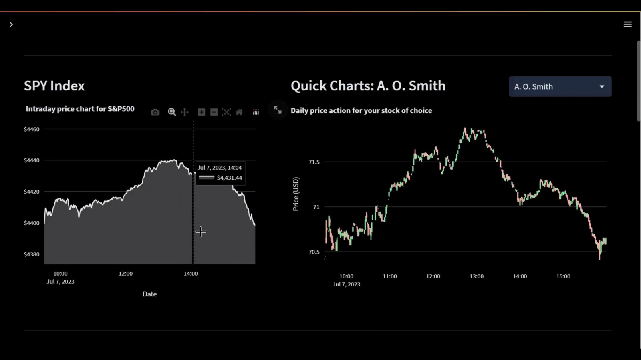


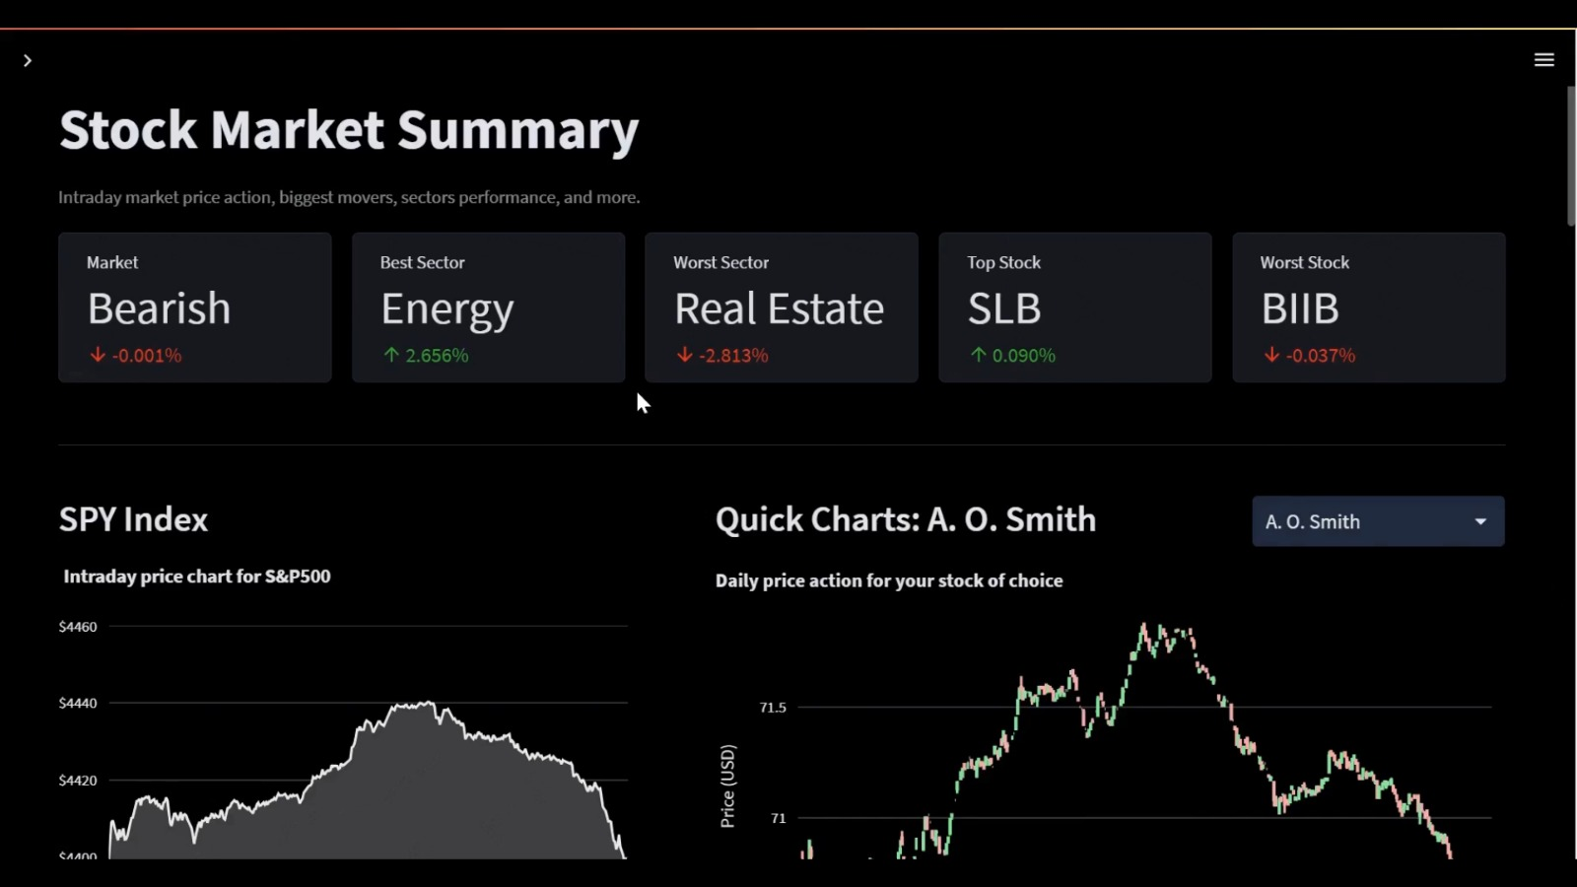

7 CONCLUSION AND POSSIBLE OUTCOMES
7.1 Conclusion
This case study successfully demonstrates the design and implementation of a modern, automated data engineering and analytics pipeline for financial market analysis. By integrating distributed data processing, workflow automation, structured data storage, and interactive visualization, the project addresses the limitations of traditional manual financial analysis systems.
The use of Apache Spark enables efficient handling of large-scale financial datasets, while Apache Airflow ensures reliable and repeatable execution of data pipelines. Structured storage in PostgreSQL supports analytical querying, and insights are effectively communicated through Power BI dashboards and an Angular frontend.
Overall, the project reflects an industry-aligned architecture that is scalable, maintainable, and suitable for real-world financial analytics use cases.
7.2 Possible outcomes
The successful deployment of this system can lead to the following outcomes:
• Improved Decision-Making:
Financial analysts and management gain faster access to accurate market insights, enabling data-driven investment and risk management decisions.
• Operational Efficiency:
Automation of ETL workflows significantly reduces manual effort, minimizes human error, and ensures consistent data processing.
• Scalability and Flexibility:
The containerized architecture allows the system to scale with increasing data volume and supports the integration of additional data sources in the future.
• Enhanced Data Visibility:
Interactive dashboards and filters provide clear visibility into market trends, volatility, and performance indicators across different time periods and assets.
• Foundation for Advanced Analytics:
The structured data model and automated pipeline create a strong foundation for future enhancements such as predictive analytics, machine learning models, and real-time data streaming.

7.3 Overall Impact
By implementing this solution, organizations can transition from reactive and manual reporting to proactive, insight-driven financial analysis. The project demonstrates how modern data engineering practices can transform raw financial data into actionable intelligence, supporting sustainable growth and informed strategic planning.

8 RESPONSE OF THE JURY
Technical & Analytical Questions:
- Which important DAX measures did you create?
The jury noted the effective use of key DAX measures such as Total Claims, Average Claim Amount, Profit Margin, Policy Renewal Rate, Active vs Expired Policies, and trend-based calculations over time. These measures enabled dynamic KPI updates and interactive analysis.

- How is data consistency maintained across multiple sources?
Data consistency is maintained through centralized data integration and preprocessing. Power Query is used to clean, standardize, and merge datasets, ensuring uniform data formats and validated relationships before analytics are performed.

- How did you handle missing or incorrect data?
Missing and incorrect data were handled during the preprocessing stage using Power Query. This included removing duplicate records, replacing or filtering null values, validating identifiers, and standardizing date and currency formats.

- How are security issues handled?
Security is managed through controlled access at the deployment level. Role-based access control ensures that sensitive financial and insurance data is accessible only to authorized users, and dashboards are securely shared via Power BI Service.
- Is your dashboard scalable for large organizations?
Yes. The jury observed that the centralized data model, automated preprocessing, and modular architecture allow the dashboard to scale efficiently as data volume and user count increase.
Case Study & Business-Oriented Questions
- How does this dashboard help management make better decisions?
The dashboard provides real-time visibility into financial performance, claims trends, and risk indicators. Interactive visuals and KPIs allow management to identify issues early, compare performance across branches, and make informed, data-driven decisions.

- What is the business impact if this is implemented in a real company?
Implementation of this solution can lead to improved operational efficiency, reduced reporting time, enhanced data accuracy, proactive risk management, and better strategic planning across finance and insurance operations.
Feedback:
- The integration of finance and insurance data into a single dashboard is practical, relevant, and well thought out.

- Effective use of Power BI features such as DAX, Power Query, and interactive visual elements was observed.

- The case study is well-structured and aligns closely with current industry requirements and practices.

9 COMPLETION CERTIFICATES

