Q1:Create an ec2 instance with the ubuntu operating system, set all the required parameters such as security groups and key pair, and also do SSH with git bash to the running instance.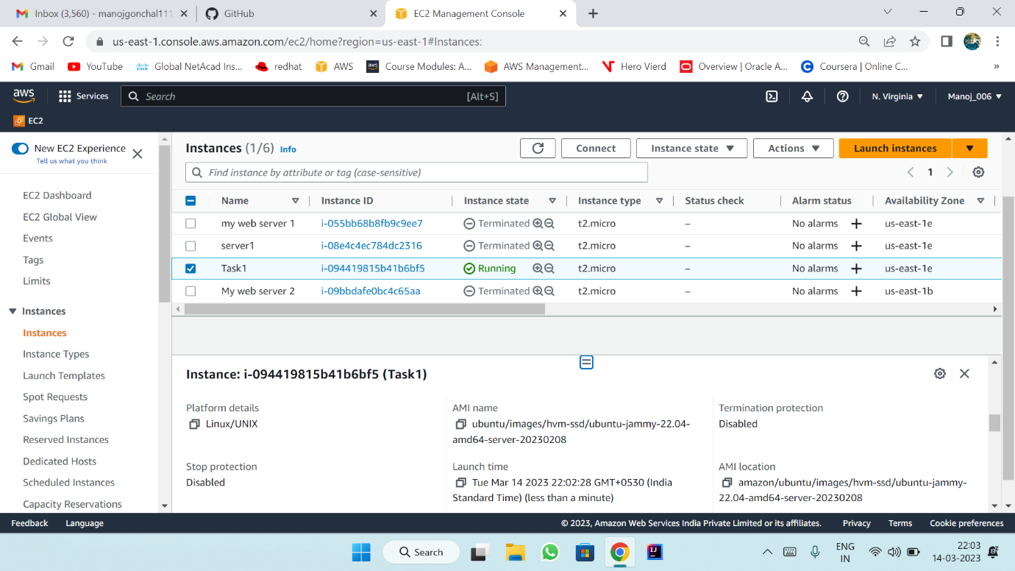
Use command “ssh -I keypairname username @ publicip or public DNS” to access the instance in git bash.
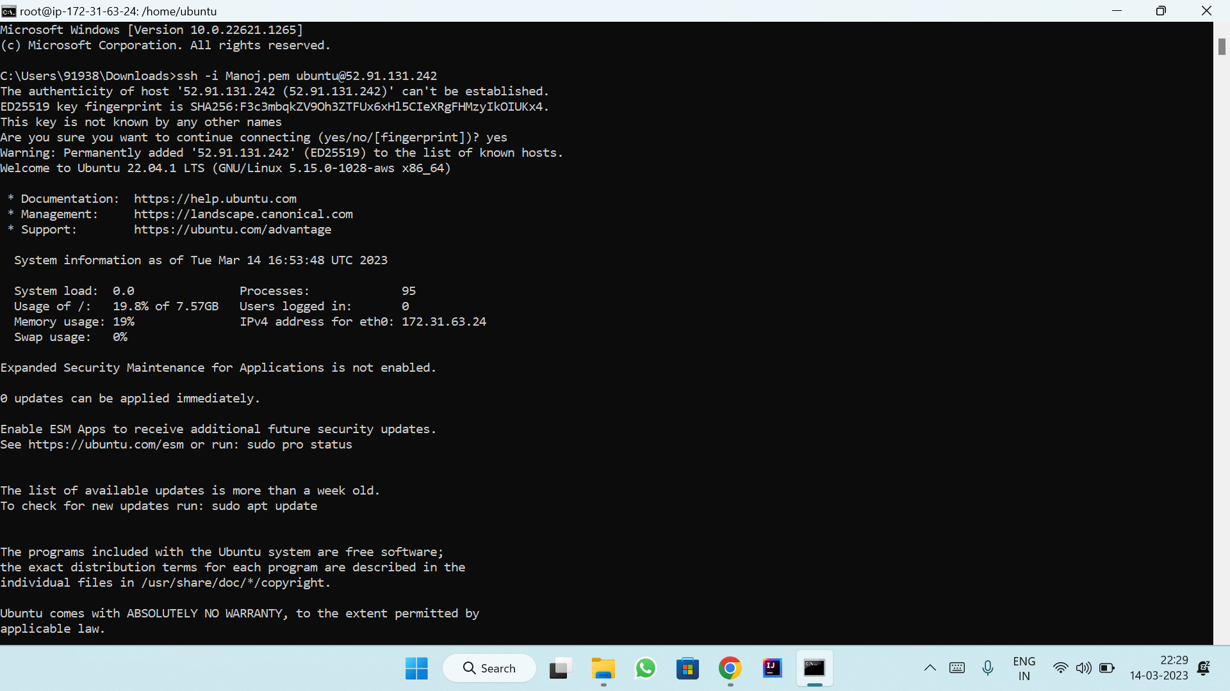

To install Nodejs command is : sudo apt install nodejs
To check weather Nodejs is installed or not the command is: nodejs --version
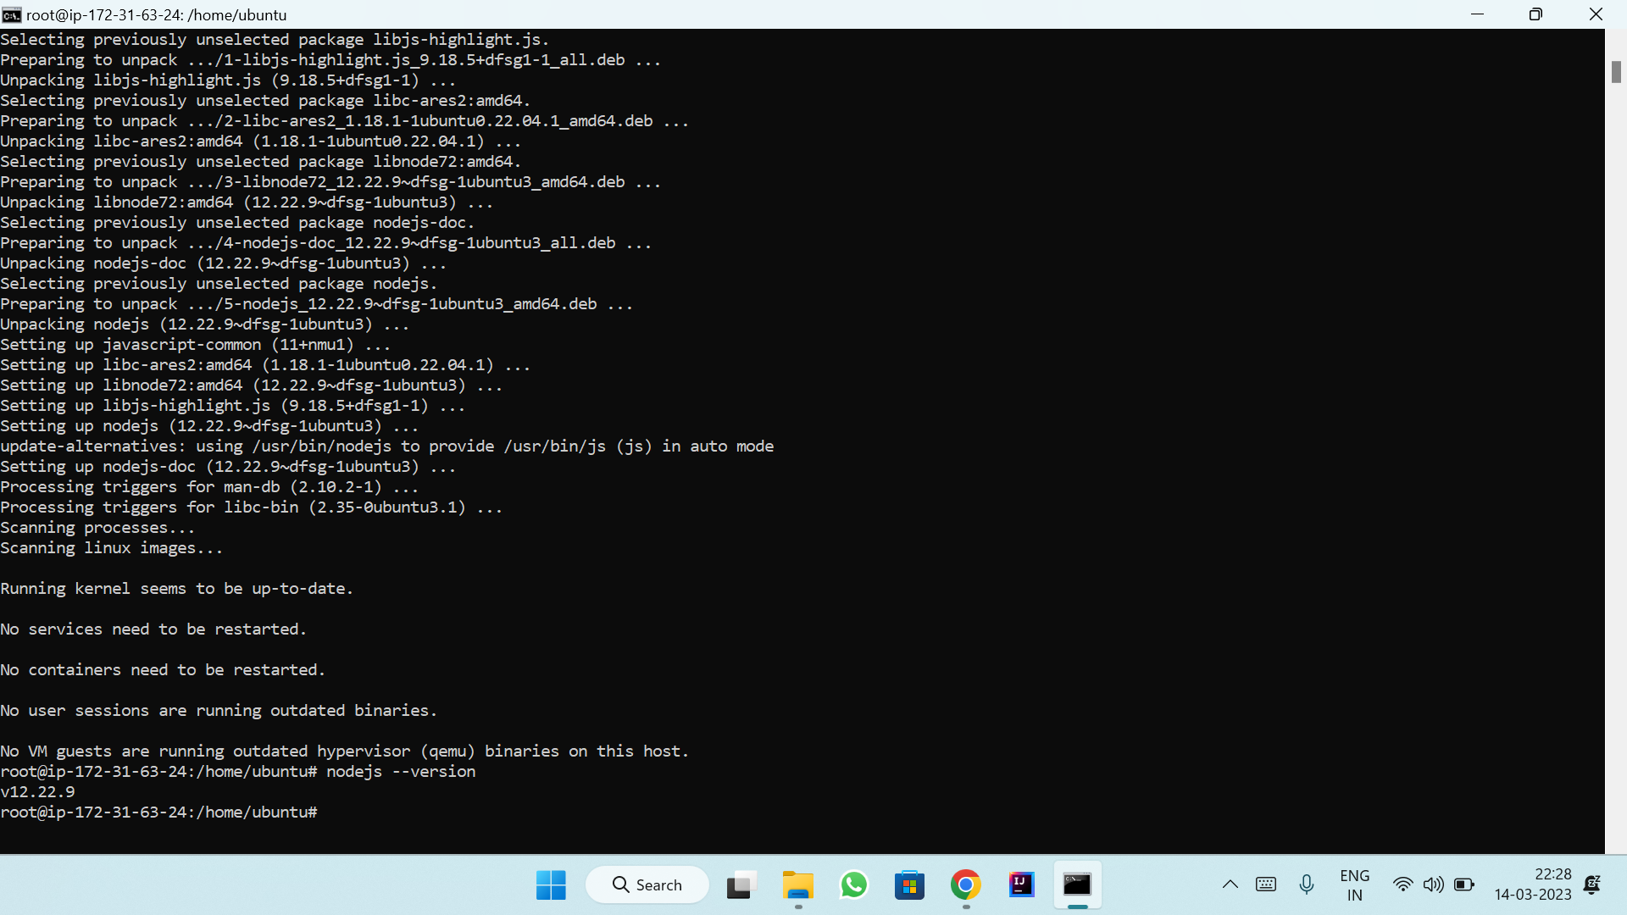

Q2: configure the instance with an elastic IP to show the static public IP address.
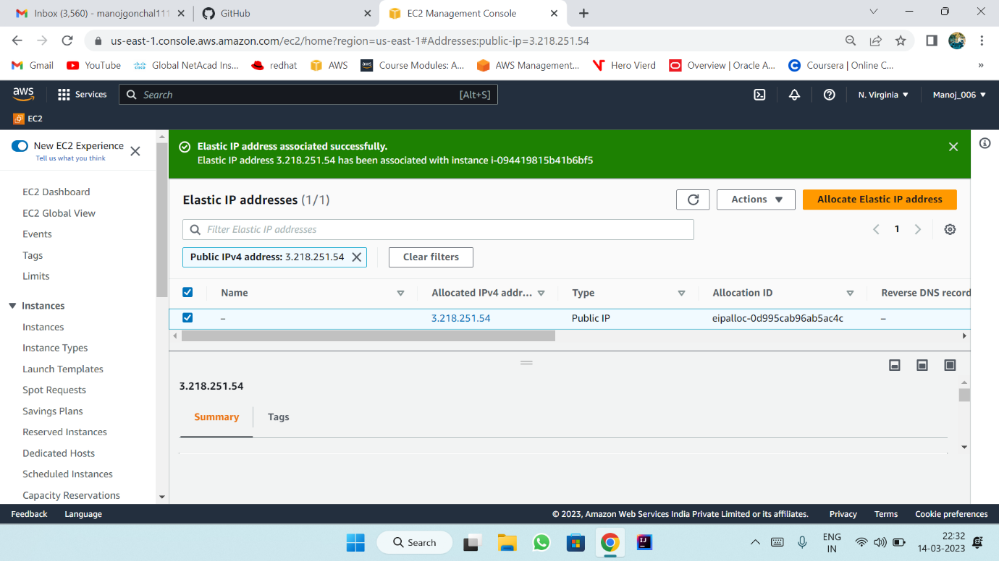
Static IP address: 3.218.251.54

Q3. create an S3 bucket and upload an object to it and show the object URL for reference.
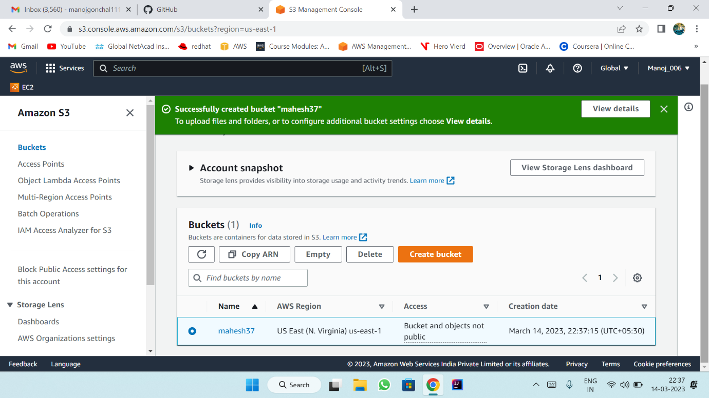

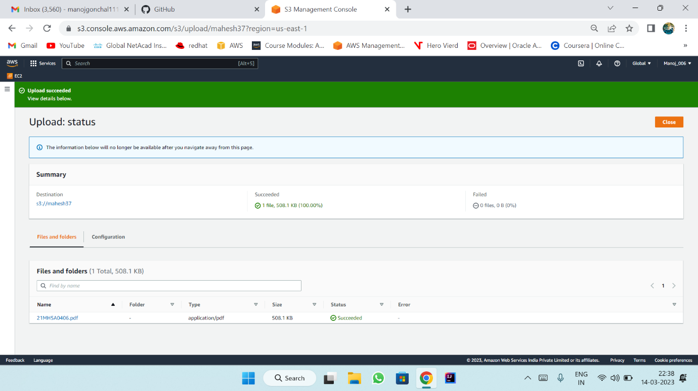

object URL : https://mahesh37.s3.amazonaws.com/21MH5A0406.pdf

