How to run the Online Notes Sharing System Django Python
1. Download the zip file
2. Extract the file, copy nss folder, and paste it on the desktop.

3. Open MySQL Create a database nsspythondb then import the SQL File available in the SQL File Folder (For MySQL we used XAMPP server).

4. Open PyCharm and click on the terminal.
5. Navigate the project folder using the cd command
cd project_path
For ex: cd C:\Users\ANUJ\OneDrive\Desktop\nss

6. Now Navigate to the Notes Sharing Folder folder
cd notessharing

7. Run the Project using the following command
python manage.py runserver
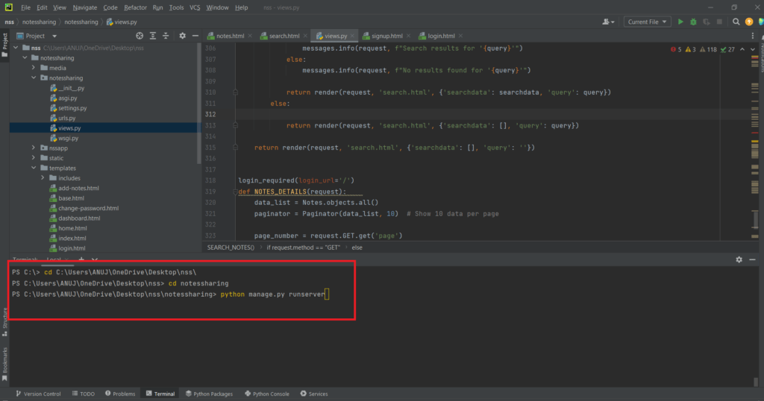

Now click the URL http://127.0.0.1:8000 and the Project will Run

Login Details

*****User*****
Username: john123
Password: Test@123 OR Register a new user.

