# SDM Final Exam

Dependent variables : EmployeePerformance, Satisfaction, Absences

From the data we can say that,

* Maritalstatus ID is replica of marital desc
* Employe status ID and employee status are correlated
* PerfscoreID similar to empperformance score
* deptID is similar to department column
* Fromdiversityjobfair is correlated with recruitment source
* There are 207 missing values in Dateoftermonation column which says that from 311 employees, 207 employees are still working and 104 are terminated

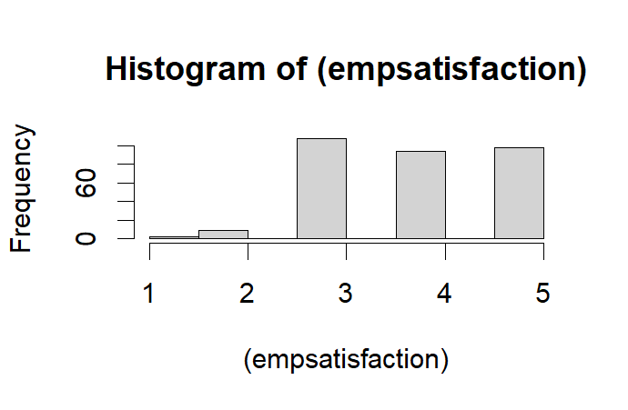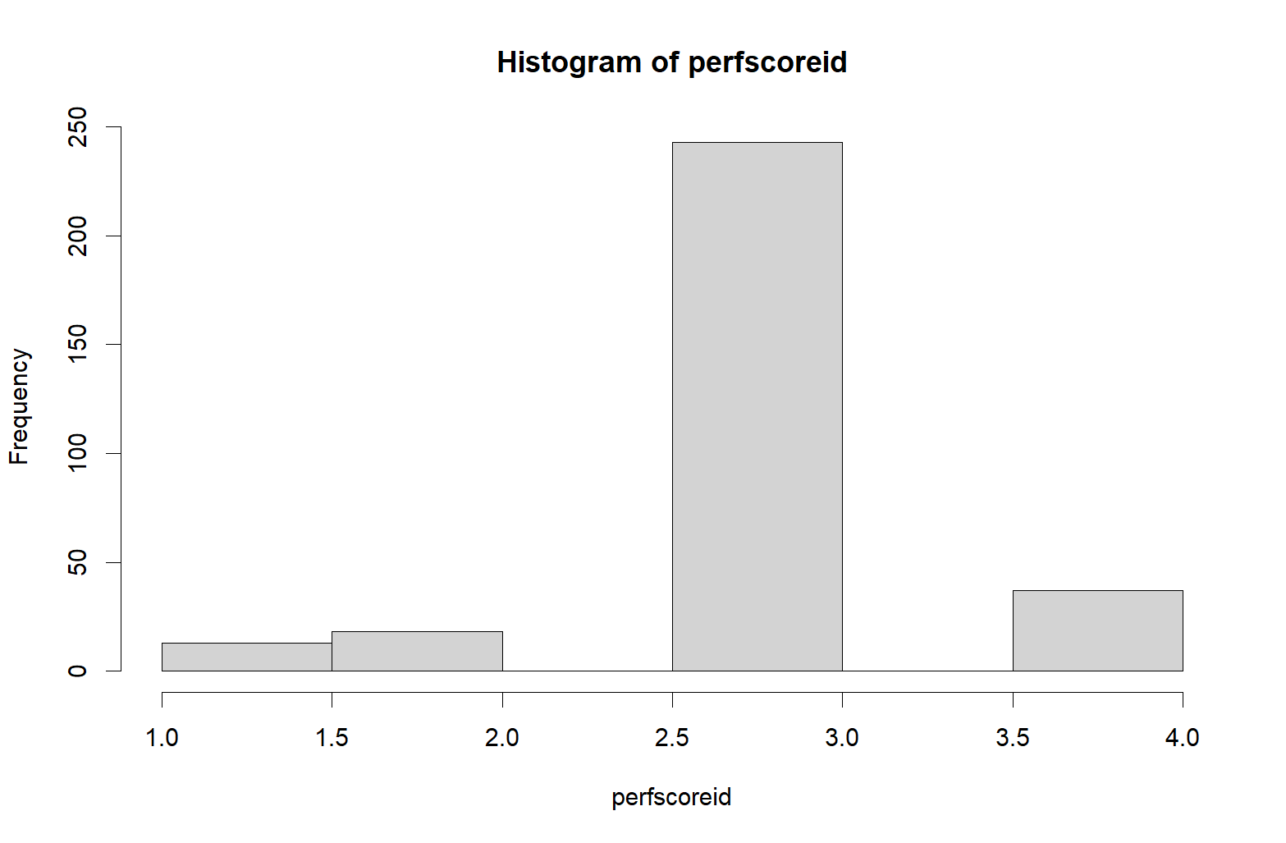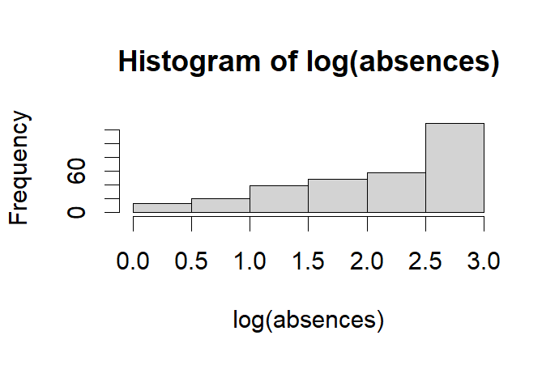

The above are the distributions of DV’s. performance is normally distributed

Predictor tables:

Dependent Variable: Employee Satisfaction

Predictor Table:

| **Variable** | **Effect** | **Rationale** |
| --- | --- | --- |
| PayRate | + | Higher pay rates can increase job satisfaction |
| SpecialProjectsCount | + | Involvement in special projects can increase job satisfaction |
| Termd | - | Being terminated can negatively impact job satisfaction |
| Absences | - | Frequent absences can negatively impact job satisfaction |
| ManagerName | ? | The impact of the employee's manager on job satisfaction varies |
| Position | ? | The level of job responsibilities, job duties, and job titles can affect job satisfaction |
| department | ? | Employees' satisfaction with their department and the work culture can impact job satisfaction |

Dependent Variable: Employee Performance

Predictor Table:

| **Variable** | **Effect** | **Rationale** |
| --- | --- | --- |
| payrate | **+** | Employee satisfaction with their compensation can impact their motivation and engagement in their job, which can ultimately affect their performance |
| PositionID | + | Higher position ID suggests a higher level of responsibility and authority |
| EmpSatisfaction | + | Satisfied employees tend to perform better on the job |
| recruitmentsource | ? | It's uncertain if sourcing employees from diversity job fairs affects performance |
| Days late last 30 | - | If the employee is late in lalst 30 days, he may not perform well |
| Department | ? | The impact of the department on employee performance varies |
| Managername | ? | The impact of the employee's manager on performance varies |

Dependent Variable: Absences

Predictor Table:

| **Variable** | **Effect** | **Rationale** |
| --- | --- | --- |
| PerScoreID | - | Low performance scores can indicate a lack of motivation or engagement |
| department | ? | The department an employee belongs to can also influence the number of absences. For instance, if an employee works in a high-stress department, they may take more time off than those working in a less stressful department |
| managerID | ? | a manager who is supportive and encouraging may have a lower absenteeism rate among their employees |
| EmpSatisfaction | - | Dissatisfied employees are more likely to take absences from work |
| DaysLateLast30 | + | Frequent lateness suggests a lack of punctuality and commitment to work |
| EngagementSurvey | - | Negative engagement survey results can indicate job dissatisfaction |
| PayRate | - | Lower pay rates can lead to absenteeism due to financial difficulties |

Correlation plot:

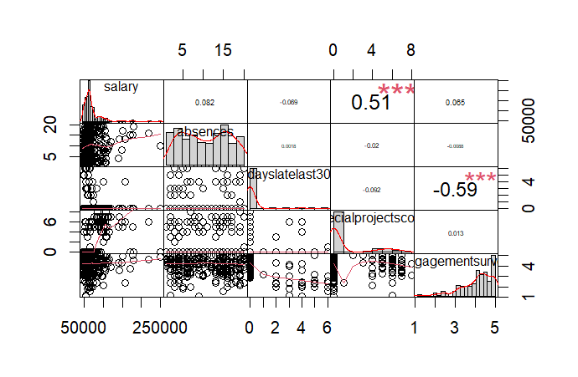

We can see that no correlation exists in the numeric columns

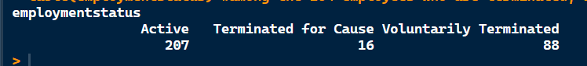

1. What are the top three predictors that contribute the most (positively or negatively) to employee performance, satisfaction, and absences, after controlling for other variables, and by how much? (6 points)

Here, employee performance and satisfaction are ordinal classes and need to have a multinomial models. Tobit model with bounds can also be used.

*pm1 <- polr(performancescore ~ empsatisfaction + managername + department +*

*dayslatelast30 + recruitmentsource + position , data=d, Hess = TRUE)*

*summary(pm1)*

*#let us run the tobit model with bounding data to analyze what factors affecting performance score*

*pm_t = tobit(perfscoreid ~ positionid+ empsatisfaction + department + managername +*

*recruitmentsource+dayslatelast30, left=1, right=4, data=d)*

*summary(pm_t)*

From the model we can interpret that

|  |  |  |
| --- | --- | --- |
| Performance | Employment satisfaction | absences |
| change in Empsatisfaction1 to empsatis5 increase performance score by more than 3.7 units | Employee satisfaction increases by 1.971 units if works under manager debra houlihan | Employee in a Admin office department has 110% more rate of absences than IT/IS |
| change in Empsatisfaction1 to empsatis4 increase performance score by more than 3.64 units | Employee satisfaction increases by 1.841 units if works under manager Lynn daneault | Employee in a executive office department has 130% more rate of absences than IT/IS |
| change in Empsatisfaction1 to empsatis3 increase performance score by more than 3.63 units | Similarly for John smith by 1.498 units | Employee in sales department has 48% more rate of absences than IT/IS |
| Employee being in executive office department has low performancescore when compared to IT/IS by 1.07 units | Manager peter Monroe decreases by 2.2 | Board of directors has lowest rate of absents by 263% when compared to base managers |
| Employee working under manager named “ peter Monroe” has low performance score by 1.019 compared to base manager | Manager simon roup decreases by 2.5 units | Employee under brandon r leblanc has lowest rate of absents by 146% compared to base managers |
| Employee being in dmin office department has low performancescore when compared to IT/IS by 0.908 units | Manager eric dougall decreases by 2.66 units |  |

1. Is there any relationship between the manager and/or department an employee works for and their performance and satisfaction scores? If so, which managers and/or departments have the highest AND lowest employee performance and satisfaction scores, and what is the extent of this gap? (2 points)

Yes, there is relationship between manager and department and their performance and satisfaction. Being in IT/IS department have higher performance and in executive departments have lowest performance which is 1.01 unit decrease in the performance rating. Similarly for different managers, the performance rating is different from the above table. Peter moroe has lowest performing employees

IT/IS department employees have higher satisfaction rates when compared to others. Manager eric dougall has lowest employee satisfaction rate

1. Which recruitment source results in the highest AND lowest performing and most AND least satisfied employees and what is the gap in performance and satisfaction between the two recruitment sources? (1 point)

Employees recruited under source career builder has the highest performance rating and under source online webapplications have low performing score and the gap is 0.3 units.

Employees recruited under under source online webapplications has the highest employee satisfaction rating and under recruitment source website have low performing score and the gap is 5 units.

1. What is the probability that a typical employee will continue working in each department of this company after 5 years? (2 points)

*km_term <- survfit(Surv(days_in_org, termd)~department, data = d)*

*summary(km_term,1825)*

the probability that a typical employee will continue working in each department after 1825 days is:

IT/IS: 0.227

Admin Offices: 0.222

Executive Office: 0 (there were no events in this department)

Production: 0.297

Sales: 0.165

Software Engineering: 0.284

1. Is there any department in the company where there is pay inequity on the basis of race or gender? How much is this pay inequity contributing to poor performance and/or low satisfaction in those departments? (3 points)

*q5_nb = glm.nb(salary ~ department*(racedesc + sex) +performancescore+empsatisfaction, data = d)*

*summary(q5_nb)*

Yes, from the model estimations, there is bias in production and software engineering departments. Normally, black or African American has 28% less salaries than White. In Production department, black or African American has 50% more salaries than white. In software department black or African American has 44% more salary than whites in software engineering department. Coming to sex, females have 4% more salary than males. In sales department , females have 13% more salary that males. There is very minimal effect on the employee satisfaction and performance score which is 5.5% and 4.4% respectively.