Prototype Design pattern (Creational Design Pattern)
- Definition:
The Prototype Pattern is used when many similar objects need to be created. Instead of creating and configuring each object from scratch, we create one template object, clone it, and modify only the fields that differ. For example, creating multiple savings accounts with the same bank rules but different customer details.

  - Sometimes creating an object from scratch is:

    - Expensive (takes time/resources)
    - Complex (many configuration steps)
    - Repetitive (same setup repeated many times)

  - Instead of creating a new object every time (similar objects), you:

    - Create one fully configured object.
    - Clone (copy) it.
    - Change only the fields that need to be different.

- When you hear requirements like below used prototype design pattern:

  - Create many similar objects
  - Use predefined templates
  - Copy existing configuration
  - Object creation is expensive
  - Avoid repeating initialization logic

- Factories create objects from inputs.

- Prototype creates objects from existing objects.

- Difference between shallow and Deep copy?
- Shallowcopy:
A shallow copy creates a new object but shares references to nested objects. Therefore, changes to mutable objects like lists or dictionaries inside the clone can affect the original object.

- Deepcopy:
A deep copy creates copies of both the object and all nested objects, so changes in the clone do not affect the original.

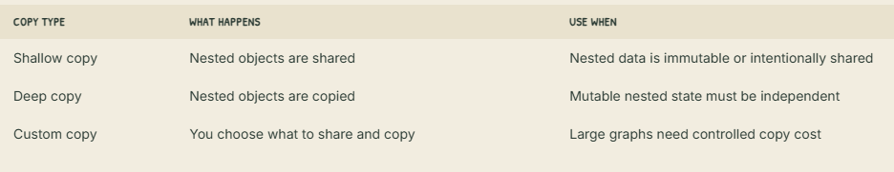

- Skip Prototype when the object is cheap to create and has a clear constructor. Avoid it when clone semantics are unclear, because explicit construction is safer than unclear copying.

- Example code for prototype Design pattern:

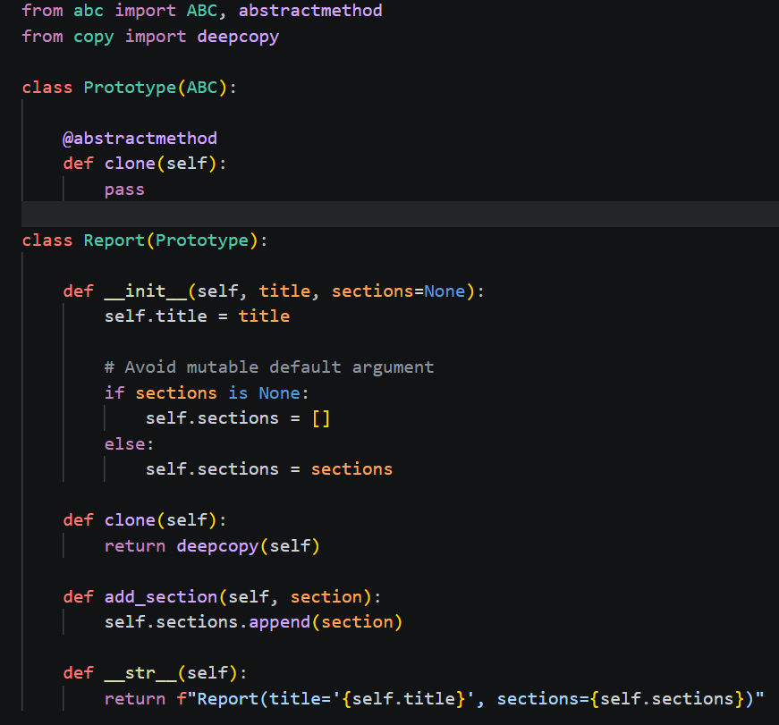

- Client code:

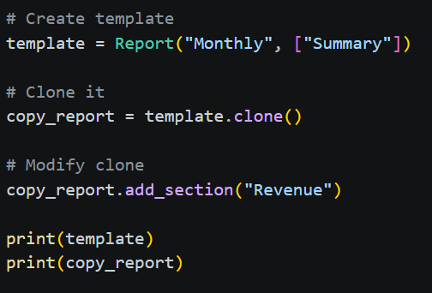
- OUTPUT:

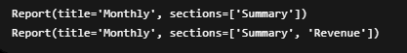

- UML Diagramm:

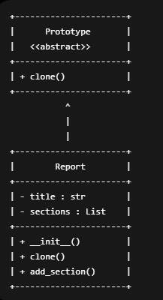

- Prototype is an abstract class (interface).
- It declares the clone () method.
- Report inherits from Prototype.
- Report provides the actual implementation of clone () using deepcopy().
- Client code clones a Report object instead of creating a new one from scratch.

Observation:

- A new object was created using cloning
    - copy_report was created by cloning template.
    - No new Report object was manually constructed.

- The clone initially had the same data as the original
  - Both reports started with:
    - title = "Monthly"
    - sections = ["Summary"]
- Modifying the clone did not affect the original
    - Adding "Revenue" to copy_report changed only the cloned object.
    - template remained unchanged.
- deepcopy() created independent copies of nested objects
    - The sections list in copy_report is a different list from the one in template.
    - They do not share the same reference.
- The Prototype Pattern reduces repetitive initialization
    - Instead of creating another Report and configuring it from scratch, we cloned an existing configured report and modified only the required field.

