LangChain document loaders

LangChain document loaders are connectors. They connect different data sources like
PDFs, websites, databases, S3, Google Drive, Notion, Slack, YouTube, emails, and
chats into one common LangChain Document (page_content, metadata) format.

Supported Data Sources
- 📄 PDF
- 📝 Word Documents
- 📊 CSV / Excel
- 🌐 Websites
- 🗄️ Databases
- ☁️ Amazon S3
- ☁️ Google Drive
- 📚 Notion
- 💬 Slack
- 🎥 YouTube
- 📧 Emails
- 💬 Chat Applications

Common document object is shown below:
Document(
page_content="Actual document text",
metadata={
"source": "...",
"page": 1,
"author": "...",})

Typical RAG Pipeline Using LangChain Document Loaders

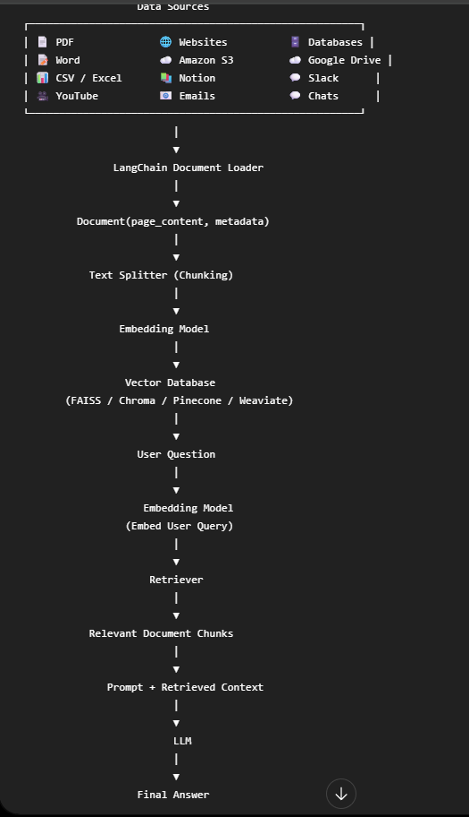

Below is a comprehensive list of the major LangChain Document Loaders

- File Based Document Loader.
- Website / Web Loaders
- Database Loaders
- Cloud Storage Loaders
- Productivity / Workspace Loaders
- Audio / Video Loaders
- Email / Chat Loaders

File Based Document Loader

Below is the list of file-based document loaders provided by langchain ecosystem

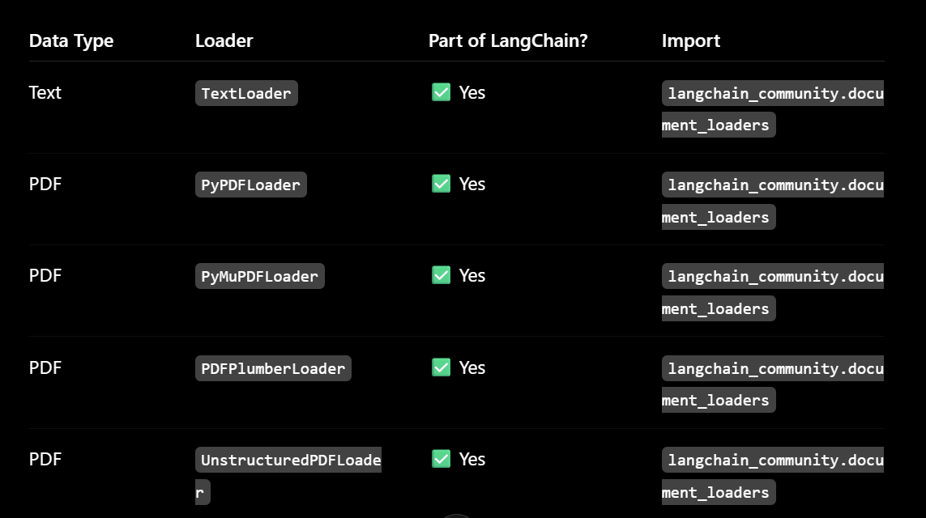

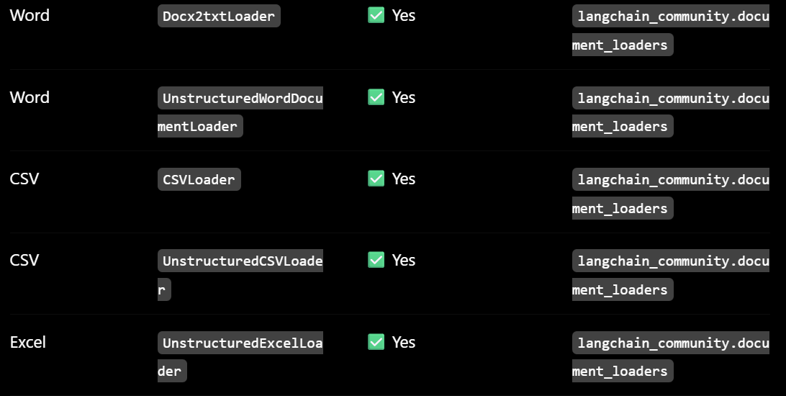

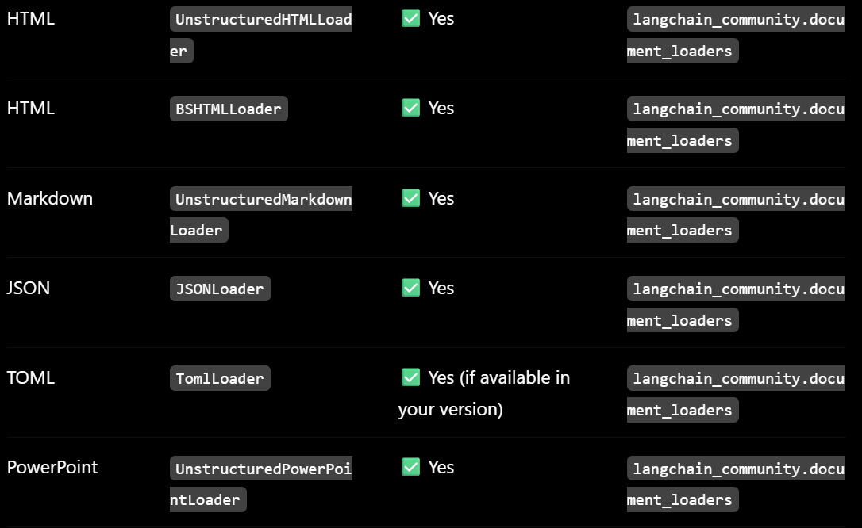

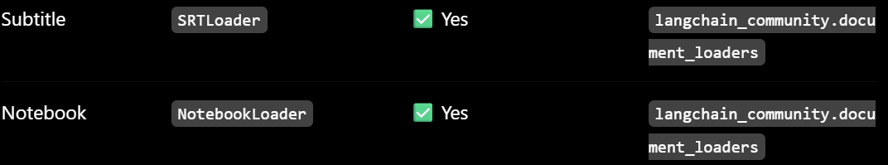

Typical RAG overflow using File based Document Loader

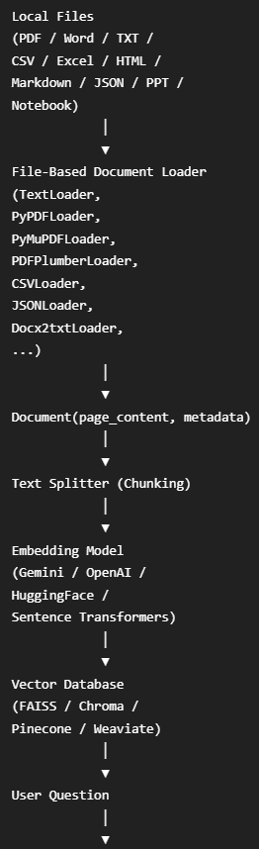
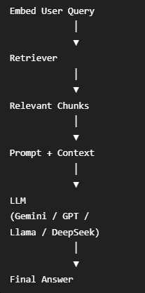

Website / Web Loaders

- All of the below are LangChain Community document loaders.
- There are available after installing : pip install lanchain_community.

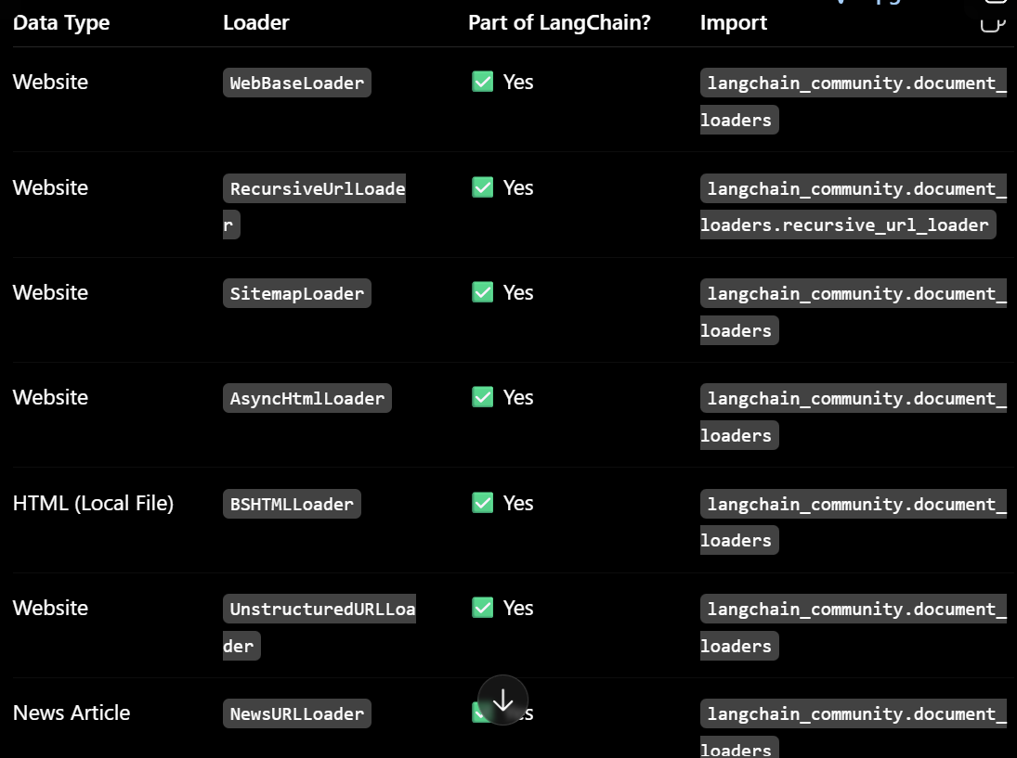

- Some loaders require additional dependencies:

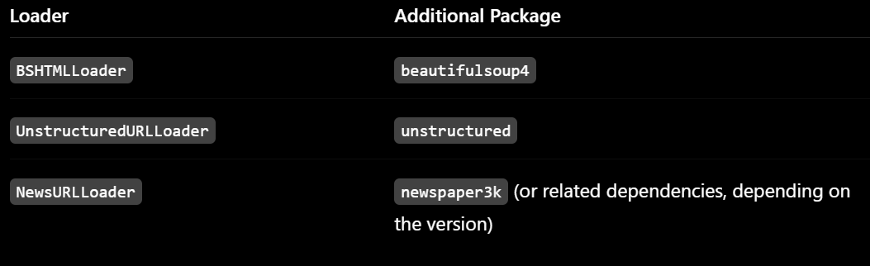

Typical RAG overflow using Website / Web Loaders

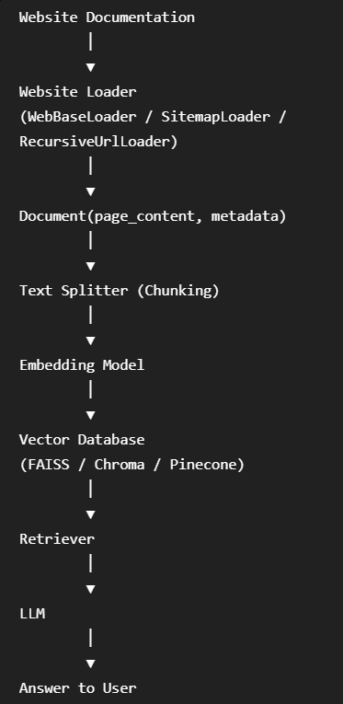

Database Loaders

- Below loaders are used to read data from databases and convert each row or record into a Lang Chain Document object.

- Each database row typically becomes one Document, where:
- page content contains the row's text.
- metadata contains additional information such as the table name, row ID, or source.

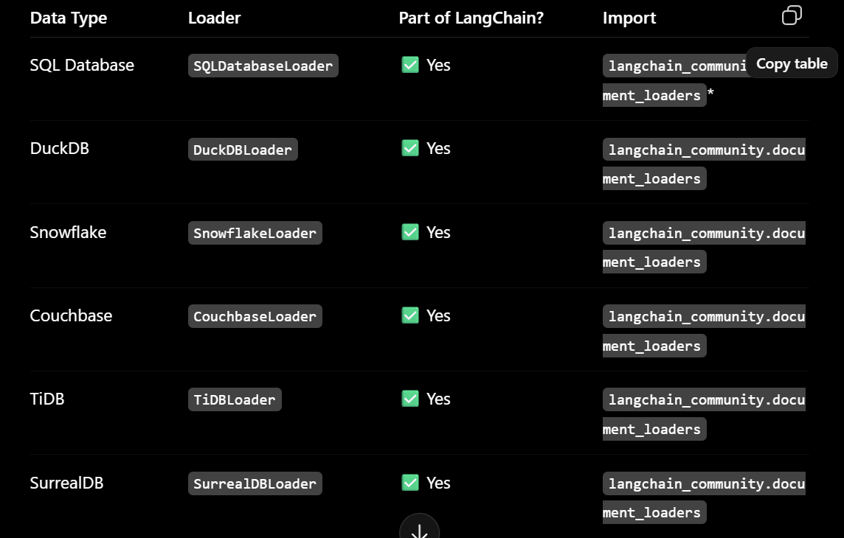

Typical RAG overflow using Database Loaders

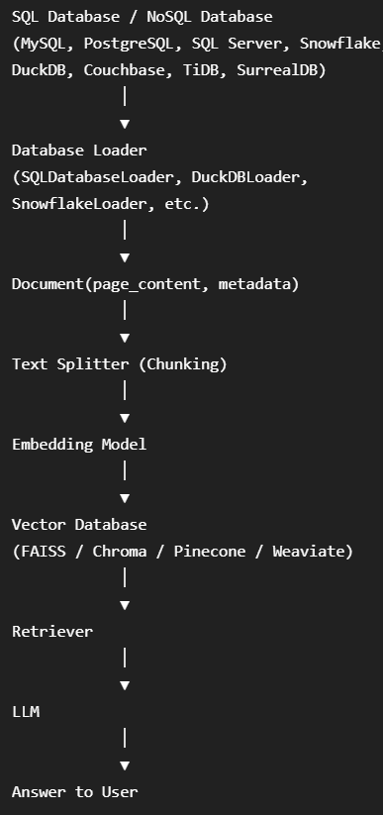

Cloud Storage Loaders

These loaders are used to load documents directly from cloud storage services and convert them into LangChain Document objects.

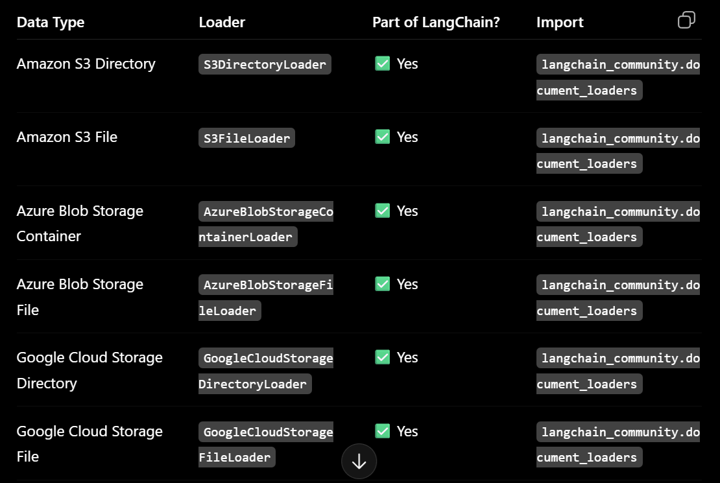

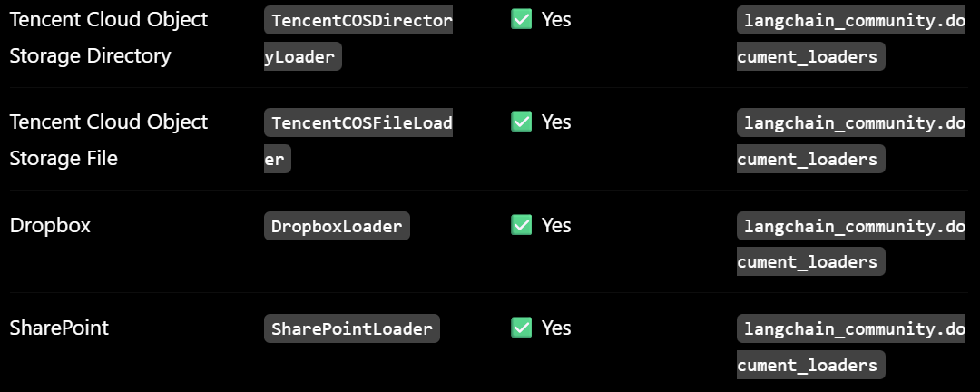

Typical RAG overflow using Cloud Storage Loaders

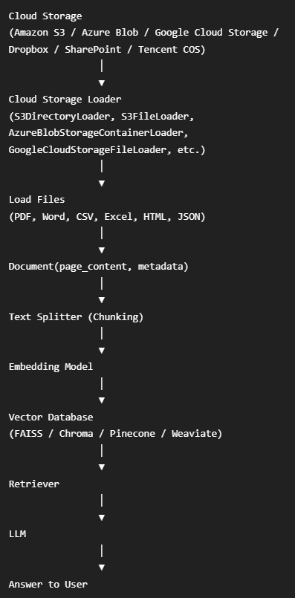

Productivity / Workspace Loaders

These loaders are used to load data from company productivity, collaboration, and project management tools into LangChain Document objects.

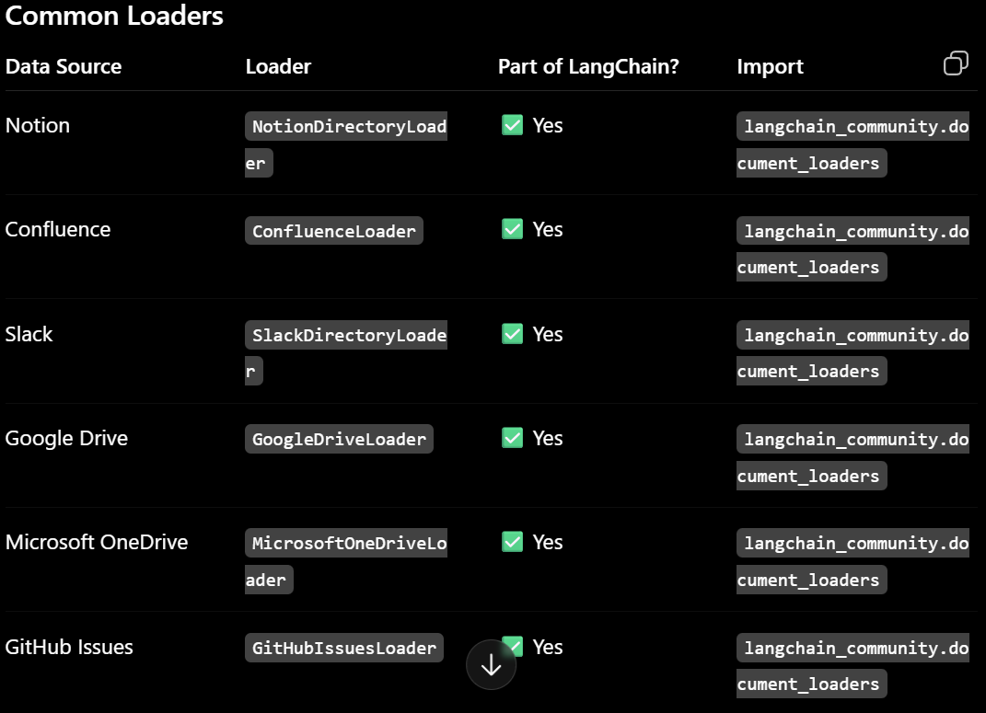

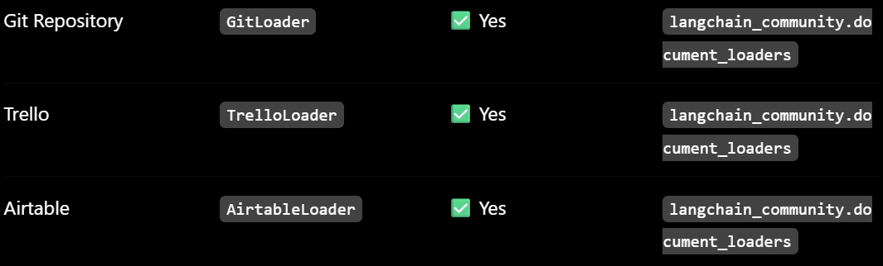

Typical RAG overflow using Productivity / Workspace Loaders

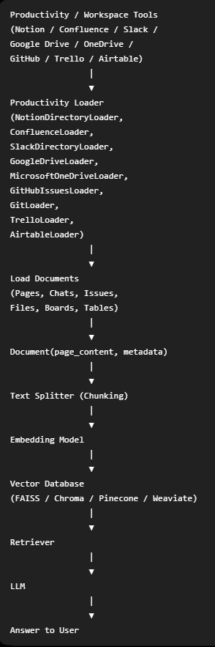

Audio / Video Loaders

These loaders are used to load audio and video transcripts into LangChain Document objects for RAG.

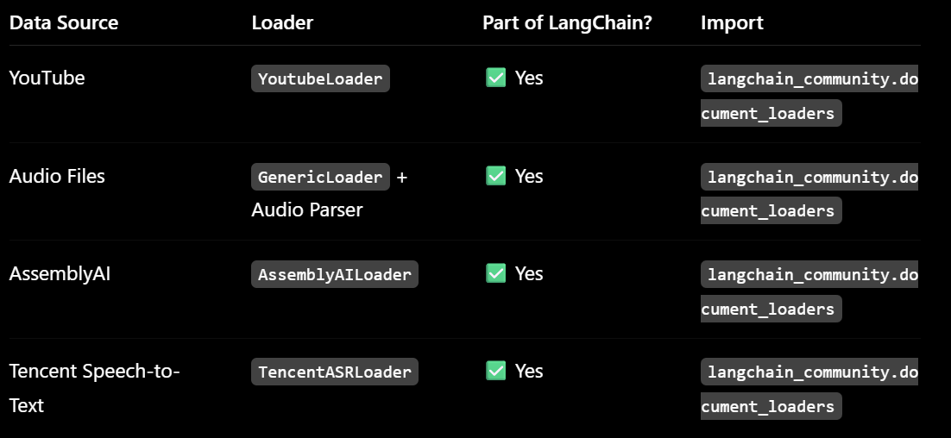

Typical RAG overflow using Audio / Video Loaders

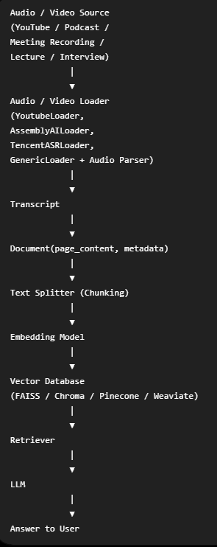

Email / Chat Loaders

These loaders are used to load emails and chat conversations into LangChain Document objects.
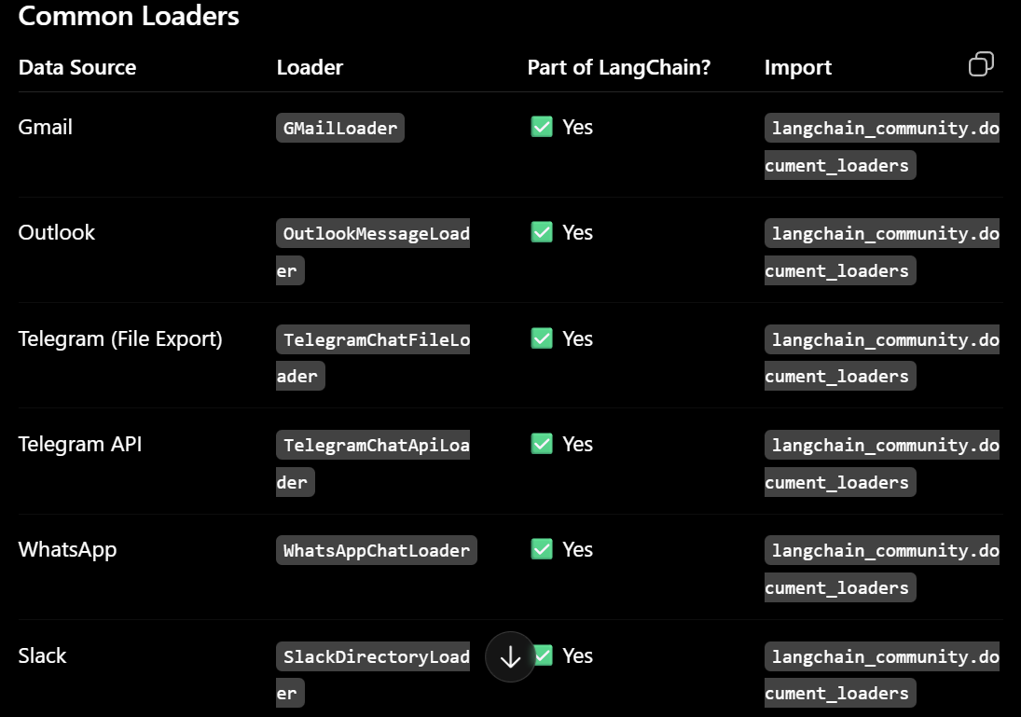

Typical RAG overflow using Email / Chat Loaders

