LangChain document loaders
- LangChain document loaders are connectors. They connect different data sources like PDFs, word documents, CSV/Excel, websites, databases, S3, Google Drive, Notion, Slack, YouTube, emails, and chats into one common LangChain Document (page_content, metadata) format.

- Common Langchain document object is shown below:
Document (
page_content="Actual document text",
metadata= {"source": "...", "page": 1,"author": "...",}
)

Typical RAG Pipeline Using LangChain Document Loaders

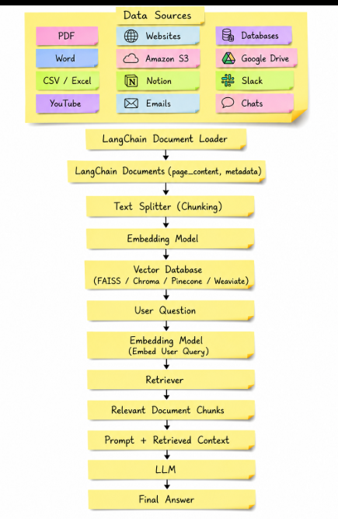

Below is a comprehensive list of the major LangChain Document Loaders

- File Based Document Loader.
- Website / Web Loaders
- Database Loaders
- Cloud Storage Loaders
- Productivity / Workspace Loaders
- Audio / Video Loaders
- Email / Chat Loaders

File Based Document Loader

Below is the list of file-based document loaders provided by langchain ecosystem

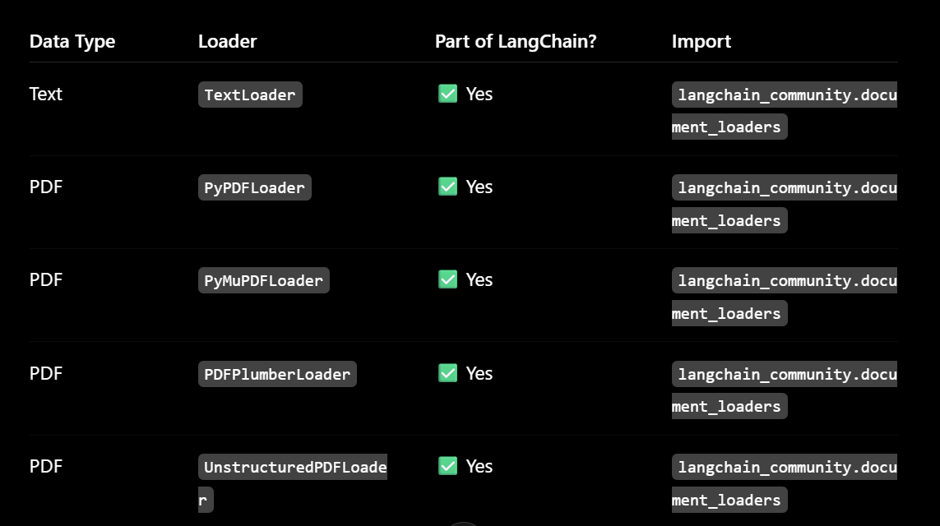

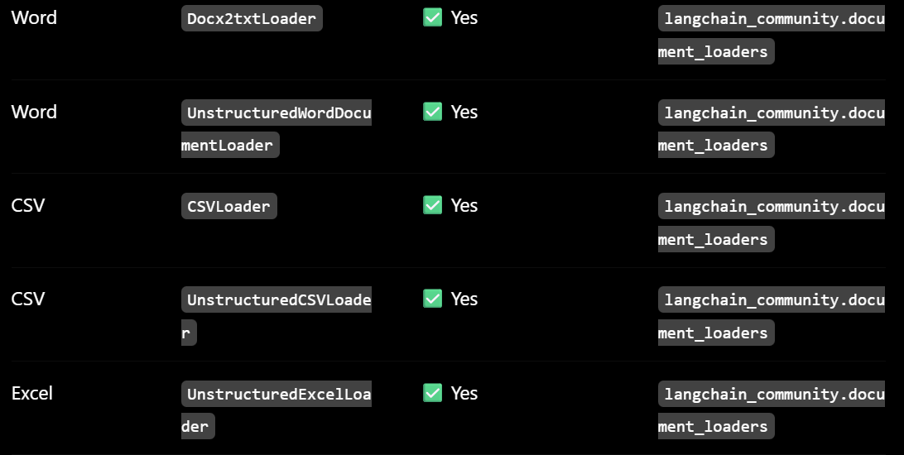

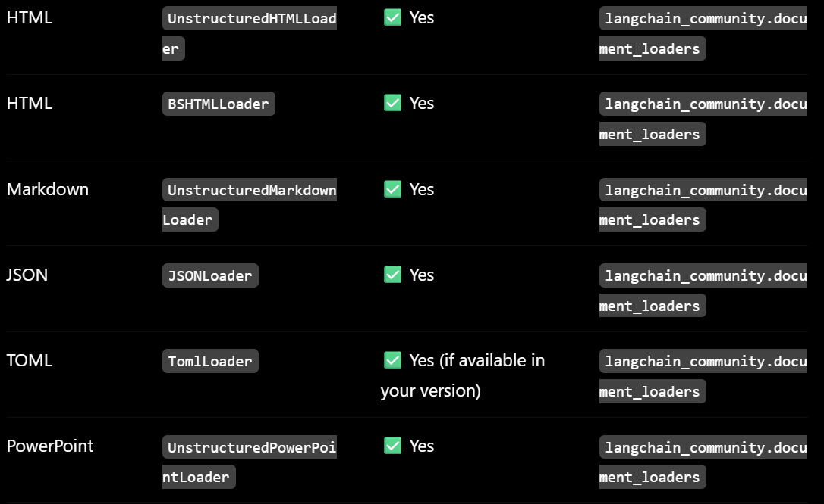
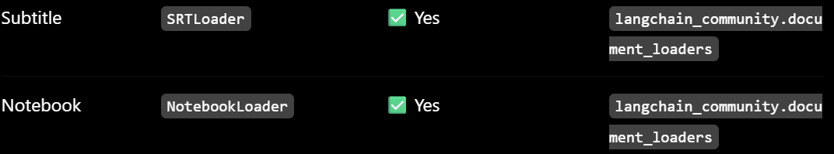

Typical RAG overflow using File based Document Loader

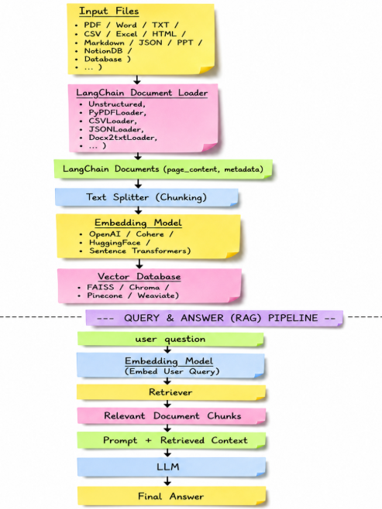
Website / Web Loaders

- All of the below are LangChain Community document loaders.
- There are available after installing : pip install lanchain_community.

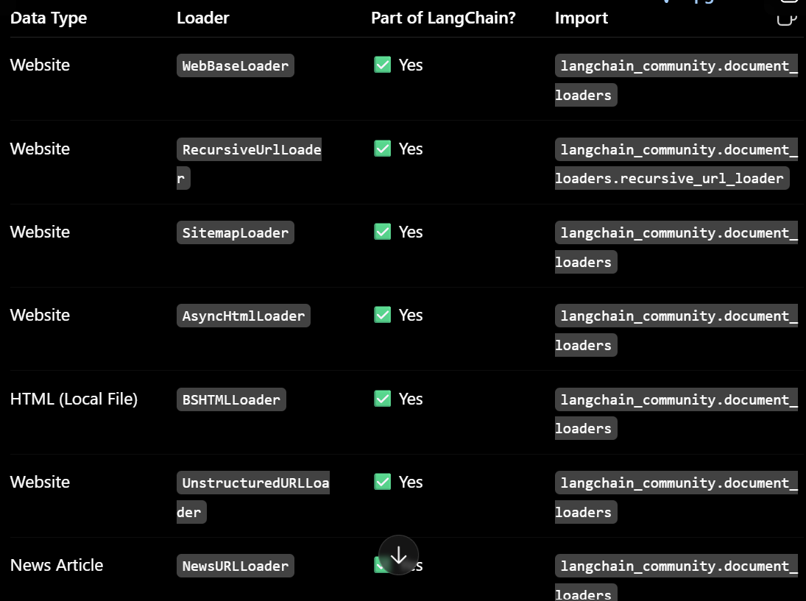

- Some loaders require additional dependencies:

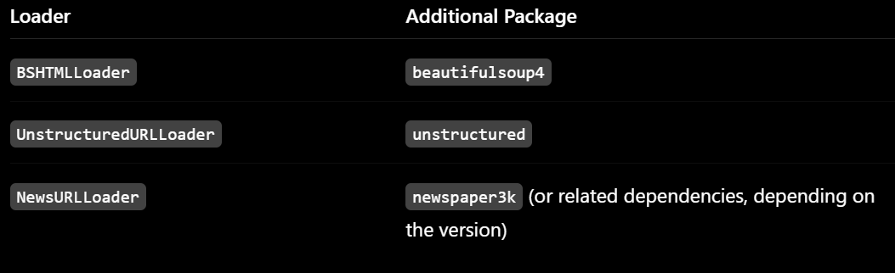

Typical RAG overflow using Website / Web Loaders

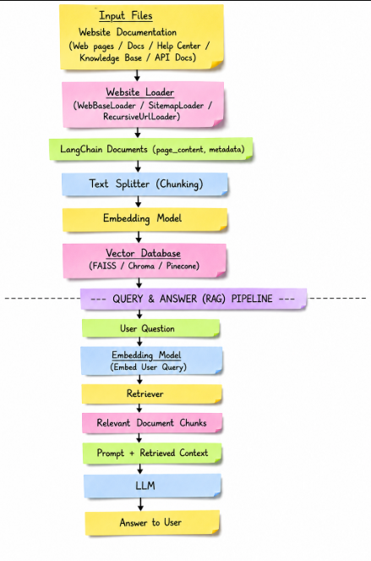

Database Loaders

- Below loaders are used to read data from databases and convert each row or record into a Lang Chain Document object.

- Each database row typically becomes one Document, where:
- page content contains the row's text.
- metadata contains additional information such as the table name, row ID, or source.

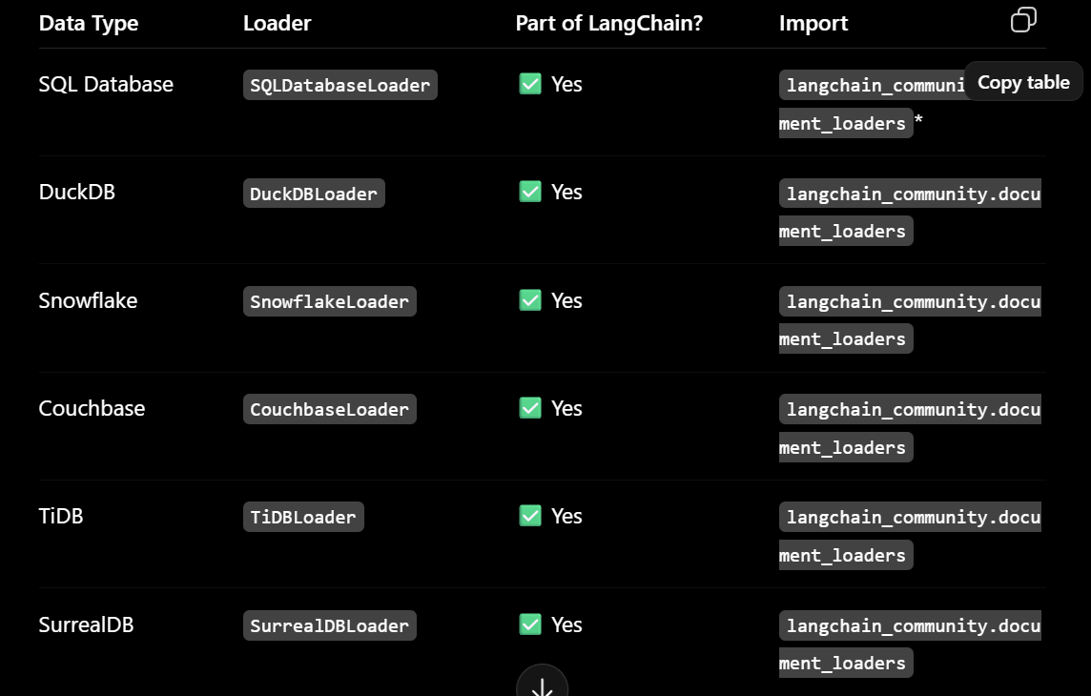

Typical RAG overflow using Database Loaders

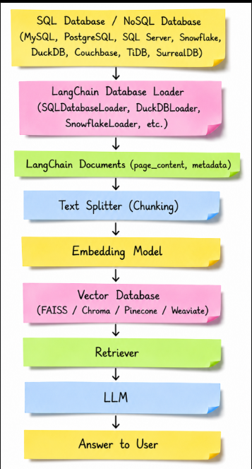

Cloud Storage Loaders

These loaders are used to load documents directly from cloud storage services and convert them into LangChain Document objects.

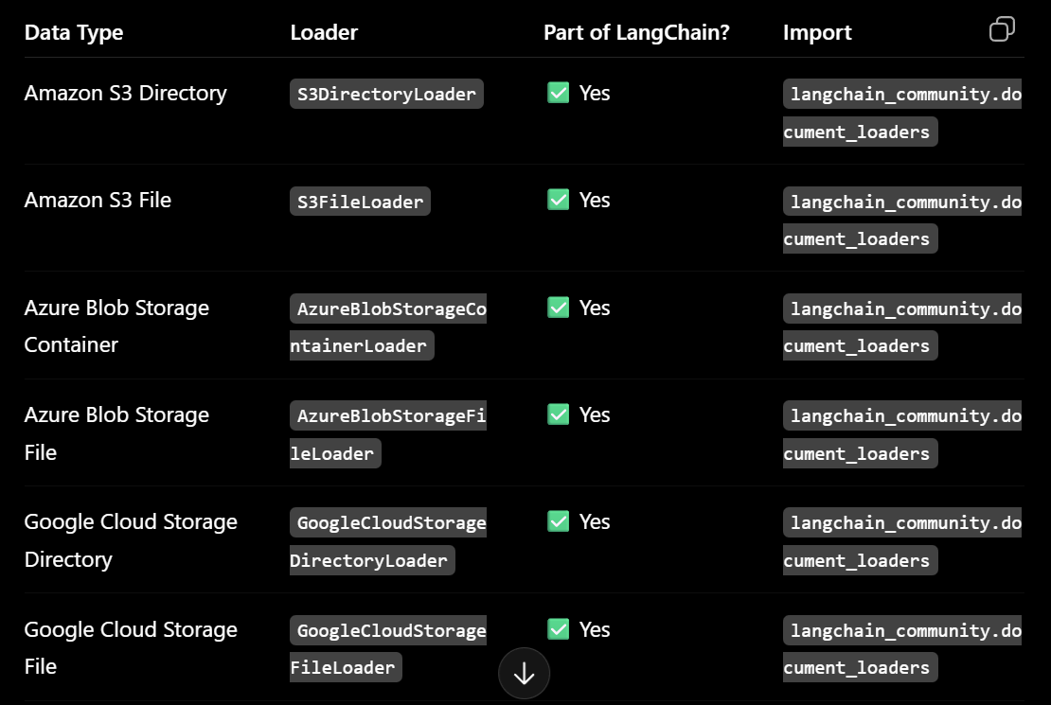

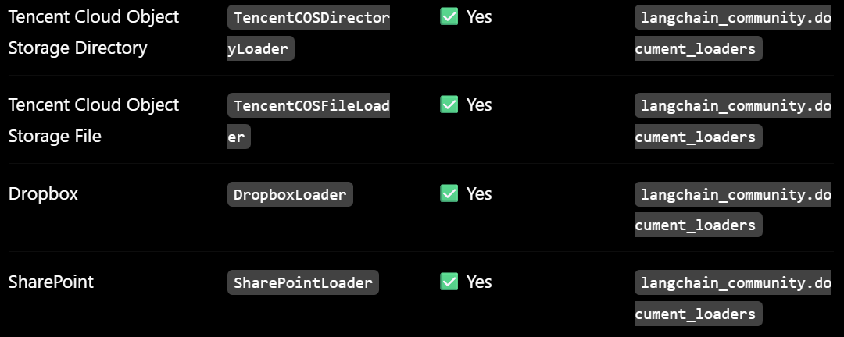

Typical RAG overflow using Cloud Storage Loaders

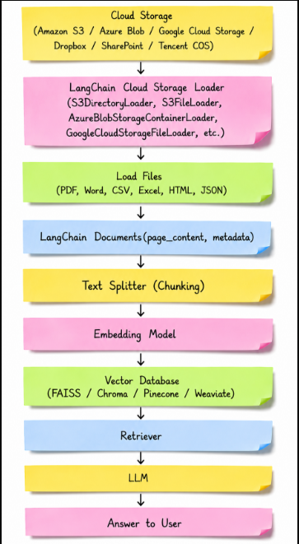

Productivity / Workspace Loaders

These loaders are used to load data from company productivity, collaboration, and project management tools into LangChain Document objects.

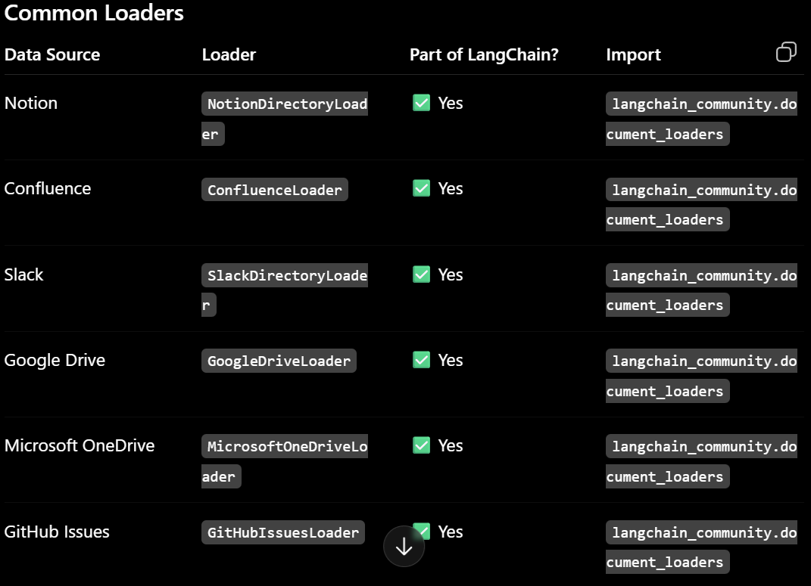

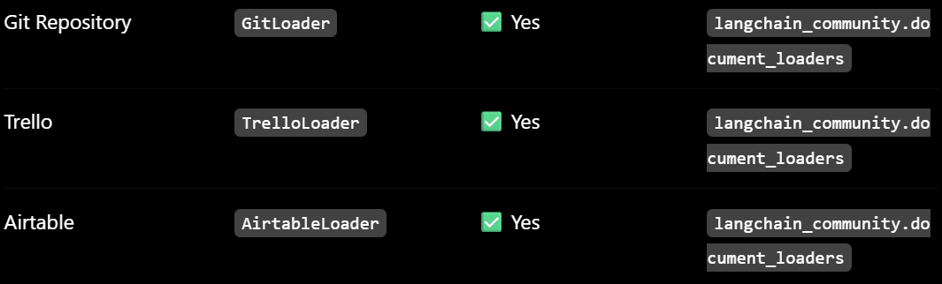

Typical RAG overflow using Productivity / Workspace Loaders

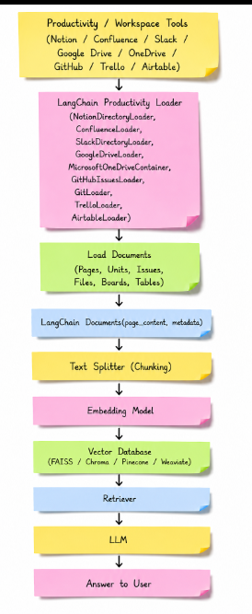

Audio / Video Loaders

These loaders are used to load audio and video transcripts into LangChain Document objects for RAG.

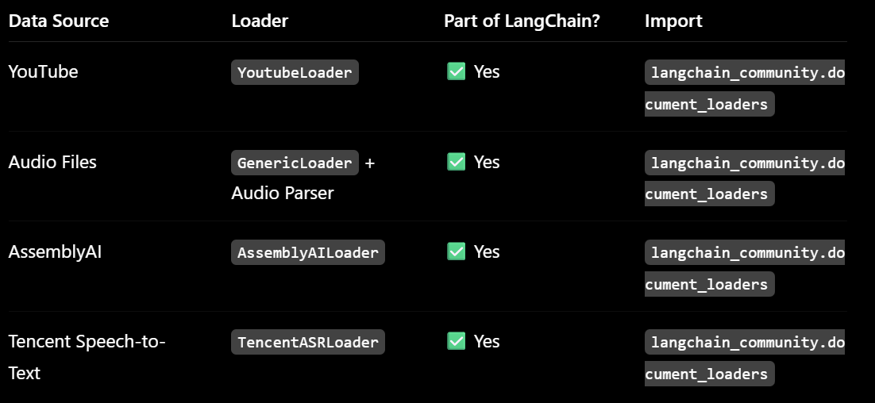

Typical RAG overflow using Audio / Video Loaders

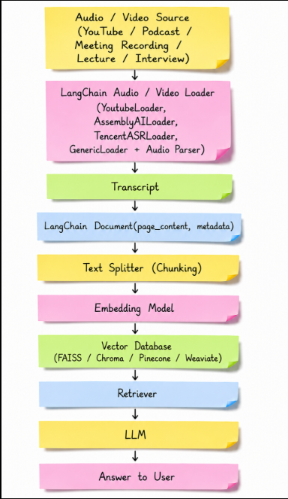
Email / Chat Loaders

These loaders are used to load emails and chat conversations into LangChain Document objects.
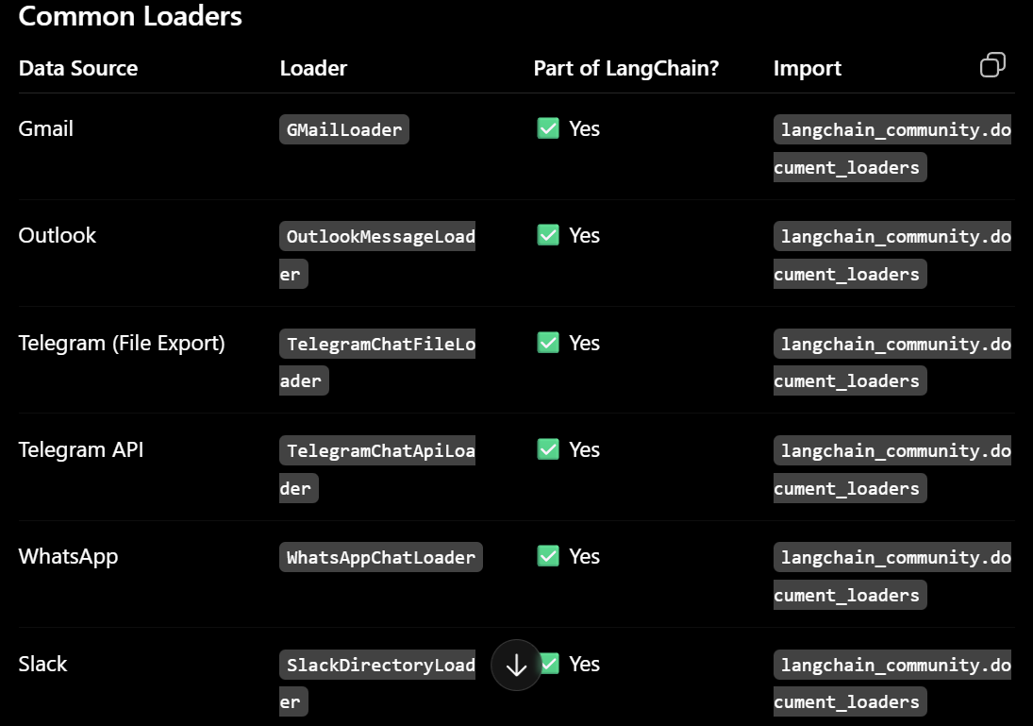

Typical RAG overflow using Email / Chat Loaders

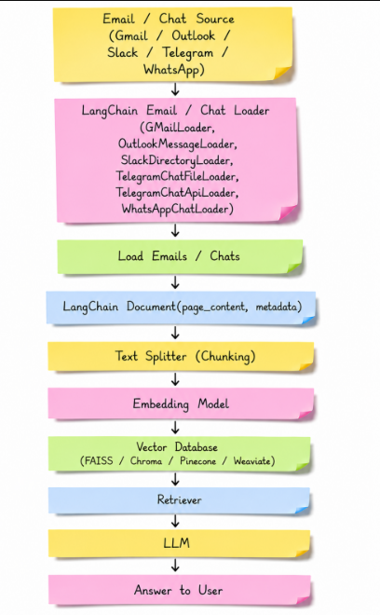
- LangChain is not itself a document parsing engine, nor is it the only option for document parsing. There are specialized document parsing libraries and services, such as Docling and LlamaParse, that are designed to extract and structure content from complex documents, particularly PDFs containing tables, images, layouts, and other structured elements.

Docling

- Docling is a document understanding/parsing library.
- Docling is used to parse the complicated documents like PDF, word, Excel, HTML, TXT.
- It tries to understand the structure and layout of the document rather than simply extracting text.
- It can then be integrated with LangChain Framework for building RAG pipeline as shown below:

RAG pipeline using Docling parser
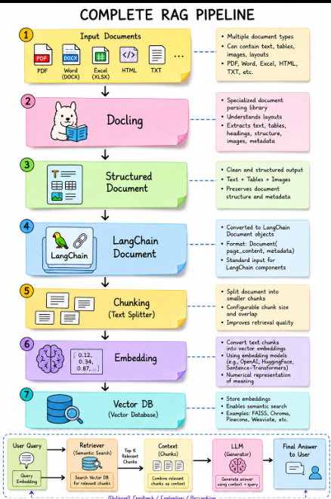

LlamaParse
- LlamaParse is also a document parsing service, but it is provided by LlamaIndex.
- It is designed especially for extracting useful structured content from difficult documents like PDF, word, Excel, HTML, TXT.
- It tries to understand the structure and layout of the document rather than simply extracting text.
- It can then be integrated with LangChain Framework for building RAG pipeline as shown below:

RAG pipeline using LlamaParse
