- Vector databases:
  - Vector databases store data as a numerical vector called embeddings and retrieves the most similar vectors using similarity search. It mainly used for semantic search, RAG, recommendation systems and image search where results are found by meaning rather than exact keyword search.

- Vector index:
- Vector index is a data structure that organizes embeddings so that vector database can find the similar vectors quickly without comparing query with every stored vector

- Different databases used different names for indexes as shown below:
- Qdrant Collection
- Pinecone index + Namespaces.
- Chroma Collection
- Milvus Collection
- OpenSearch Collection

- Vector databases store vectors and vector index make searching of those vectors faster.

- Similarity Search:
- Similarity search is the process of finding stored vectors that are closest and similar to query vector.
- It compares vector using metric like a cosine similarity, Euclidean distance and dot product.
Example:
Search for “How can I recover my account?” may retrieve “Steps to reset your password” because both have similar meaning, even though the words are different.

- What are vector databases that most used across industry solution?
- Pinecone, Milvus, Qdrant, FAISS, Chroma DB, PostgreSQL + pgvector
OpenSearch / AWS Open search, Azure AI Search, Vertex AI vector search, BigQuery Vector Search.

- What are vector database deployment methods?
- Different database deployments methods are as fallows
- In-Memory Vector Store
    - Examples: FAISS, Chroma
    - Data/index is primarily kept in memory.
    - Mainly useful for development, testing, and smaller applications.
    - Persistence depends on specific implementation/configuration.

- Self-Hosted / Local Persistent Vector Database
- Examples: Chroma, Qdrant, Milvus.
- You deploy the vector database on your own machine or server.
- You are responsible for installation, storage, backups, scaling, monitoring, and maintenance.
- You manage the infrastructure.
- Vendor-Managed SaaS Vector Database
- Examples: Pinecone, Weaviate, Qdrant Cloud, Milvus
- The vector database is hosted and operated by the database vendor.
- The vendor manages infrastructure, maintenance, availability, and scaling.
- The database vendor manages the infrastructure.

- Cloud-Provider Managed Vector Search
- Examples: Azure AI Search, Amazon OpenSearch Service, Google Vertex AI Vector Search.
- The service is provided and managed by a cloud provider.
- The cloud provider manages the underlying infrastructure and service operations.
- AWS, Azure, or GCP manages the service.

Different types of vector indexes

- Vector indexes are broadly divided into two major approaches:
- Exact Search
  - FLAT
- Approximate Search
  - IVF (Inverted File Index)
  - HNSW (Hierarchical Navigable Small World)

- FLAT:
  - FLAT is the simplest approach. The query vector is compared against every vector in the database. Then the nearest vectors are selected.
  - FLAT gives exact search but can be slow at large scale because it compares the query against every vector.
  - Advantages
    - Very simple
    - Exact nearest-neighbour search
    - High accuracy
  - Disadvantages
    - Expensive for very large datasets
    - Search time increases as number of vectors increases

- IVF (Inverted File Index):
- The basic idea is to divide similar vectors into clusters as shown below

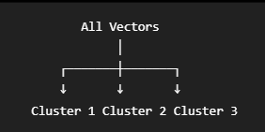

- When query arrives

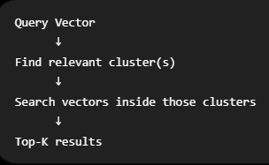

- With IVF search subset will be decreased compare to FLAT.

- Advantages
  - Faster than exhaustive search
  - Useful for large datasets
  - Reduces search space
- HNSW (Hierarchical Navigable Small World)
  - HNSW uses a graph-based structure.
  - Vectors are represented as nodes, with connections to neighboring/similar vectors as shown below:
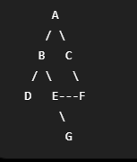
  - When query arrives
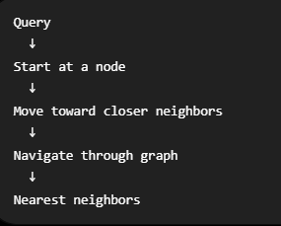
  - Advantages:
    - Very fast similarity search
    - Excellent for large-scale vector search
    - Commonly used for low-latency retrieval
  - Disadvantages
    - Uses additional memory for graph structure
    - Approximate rather than exhaustive search
    - Index construction can be more expensive
- Conclusion:
Vector indexing is the mechanism that makes similarity search over large collections of embeddings practical, FLAT provides exact search, while IVF and HNSW provide faster approximate search using clusters and graphs respectively.

- Vector database can store vector in the fallowing format
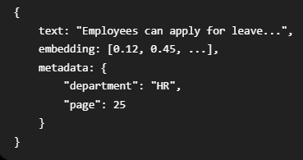
- Difference between vector store and vector databases?
- Vector Store is primarily focused on storing and retrieving embeddings. Think of a vector store as a specialized storage/retrieval layer. In the LangChain ecosystem, you'll often hear "vector store" because LangChain provides a common abstraction for working with different vector backends.
- A vector database goes beyond simply storing vectors. It provides Vector storage, Vector indexes, Similarity search, Metadata filtering, CRUD operations, Persistence, Scalability, Access control, Replication/distribution, Monitoring/operational capabilities.
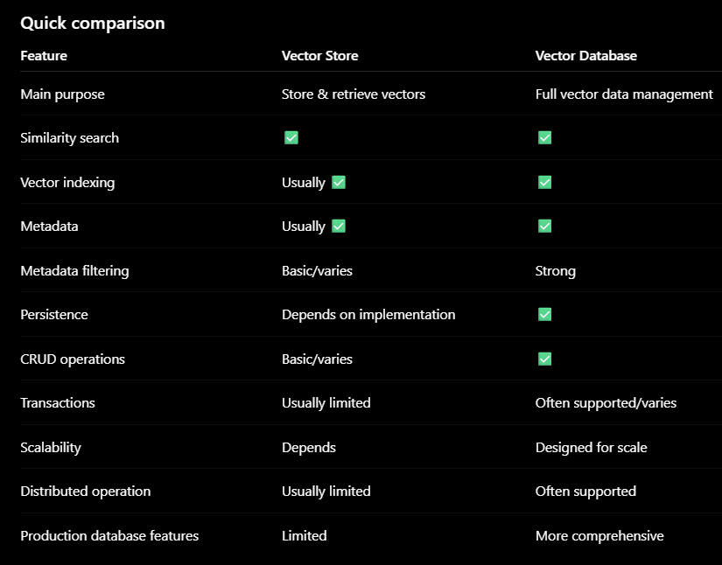

- Conclusion:
    - vector database is a full database system, while "vector store" is often a storage/retrieval abstraction.

- Vector Dimensions:
- Every embedded model produces fix sized vector.
- Example like Model A: 384 dimensions, Model B: 768 dimensions, Model C: 1536 dimensions
- Vector databases collection/index must match embedded model output dimensions.
- 1536 dimension index cannot directly accept a 768 dimension vector.

