**ANNA UNIVERSITY: CHENNAI 600 025**

**BONAFIDE CERTIFICATE**

Certified that this project report “**RAILWAY TRACK JOINTS MONITORING SYSTEM”** is the bonafide work of “**KARTHIK RAJA C (312315104077)** and **KEWIN FERNANDO. A (312315104080)**” who carried out the project work under my supervision.

|  |  |
| --- | --- |
| **SIGNATURE** | **SIGNATURE** |
| Dr.A.Chandrasekar M.E.,Ph.D., | Mr.P.Naveen M.E., |
| **HEAD OF THE DEPARTMENT** | **SUPERVISOR** |
| Professor | Assistant Professor |
| Department of Computer Science | Department of Computer Science |
| St. Joseph’s college of  Engineering | St. Joseph’s college of Engineering |
| Chennai. | Chennai. |

Submission of the University Viva-Voce held on_______________

|  |  |
| --- | --- |
| **INTERNAL EXAMINER** | **EXTERNAL EXAMINER** |

**ACKNOWLEDGEMENT**

The contentment and elation that accompany the successful completion of any work would be incomplete without mentioning the people who made it possible.

Words are inadequate in offering our sincere thanks and performed gratitude to beloved **Dr. B. Babu Manoharan, M.A., M.B.A., Ph.D.,** Chairman,

St. Joseph’s Group of Institutions for providing an opportunity to study in his esteemed Institution.

We express our sincere thanks and gratitude to **Ms.S.Jessie Priya, M.Com.,** Managing Director and also our thanks to **Mr. B. Shashi Sekar, M.Sc.,** Director, St. Joseph’s Group of Institutions for extended their helping hands at all times.

We are extremely happy to express our sincere thanks and gratitude to **Dr.Vaddi Seshagiri Rao, M.E., M.B.A., Ph.D.,** Principal and also extends our thanks to **Dr. B. Parvathavarthini, M.E., M.B.A., Ph.D.,** Dean (Research), St. Joseph’s College of Engineering for their encouragement throughout the course.

We also express our sincere thanks and most heartfelt sense of gratitude to **Dr. A. Chandrasekar, M.E., Ph.D.,** Professor and Head of the Department of Computer Science and Engineering, for his dedication, commendable support and encouragement for the completion of project work with perfection.

It is with deep sense of gratitude that we acknowledge our indebtedness to our supervisor **Mr. P. Naveen, M.E.,** Assistant Professor, Department of Computer Science and Engineering, for his valuable suggestions and for his technical support rendered during the project phase.

Last but not the least we thank our family members and friends who have been the greatest source of support to us.

**CHAPTER 1**

**INTRODUCTION**

**1.1 AIM**

The main aim of this project is to detect cracks or any displacement on a railway track joints with the use IoT solutions based upon the sensors like MEMS, IR and voltage.

**1.2 SYNOPSIS**

Railway tracks do not come as a single stretch of metal. The entire track system is an assembly of smaller tracks which are interlinked using a connectors or joints. The joints are also known as Railway fish plate which is a metal bar that is used to connect the ends of two rails by fish bolts as the connection part between two rails.

In cities and the urban sides, the maintenance of these systems and the joints are done with timely durations but when we look at the rural areas where there is very little human movement, these things are not maintained just as much. Sometimes due to the heat or abrasion and also lack of maintenance can cause the cracks on these joints or fish plates. This may also include the displacement in the position of the joints along with the track. To monitor such anomalies, we have come up with a monitoring system which implements the use of a few sensors to detect any cracking or displacement of the tracks.

We have implemented three sensors which include the MEMs sensor, IR sensor and voltage sensor. The Micro-Electro-Mechanical Systems sensor is a tilt detection sensor which takes in native coordinates of the track and stores it. When there is a change in these coordinates, the signal gets tipped off and is notified. The IR sensor is used to detect the cracks. It consists of a receiver and a transmitter. If there is a crack, then the IR signal will not get received by the receiver and the signal gets tipped off.

The third sensor is a voltage sensor which contains a negative and positive terminal, which is connected to either sides of the connection plates and a voltage of 15V is passed through it. If the voltage signal is not received on the negative terminal, then that indicates a break in the connectivity of the plates.

Using these three different types of sensors, we can monitor these track joints. Depending upon the output from these sensors, the train unit either stops or moves. This is done via the RF transmission and even if one of the sensors detects some anomaly, the train unit gets the signal and its motor stops.

**CHAPTER 2**

**SYSTEM ANALYSIS**

**2.1 EXISTING SYSTEM**

The existing system is condition monitoring. Condition monitoring detects and identifies deterioration in structures and infrastructure before the deterioration causes a failure or prevents rail operations. In simple condition monitoring, sensors monitor the condition of a structure or machinery. If the sensor readings reach a predetermined limit or fault condition, then an alarm is activated.

However, this simplistic approach may lead to a large number of false alarms and missed failures. It only provides local analysis but does not take advantage of the superior capabilities when the sensors are networked and their data processed collectively. Integrated data processing allows an overall picture of an asset’s condition to be achieved and overall condition trends to be determined.

**2.2. PROPOSED SYSTEM**

To overcome the existing problem we have come with our project where we implement sensors like the MEMS sensor, IR sensor and the voltage sensor. All of the intermediate data is sent via Wi-Fi Module to the user.

The MEMS sensor is used for tilt detection, if it’s goes abnormal then it will send the data through Wifi-Module to the user. IR sensor is used for crack detection of the railway track. If it’s abnormal data send through Wi-Fi Module to the webpage and also display on LCD.

We are using Voltage sensor for the purpose of checking continuity of the track. In second part of this project we design the receiving unit where user can see all the updated data on the webpage through Wi-Fi communication in their computer. In 3rd part of this project we design train unit too which is controlled through RF communication with eh RF transmitter on the main unit and a RF receiver on the train unit. If there is any abnormal activity, the train gets signaled and the engine stops.

**2.3. LITERATURE SURVEY**

**2.3.1. TITLE**: A Railway Locomotive Monitoring System Using IoT

**AUTHOR:** Ashwini G V, Manasa M1, Ramya K, Ashoka S

**YEAR:** 2018

The explosively growing demand of internet of things (IoT) has rendered broad scale advancements in the fields across sensors, radio access, network, and hardware/software platforms for mass-market applications. A cost-effective IoT solution consisting of device platform, gateway, IoT network and platform server for smart railway infrastructure. The IoT solution applied for the smart railway application makes it easy to grasp the condition information distributed over a wide railway area. One of the important issues for railway operators is maintenance of their railway systems. The railway system consists of various entities including train vehicles, tracks, facilities (i.e. tunnels and bridges), catenary and electrical devices in trackside. It is essential for the railway operators to guarantee that every entity of the railway system operates in good condition. Any operational faults are supposed to be strictly prevented, because an unexpected fault may threat the safety of massive passengers. The proposed railway locomotive monitoring systems as the facilities like estimation of the fuel consumption & distance covered by train, to detect unwanted objects on tracks & any cracking in the tracks and also provide health services to the passengers.

**2.3.2. TITLE:** The Power of Models: Modeling Power Consumption for IoT devices

**AUTHOR:** N Borja Martinez, Member, IEEE, M`arius Mont´on, Member, IEEE, Ignasi Vilajosana, and Joan Daniel Prades,

**YEAR:** 2015

Low-energy technologies in the Internet of Things era are still unable to provide the reliability needed by the industrial world, particularly in terms of the wireless operation that pervasive deployments demand. While industrial wireless performance has achieved an acceptable degree in communications, it is no easy task to determine an efficient energy dimensioning of the device in order to meet the application requirements. This is especially true in the face of the uncertainty inherent in energy harvesting. Thus, it is of utmost importance to model and dimension the energy consumption of IoT applications at the pre-deployment or pre-production stages, especially when considering critical factors such as reduced cost, life-time, and available energy. This paper presents a comprehensive model for the power consumption of wireless sensor nodes. The model takes a system level perspective to account for all energy expenditures: communications, acquisition and processing.

**2.3.3. TITLE:** M2M Service Platforms: Survey, Issues, and Enabling Technologies

**AUTHOR:** Jaewoo Kim, Jaiyong Lee, Member, IEEE, Jaeho Kim, and Jaeseok Yun,Member,IEEE.

**YEAR:** 2014

Machine-to-Machine (M2M) refers to technologies with various applications. In order to provide the vision and goals of M2M, an M2M ecosystem with a service platform must be established by the key players in industrial domains so as to substantially reduce development costs and improve time to market of M2M devices and services. The service platform must be supported by M2M enabling technologies and standardization. In this paper, we present a survey of existing M2M service platforms and explore the various research issues and challenges involved in enabling an M2Mservice platform. We first classify M2M nodes according to their characteristics and required functions, and we then highlight the features of M2M traffic. Based on these, we propose an M2M service platform (M2SP) architecture and its functionalities, and present the M2M ecosystem with this platform. Different application scenarios are given to illustrate the interaction between the components of the proposed platform. In addition, we discuss the issues and challenges of enabling technologies and standardization activities, and outline future research directions for the M2M network.

**2.3.4. TITLE**: Energy-Efficient Wireless Communications: Tutorial, Survey, and Open Issues

**AUTHOR:** Geoffrey Ye Li, Zhikun Xu, Cong Xiong, Chenyang Yang, Shunqing Zhang, Yan Chen, and Shugong Xu.

**YEAR:** 2014

With explosive growth of high-data-rate applications, more and more energy is consumed in wireless networks to guarantee quality-of-service (QoS). Therefore, energy-efficient communications have been paid increasing attention under the background of limited energy resource and environmental-friendly transmission behaviors. In this article, basic concepts of energy-efficient communications are first introduced and then existing fundamental works and advanced techniques for energy efficiency (EE) are summarized, including information-theoretic analysis, orthogonal frequency division multiple access (OFDMA) networks, multiple-input multiple-output (MIMO) techniques, relay transmission, and resource allocation for signaling. Some valuable topics on energy-efficient design are also identified for future research.

**2.3.5. TITLE**: A Survey on Facilities for Experimental Internet of Things Research

**AUTHOR:** Alexander Gluhak, Srdjan Krco, Michele Nati, Dennis Pfisterer,Nathalie Mitton and Tahiry Razafindralambo.

**YEAR:** 2014

The initial vision of the Internet of Things (IoT) was of a world in which all physical objects are tagged and uniquely identified by RFID transponders. However, the concept has grown into multiple dimensions, encompassing sensor networks able to provide real-world intelligence and goal-oriented collaboration of distributed smart objects via local networks or global interconnections such as the Internet. Despite significant technological advances, difficulties associated with the evaluation of IoT solutions under realistic conditions, in real world experimental deployments still hamper their maturation and significant roll out. In this article we identify requirements for the next generation of the IoT experimental facilities. While providing a taxonomy, we also survey currently available research test beds, identify existing gaps and suggest new directions based on experience from recent efforts in this field.

**CHAPTER 3 REQUIREMENT SPECIFICATIONS**

**3.1 INTRODUCTION**

The requirements specification is a technical specification of requirements for the Hardware and software products. It is the first step in the requirements analysis process it lists the requirements of a particular system including functional, performance and security requirements. The requirements also provide usage scenarios from a user, an operational and an administrative perspective. The purpose of software requirements specification is to provide a detailed overview of the software project, its parameters and goals. This describes the project target audience and its user interface, hardware and software requirements.

**3.2 HARDWARE SPECIFICATION**

MEMS Sensor

Voltage Sensor

IR Sensor

MicroController

WiFi Module

UART

LCD Monitor

DC Motor

RF tx

RF rx

**3.2.1. MEMS SENSOR**

Microelectromechanical systems is the technology of microscopic devices, particularly those with moving parts. It merges at the nano-scale into [nanoelectromechanical systems](https://en.wikipedia.org/wiki/Nanoelectromechanical_systems) (NEMS) and [nanotechnology](https://en.wikipedia.org/wiki/Nanotechnology). MEMS are also referred to as [micromachines](https://en.wikipedia.org/wiki/Micromachinery) in Japan, or micro systems technology (MST) in Europe. MEMS are made up of components between 1 and 100 micrometers in size and MEMS devices generally range in size from 20 micrometres to a millimetre, although components arranged in can be more than 1000 mm2.Inclinometers measure the orientation angle of an object with respect to the force of gravity. This is done by means of an accelerometer, which monitors the effect of gravity on a tiny mass suspended in an elastic support structure. When the device tilts, this mass will move slightly, causing a change of capacitance between the mass and the supporting structure. The tilt angle is calculated from the measured capacitances.

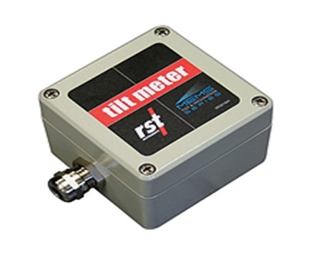

**Figure 3.1 MEMS SENSOR**

**3.2.2. IR SENSOR**

An [Infrared sensor](https://www.elprocus.com/ir-remote-control-basics-operation-application/) is an electronic device, that emits in order to sense some aspects of the surroundings. An IR sensor can measure the heat of an object as well as detects the motion.These types of sensors measures only infrared radiation, rather than emitting it that is called as a [passive IR sensor](https://www.elprocus.com/passive-infrared-pir-sensor-with-applications/). Usually in the infrared spectrum, all the objects radiate some form of thermal radiations. These types of radiations are  invisible to our eyes, that can be detected by an infrared sensor.The emitter is simply an IR LED and the detector is simply an IR photodiode which is sensitive to IR light of the same wavelength as that emitted by the IR LED. When IR light falls on the photodiode, The resistances and these output voltages, change in proportion to the magnitude of the IR light received

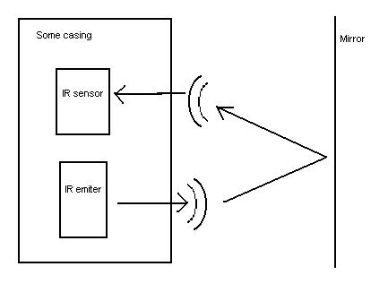

**Figure 3.2 IR SENSOR**

**3.2.3. VOLTAGE SENSOR**

The Voltage Sensor is a simple module that can used with PIC(or any other microcontroller with input tolerance of 5V) to measure external voltages that are greater than its maximum acceptable value which is 5V in case of PIC.

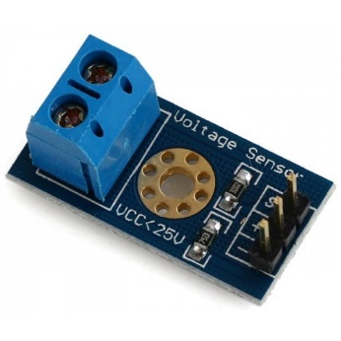

**Figure 3.3 VOLTAGE SENSOR**

**3.2.4. Wi-Fi MODULE**

The WiFi Module is a self contained SOC with integrated TCP/IP protocol stack that can give any microcontroller access to your WiFi network. The is capable of either hosting an application or offloading all Wi-Fi networking functions from another application processor. Each module comes pre-programmed with an AT command set firmware, meaning, you can simply hook this up to your Arduino device and get about as much WiFi-ability.

**3.2.5. RF TX & RF RX**

This RF module comprises of an RF Transmitter and an RF Receiver. The transmitter/receiver (Tx/Rx) pair operates at a frequency of 434 MHz. An RF transmitter receives serial data and transmits it wirelessly through RF through its antenna connected at pin4. The transmission occurs at the rate of 1Kbps - 10Kbps.The transmitted data is received by an RF receiver operating at the same frequency as that of the transmitter.

The RF module is often used along with a pair of encoder/decoder. The encoder is used for encoding parallel data for transmission feed while reception is decoded by a decoder.

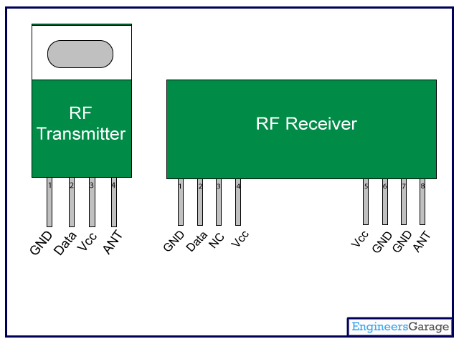

**Figure 3.5 RF tx & RF rx**

**3.2.6. MICROCONTROLLER**

PIC16F877a is a 40-pin PIC Microcontroller and is used mostly in [Embedded Projects](https://www.theengineeringprojects.com/2016/10/embedded-system-projects.html) and Applications. Few of its features are as follows:

It has five Ports on it starting from Port A to Port E. It has three Timers in it, two of which are 8 bit Timers while 1 is 16 Bit. It supports both hardware pin interrupts and timer interrupts.

Each PIC Microcontroller has a basic circuit and if you won’t design the basic circuit then it won’t work. It’s just like providing power to your PIC Microcontroller and it works on +5V level

In order to provide it power in PIC case we also need to provide the frequency at which it will work.

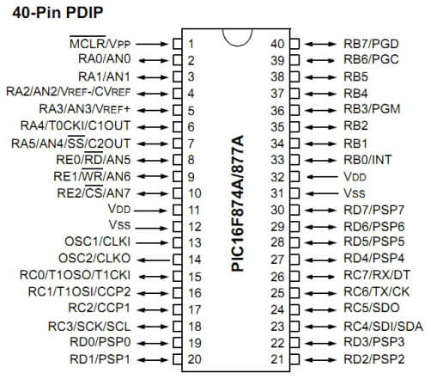

**Figure 3.6 PIC**

**3.2.7. DC MOTOR**

This module is to replicate the engine as that of an actual train engine which have quite a lot of resemblance. The DC motor works because, simply put, when a current is passed through the motor circuit, there is a reaction between the current in the field and the current in the armature which causes the armature to turn.

The armature and the field are connected in series and the whole motor is referred to as "series wound".

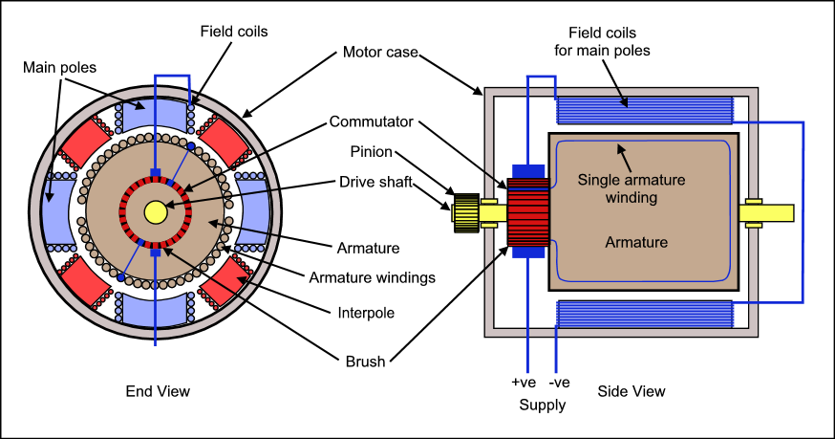

**Figure 3.7 DC MOTOR**

**3.2.8. LCD**

This is going to be the display device which is going to display the happenings in the modules. It signals when there is a change in the native characteristics of the sensors or any sort of anomalies. In the LCD display, there are 16 pins. First two pins VSS and VDD are for providing power to the display. Connect these pins to the GND and 5V supply pins in the Arduino Uno. 3rd pin of the LCD is named as Vo which is used for adjusting display contrast. We can use a 10KΩ preset for that, connect variable end to Vo and fixed ends to VSS and VDD. 4th pin RS is the Register Select pin which is used to multiplex the data and command information send to the LCD module. Data information is the ASCII value of the information to be displayed on the LCD

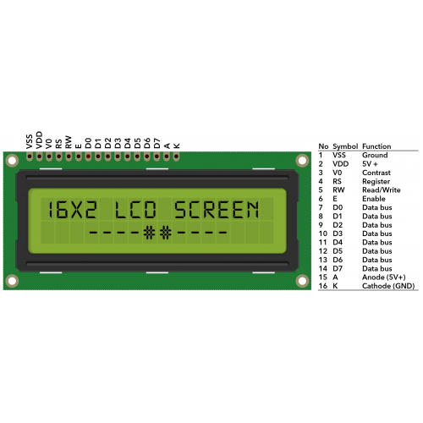

**Figure 3.8 LCD MONITOR**

**3.2.9. UART**

Universal Asynchronous Receiver/Transmitter, and it is an inbuilt IC within a microcontroller but not like a communication protocol. The main function of UART is to serial data communication. In UART, the communication between two devices can be done in two ways namely serial data communication and parallel data communication.

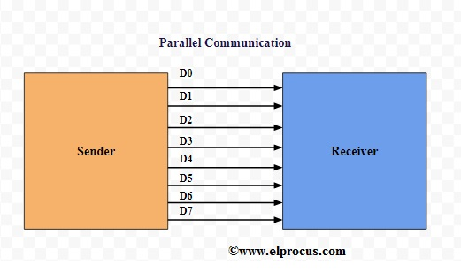

**Figure 3.9 UART**

In serial data communication, the data can be transferred through a single cable or line in a bit- by- bit form and it requires just two cables. Serial data communication is not expensive when we compared with parallel communication. It requires very less circuitry as well as wires. Thus, this communication is very useful in compound circuits compared with parallel communication.

In parallel data communication, the data can be transferred through multiple cables at once. Parallel data communication is expensive as well as very fast, as its requires additional hardware and cables. The best examples for this communication are old printers, PCI, RAM, etc.

**3.3. SOFTWARE REQUIREMENTS**

* MP lab
* Embedded C
* HTML

**3.3.1. MP LAB**

Microchip has a large suite of software and hardware development tools integrated within one software package called MPLAB Integrated Development Environment (IDE). MPLAB IDE is a free, integrated toolset for the development of embedded applications on Microchip's PIC and dsPIC microcontrollers. It is called an Integrated Development Environment, or IDE, because it provides a single integrated environment to develop code for embedded microcontrollers.

MPLAB IDE runs as a 32-bit application on MS Windows, is easy to use and includes a host of free software components for fast application development and super-charged debugging. MPLAB IDE also serves as a single, unified graphical user interface for additional Microchip and third party software and hardware development tools. Moving between tools is a snap, and upgrading from the free software simulator to hardware debug and programming tools is done in a flash because MPLAB IDE has the same user interface for all tools.

**Components of MPLAB IDE**

The MPLAB IDE has both built-in components and plug-in modules to configure the system for a variety of software and hardware tools.

**Project Manager**: The project manager provides integration and communication between the IDE and the language tools.

**Editor**: The editor is a full-featured programmer's text editor that also serves as a window into the debugger.

**Assembler/Linker and Language Tools**: The assembler can be used stand-alone to assemble a single file, or can be used with the linker to build a project from separate source files, libraries and recompiled objects. The linker is responsible for positioning the compiled code into memory areas of the target microcontroller.

**Debugger**: The Microchip debugger allows breakpoints, single stepping, watch windows and all the features of a modern debugger for the MPLAB IDE. It works in conjunction with the editor to reference information from the target being debugged back to the source code.

**Execution Engines**: There are software simulators in MPLAB IDE for all PIC micro MCU and dsPIC DSC devices. These simulators use the PC to simulate the instructions and some peripheral functions of the PIC micro MCU and dsPIC DSC devices. Optional in-circuit emulators and in-circuit debuggers are also available to test code as it runs in the applications hardware.

**Key Features**

MPLAB IDE is a Windows Operating System (OS) based Integrated Development Environment for the PIC MCU families and the dsPIC Digital Signal Controllers.

The MPLAB IDE provides the ability to:

* Create and edit source code using the built-in editor.
* Assemble, compile and link source code.
* Debug the executable logic by watching program flow with the built- in simulator or in real time with in-circuit emulators or in-circuit debuggers.
* Make timing measurements with the simulator or emulator.
* View variables in Watch windows.
* Program firmware into devices with device programmers.

**3.3.2 EMBEDDED C**

Embedded C is one of the most popular and most commonly used Programming Languages in the development of Embedded Systems. So, in this article, we will see some of the Basics of Embedded C Program and the Programming Structure of Embedded C. Embedded C is perhaps the most popular languages among Embedded Programmers for programming Embedded Systems. There are many popular programming languages like Assembly, BASIC, C++ etc. that are often used for developing Embedded Systems but Embedded C remains popular due to its efficiency, less development time and portability.

**Components of Embedded C**

**Comments**: Comments are readable text that are written to help us understand the code easily. They are ignored by the compiler and do not take up any memory in the final code.

There are two ways you can write comments: one is the single line comments denoted by // and the other is multiline comments denoted by /*….*/.

**Preprocessor Directive**

A Preprocessor Directive in Embedded C is an indication to the compiler that it must look in to this file for symbols that are not defined in the program.

In C Programming Language (also in Embedded C), Preprocessor Directives are usually represented using #include… or #define.In Embedded C Programming, we usually use the preprocessor directive to indicate a header file specific to the microcontroller, which contains all the SFRs and the bits in those SFRs.

In case of 8051, Keil Compiler has the file “reg51.h”, which must be written at the beginning of every Embedded C Program.. Global Variables: Global Variables, as the name suggests, are Global to the program i.e. they can be accessed anywhere in the program.

**Local Variables:**Local Variables, in contrast to Global Variables, are confined to their respective function.

**Main Function**: Every C or Embedded C Program has one main function, from where the execution of the program begins.

**CHAPTER 4**

**PROJECT PURPOSE**

**4.1. PURPOSE**

The main objective or purpose of this system is to provide an efficient method for detecting cracks or obstacles on the course of a train

\in a railway track. This is done through intermediating IOT based solutions paired up with a few sensors to help detect the cracks or obstacles.

We propose a few sensors like the IR sensor which contains a transmitter and a receiver attached to the same unit. This way the IR ray is sent and if there is an obstacle, there comes a disturbance and it is notified.

We also bring up the MEMS sensor which is used to detect the displacement in the track. The way this works is we input the x, y and z coordinates to the sensor and If there is any displacement it gets reflected on the output.

The final sensor is a voltage sensor which uses the principle of conductivity through the railway tracks to detect the flow and to detect any sort of blockage or any hinderence to the flow of the electricity.

**4.2. PROJECT OBJECTIVES**

Objectives are very important in defining a system in order to set the things needed to be done for the completion of the product.

The main objectives of our Railway Monitoring System Includes:

* To detect the cracks in the railway track joints
* To detect discontinuity of the track joints.
* To detect the displacement in position of the track.

**4.3. SYSTEMFEATURES**

The system contains three units out of which two are hardware. The units include the Main Unit, the Receiving unit and the Train unit. The main unit contains all of the sensors including an LCD for displaying the output. There are three sensors and they include the MEMS sensor, IR sensor and a voltage sensor. It contains a RT transmitter which is linked with the Train unit. The train unit contains a RF receiver and the trains motor connectivity.

Depending upon the frequency, the trains stops or moves. The receiving unit contains a server docked to the webpage which keeps tracks of all the made surveys.

The MEMS sensor is used to find out if there is a displacement in the position of the railway track. The Voltage sensor uses the principle of conductivity and a beam of voltage is passed through one edge of the railway track and is expected to be received on the other end. This ensures that there is no breakage in connectivity. The third sensor is an IR sensor which contains both a receiver and transmitter which is used to detect the obstacles.

An LCD screen to display the intermediate outcomes. Everything is connected to the micro controller and through the tasks are executed. An UART is fitted to the WiFi module to sync the information with the webpage.

**4.4 DESIGN AND IMPLEMENTATION CONSTRAINTS**

**4.4.1 Constraints in Analysis**

* Constraints as Informal Text
* Constraints as Operational Restrictions
* Constraints Integrated in Existing Model Concepts
* Constraints as a Separate Concept
* Constraints Implied by the Model Structure

**4.4.2 Constraints in Design**

* Sizing comparative constraints.
* Achieving large scale implementation.
* Fragile components.
* Determination of the Involved Actions.
* Global actions and Constraint Realization.

**4.4.3 Constraints in Implementation**

A hierarchical structuring of relations may result in more classes and a more complicated structure to implement. Therefore it is advisable to transform the hierarchical relation structure to a simpler structure such

as a classical flat one. It is rather straightforward to transform the developed hierarchical model into a bipartite, flat model, consisting of classes on the one hand and flat relations on the other. Flat relations are preferred at the design level for reasons of simplicity and implementation ease. There is no identity or functionality associated with a flat relation. A flat relation corresponds with the relation concept of entity-relationship modeling and many object oriented methods.

**4.5. OTHER NONFUNCTIONAL REQUIREMENTS**

The server controls and communicates with the following three main general components.

* MEMS sensor responsible for determining the tilt shift and the displacement of the tracks.
* IR sensor whose main purpose is to detect any cracks and alo obstacles on the tack.
* Voltage sensor which is used to check the conductivity of the tracks by passing voltage through.

**Safety Requirements**

* 1. The server may be safety-critical. If so, there are issues associated with its integrity level.
  2. Since these are going to be set up in places with less human interaction, the liability of the components used can be a threat.
  3. Systems with different requirements for safety levels must be separated.
  4. It must be made sure that the right data gets stored on the server database.
  5. If a computer system is to run software of a high integrity level then that system should not at the same time accommodate software of a lower integrity level.

**CHAPTER 5**

**SYSTEM DESIGN**

**5.1. ARCHITECTURE DIAGRAM**

**MAIN UNIT**

**PIC16F877A**

**MEMS SENSOR**

**LCD**

**VOLTAGE SENSOR**

**RF TX**

**UART**

**IR SENSOR**

**Wi-Fi**

**Module**

**RECEIVING UNIT**

**Webpage**

**Server**

**TRAIN UNIT**

**DC MOTOR**

**RF RX**

**5.2. MODULE**

* Main Module.
* Receiving Module.
* Train unit.

**5.2.1 MAIN UNIT**

This is the main unit of the system and this contains all of the necessary modules and transmitters. The three main sensory devices used here are MEMS sensor, Voltage sensor and then an IR sensor each used to achieve a specific task.

The MEMS sensor is used to find out if there is a displacement in the position of the railway track. The Voltage sensor uses the principle of conductivity and a beam of voltage is passed through one edge of the railway track and is expected to be received on the other end. This ensures that there is no breakage in connectivity.

The third sensor is an IR sensor which contains both a receiver and transmitter which is used it detect the obstacles.

This unit is fitted with an LCD screen to display the intermediate outcomes. Everything is connected to the raspberry pi and through the tasks are executed. An UART is fitted to the wifi module to sync the information with the webpage. There is an RF transmitter which signals the train unit which contains the corresponding receiver unit.

**5.2.2. RECEIVING UNIT**

This is the connectivity unit which contains a specified server to which the main unit communicates and the data is synced into webpage to store the details of the happenings in a table format.

**5.2.3 TRAIN UNIT**

This is unit refers to the unit on the train itself. The train unit contains primarily the motor or the engine which communicates with the main unit via the RF receiver which gets the information from the RF transmitter on the main unit.

So if any of the sensors report any sort of anomalies the RF transmitter on the Main unit sends a signal to the train unit and the RF receiver unit captures it and either stops the movement of the engine or does not alter anything.

**CHAPTER 6**

**CODING,ALGORITHM AND OUTPUTS**

**6.1. CODING**

Once the design aspect of the system is finalizes the system enters into the coding and testing phase. The coding phase brings the actual system into action by converting the design of the system into the code in a given programming language. Therefore, a good coding style has to be taken whenever changes are required it easily screwed into the system.

**6.1.1. CODING STANDARDS**

Coding standards are guidelines to programming that focuses on the physical structure and appearance of the program. They make the code easier to read, understand and maintain. This phase of the system actually implements the blueprint developed during the design phase. The coding specification should be in such a way that any programmer must be able to understand the code and can bring about changes whenever felt necessary. Some of the standard needed to achieve the above-mentioned objectives are as follows:

* Program should be simple, clear and easy to understand.

* Naming conventions

* Value conventions

* Script and comment procedure

* Message box format

* Exception and error handling

**6.1.2. NAMING CONVENTIONS**

Naming conventions of classes, data member, member functions, procedures etc., should be **self-descriptive**. One should even get the meaning and scope of the variable by its name. The conventions are adopted for **easy understanding** of the intended message by the user. So it is customary to follow the conventions. These conventions are as follows:

**6.1.3. CLASS NAMES**

Class names are problem domain equivalence and begin with capital letter and have mixed cases.

**6.1.4. MEMBER FUNCTION AND DATA MEMBER NAME**

Member function and data member name begins with a lowercase letter with each subsequent letters of the new words in uppercase and the rest of letters in lowercase.

**6.1.5. VALUE CONVENTIONS**

Value conventions ensure values for variable at any point of time. This involves the following:

* Proper default values for the variables.
* Proper validation of values in the field.
* Proper documentation of flag values.

**6.1.6. SCRIPT WRITING AND COMMENTING STANDARD**

Script writing is an art in which indentation is utmost important. Conditional and looping statements are to be properly aligned to facilitate easy understanding. Comments are included to minimize the number of surprises that could occur when going through the code.

**6.2.ALGORITHM AND FLOWCHART**

**MEMS SENSOR**

set a

set M1 //motor

set M // Mems sensor value

set L // LCD

if (M.yaxis>300&&M.yaxis<400)

{

a=true;

}

End if

while(!a)

{  
L.display(“Track displaced”)

M1.Speed(0), Log(value)

}

end while

**VOLTAGE SENSOR**

set v //Voltage sensor value

set M1 //motor

set L //LCD

if(v<12)

{

set a = true;

while(a)

{

L.display(“continuity break”);

M.speed(0)

log(value)

}

}end while

}end if

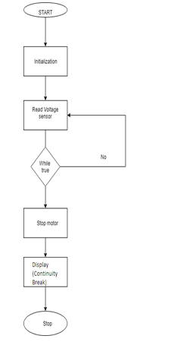**IR SENSOR**

set I //IR sensor value

set M1 //motor

set L //LCD

if(I.value(low))

{  
set a = true;

while(true)

{

M.speed(0);

L.display(“crack detected”);

log(value);

}end while

}end if

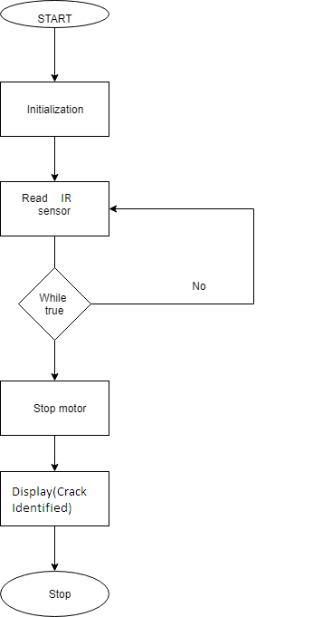

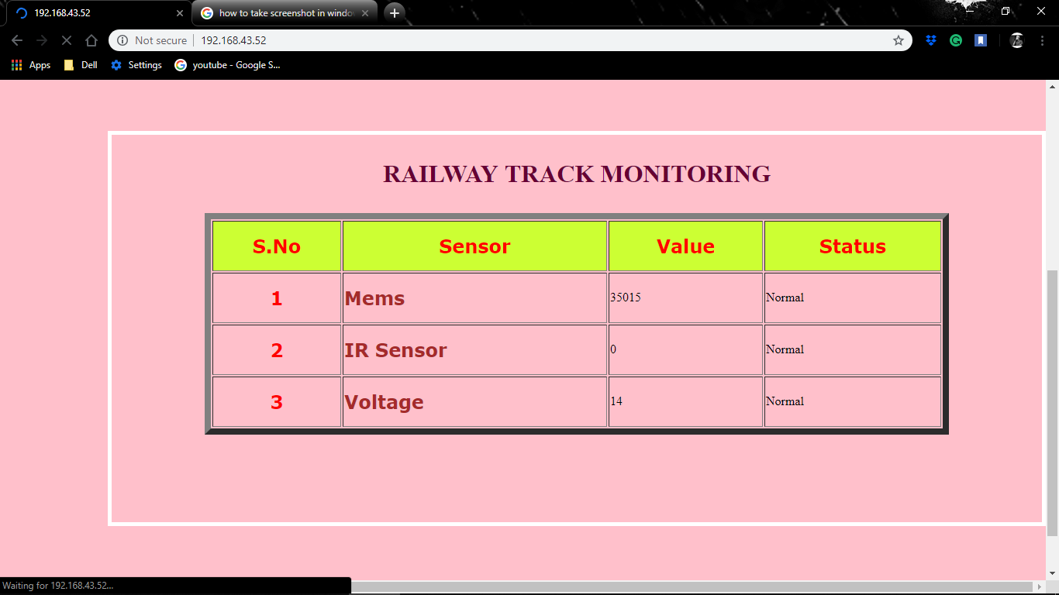

**CHAPTER 7**

**CONCLUSION AND FUTURE SCOPE**

Asthe increase in demand of new upcoming technologies that are being implemented in socially responsible causes this technology will also take its place in such causes that prevents massacres in train accidents and be responsible for saving hundreds of lives in preventing such accidents. Railway track joints monitoring system provides ease of access and maintenance to the railway employees and to access the faulty regions of the track joints. Not only finding the faults or any cracks but also preventing accidents by stopping the currently approaching train near the which saves the people travelling in that train. Further improvements can also be made by adding additional sensors and gaining more precision with the advancements in technology. By means of monitoring the joints with more precision and fast transfer could save time and prevent accidents.

Future implements such as increased range in information transmission and speed of information retrieval can be improved that can make maintenance team with more fast response. Providing additional components such as GPS etc. could improve the accuracy to identify the position of the particular system which has detected the crack or discontinuity or displacement. Other than identifying the particular system and problem ,if any train passing by the track has to be stopped can be improved by using powerful transmitter and receiver so as to protect the lives of the passengers.

**REFERENCES**

[1] Ashwini G V, Manasa M1, Ramya K, Ashoka 2018 – “A Railway Locomotive Monitoring System Using IoT” , 2018.

[2]N Borja Martinez, Member, IEEE, M`arius Mont´on, Member, IEEE, Ignasi Vilajosana, and Joan Daniel Prades – **“**The Power of Models: Modeling Power Consumption for IoT devices”**,** 2015.

[3] **:** Jaewoo Kim, Jaiyong Lee, Member, IEEE, Jaeho Kim, and Jaeseok Yun,Member,IEEE.- “M2M Service Platforms: Survey, Issues, and Enabling Technologies”,2014.

[4] Geoffrey Ye Li, Zhikun Xu, Cong Xiong, Chenyang Yang, Shunqing Zhang, Yan Chen, and Shugong Xu.-“Energy-Efficient Wireless Communications: Tutorial, Survey, and Open Issues” ,2014.

[5]Alexander Gluhak, Srdjan Krco, Michele Nati, Dennis Pfisterer,Nathalie Mitton and Tahiry Razafindralambo.- “A Survey on Facilities for Experimental Internet of Things Research”,2014.