CYBERSECURITY PROJECT REPORT

Automated Phishing
Detection &
Email Security Workflow
SOC Automation · Threat Intelligence · Real-Time Alerting

Author: Manojkumar Chiruvella
Type: SOC Automation / Cybersecurity
Platform: n8n Workflow Automation
APIs: VirusTotal · Telegram Bot · WHOIS
Date: April 2026
github.com/manoj0m27/Cybersecurity_soc-projects
AI-Powered SOC Automation · Confidential Project Report

1. PROJECT OVERVIEW
This project implements a fully automated phishing detection system designed to replicate a real-world Security Operations Center (SOC) workflow. The system continuously monitors incoming emails via IMAP, extracts embedded URLs, submits them to threat intelligence platforms for analysis, and delivers real-time alerts through Telegram when malicious content is detected.
The solution leverages n8n as the orchestration backbone, integrating multiple APIs and processing layers to provide end-to-end automation — eliminating the need for manual email inspection while maintaining high detection accuracy.
🔍 Automated URL Extraction | ⚡ Real-Time Threat Detection
Parses HTML & plain text email bodies for all embedded links | Submits URLs to VirusTotal and evaluates multi-engine scan results
📡 Instant Telegram Alerts | 🔄 SOC-Style Pipeline
Sends detailed phishing alerts with URL, risk level, and domain info | Fully automated workflow from email ingestion to incident alert
2. OBJECTIVES
The primary objectives of this project are:
- Detect phishing URLs embedded in incoming emails with minimal false negatives
- Automate the entire threat analysis pipeline using external intelligence APIs
- Reduce manual effort required in traditional email security monitoring workflows
- Provide real-time, actionable alerts for security analysts and system administrators
- Build a scalable, modular SOC-style automation architecture
- Handle edge cases such as malformed URLs, duplicate links, and API rate limits
3. TECHNOLOGIES & TOOLS USED

Technology | Category | Purpose
n8n | Workflow Automation | Orchestrates the entire detection pipeline
IMAP Protocol | Email Monitoring | Monitors mailbox for new incoming emails
VirusTotal API | Threat Intelligence | Multi-engine URL scanning & malicious detection
WHOIS / URLScan | Domain Intelligence | Checks domain age, registration, and reputation
JavaScript | Data Processing | URL extraction, cleaning, risk scoring logic
HTTP Request Node | API Integration | Handles all external API calls within workflow
Telegram Bot API | Alerting & Notification | Delivers real-time phishing alerts to analysts
4. SYSTEM ARCHITECTURE
The system follows a linear event-driven pipeline where each node performs a discrete function, enabling modularity and easy debugging. The workflow is composed of eight major processing stages:
Stage | Component | Description
1 | Email Trigger (IMAP) | Listens for new unread emails and triggers the workflow
2 | URL Extraction | Parses email body (HTML & plain text) and extracts all URLs using regex
3 | URL Cleaning | Normalizes, deduplicates, and validates URLs before analysis
4 | Batch Processing | Splits URL list into individual items to respect API rate limits
5 | VirusTotal Submission | Submits each URL to VirusTotal for multi-engine security scanning
6 | WHOIS Domain Check | Retrieves domain age and registration info for supplementary context
7 | Risk Evaluation | Aggregates scan results; classifies URL as HIGH / MEDIUM / SAFE risk
8 | Telegram Alert | Sends formatted phishing alert to the designated Telegram channel
4.1 Architecture Flow Diagram
The following n8n workflow diagram illustrates the complete end-to-end pipeline:
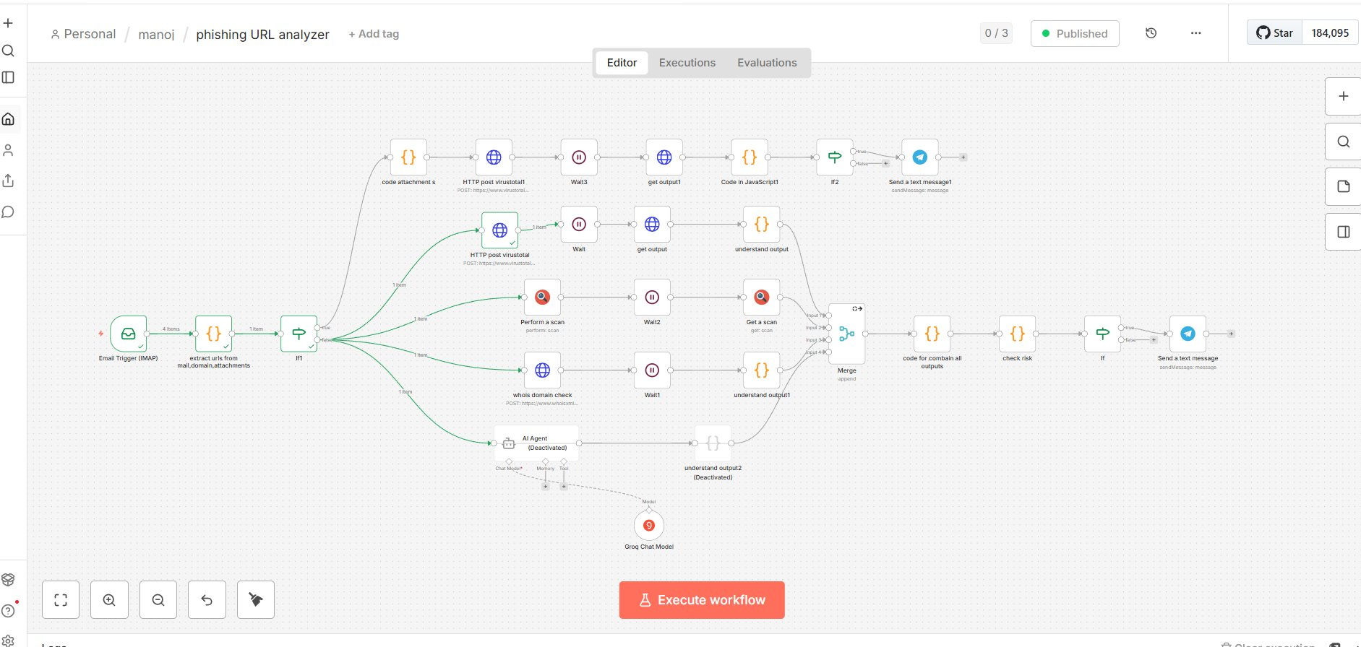
Figure 1: n8n Phishing URL Analyzer Workflow — Personal / manoj / phishing URL analyzer
5. DETAILED WORKFLOW EXPLANATION
5.1 Email Monitoring (IMAP Trigger)
The workflow initiates via an IMAP Email Trigger configured to poll a monitored mailbox at defined intervals. The node filters exclusively for unread (UNSEEN) messages using IMAP flags, ensuring no email is processed twice. Upon detection of a new email, the full message payload — including headers, body, and attachment metadata — is forwarded downstream.
5.2 URL Extraction
A JavaScript Code Node processes the raw email payload to extract all URLs present in both the HTML and plain text components of the email body. A regular expression pattern identifies HTTP and HTTPS links, including those embedded in anchor tags, shortened links, and encoded formats. Results are normalized into a flat array of URL strings.
5.3 URL Cleaning & Deduplication
Prior to analysis, all extracted URLs undergo a multi-step sanitization process:
- Malformed and incomplete URLs are discarded
- Fragment-only and relative URLs are removed
- Duplicate entries are eliminated using a Set-based deduplication approach
- Remaining URLs are normalized to a consistent format

5.4 Batch Processing
To comply with VirusTotal's API rate limits (4 requests per minute on the free tier), the workflow uses n8n's Split in Batches node to process one URL at a time. A Wait node introduces a configurable delay between API calls, preventing throttling errors and ensuring all URLs are processed reliably.
5.5 Threat Intelligence Scanning (VirusTotal)
Each URL is submitted to the VirusTotal API via HTTP POST request. The API queues the URL for analysis by 70+ antivirus engines and web scanners. Due to the asynchronous nature of VirusTotal's scanning, a Wait node pauses execution for 10–15 seconds before a second HTTP GET request retrieves the completed scan report.
5.6 Domain Intelligence (WHOIS Check)
In parallel with VirusTotal scanning, a WHOIS API call fetches domain registration metadata including domain age in days, registrar information, and creation date. Newly registered domains (typically under 30 days old) are flagged as higher-risk indicators, supplementing the VirusTotal verdict.
5.7 Risk Evaluation & Scoring
A JavaScript evaluation node aggregates all scan results and applies the following risk classification logic:
Risk Level | Criteria | Action
🔴 HIGH | ≥1 malicious detection by VirusTotal engines | Immediate Telegram alert sent
🟡 MEDIUM | Suspicious flags OR very new domain (<30 days) | Alert sent with advisory note
🟢 SAFE | Zero detections, established domain | No alert generated

5.8 Alert Delivery (Telegram Bot)
When a URL is classified as HIGH risk, a formatted alert is dispatched via Telegram Bot API to a designated channel. The alert message includes the following structured data:
- Flagged URL with risk level classification
- VirusTotal Results: Malicious and Suspicious engine counts
- Domain name extracted from URL and domain age in days
- Detection attribution: 'Detected by AI SOC Automation'

6. SYSTEM OUTPUT & RESULTS
The following test case demonstrates the system in action. A test email containing the URL http://testphp.vulnweb.com/userinfo.php was processed through the pipeline. The workflow successfully identified the URL as HIGH risk based on a positive VirusTotal detection, and delivered a Telegram alert in real time.
Alert Field | Value
URL Analyzed | http://testphp.vulnweb.com/userinfo.php
Risk Level | 🔴 HIGH
Malicious Detections | 1 (out of 70+ engines)
Suspicious Detections | 0
Domain | testphp.vulnweb.com
Domain Age | 3,293 days (~9 years)
Detected By | AI SOC Automation

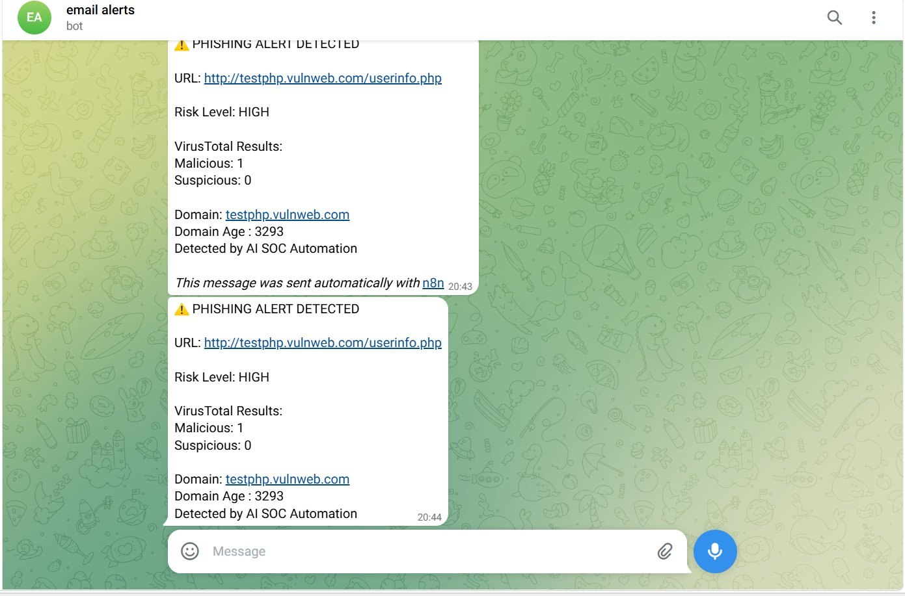
Figure 2: Telegram Alert — Real-time Phishing URL Detection Output
7. KEY FEATURES

✅ Automated Phishing Detection | ✅ Multi-URL Per Email Support
Zero manual intervention required — the system autonomously monitors, analyzes, and alerts. | Handles emails with multiple embedded links, processing each one individually.
✅ Malformed URL Handling | ✅ Rate-Limit Aware Scanning
Robust cleaning logic discards broken and incomplete URLs before API submission. | Batching and Wait nodes ensure compatibility with free-tier API quotas.
✅ Real-Time Alerting System | ✅ SOC-Style Workflow Design
Telegram alerts are dispatched within seconds of a positive phishing detection. | Modular node architecture mirrors enterprise-grade SOC detection pipelines.
8. CHALLENGES & SOLUTIONS

Challenge | Root Cause | Solution Implemented
Multiple URLs per email | Email bodies contain many embedded links | Converted URL array to individual workflow items
Broken / malformed URLs | HTML encoding, partial links, fragments | Multi-step sanitization & validation logic
VirusTotal API rate limits | Free tier: 4 requests/minute | Batch processing + configurable Wait nodes
Duplicate URL processing | Same link appears in HTML & plain text | Set-based deduplication before batch split
Async scan results (VirusTotal) | Scans not ready immediately after submission | Implemented polling with configurable delay
9. SECURITY CONSIDERATIONS
The following security best practices have been applied throughout the design and implementation of this system:
- API credentials (VirusTotal, Telegram Bot Token) are stored as encrypted n8n credentials — never hardcoded in workflow nodes
- All URLs are analyzed in sandboxed API environments — no URLs are executed or fetched by the workflow host
- IMAP credentials are secured via n8n's encrypted credential store with TLS-enforced connections
- Rate limiting is handled proactively, preventing abuse of third-party API quotas
- The system is designed to be extended with URLScan.io sandbox integration for deeper behavioral analysis
- Alert messages include only necessary data — no sensitive email content is forwarded to Telegram
10. FUTURE ENHANCEMENTS
The following enhancements are planned to extend the system's capabilities:
- SIEM Integration — Connect output to Splunk or Elastic SIEM for centralized security logging
- Enhanced Domain Intelligence — Integrate PassiveDNS and Shodan for deeper domain context
- Machine Learning Classification — Train a local ML model on URL features for improved accuracy
- Automated Sender Blocking — Auto-block malicious senders via email gateway API upon detection
- Analytics Dashboard — Build a real-time Grafana or n8n dashboard for detection metrics
- Attachment Sandboxing — Submit email attachments to a sandboxing service for dynamic analysis
- Multi-Channel Alerting — Add Slack, PagerDuty, and email notification alongside Telegram
11. PORTFOLIO & LINKEDIN DESCRIPTION
Short Version (1–2 lines)
Built an automated phishing detection system using n8n, integrating VirusTotal API for threat intelligence and Telegram Bot API for real-time SOC-style alerting on malicious email URLs.
Detailed Bullet Points
- Developed an end-to-end automated phishing URL detection workflow using n8n automation platform
- Integrated VirusTotal API (70+ engine scanning) and WHOIS domain intelligence for multi-vector threat analysis
- Implemented batch processing, deduplication, and rate-limit-aware scanning to handle production-scale email volumes
- Engineered a real-time alerting pipeline via Telegram Bot API with structured risk-level classification
- Designed a modular, SOC-style automation architecture extensible with SIEM and ML components

GitHub: github.com/manoj0m27/Cybersecurity_soc-projects · LinkedIn: linkedin.com/in/manojkumar-chiruvella-15124b2a6

