1.Counting Elements

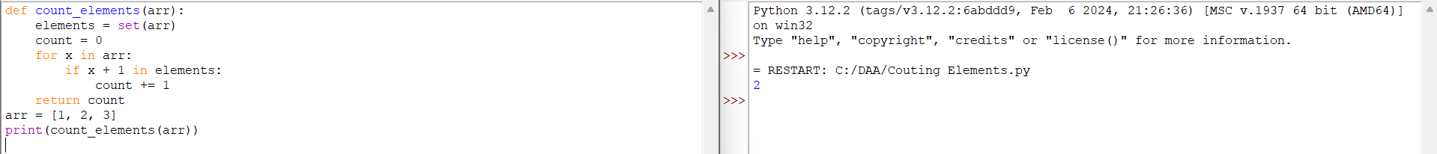

2.Perform String Shifts

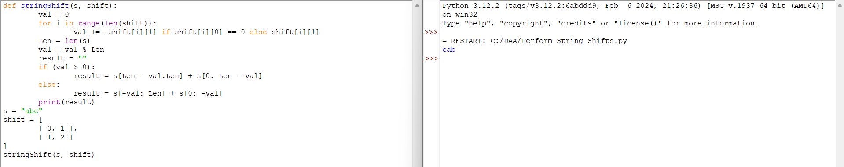

3.Leftmost Column With at Least a One

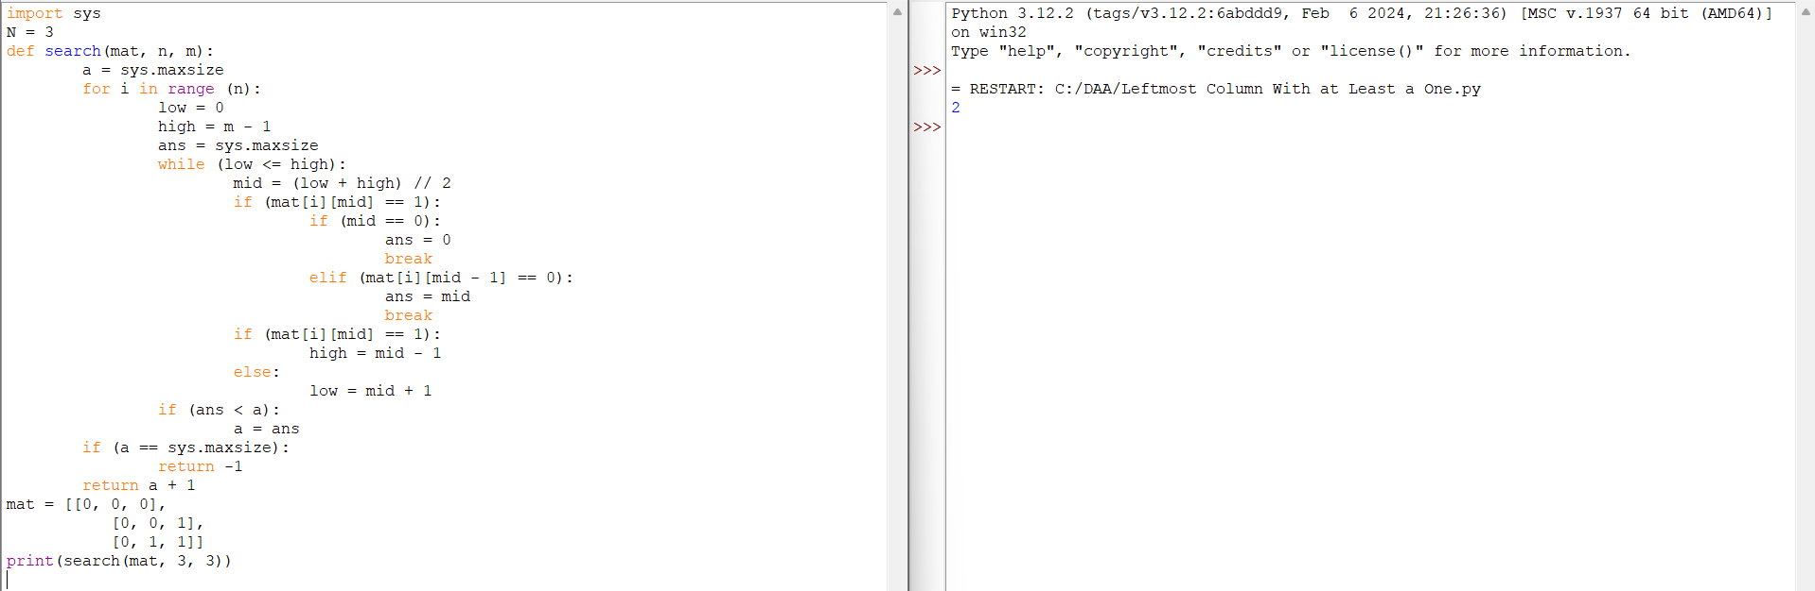

4.First Unique Number

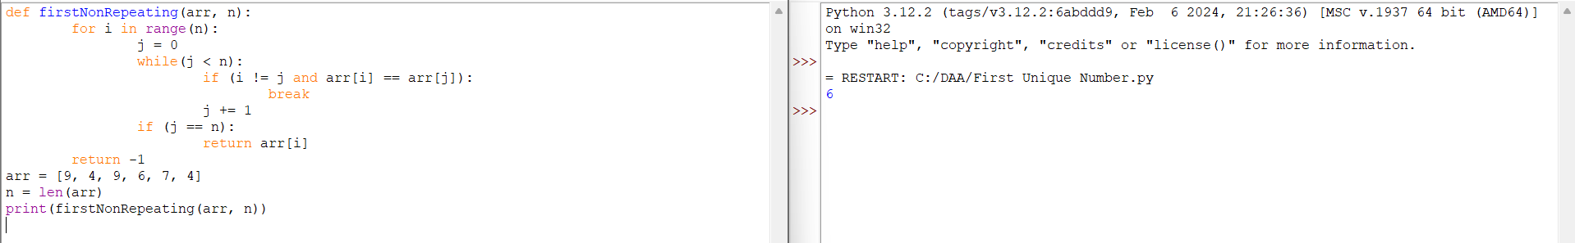

5. Check If a String Is a Valid Sequence from Root to Leaves Path in a Binary Tree Given a binary tree where each path going from the root to any leaf form a valid sequence, check if a given string is a valid sequence in such binary tree.

We get the given string from the concatenation of an array of integers arr and the concatenation of all values of the nodes along a path results in a sequence in the given binary tree.

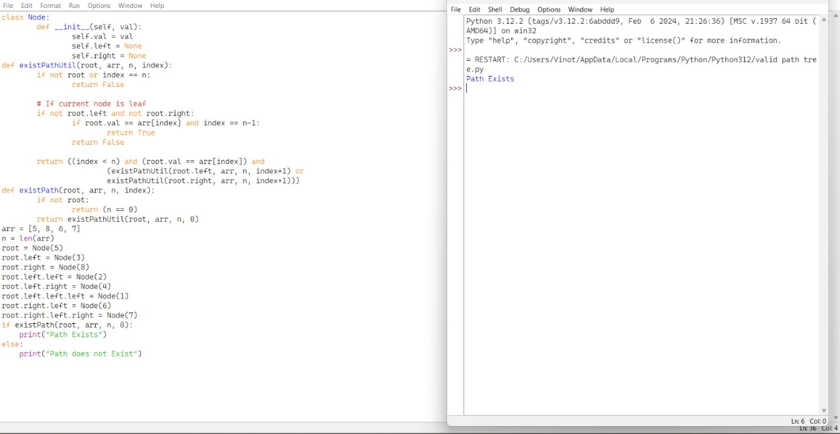

6.Kids With the Greatest Number of Candies

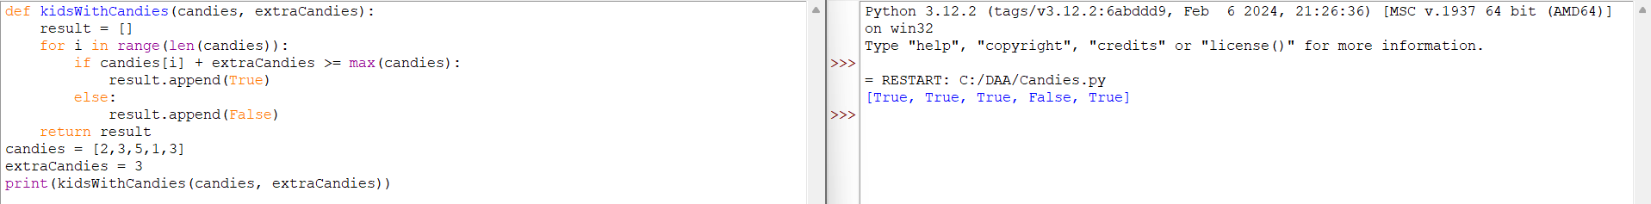

7.Max Difference You Can Get from Changing an Integer

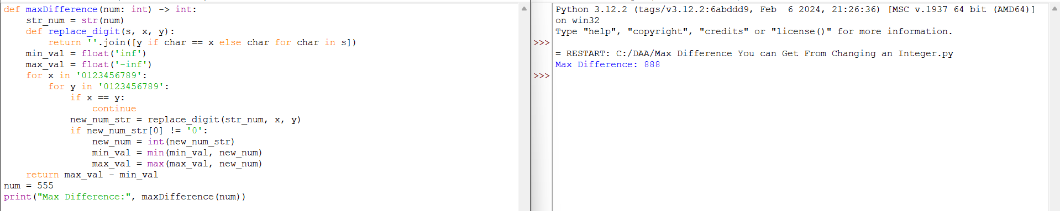

8.Check If a string Can Break Another String

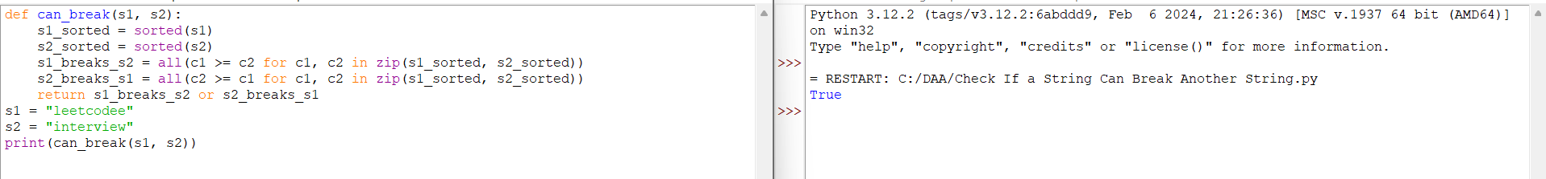

9.Number of Ways to Wear Different Hats To Each Other

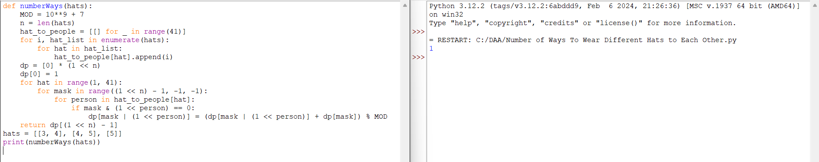

10.Next Permutation

