


Smart Parking System for Smart Cities

Prepared For Smart–Internz Internet of Things (IoT)

By
Manoj Mansing Chougule
D.Y. Patil Agriculture and Technical University, Talsande.

Skills Utilized
- HTML5
- CSS3
- JavaScript
- React.js
- Firebase Realtime Database
- Firebase Authentication
- Python Flask
- REST API Development
- NodeMCU ESP8266
- HC-SR04 Ultrasonic Sensor
- RC522 RFID Reader
- SG90 Servo Motor
- SSD1306 OLED Display
- QR Code Generation
- Git & GitHub
- IoT Integration
- Smart Dashboard Analytics

Project Overview
Smart Parking System for Smart Cities is an Internet of Things (IoT) based intelligent parking management solution designed to address parking congestion and inefficient parking utilization in urban areas.
The system provides real-time parking slot monitoring, RFID-based vehicle authentication, automatic gate control, smart parking slot allocation, EV charging management, QR-code ticket generation, parking reservation, vehicle entry and exit monitoring, revenue tracking, and dashboard analytics.
The project integrates IoT hardware devices such as NodeMCU ESP8266, Ultrasonic Sensors, RFID Readers, Servo Motors, OLED Displays, and cloud technologies including Firebase Realtime Database to create a centralized parking management platform.
The system enables drivers to check parking availability in real time, reserve slots, generate parking tickets, make payments, and access parking facilities efficiently while allowing administrators to monitor parking operations through a live dashboard.

Key Features
1. Real-Time Parking Slot Monitoring
Displays live availability of parking slots.
2. Smart Slot Allocation
Automatically assigns suitable parking slots.
3. RFID-Based Authentication
Allows authorized vehicle entry using RFID cards.
4. Automatic Gate Control
Opens and closes gates automatically using Servo Motors.
5. Parking Slot Reservation
Allows users to reserve parking spaces online.
6. QR Code Ticket Generation
Generates digital parking tickets with unique booking IDs.

7. Dynamic Parking Pricing
Calculates parking charges based on parking duration and occupancy.
8. EV Charging Management
Provides dedicated parking slots for electric vehicles.
9. Vehicle Entry & Exit Monitoring
Tracks vehicle movement in real time.
10. Dashboard Analytics
Provides occupancy statistics, revenue reports, and parking insights.
11. Firebase Cloud Integration
Synchronizes parking data instantly.
12. Multi-Floor Parking Management
Supports multiple parking floors and slot categories.
13. Revenue Management
Tracks parking revenue and transactions.
14. Smart Notifications
Provides alerts and booking confirmations.
15. IoT Device Monitoring
Monitors sensor and hardware status.

Architecture
Hardware Layer
- NodeMCU ESP8266
- HC-SR04 Ultrasonic Sensor
- RC522 RFID Reader
- SG90 Servo Motor

- SSD1306 OLED Display
- Buzzer
- RGB Status LEDs
Cloud Layer
- Firebase Realtime Database
- Firebase Authentication
Application Layer
- React Dashboard
- Parking Reservation System
- Analytics Panel
- QR Ticket Module
User Layer
- Vehicle Owner
- Parking Administrator
- Security Staff

Final Project Flow
1. Requirement Analysis
- Studied urban parking congestion problems.
- Identified need for smart parking management.
- Defined system objectives.
- Planned IoT-based parking monitoring.

2. User Interface Development
- Designed Smart Parking Dashboard.

- Created Reservation Module.
- Developed Analytics Panel.
- Implemented QR Ticket Interface.
- Developed Admin Monitoring Dashboard.

3. Firebase Integration
- Configured Firebase Realtime Database.
- Connected frontend with Firebase.
- Enabled real-time synchronization.
- Stored parking and booking information.

4. Parking Slot Monitoring Module
- Implemented live slot monitoring.
- Displayed FREE, BOOKED, OCCUPIED status.
- Updated slot status automatically using IoT sensors.

5. RFID Authentication Module
- Registered RFID cards.
- Verified vehicle authorization.
- Allowed secure parking access.

6. Smart Slot Allocation Module
- Assigned nearest available slot.
- Managed VIP slots.
- Managed EV charging slots.

- Prevented duplicate allocation.

7. Vehicle Booking Module
- Collected user details.
- Captured vehicle information.
- Validated reservation requests.
- Stored bookings in Firebase.

8. Parking Fee Calculation Module
- Calculated charges automatically.
- Applied dynamic pricing.
- Generated final bill.

9. QR Ticket Generation Module
- Generated unique booking IDs.
- Created QR Code tickets.
- Stored booking references.

10. EV Charging Module
- Allocated EV parking slots.
- Calculated charging duration.
- Calculated charging cost.
- Integrated charging billing.

11. Vehicle Entry and Exit Monitoring
- Counted incoming vehicles.
- Counted outgoing vehicles.
- Updated dashboard statistics.
- Managed gate operations.

12. Analytics Dashboard
- Parking Occupancy Analytics
- Revenue Analytics
- Vehicle Statistics
- Slot Utilization Reports
- Daily Reports
- Monthly Reports

13. GitHub Deployment
- Maintained source code repository.
- Managed version control.
- Documented project updates.

14. Testing and Validation
- Tested booking functionality.
- Tested RFID authentication.
- Tested QR generation.
- Tested Firebase synchronization.
- Tested dashboard responsiveness.

- Tested IoT device communication.

User Scenarios
Scenario 1: Parking Slot Reservation
User reserves parking slot, receives QR ticket, and confirms booking.
Scenario 2: RFID Vehicle Entry
User scans RFID card, system verifies authorization, gate opens automatically.
Scenario 3: Administrator Monitoring
Admin monitors occupancy, revenue, vehicle count, and parking status.
Scenario 4: EV Vehicle Parking
System allocates EV slot and tracks charging progress.
Scenario 5: QR Ticket Verification
User presents QR ticket, booking is verified, and access is granted.

Challenges Faced
- Firebase Realtime Database Integration
- RFID Communication
- Real-Time Sensor Data Synchronization
- Dynamic Pricing Logic
- EV Charging Calculations
- QR Code Generation
- Dashboard Analytics Design
- Multi-Floor Parking Management
- Responsive UI Development
- IoT Hardware Integration

Output Pages
- Home Dashboard
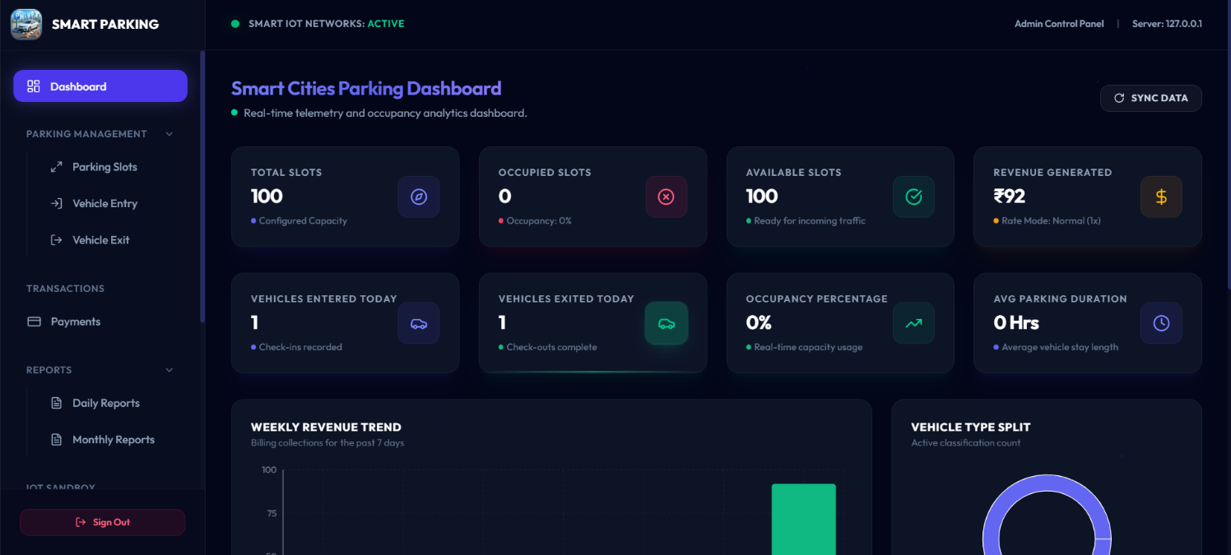
- Parking Slot Management
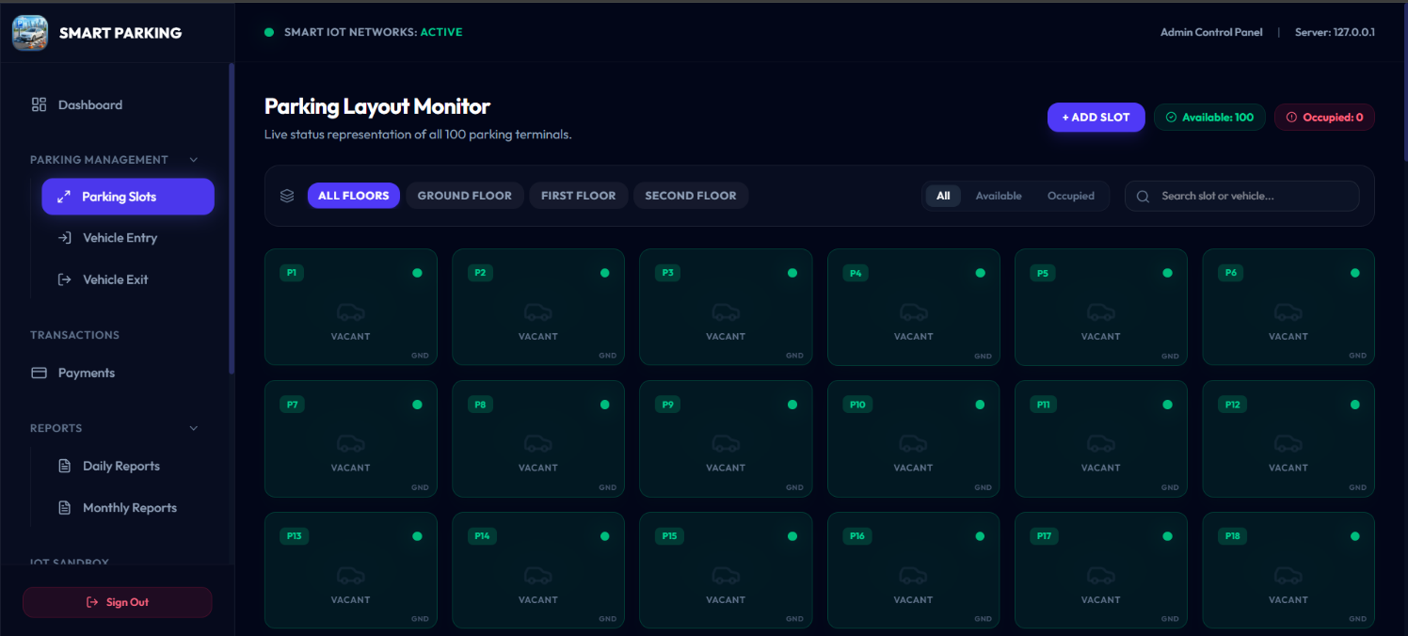

- Vehicle Entry Management
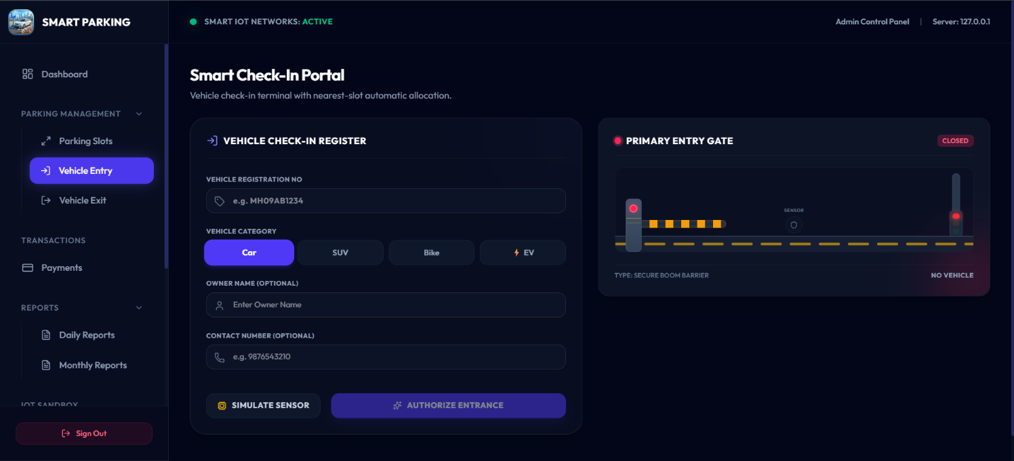
- Vehicle Exit Management
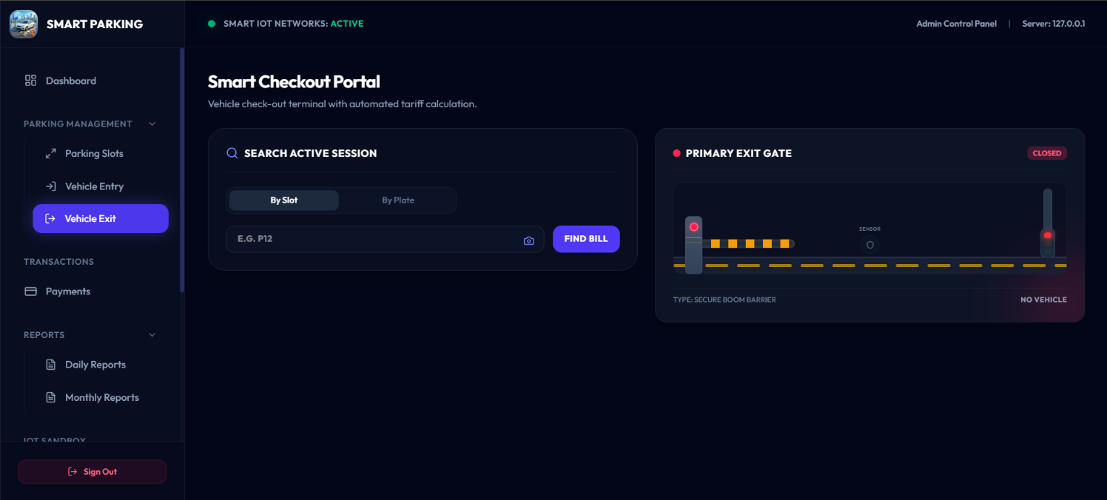

- Vertual IOT Node Management
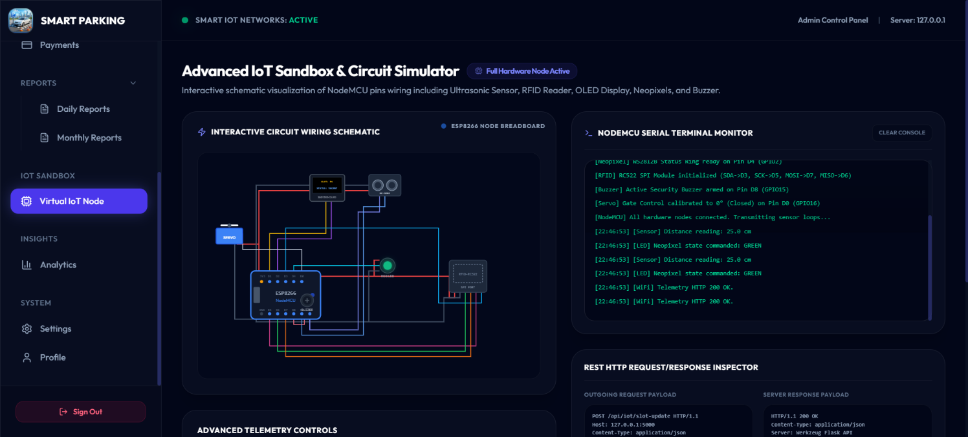

Conclusion
The Smart Parking System for Smart Cities successfully demonstrates the practical implementation of Internet of Things (IoT), cloud computing, and web technologies in solving real-world parking challenges.
The system provides real-time parking monitoring, RFID authentication, automatic gate control, parking reservation, QR ticket generation, dynamic pricing, EV charging management, and advanced analytics through a centralized dashboard.
By integrating Firebase Realtime Database, NodeMCU ESP8266, Ultrasonic Sensors, RFID technology, and modern web technologies, the project delivers an efficient, scalable, and smart parking solution suitable for future smart city infrastructure.

