- Prove that Cylindrical coordinate system is orthogonal
- Express the vector 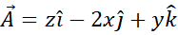 in cylindrical coordinates
- Express the vector 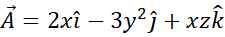 in cylindrical polar coordinates
- Prove that Spherical co ordinate system is orthogonal
- Express the vector 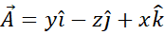 in spherical coordinate system and hence find

