

Department of Computer Applications MCA –A SECTION (Batch: 2023-2025)
Session: June 2025 to September 2025 PROJECT WORK – SYNOPSIS

TITLE OF THE PROJECT: | HomeEase
STUDENT NAME & SECTION: | MANOJKUMAR NAIK – ‘A’
REGISTRAYION NO: | 23P01061
GUIDE NAME: | DR. SHEETAL


HomeEase

Objectives:
- To develop a user-friendly platform that simplifies finding and booking home service professionals.
- To allow service providers to list their services, availability, and manage bookings.
- To create a secure and efficient booking system for both users and service providers.
- To maintain a record of bookings, feedback, and service history.
- To provide admin control over user and provider activities.

Introduction:
In today’s fast-paced world, people often struggle to find reliable and skilled professionals for home-related services. "HomeEase" is a web-based platform designed to bridge this gap by connecting users with verified service providers such as builders, painters, and interior designers. The system allows users to browse, book, and manage appointments for various home services, ensuring convenience and efficiency from the comfort of their homes.
Major Modules:
1. User Module
- Sign up/login
- Browse service providers
- Book appointments
- View booking history
- Post reviews/ratings


2. Service Provider Module
- Register and manage services
- Update availability
- Accept/decline bookings
- View customer feedback

3. Admin Module
- Manage users and providers
- Approve or remove listings
- Monitor overall system activity

4. Booking Module
- Appointment scheduling
- Time and date management
- Status tracking (Pending, Confirmed, Completed)

5. Search and Filter Module
- Filter by service category, rating, location, etc.



Hardware Requirements:
• Processor: Intel i3 or higher
• RAM: 4GB minimum (8GB recommended)
• Storage: 500GB HDD or 256GB SSD
• Internet: Required for server hosting or local testing with Django

Software Requirements:
• Operating System: Windows/Linux/MacOS
• Backend: Django (Python 3.9+)
• Frontend: HTML5, CSS3, JavaScript
• Database: SQLite (or MySQL/PostgreSQL for production)
• Server: Localhost (development) or cloud-based (Heroku, PythonAnywhere)
• Browser: Chrome/Firefox



System Workflow:
• User Registration/Login
• Browse Service Providers by Category
• Book a Service → Select Date/Time → Confirm
• Provider Reviews Booking → Accept/Reject
• Booking Status Updated → Notification to User
• After Service Completion → User Provides Feedback

System Architecture:
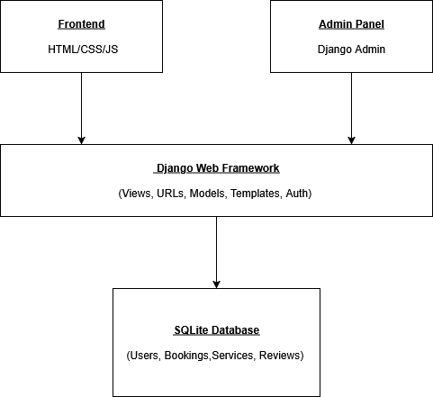



Future Enhancement/Scope:
• Add payment gateway integration for online payments.
• Integrate Google Maps API for real-time location-based service suggestions.
• Develop a mobile app version using React Native or Flutter.
• Implement chat system between users and service providers.
• Use AI to suggest best-fit professionals based on past bookings and reviews.

Conclusion:
"HomeEase" successfully provides a platform for users to easily find and book trustworthy home service professionals. It simplifies the entire service booking process, bringing all stakeholders under one digital roof. With scope for future enhancements, the platform is scalable and adaptable for real-world deployment.

Guide Signature Student Signature

