Software Requirements Specification (SRS)

Employee Management System

Modules Included:
Attendance Management Leave & Permission Management
Employee Handbook Reimbursement Management

Submitted By:
Manoj V

Submited To: HR - Sumitha Date :17-04-2026

CONTENTS

- Module 1: Attendance Management System 3
  - Purpose . . . . . . . . . . . . . . . . . . . . . . . . . . . . . . . . . . . . 3
  - Scope . . . . . . . . . . . . . . . . . . . . . . . . . . . . . . . . . . . . . 3
  - Role . . . . . . . . . . . . . . . . . . . . . . . . . . . . . . . . . . . . . . 3
  - Functional Requirements . . . . . . . . . . . . . . . . . . . . . . . . . . . 3
  - Business Rules . . . . . . . . . . . . . . . . . . . . . . . . . . . . . . . . 4
  - Workflow . . . . . . . . . . . . . . . . . . . . . . . . . . . . . . . . . . . 7
  - Attendance Table Representation . . . . . . . . . . . . . . . . . . . . . . 7
  - Non-Functional Requirements . . . . . . . . . . . . . . . . . . . . . . . . 8
  - Database Design Explanation . . . . . . . . . . . . . . . . . . . . . . . . 8
- Module 2: Leave & Permission Management 10
  - Purpose 10
  - Scope 10
  - Role 10
  - Functional Requirements 10
  - Business Rules 11
  - Workflow 13
  - Non-Functional Requirements 14
  - Database Design 15
  - Database Design Explanation 15
- Module 3: Reimbursement Management 17
  - Purpose 17
  - Scope 17
  - Role 17
  - Functional Requirements 17
  - Business Rules 18
  - Workflow 20
  - Additional Functional Requirements 21
  - Advanced Business Rules 22
  - Error Handling 23
  - Security Requirements 23
  - Audit and Logging 23
  - Reporting Features 23
  - Edge Case Handling 23
  - Future Enhancements 24
  - Non-Functional Requirements 24
  - Database Design Explanation 25
- Module 4: Employee Handbook Management 27
  - Purpose 27
  - Scope 27
  - Role 27
  - Functional Requirements 27
  - Business Rules 28
1
  - Workflow 29
  - Non-Functional Requirements 30
  - Database Design Explanation 31
- Module 5: Asset Management System 33
  - Purpose 33
  - Scope 33
  - Role 33
  - Functional Requirements 33
  - Business Rules 34
  - Workflow 35
  - Non-Functional Requirements 36
  - Database Design Explanation 37

2

MODULE 1: ATTENDANCE MANAGEMENT SYSTEM
Date: 17-04-2026

Purpose
The purpose of the Attendance Management System is to track employee working hours, attendance status, break durations, permission hours, and overtime while ensuring strict adherence to company policies.

Scope
This module handles employee check-in, check-out, break tracking, attendance classifica-tion (Present, Late, Leave, Absent), permission integration, and overtime calculation.

Role
- Employee
- HR/Admin
- Manager (for leave and permission approval)

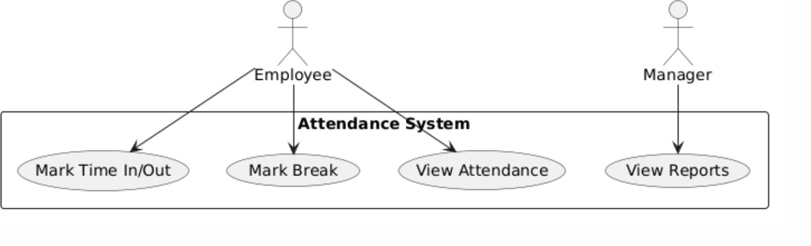

Figure 1: Attendance Use Case Diagram

Functional Requirements
- FR1: Employee shall be able to perform daily Time In (check-in).
- FR2: System shall record Time In for each working day.
- FR3: System shall determine attendance status based on Time In.
- FR4: Employee shall be able to start and end breaks.
- FR5: Employee shall be able to select break types (Lunch, Tea, etc.).
- FR6: System shall track break duration accurately.

3

- FR7: Employee shall be able to perform Time Out manually.
- FR8: System shall calculate total working hours.
- FR9: System shall calculate overtime based on valid Time Out conditions.
- FR10: System shall prevent automatic overtime calculation without valid Time Out.
- FR11: System shall mark Time Out as empty or ”-” if not recorded before midnight.
- FR12: System shall not calculate overtime if Time Out is missing.
- FR13: System shall finalize attendance data only after Time Out.
- FR14: System shall mark employee as Absent if both Time In and Time Out are missing.
- FR15: System shall mark employee as Leave if leave is approved for that day.
- FR16: System shall display permission hours details in attendance records.

Business Rules

BR1: Attendance Status Rule
      - If Time In is at or before 9:30 AM, status = Present.
      - If Time In is after 9:30 AM, status = Late.
      - If employee has approved leave, status = Leave.
      - If both Time In and Time Out are missing and no leave exists, status = Absent.

BR2: Break Management Rule
      - Employee must select a break type before starting a break.
      - System shall allow Start Break and End Break actions.
      - Break duration shall be calculated as the difference between start and end time.

BR3: Overtime Calculation Rule
      - Overtime shall only be calculated if Time Out is manually recorded.
      - Time Out must be recorded before 12:00 AM (midnight) of the same day.
      - If Time Out is after midnight or missing, overtime shall not be calculated.

4

BR4: Missing Time Out Rule (Dash Rule)
      - If employee does not perform Time Out before midnight:
        - Time Out field shall remain empty or display ”-”.
        - No overtime shall be calculated.
        - System shall not auto-generate Time Out.

BR5: Leave Priority Rule
      - If leave is approved for a day, system shall mark status as Leave.
      - Leave status overrides Present, Late, and Absent.

BR6: Permission Integration Rule
      - Approved permission hours shall be included in attendance.
      - Permission details must be displayed in attendance records.
      - Permission can adjust Late status if it covers late duration.

BR7: End of Day Rule
      - Every workday must be completed with a manual Time Out.
      - Only after Time Out, the system shall finalize:
        - Total working hours
        - Break duration
        - Overtime (if applicable)

5


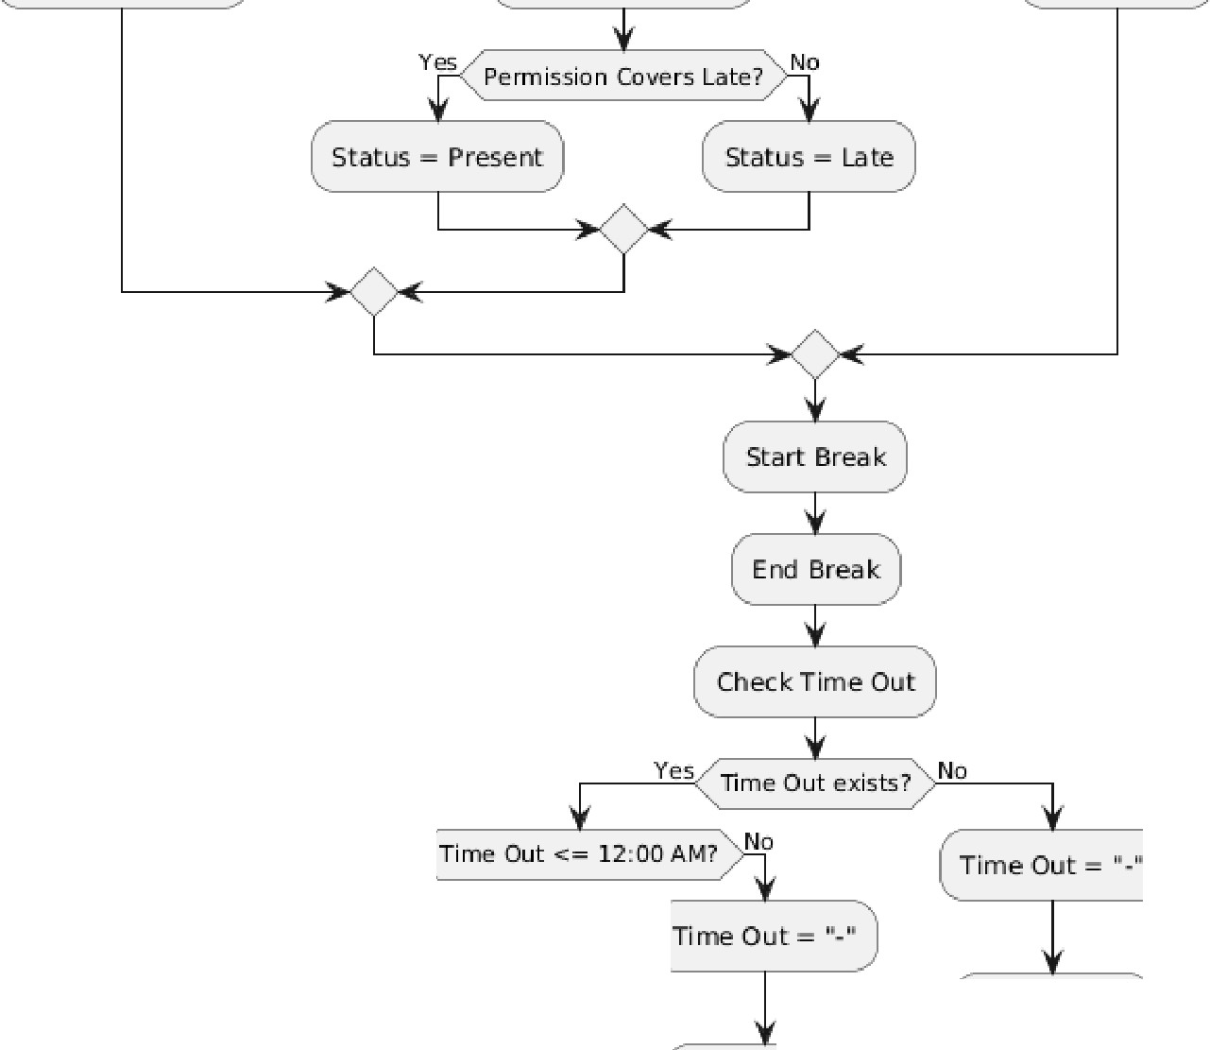
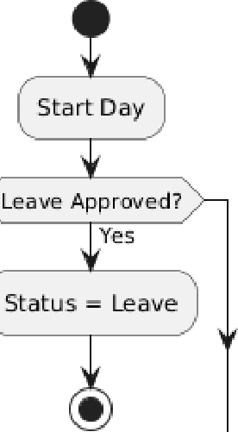
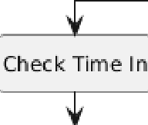
�---------Y_e---<5 Time In ex:ists? ,N_□ �

Yes Time In <= 9:30 AM? �N_o _ Yes Time Out exists? No

Statu.s = Present Check Permission lnva,Iid Case Starns. = Absent

Yes

Calculate Working Hours

No Overtime


Calculate Br,eak Duration No Overtime

Calculate Overtime

Sa11e Attendance Record
•
Figure 2: Attendance Activity Diagram

6

Workflow
- Employee logs into the system.
- If leave is approved:
  - Mark status as Leave.
- Else if no Time In and no Time Out:
  - Mark status as Absent.
- Else:
  - Employee performs Time In.
  - System checks late condition.
  - If permission exists, adjust status accordingly.
- Employee may start and end breaks.
- Employee performs Time Out before midnight.
- System calculates:
  - Total working hours
  - Break duration
  - Overtime (if valid)
- If Time Out is not recorded:
  - Time Out is marked as ”-”
  - No overtime is calculated

Attendance Table Representation
- Date
- Time In
- Time Out
- Break Duration
- Permission Hours
- Total Working Hours
- Overtime
- Status (Present / Late / Leave / Absent)

7

Non-Functional Requirements
- Performance: System should process attendance actions in real-time.
- Reliability: Attendance data must be accurate and consistent.
- Security: Only authenticated users can access attendance data.
- Usability: Interface should be simple and easy to use.
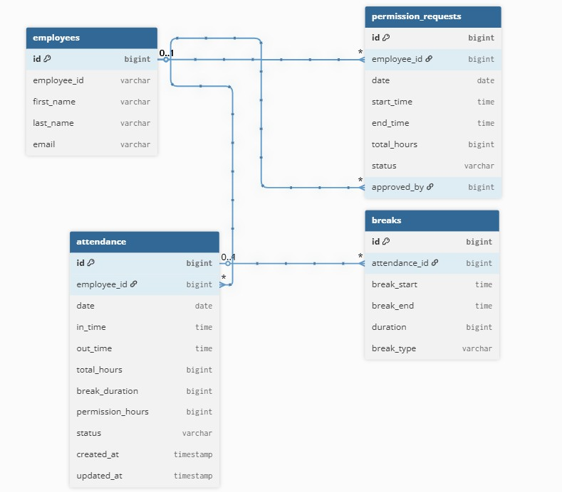
Figure 3: Attendance Database Diagram

Database Design Explanation
The Attendance module uses a relational database to track employee daily attendance, break details, and permission hours.

Employees
Stores employee details. It is used to link attendance records with each employee.

Attendance
Stores daily attendance records including date, time in, time out, total working hours, break duration, permission hours, and status (Present, Late, Leave, Absent, LOP).

8

Breaks
Stores break details for each attendance record. It includes break start time, end time, duration, and type (Lunch, Tea). One attendance record can have multiple breaks.

Permission Integration
Permission hours from the permission module are stored in the attendance table and used in working hour calculations and late adjustment.

Relationships
      - One employee can have multiple attendance records.
      - One attendance record can have multiple break records.
      - Attendance is linked with permission data for accurate time calculation.

9

MODULE 2: LEAVE & PERMISSION MANAGEMENT
Date: 17-04-2026

Purpose
The Leave & Permission Management module enables employees to request and track leave and permission, ensures compliance with leave entitlement policies based on tenure, automates approval workflows, tracks leave balances with LOP (Loss of Pay) calculation, and integrates with the Attendance module.

Scope
This module includes leave request submission, approval workflows, leave balance track-ing, permission management, holiday configuration, and attendance synchronization.

Role
- Employee
- Manager / Approver
- HR/Admin

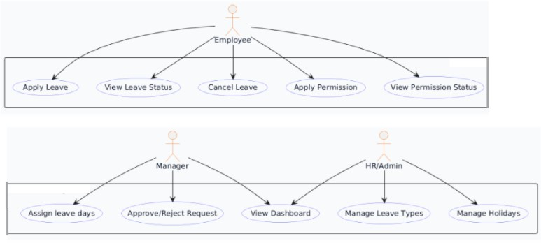

Figure 4: Leave & Permission Use Case Diagram

Functional Requirements

Leave Management
      - FR1: Employee shall apply leave by selecting leave type, date range, and reason.
      - FR2: System shall prevent overlapping leave requests.

10

      - FR3: System shall calculate total leave days.
      - FR4: System shall classify leave into Paid or LOP.
      - FR5: Employee shall view leave balance (total, used, remaining).
      - FR6: Manager shall approve/reject leave with remarks.
      - FR7: System shall create attendance records after approval.
      - FR8: Employee shall cancel leave (Pending/Approved only).
      - FR9: System shall remove attendance records on cancellation.

Permission Management
      - FR10: Employee shall apply permission with start and end time.
      - FR11: System shall validate time (end ¿ start).
      - FR12: System shall calculate permission duration in minutes.
      - FR13: Manager shall approve/reject permission.
      - FR14: Approved permission shall update attendance.permission hours.
      - FR15: Employee shall view permission status.

Manager Dashboard
      - FR16: Manager shall view all leave and permission requests.
      - FR17: Manager shall filter requests by status.
      - FR18: Manager shall view employee-wise leave statistics.
      - FR19: System shall display timestamps for approval/rejection.

Holiday Management
      - FR20: HR/Admin shall create holidays.
      - FR21: Holidays shall be excluded from leave calculations.
      - FR22: Employees shall view holiday calendar.

Business Rules

BR1: Provisional Period Rule
      - First 6 months: 1 leave per month.
      - No carry forward.
      - Unused leave expires monthly.

11

BR2: Permanent Period Rule
      - After 6 months: 1.5 leaves per month.
      - Leaves accumulate within company year (April to March).
      - Leave resets at end of company year.

BR3: Leave Allocation Rule
      - Allocation calculated at approval time.
      - Extra leave marked as LOP.

BR4: LOP Rule
      - LOP does not consume paid balance.
      - Attendance marked as LOP.

BR5: Leave Cancellation Rule
      - Only Pending or Approved leave can be canceled.
      - Attendance records removed on cancellation.

BR6: Permission Rule
      - Permission duration = end time - start time.
      - Approved permission updates attendance.
      - Permission may override late marking.

BR6: Planned vs Unplanned Leave Rule
      - Planned Leave: Used for advance planning. The system shall display a warning if the leave start date is less than 5 days from the current date.
      - Unplanned Leave: Used for emergency situations. No advance notice is required.
      - Only Planned and Unplanned leave types are allowed for application in the system.
      - Additional leave types may be configured by Admin for future use.

BR7: Leave Cancellation Rule
      - Employee may cancel leave only if status is Pending or Approved.
      - Canceled leave requests may be re-applied.
      - If an Approved leave is canceled:
        - System shall remove auto-generated attendance records (Leave/LOP).
        - Manual attendance records (with in time already recorded) shall not be re-moved.

12

BR7: Approval Workflow Rule
      - Employee submits request → Pending.
      - Manager approves → Approved.
      - Manager rejects → Rejected.

BR8: No Manual Edit Rule
      - Employees cannot edit requests after submission.
      - Managers cannot modify after approval.

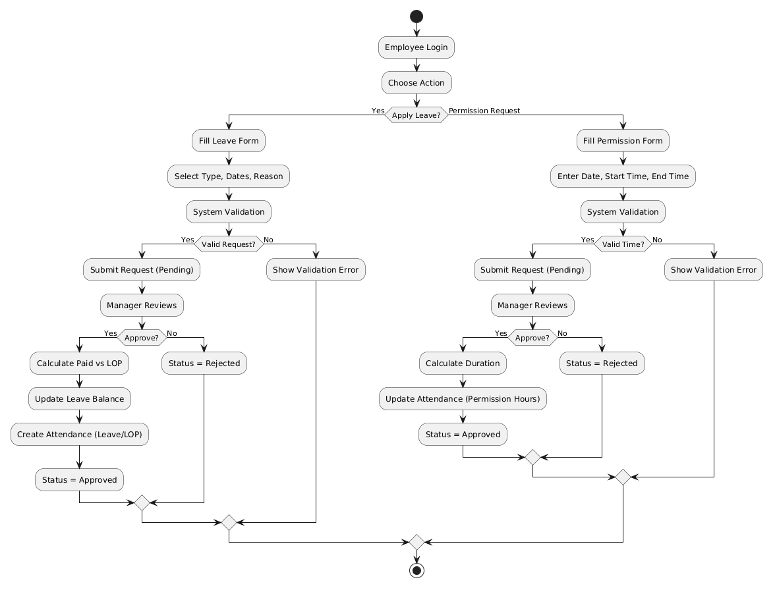

Figure 5: Leave & Permission Activity Diagram

Workflow

Leave Workflow
- Employee applies leave.

13

- System validates request.
- Manager reviews request.
- Manager approves/rejects.
- System updates attendance and balance.

Permission Workflow
- Employee applies permission.
- System validates timing.
- Manager approves/rejects.
- System updates attendance.

Non-Functional Requirements
- Performance: Response within 1-2 seconds.
- Security: JWT authentication and role-based access.
- Scalability: Support thousands of employees.
- Usability: Simple and intuitive interface.

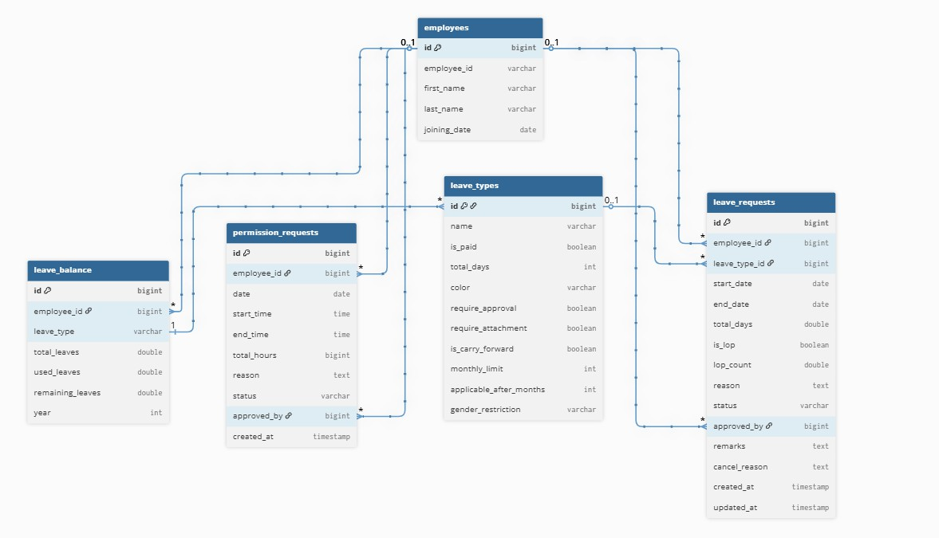

Figure 6: Leave & Permission Database Diagram 14

Database Design

leavetypes
      - id (PK)
      - name
      - is paid
      - total days
      - color
      - applicable after months

Database Design Explanation
The Leave and Permission module uses a relational database to manage leave requests, permissions, balances, and holidays.

Employees
Stores employee details including joining date, which is used for leave eligibility calcula-tion.

Leave Types
Defines different leave categories such as Casual, Sick, and LOP with rules like paid/unpaid and eligibility.

Leave Requests
Stores all leave applications with details like dates, status, and approval information. It is used for leave tracking and LOP calculation.

Leave Balance
Maintains employee leave balance including total, used, and remaining leaves based on company rules.

Permission Requests
Stores short-duration permission requests with start time, end time, and approval status. Approved permissions are linked to attendance.

Holidays
Stores government and company holidays, which are excluded from leave and attendance calculations.

15

Relationships
      - One employee can have multiple leave requests.
      - One employee can have multiple permission requests.
      - Each leave request is linked to a leave type.

16

MODULE 3: REIMBURSEMENT MANAGEMENT
Date: 17-04-2026

Purpose
The Reimbursement Management module enables employees to submit reimbursement claims with multiple expense categories such as lodging, food, and others. It supports advance tracking, bill upload with preview, and a structured approval workflow handled by HR Admin.

Scope
This module includes claim submission, multi-category expense tracking, approval work-flow, claim history, and analytics dashboard.

Role
- Employee
- HR Admin
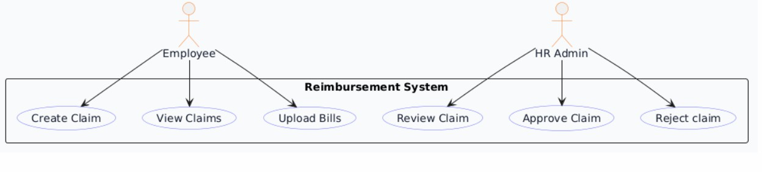
Figure 7: Reimbursement Use Case Diagram

Functional Requirements

Claim Submission
      - FR1: Employee shall create a reimbursement claim with reason, travel dates, and advance amount.
      - FR2: System shall support multiple expense categories (lodging, food, others).
      - FR3: System shall allow submission even if only one category is filled.
      - FR4: System shall set claim status as Pending at submission.
      - FR5: System shall auto-set submission date.
      - FR6: System shall calculate total claimed amount.
      - FR7: System shall calculate return amount as:
17

– amount to return = advance amount - total amount claimed
      - FR8: Employee shall preview uploaded bills before submission.

Category Calculations
      - FR9: Lodging amount = days × persons × rate.
      - FR10: Food total = morning + afternoon + evening + night.
      - FR11: Other expenses are directly stored.

Claim Visibility
      - FR12: Employee shall view own claims.
      - FR13: Employee shall view claim details.
      - FR14: HR Admin shall view all claims.
      - FR15: HR Admin shall view claim summary list.

Approval Workflow
      - FR16: HR Admin shall approve claim with approved amount.
      - FR17: HR Admin shall mark claim as Recheck with reason.
      - FR18: System shall maintain statuses: Pending, Approved, Recheck.
      - FR19: Employee shall view final status and remarks.

Deletion
      - FR20: Claim deletion allowed only in Pending status.
      - FR21: System shall block deletion for processed claims.

Analytics
      - FR22: System shall provide dashboard metrics (total, pending, approved, recheck).
      - FR23: System shall provide category-wise expense breakdown.
      - FR24: System shall provide monthly trends.
      - FR25: System shall provide status distribution.

Business Rules

BR1: Initial Status
      - Every claim starts with status Pending.

18

BR2: Claim Ownership
      - Claims are linked to logged-in employee only.

BR3: Calculation Integrity
      - Backend recalculates lodging and food totals.

BR4: Total Calculation
      - Total amount = sum of all category amounts.

BR5: Return Amount
      - Positive value → employee returns money.
      - Negative value → company pays employee.

BR6: Approval Rule
      - Approval allowed only when status is Pending.
      - Approved status must include approved amount.

BR7: Recheck Rule
      - Recheck must include reason.
      - Approved amount must not be set.

BR8: Deletion Rule
      - Only Pending claims can be deleted.

BR9: Role-Based Access
      - Employee → own claims only.
      - HR Admin → all claims.

19

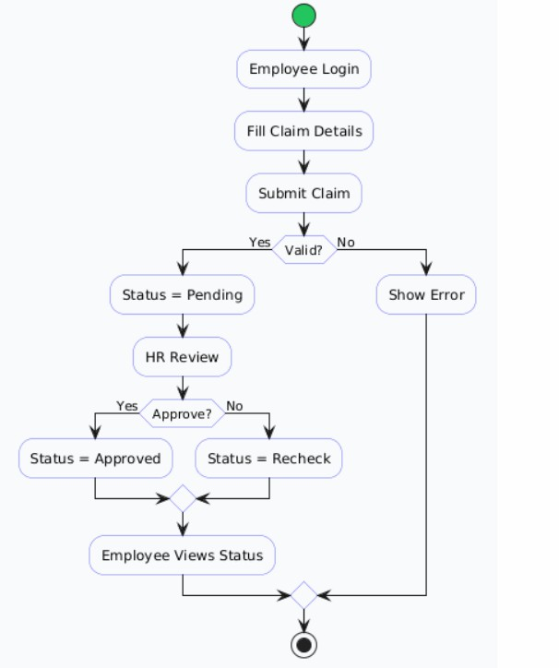

Figure 8: Reimbursement Activity Diagram

Workflow

Claim Submission
- Employee enters claim details.
- Employee adds expense categories.
- Employee uploads bills.
- System calculates totals.
- Claim saved as Pending.

20

Approval Flow
- HR Admin reviews claim.
- HR Admin approves or marks recheck.
- System updates status.
- Employee views result.

Cancellation
- Employee cancels Pending claim.
- System deletes claim.

Analytics Flow
- HR Admin opens dashboard.
- System loads summary and charts.
- Filters applied.
- Data displayed.

Additional Functional Requirements

Validation Rules
      - System shall ensure all mandatory fields are filled before submission.
      - System shall validate that travel end date is greater than or equal to travel start date.
      - System shall ensure at least one expense category is added before submission.
      - System shall validate that all numeric values (amount, rate, days) are greater than zero.
      - System shall restrict invalid file formats for bill uploads (only PDF, JPG, PNG allowed).

File Handling
      - System shall allow multiple file uploads per claim.
      - System shall support preview of uploaded images before submission.
      - System shall store file references securely.
      - System shall allow HR Admin to preview files during review.

21

Status Tracking
      - System shall maintain claim lifecycle with statuses: Pending, Approved, Recheck.
      - System shall record timestamps for each status change.
      - System shall store admin remarks for Approved or Recheck states.

Notification System
      - System shall notify HR Admin when a new claim is submitted.
      - System shall notify employee when claim status is updated.
      - Notifications may be shown via UI alerts or email (optional).

Search and Filtering
      - HR Admin shall filter claims by employee, project, status, and date range.
      - Employee shall search claims based on date or status.
      - System shall support sorting based on submission date and amount.

Advanced Business Rules

BR10: Duplicate Prevention Rule
      - System shall prevent duplicate claim submissions for the same date range and rea-son.

BR11: Partial Approval Rule
      - HR Admin may approve a claim with an amount lower than total claimed.
      - Difference amount shall not be automatically adjusted; only approved amount is final.

BR12: Mandatory Proof Rule
      - If bill available flag is true, corresponding file must be uploaded.
      - Claims without required proof may be marked for recheck.

BR13: Read-Only After Approval
      - Once claim is Approved or Recheck, employee cannot edit the claim.

BR14: Data Consistency Rule
      - All calculated fields must be derived from backend logic only.
      - Frontend values must not override backend calculations.

22

Error Handling
- System shall return validation error messages for invalid input.
- System shall prevent submission if required fields are missing.
- System shall handle file upload errors gracefully.
- System shall display meaningful error messages to users.

Security Requirements
- All APIs shall be protected using JWT authentication.
- Role-based access control shall restrict operations.
- Employees shall not access other employees’ claims.
- Sensitive data such as file attachments shall be securely stored.

Audit and Logging
- System shall log all claim submissions.
- System shall log approval and recheck actions.
- System shall maintain audit trail for admin actions.

Reporting Features
- System shall allow export of claim data in Excel or CSV format.
- HR Admin shall generate reports based on filters.
- Reports shall include claim summary and detailed breakdown.

Edge Case Handling
- If advance amount is zero, system shall still process claim normally.
- If total claimed amount is zero, claim shall not be submitted.
- If employee submits large number of items, system shall handle without performance degradation.
- If no category entries exist, submission shall be blocked.

23

Future Enhancements
- OCR-based bill reading.
- AI-based fraud detection.
- Integration with payroll system.
- Mobile app support.
- Multi-level approval workflow.

Non-Functional Requirements
- Performance: Response within 2–3 seconds.
- Security: JWT authentication and role-based access.
- Data Integrity: Backend validation for calculations.
- Scalability: Support large number of claims.
- Usability: Easy form entry and clear dashboards.

24

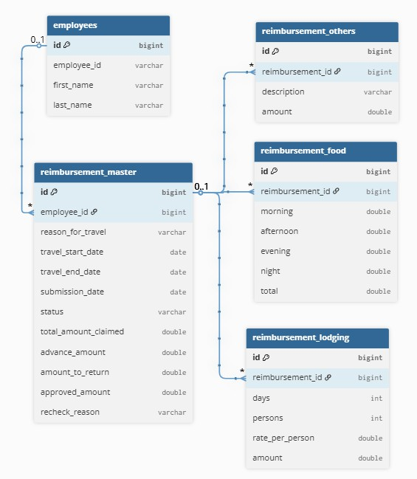
Figure 9: Reimbursement Database Diagram

Database Design Explanation
The Reimbursement module uses a relational database to manage claims and expense details.

Employees
Stores employee information. It is used to link claims with employees.

Reimbursement Master
Stores main claim details such as travel information, total claimed amount, advance amount, and status (Pending, Approved, Recheck).

25

Reimbursement Lodging
Stores lodging expenses including number of days, persons, and calculated amount.

Reimbursement Food
Stores food expenses including meal-wise cost and total amount.

Reimbursement Others
Stores additional expenses with description and amount.

Relationships
      - One employee can have multiple reimbursement claims.
      - One claim can have multiple expense entries (lodging, food, others).

26

MODULE 4: EMPLOYEE HANDBOOK MANAGEMENT
Date: 17-04-2026

Purpose
The Employee Handbook module provides a centralized system where employees can view company policies, and HR/Admin can create, update, and manage these policies with version control.

Scope
This module includes policy creation, editing, version tracking, employee read-only access, and policy archiving.

Role
- Employee
- HR/Admin
- System
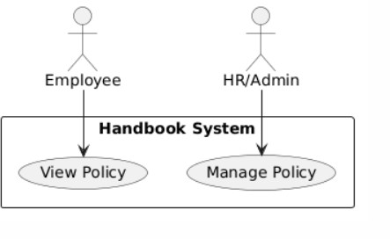

Figure 10: Handbook Use Case Diagram

Functional Requirements

Policy Management
      - FR1: HR/Admin shall create policies with title and content.
27

      - FR2: System shall allow optional description.
      - FR3: System shall assign default version as 1.0.
      - FR4: System shall store policy status as ACTIVE.
      - FR5: HR/Admin shall update policy content.
      - FR6: System shall maintain version history.
      - FR7: System shall increment version on content change.

Policy Access
      - FR8: Employees shall view only ACTIVE policies.
      - FR9: Employees shall view policy details in read-only mode.
      - FR10: HR/Admin shall view all policies including archived ones.

Policy Archive
      - FR11: HR/Admin shall archive policies.
      - FR12: Archived policies shall not be visible to employees.
      - FR13: Archived policies remain in database for reference.

Notifications
      - FR14: System shall notify employees on policy creation.
      - FR15: System shall notify employees on policy updates.

Business Rules

BR1: Access Control
      - Employees have read-only access.
      - Only HR/Admin can create, edit, or archive policies.

BR2: Policy Status
      - Status values are ACTIVE and ARCHIVED.
      - Only ACTIVE policies are visible to employees.

BR3: Version Rule
      - Initial version is 1.0.
      - Version increments on content updates.

28

BR4: Version History
      - Every update creates a new version record.

BR5: Archive Rule
      - Archive is a soft delete.
      - Archived policies remain available for admin reference.

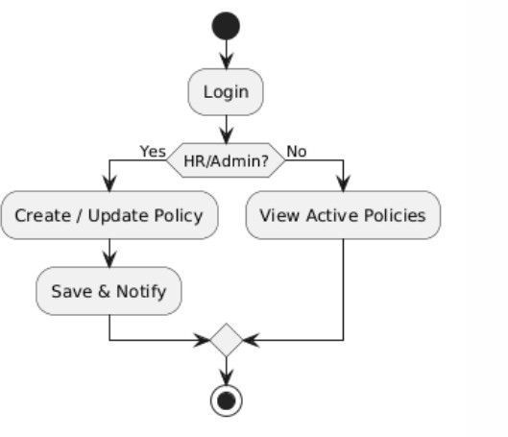

Figure 11: Handbook Activity Diagram

Workflow

Policy Creation
- HR/Admin creates policy.
- System saves policy as ACTIVE.
- System creates version record.
- System sends notification.

29

Policy Update
- HR/Admin edits policy.
- System updates content.
- System increments version.
- System stores version history.

Policy Viewing
- Employee opens handbook.
- System displays ACTIVE policies.
- Employee views content in read-only mode.

Policy Archive
- HR/Admin selects policy.
- System updates status to ARCHIVED.
- Policy is hidden from employees.

Non-Functional Requirements

Performance
      - Policy retrieval should be fast (within 1 second).

Security
      - JWT authentication required.
      - Role-based access enforced.

Usability
      - Policies should be easy to read.
      - UI should support scrolling and full view.

Scalability
      - System should support multiple policies and versions.

30

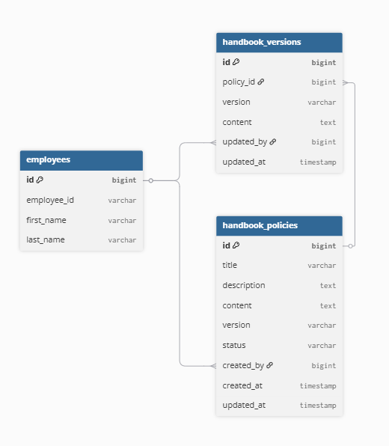

Figure 12: Handbook Database Diagram

Database Design Explanation
The Employee Handbook module uses a simple relational structure to manage policies and their version history.

Employees
Stores employee details. It is used to track which HR/Admin created or updated policies.

Handbook Policies
Stores the main policy data including title, content, version, and status (ACTIVE or ARCHIVED). Only active policies are visible to employees.

31

Handbook Versions
Stores version history of each policy. Every update creates a new version record with updated content and version number.

Relationships
      - One employee can create multiple policies.
      - One policy can have multiple version records.
      - Version updates are linked to employees who performed the changes.

32

MODULE 5: ASSET MANAGEMENT SYSTEM
Date: 18-04-2026

Purpose
The Asset Management module is designed to manage organizational assets such as lap-tops, desktops, and air conditioning units. It enables tracking of asset details, employee assignment, and maintenance schedules in a centralized system.

Scope
This module includes asset creation, asset assignment to employees, maintenance/service tracking, and reporting. The system ensures accurate tracking of asset usage and condi-tion.

Role
- System Admin
- HR (View Only)

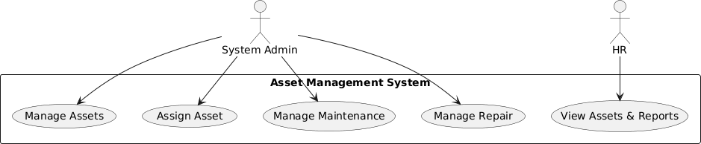

Figure 13: Asset Management Use Case Diagram

Functional Requirements

Asset Management
      - FR1: System Admin shall create and add new assets.
      - FR2: System Admin shall update asset details.
      - FR3: System Admin shall delete assets.
      - FR4: System shall store asset details such as asset code, type, make, model, and specifications.
      - FR5: System shall display asset status (In Use, Available, Under Maintenance).

33

Asset Assignment
      - FR6: System Admin shall assign assets to employees.
      - FR7: System shall store employee details linked to assets.
      - FR8: System shall allow updating or reassigning assets.
      - FR9: System shall display which employee is assigned to each asset.

Maintenance Management
      - FR10: System Admin shall create maintenance schedules for assets.
      - FR11: System shall store planned service dates.
      - FR12: System Admin shall update actual service dates.
      - FR13: System shall track maintenance status (Pending, Completed, Issue).
      - FR14: System shall display maintenance data in a table format similar to the provided template.

View Access (HR)
      - FR15: HR shall view all asset details.
      - FR16: HR shall view asset assignment information.
      - FR17: HR shall view maintenance schedules and status.
      - FR18: HR shall not be allowed to create, edit, or delete data.

Dashboard
      - FR19: System shall display summary information such as total assets, in-use assets, and maintenance status.

Business Rules

BR1: Asset Code Rule
      - Each asset must have a unique asset code.

BR2: Assignment Rule
      - One asset can be assigned to only one employee at a time.

BR3: Maintenance Rule
      - Each asset can have multiple maintenance records.
      - Planned and actual dates must be tracked.

34

BR4: Role-Based Access
      - System Admin has full access.
      - HR has read-only access.

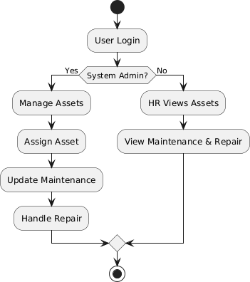

Figure 14: Asset Management Activity Diagram

Workflow

Asset Creation
- Admin adds asset details.
- System saves asset.

Asset Assignment
- Admin selects asset.

35

- Admin assigns to employee.
- System updates assignment.

Maintenance Tracking
- Admin creates maintenance schedule.
- Admin updates actual service date.
- System updates status.

Non-Functional Requirements
- Performance: System should respond within 2–3 seconds.
- Security: JWT authentication with role-based access.
- Data Integrity: All asset and maintenance data must be accurate and validated.
- Scalability: System should support increasing assets and users.
- Usability: Interface should be simple and similar to the given template.

36

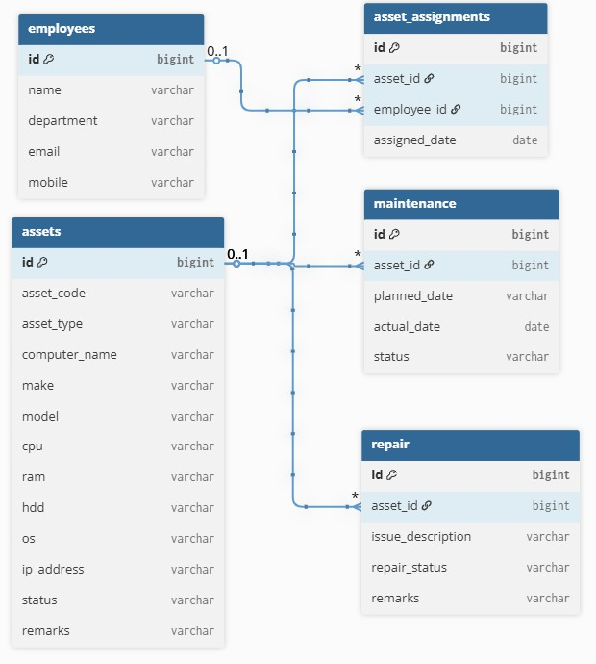

Figure 15: Asset Management Database Diagram

Database Design Explanation
The Asset Management module follows a structured relational design.

Assets
Stores asset details such as asset code, type, specifications, and status.

Asset Assignment
Stores mapping between assets and employees.

37

Maintenance
Stores maintenance schedule including planned and actual dates.

Relationships
      - One asset can have one active assignment.
      - One asset can have multiple maintenance records.

38

