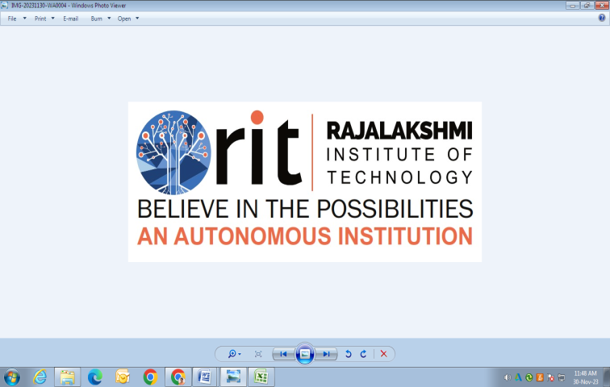
RAJALAKSHMI INSTITUTE OF TECHNOLOGY
(An Autonomous Institution, Affiliated to Anna University, Chennai)

DEPARTMENT OF ARTIFICIAL INTELLIGENCE AND DATA SCIENCE
ACADEMIC YEAR 2025 - 2026
SEMESTER III
ARTIFICIAL INTELLIGENCE LABORATORY
MINI PROJECT REPORT

REGISTER NUMBER | 2117240070180
NAME | Manoj Kumar
PROJECT TITLE | Flappy Bird with AI Agent using Reinforcement Learning
DATE OF SUBMISSION
FACULTY IN-CHARGE | Ms . Phebe Persis

Signature of Faculty In-charge

INTRODUCTION
This project is about creating an intelligent computer program that can play the Flappy Bird game on its own.
It uses Reinforcement Learning (RL) — a type of Artificial Intelligence where an agent learns by interacting with an environment and improving through rewards and penalties.
In the Flappy Bird game, the bird must pass through gaps between pipes without hitting them. This requires proper timing and quick decisions.
The AI agent learns the correct timing for flapping to stay alive and score more points, similar to how a human learns through practice.
PROBLEM STATEMENT
To develop an AI agent that can play Flappy Bird automatically using the Proximal Policy Optimization (PPO) algorithm.
The agent should learn by trial and error, improving its performance and surviving longer after each training session.
GOAL
The main goal is to train a reinforcement learning agent that learns from its mistakes and achieves stable gameplay — flying through pipes with fewer collisions and higher scores.
THEORETICAL BACKGROUND
Flappy Bird is modeled as a Markov Decision Process (MDP) where:
- State: Bird’s position, velocity, and distance from the next pipe
- Action: Flap or not flap
- Reward: +1 for every pipe passed, −1 for hitting a pipe or ground
Algorithm Used — PPO (Proximal Policy Optimization):
PPO is a reinforcement learning algorithm that improves the agent’s decisions step-by-step.
It is more stable and efficient than older algorithms like Q-learning.
PPO controls the size of updates, which helps the agent learn smoothly without losing past progress.
Why PPO was chosen:
- It gives stable and consistent learning.
- Works well for continuous and dynamic games.
- Has been successfully used in other AI game projects.
ALGORITHM EXPLANATION WITH EXAMPLE
- Start the game and initialize the PPO model.
- The agent observes the bird’s position, velocity, and the next pipe distance.
- It decides whether to flap or not.
- Based on the result, it gets a reward or penalty.
- PPO updates the learning policy using this feedback.
- This process repeats for many games until the agent learns to play efficiently.
Example:
At first, the bird keeps crashing.
After several rounds of training, it learns when to flap and avoids pipes, resulting in a higher score.
IMPLEMENTATION AND CODE
Language: Python
Libraries Used: Pygame, Gymnasium, Stable-Baselines3, Torch, NumPy
Main Files:
- flappy.py – Defines the game environment
- train_agent.py – Used for training the PPO model
- play_agent.py – Runs the trained model to play the game
GitHub Repository:
🔗https://github.com/manoj2577/flappy_bird.git
OUTPUT :
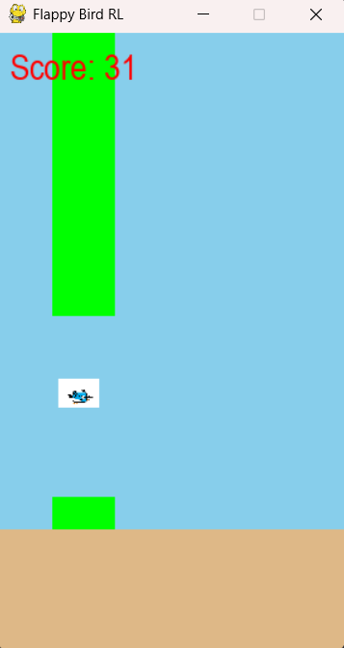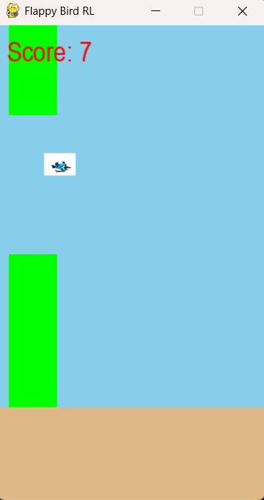
RESULTS AND FUTURE ENHANCEMENT
Results:
- The PPO agent successfully learns the timing and movement needed to survive longer.
- The trained model achieves scores above 20+ after proper training.
- The AI shows visible improvement compared to its early attempts.
Future Enhancements:
- Try other algorithms like Deep Q-Learning (DQN) or A3C for comparison.
- Use CNNs to train directly from images instead of raw values.
- Add difficulty levels, improved visuals, and background music.
- Create multi-agent training for competition between AIs.

Git Hub Link of the project and report | 🔗 https://github.com/manoj2577/flappy_bird.git
REFERENCES
- • Sutton, R. S., & Barto, A. G. (2018). Reinforcement Learning: An Introduction. MIT Press.
- • Schulman, J., Wolski, F., Dhariwal, P., Radford, A., & Klimov, O. (2017). Proximal Policy Optimization Algorithms. arXiv:1707.06347.
- • Stable-Baselines3 Documentation – https://stable-baselines3.readthedocs.io
- • Gymnasium (OpenAI Gym) – https://gymnasium.farama.org
- • Pygame Official Documentation – https://www.pygame.org/docs/

