


571-294-6997

manoj0134@gmail.com

Manoj S. Kommagiri
Columbus, OH
SUMMARY
- An expert data and Web development professional with over 13yrs experience and an impeccable record of developing and delivering data driven applications and business intelligence analytics with expertise in business intelligence, Reporting, Full stack Web Development, Data analysis, ETL (SSIS) processes and data modeling and Cloud Engineering.

HIGHLIGHTS OF QUALIFICATIONS
- Dedicated IT professional with years of expertise in software Development, business analysis, database development, and reporting, primarily across the MS SQL server suite of products for business and financial decision-making.
- Demonstrated success in all aspects of enterprise-wide analytics architecture including data integration, data modeling, and data management, combined with skills in SQL server ETL/reporting tools like SSRS and SSIS.
- Proficient in developing Full Stack Applications and API’s and Reporting Solutions to democratize the data across the organization.
- Utilize Solid design principles and cutting-edge technologies, providing guidance on technology choices per project, taking ownership and working across the full stack.
- Experienced in developing data integration, workflow, and ETL solutions for data warehousing using SSIS.
- Proficient in data structures and fact tables from a variety of systems, including proprietary SQL data tables.
- Competent in dimensional and relational modeling techniques, facilitating informed business decisions.
- Strong quantitative, analytical, critical thinking, and problem-solving skills with exceptional attention to detail.

CORE COMPETENCIES
- Full Stack Web Development | - Business Intelligence & Analytics | - Data Engineering & ETL
- Data Integration & Modeling | - System Development Life Cycle | - Enterprise Data Reporting
- Database Development | - Cloud Engineering | - Documentation & Training

TECHNICAL SKILLS
Databases | SQL Server, Oracle, Sybase, Azure SQL Database
Reporting Tools | SQL Server Reporting Services, Power BI, Tableau, Crystal Reports
OLAP Tools | SQL Server Analysis Services 2000 / 2005 / 2008
ETL Tools | SQL Server Integration Services 2005 / 2008,2015, DTS
Database Tools | SQL Server Management Studio, SQL Server Business Intelligence Studio, Manager, SQL Profiler, Query Analyzer
Programming Languages | C#, Java, JavaScript, TypeScript, Python, C, HTML, CSS
UI Frameworks | Angular 11/10, Redux, Ngrx Store, Telerik Kendo UI
Web Technologies | ASP.NET Framework, ASP.NET Core, ADO.NET, LINQ, Entity Framework, Apache Tomcat
Source Control | Team Foundation Server (TFS), Azure DevOps Server, GIT, Visual Source Safe (VSS)
Development Tools | MS Visual Studio, Visual Studio Code, IntelliJ, Eclipse, Postman
Testing Tools | Jasmine, Karma, Mockito, xUnit.
Office Productivity | MS Word/PowerPoint/Excel/Visio, MS Outlook, Visual Studio Team Systems (VSTS)
Operating Systems | Windows, Linux, UNIX
Methodologies | MVC, Agile, Kanban
Environments | MS Windows 2016/2019 server, Windows, Linux Fedora, Azure
Cloud Technologies | Microsoft Azure, Azure Synapse, Azure Application Gateway, Azure Static Web Apps, App Services, Virtual Networks, Azure Functions, Azure DevOps and Microservices.

PROFESSIONAL BACKGROUND

SATIN SOLUTIONS 2011 – Present
Senior Software Engineer

- Responsible to gather business and functional requirements from SMEs and articulate them into refined technical requirements, design applications and solutions to meet the requisites with highest standards.
- Proficient in developing Enterprise Full Stack Applications and API’s and Reporting Solutions like Power BI and SSRS to democratize the data across the organizations.
- Develop the Frontend using Angular Framework (v9-12) and the entire backend with .NET Core (v8 LTS). The system used REST API’s created using .NET Core for retrieval of the data from various relational Database (SQL Server/Oracle). Used Entity Framework Core (EF Core) as an ORM and used Repository Pattern (to provide abstraction between data access layer and the business logic layer) and Unit of Work for handle transactions during updates and inserts across tables consistently.
- Used the CQRS and Mediator design pattern (using Mediatr library) to separate out the create/update operations (commands) and reads(queries) to provide a scalable and consistent way to add new REST end points without adding too many dependencies to the controllers.
- Used various libraries like Automapper (converting between types), Serilog (logging framework), NewtonSoft (converting between JSON and back) to allow for both extensibility and easier maintenance.
- Used JWT authentication for handling authentication and authorization (using claims information contained in the JWT tokens) for the users and used Swagger to document the various end points.
- Used xUnit and MOQ for Designing unit tests and integration tests for testing the business logic and incorporated the tests as a part of the CI/CD pipeline.
- Write Unit tests using Jasmine and Karma to identify the issues with Applications.
- Create REST APIs using .Net Core to expose the data from various discreet systems and Applications and made the data available across the organization to allow for better business decisions and integration.
- Worked on TDD methodologies, by developing Unit and Integration tests as part of the modules developed.
- Developed applications using N tier methodology, MVC architecture and followed AGILE methodology.
- Converted existing front-end UI from Razor and JavaScript to Angular for better performance.
- Use C# with combination of Entity framework and CSLA Architecture to develop the product.
- Designed and developed databases for the applications in SQL Server, including triggers and stored procedures.
- Examine reports and eliminate bugs in stored procedures; apply data flow and control flow transformations.
- Develop complex Stored Procedures, Triggers, Functions, Indexes, Tables, Views, and other T-SQL code and SQL joins for applications. Approve data and support IT applications to remove reporting disparities.
- Capture, edit, and display data for reporting applications by building programs and developing screens and other processes. Translate reporting needs through creation of SQL queries; ensure data integrity.
- Leverage SQL server Reporting Services, Oracle, MS Team Foundation Server DB Schema, Sybase IQ Systems to draft and maintain complex reports in MS SQL data sources.
- Setup full CI/CD pipelines to automate the deployments and testing processes to ensure faster development cycles and automated testing/approval process.
- Create complex OLAP cubes with multiple fact measures groups, and multiple dimension hierarchies based on the reporting needs.
- Define Relationships Between Dimensions and Measure Groups like Fact Relationship, Many-to-Many Relationship, Dimension Granularity within a Measure Group.
- Defined Calculated members, named sets, and executed other script commands using MDX expressions.
- Wrote complex Stored Procedures and triggers to capture updated and deleted data from OLTP systems.
- Involved in implementation of strong referential integrity and auditing using triggers.
- Involved in Data modeling for OLAP system and designed logical and physical models using Erwin 7.0 & Visio 7.0
- Actively involved in System Performance by tuning SQL queries and stored procedures by using SQL Profiler.
- Created Drill Reports which gives all the details as per business requirements which runs on daily basis using SSRS Reporting services.
- Generated various Report models on Views (due to security issues) and deployed them on to the production reporting server and generated various Report models and ad-hoc reports. Designed and implemented stylish report layouts.
- SSAS tabular model design and development experience
- SSRS experience
- SSIS experience to load the Tabular model from the SQL Server database.
- Experience with TSQL; windowing functions; Hashing and how it can be used (HASHBYTES function and BINARY_CHECKSUM and CHECKSUM_AGG).
- Proficient in developing Enterprise Full Stack Applications and API’s and Reporting Solutions to democratize the data across the organization.
- Worked on Setting up the Enterprise Cloud Security (Azure ADB2C and Identity Provider Integration) for Applications in the Azure Cloud for the (Azure B2C) to allow authentication to leverage the various identity providers to scale across thousands of users.
- Worked on Designing Enterprise Cloud Architecture on Azure along with other Architects for various cloud Applications in collaboration with Microsoft to ensure the Architecture meets and follows industry standards and best practices.

Project: Enterprise Application Development and Data Analytics
Client: OHIO Department of Transportation
Environment & Tools: .Net Core 8 Web API, Angular 17, Java, MS SQL Server, Power BI, SSRS, SSIS, Azure TFS Devops Server, Postman, IIS, Swagger, Entity Framework, Azure App Services, Azure Application Gateways, Azure Static Web Apps, Azure Functions, Azure SQl Databases,

- Designed a Reporting Solution from start to finish and created more 150 reports using various Data visualization Tools to allow for tracking of every metric associated with the construction management system.
- Handcrafted most of the underlying reporting queries to move almost all data processing to Databases servers to reduce the processing times substantially to allow for Dashboard metrics to be near real time.
- Worked extensively with the Database and Application Development teams to integrate the data with the enterprise data warehouse to provide statewide access.
- Worked on migration of all the existing reporting solutions to new reporting servers and implemented various security measures and access control to bring it in compliance with State privacy laws.
- Research, Architect and Develop the Cloud Native DRIVES Application hosted on Microsoft Azure to be used by Mobility Ohio /Office of Transit to track vehicles and drivers across statewide and run automated checks for violations across the state.
- Research and Design and Develop the Automated Research Management used by the Research in ODOT Statewide to identify the cost, management and funding associated with research projects funded by the State of Ohio.
- Architect and develop the AssetWise Translator Application to allow the processing of all the data from AssetWise (owned by third party Vendor -Bentley) to manage all the bridges statewide and load into the Datawarehouse on a daily basis. Made additional enhancements to reduce the processing time from 5 hrs. to under 100 min and realize a performance gain of more than 300% ensuring the data is more readily available and application is more resilient.
- Rearchitect the CSSCES, CLOI, Consultant payment applications used by consulting services team to manage the prequalification, approvals, letter of Interest and Payment to the Consulting Firms. Modified the Application to fix the security flaws (lo4j, XSS) and upgrade to a modern JDK; repoint the data sources to SQL server from Sybase ASE to ensure data is in sync with the rest of ODOT systems.
- Created REST APIs to expose the data from various discreet systems and Applications and made the data available across the organization to allow for better business decisions and integration.
- Developed applications using N tier methodology, clean coding Architecture and followed AGILE methodology.
- Setup full CI/CD pipelines to automate the deployments and testing processes to ensure faster development cycles and bring more agility to the deployment process.
- Develop complex Stored Procedures, Triggers, Functions, Indexes, Tables, Views, and other T-SQL code and SQL joins for applications.
- Capture, edit, and display data for reporting applications by building programs and developing screens and other processes. Translate reporting needs through creation of SQL queries; ensure data integrity.
- Import and export data into a staging area from a variety of data sources like Excel Spreadsheets, Text file, CSV files, and SQL Server databases by using SSIS packages. Use Visio in building Enterprise Data Warehouse tables and involved in designing the logical/physical data models for AssetWise translator.
- Used Power BI reporting to create dashboards and reports with automatic subscription.
- Generated various Report models on Views (due to security issues) and deployed them on to the production reporting server and generated various Report models and ad-hoc reports. Designed and implemented stylish report layouts.

Application: Automated Research and Management System
Application Purpose: The State of Ohio uses the ARMS system to track and fund the Research Project Initiatives statewide and nationwide in collaboration with other states.

- Researched, Designed and Developed the Automated Research Management System (ARMS) used statewide to identify the cost, management and funding associated with the research projects funded by the State of Ohio or a consortium of states.
- Migrated the existing manual build process to use Modern Devops practice and set up CI/CD Integration for automated builds and deployments.
- Streamlined/Rearchitected the Data Model/Application and implemented APIs to allow for both Enterprise-wide Integration with other systems and democratization of Data.
- Developed Reporting Solutions using Power BI/SSRS/Tableau and implemented Dashboards to identify KPIs, run extensive analytics to identify the ROI on the research initiatives.
- Took ownership as lead developer and did code reviews, design sessions with other developers and feature brainstorming with the business users to identify any potential bottlenecks for successful product delivery.

Application: AssetWise Translator Application
Application Purpose: State of Ohio uses the AssetWise Translator to track the status, condition, and maintenance of all the Bridges, Tunnels and other Assets Statewide and Integrate the Data from AssetWise Bridge System into the Enterprise Data warehouse and other downstream Financial Systems to track expenditure and allocation of federal grants.

- Architected and developed the AssetWise Translator Application from start to finish to manage and process all the data from AssetWise System used by the State of Ohio to manage the bridges and roadways statewide to integrate into the into the data warehouse and other financial systems daily.
- Enhanced the Application incrementally to process more than 218 million rows and datapoints on a nightly basis.
- Refactored the Application and implemented better data algorithms and strategies to reduce the processing time from over to 5 hrs. to under 100 min thus allowing for multiple runs over a 24-hr. time window and provide more current data enterprise wide to facilitate data driven decisions.
- Designed robust logging and enhanced automated health checks for the application to preemptively fix any potential issues.
- Developed the Devops pipeline for CI/CD integration and allow for faster deployments.

Application: Construction Management Reporting System. -Reporting Solution -Internal
Application Purpose: The Construction Management Reporting system is used Statewide by the Districts, County and
State offices to get near Realtime Information about the Status, expenditure of all the construction Projects.
Statewide and forecast the potential costs associated with New Project Initiatives thereby enabling Data Driven
decisions.

- Designed a Reporting Solution from start to finish and created more 150 reports using various Data visualization Tools to allow for tracking of every metric associated with the construction management system.
- Handcrafted most of the underlying reporting queries to move almost all data processing to Databases servers to reduce the processing times substantially to allow for Dashboard metrics to be near real time.
- Worked extensively with the Database and Application Development teams to integrate the data with the enterprise data warehouse to provide statewide access.
- Worked on migration of all the existing reporting solutions to new reporting servers and implemented various security measures and access control to bring it in compliance with State privacy laws.

Project: Application Development and Reporting Analytics
Client: Education Management Corporation
Environment: MS SQL Server 2008/2005, SSRS, SSIS, ASP.NET Framework, Windows 2008 server

- Lead complete System Development Life Cycle processes; acquire business requirements and perform data analysis and data modeling; continually monitor the system to remove any bottlenecks.
- Draft high-level documents, perform coding, testing, deployment of ETL using SSIS and reporting using SSRS, Tableau.
- Generate reports using SSRS and define Check constraints, Business Rules, Indexes, and Views.
- Optimize queries and improve database performance by engaging in system performance by tuning SQL query stored procedures using Execution Plans, SQL Profiler, and Database Engine Tuning Advisor.
- Work in development, testing, and production servers; contribute to developing Enterprise Data Warehouse by creating logical/physical data models and establishing the primary key and foreign key, using Visio.
- Bring data into a staging area from several sources (i.e.: text files, Excel Used SSIS) to populate the Fact, Dimension, and mapping tables, and automate processes using SSIS 2008.
- Import and export data into a staging area from Excel Spreadsheets, Text files, CSV files, and Access SQl server, Oracle databases by developing SSIS packages by applying various Data flow and Control flow transformations to meet the business needs. Evaluate reports and eliminate bugs in stored procedures.
- Developed SSIS packages to conduct simple and complex transformations and executed these packages using the scheduled jobs.
- Developing T-SQL queries, triggers, functions, cursors, and stored procedures.
- Responsible for logical and physical design of SQL Server databases. Alter the schema for the required objects.
- Used DDL and DML for writing triggers, stored procedures, and data manipulation. Created views to restrict access to data in a table for security.
- Build logic for creating data mart using star schema and populating Fact, Dimension and Reporting tables.
- Improve SSIS package and SSRS reports’ performance by implementing Performance Tuning and Query Optimization and developing indexes. Generate complex reports using SSRS 2008; prepare ad hoc reports and SQL code.
- Apprise operations of success or failure of different processes through configuration of Send Mail Task; also, facilitated logging to monitor the loading process. Create, deploy, maintain, and validate SQL queries/scripts.
- Use SSMS and T-SQL to develop new database files and database file groups in SQL Server 2008.
- Leverage SSRS to prepare sub reports and drill down reports as per client needs; develop report models and deploy low-level security filters. Schedule and create snapshots and subscriptions for reports.
- Created and Tune SQL queries using Execution Plan, SQL Profiler, and Database Engine Tuning Advisor to enhance queries and improve database performance and execution time for streamlining reporting application performance.
- Use star schema and populate Fact, Dimension, and Reporting tables for designing logic for creating data mart.
- Import and export data into a staging area from Excel Spreadsheets, Text file, CSV files, and SQL Server databases by developing SSIS packages. Use Visio in building Enterprise Data Warehouse and design logical/ physical data models.

George Mason University 2009 – 2011
Graduate Teaching Associate

Environment: MS SQL Server 2005/2008 Enterprise Edition
- Instruct and grade the students enrolled in a Graduate level course in the University and provide additional help in formulating the course assignments.
- Perform various IT related tasks to assist the professors with Course Design and Course Software Delivery.
- Assist the Instructors/professors in preparing the course curriculum and additionally provide mentorship to the students.

ACADEMICS & CREDENTIALS
George Mason University, Fairfax VA USA – Master of Science in Telecommunications (Core: Computer systems networking and Telecommunications)
JNTU University, Hyderabad India – Bachelor of Technology in Electronics & Communications

Affiliations:
National Society of Professional Engineers (NSPE) – Member
International Association of Engineers (IAENG) – Member

Certifications:
Microsoft Certified Azure Data Fundamentals 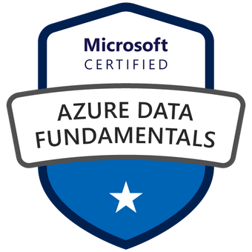
MICROSOFT CERTIFIED AZURE FUNDAMENTALS 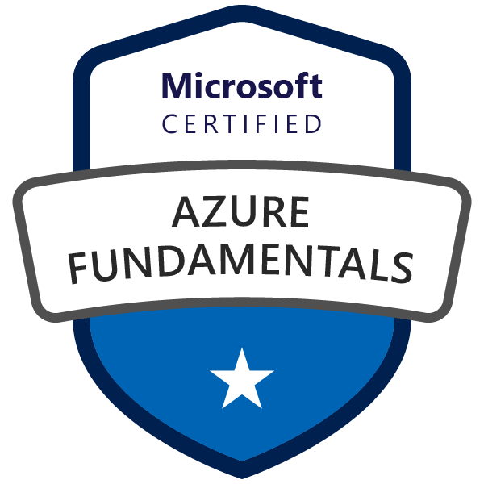
Oracle Cloud Infrastructure Foundations Certified Associated 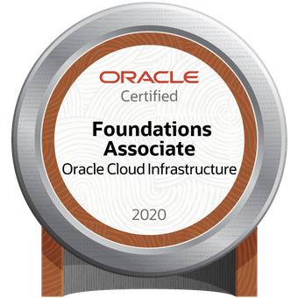
Microsoft Power BI Desktop | Advanced Integration Services | SSIS Design Patterns for Data Warehousing |

