Create a VPC:
Resources:
# First, a VPC:
VPC:
Type: AWS::EC2::VPC
Properties:
CidrBlock: 10.1.0.0/16
EnableDnsSupport: true
EnableDnsHostnames: true
Tags:
- Key: Name
Value: !Join ['', [!Ref "AWS::StackName", "-VPC" ]]

Defining a parameter in a template
The following example declares a parameter named InstanceTypeParameter. This parameter lets you specify the Amazon EC2 instance type for the stack to use when you create or update the stack.
Note that InstanceTypeParameter has a default value of t2.micro. This is the value that AWS CloudFormation uses to provision the stack unless another value is provided
"Parameters" : {
"InstanceTypeParameter" : {
"Type" : "String",
"Default" : "t2.micro",
"AllowedValues" : ["t2.micro", "m1.small", "m1.large"],
"Description" : "Enter t2.micro, m1.small, or m1.large. Default is t2.micro."
}
}

Parameters:
InstanceTypeParameter:
Type: String
Default: t2.micro
AllowedValues:
- t2.micro
- m1.small
- m1.large
Description: Enter t2.micro, m1.small, or m1.large. Default is t2.micro.

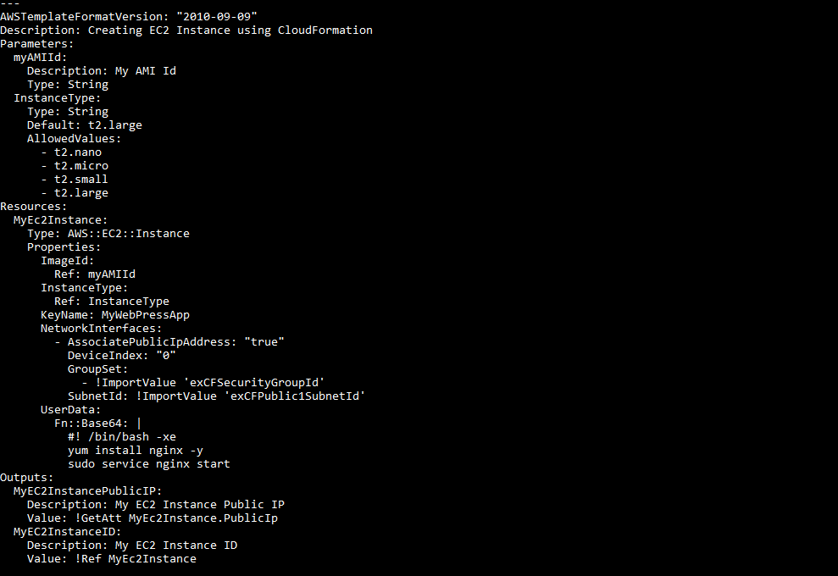

Resources:
Ec2Instance:
Type: AWS::EC2::Instance
Properties:
InstanceType: t2.micro
ImageId: ami-063dd30adbb186909 # Amazon Linux AMI in N.California
Tags:
- Key: test
Value: My EC2 Instance
- Key: Type
Value: Worker Instance

Q - Create a VPC
Resources:
# First, a VPC:
VPC:
Type: AWS::EC2::VPC
Properties:
CidrBlock: 10.1.0.0/16
EnableDnsSupport: true
EnableDnsHostnames: true
Tags:
- Key: Name
Value: myVP

-----------------------------------------------------------------------------------------
Q - Two Public Subnet with 64 IPS
Resources:
VPC:
Type: AWS::EC2::VPC
Properties:
CidrBlock: 10.0.0.0/16
EnableDnsHostnames: true
Tags:
- Key: Name
Value: myVPC

InternetGateway:
Type: AWS::EC2::InternetGateway
Properties:
Tags:
- Key: Name
Value: myVPC Internet Gateway

AttachGateway:
Type: AWS::EC2::VPCGatewayAttachment
Properties:
VpcId: !Ref VPC
InternetGatewayId: !Ref InternetGateway

PublicSubnet1:
Type: AWS::EC2::Subnet
Properties:
VpcId: !Ref VPC
Ipv6CidrBlock: 2001:db8:2234:1a00::/64
AvailabilityZone: ap-south-1a
Tags:
- Key: Name
Value: Public Subnet 1

PublicSubnet2:
Type: AWS::EC2::Subnet
Properties:
VpcId: !Ref VPC
Ipv6CidrBlock: 2001:db8:2235:1a00::/64
AvailabilityZone: ap-south-1a
Tags:
- Key: Name
Value: Public Subnet 2

Q - Two Private Subnet 64 Ips

Resources:
VPC:
Type: AWS::EC2::VPC
Properties:
CidrBlock: 10.0.0.0/16
EnableDnsHostnames: true
Tags:
- Key: Name
Value: myVPC

InternetGateway:
Type: AWS::EC2::InternetGateway
Properties:
Tags:
- Key: Name
Value: myVPC Internet Gateway

AttachGateway:
Type: AWS::EC2::VPCGatewayAttachment
Properties:
VpcId: !Ref VPC
InternetGatewayId: !Ref InternetGateway

PrivateSubnet1:
Type: AWS::EC2::Subnet
Properties:
VpcId: !Ref VPC
Ipv6CidrBlock: 2001:db8:2234:1a00::/64
AvailabilityZone: !Select
- '0'
- !GetAZs ''
Tags:
- Key: Name
Value: Private Subnet 1

PrivateSubnet2:
Type: AWS::EC2::Subnet
Properties:
VpcId: !Ref VPC
Ipv6CidrBlock: 2001:db8:2234:1a00::/64
AvailabilityZone: !Select
- '0'
- !GetAZs ''
Tags:
- Key: Name
Value: Private Subnet 2

-----------------------------------------------------------------------------------------------------------------------------------------
- Q - Private Subnet have S3 VPC endpoint
Description: 'Add VPC Endpoint to S3 from private subnets'
Parameters:
VpcId:
Description: The VPC ID of the VPC that this endpoint will be attached to
Type: AWS::EC2::VPC::Id
AllowedPattern: "[a-z0-9-]*"
RouteTableId:
Description: The Routing Table ID of the Routing Table that this endpoint will be added to
Type: String
AllowedPattern: "[a-z0-9-]*"
Resources:
S3Endpoint:
Type: "AWS::EC2::VPCEndpoint"
Properties:
PolicyDocument:
Version: 2012-10-17
Statement:
- Effect: Allow
Principal: '*'
Action:
- 's3:GetObject'
- 's3:PutObject'
- 's3:DeleteObject'
Resource:
- 'arn:aws:s3:::aws-allow-ec2-vpc-endpoint/*'
RouteTableIds:
- !Ref RouteTableId
ServiceName: !Join
- ''
- - com.amazonaws.
- !Ref 'AWS::Region'
- .s3
VpcId: !Ref VpcId
Outputs:
StackName:
Description: 'Stack name'
Value: !Sub '${AWS::StackName}'
Endpoint:
Description: 'The VPC endpoint to S3.'
Value: !Ref S3Endpoint

- Q - Allow only Ports 80,443,22 between private Subnet
Resources:
#Create a VPC:
VPC:
Type: AWS::EC2::VPC
Properties:
CidrBlock: 10.1.0.0/16
EnableDnsSupport: true
EnableDnsHostnames: true
Tags:
- Key: Name
Value: !Join ['', [!Ref "AWS::StackName", "-VPC" ]]

ALBSecurityGroup:
Type: 'AWS::EC2::SecurityGroup'
Properties:
VpcId: !Ref VPC
GroupDescription: Enable SSH/HTTP/HTTPS access
SecurityGroupIngress:
- IpProtocol: 'tcp'
FromPort: '80'
ToPort: '80'
CidrIp: !Ref ALBAccessCIDR
- IpProtocol: 'tcp'
FromPort: '443'
ToPort: '443'
CidrIp: !Ref ALBAccessCIDR
- IpProtocol: 'tcp'
FromPort: '22'
ToPort: '22'
CidrIp: !Ref ALBAccessCIDR
Tags:
- Key: Name
Value: SecurityGroup

- Q - Create a VM in Public Subnet

- name: Ansible test
hosts: localhost
tasks:
- name: launching AWS instance using Ansible
ec2:
key_name: aws_instance_Ansible
instance_type: t2.micro
image: ami-0dacb0c129b49f529
region: us-east-2
wait: yes
group: Ansible
count: 1
vpc_subnet_id: default
assign_public_ip: yes
aws_access_key: ***********xxxxxxxx
Aws_secret_key: ***********xxxxxxxx

- Q - Use the AMI and Create an Autoscaling group in Private subnet
Resources:
Type: AWS::AutoScaling::AutoScalingGroup
Properties:
AvailabilityZones:
Fn::GetAZs: ""
LaunchConfigurationName:
Ref: "myLaunchConfig"
MinSize: "1"
MaxSize: "4"
LoadBalancerNames:
- Ref: "myLoadBalancer"
MetricsCollection:
- Granularity: "1Minute"
Metrics:
- "GroupMinSize"
- "GroupMaxSize"
Tags:
- Key: Environment
Value: Production
PropagateAtLaunch: "true"
- Key: Purpose
Value: WebServerGroup
PropagateAtLaunch: "false"

Q - Create Load balancer in Public Subnet

MyLoadBalancer:
Type: AWS::ElasticLoadBalancing::LoadBalancer
Properties:
AvailabilityZones:
- "us-east-1a"
Instances:
- Ref: logical name of AWS::EC2::Instance resource 1
- Ref: logical name of AWS::EC2::Instance resource 2
Listeners:
- LoadBalancerPort: '80'
InstancePort: '80'
Protocol: HTTP
HealthCheck:
Target: HTTP:80/
HealthyThreshold: '3'
UnhealthyThreshold: '5'
Interval: '30'
Timeout: '5'

Parameters

Use the optional Parameters section to customize your templates.
Parameters enable you to input custom values to your template each time you create or update a stack.

Parameters:
InstanceTypeParameter:
Type: String
Default: t2.micro
AllowedValues:
- t2.micro
- m1.small
- m1.large
Description: Enter t2.micro, m1.small, or m1.large. Default is t2.micro.
---------------------------------------------------------------------------------------------------------------------

General requirements for parameters

The following requirements apply when using parameters:

You can have a maximum of 200 parameters in an AWS CloudFormation template.

Each parameter must be given a logical name (also called logical ID), which must be alphanumeric and unique among all logical names within the template.

Each parameter must be assigned a parameter type that is supported by AWS CloudFormation. For more information, see Type.

Each parameter must be assigned a value at runtime for AWS CloudFormation to successfully provision the stack.
You can optionally specify a default value for AWS CloudFormation to use unless another value is provided.

Parameters must be declared and referenced from within the same template. You can reference parameters from the Resources and Outputs sections of the template.

-------------------------------------------------------------------------------------------------------------------
Parameters:
DBPort:
Default: 3306
Description: TCP/IP port for the database
Type: Number
MinValue: 1150
MaxValue: 65535
DBPwd:
NoEcho: true
Description: The database admin account password
Type: String
MinLength: 1
MaxLength: 41
AllowedPattern: ^[a-zA-Z0-9]*$
------------------------------------------------------------------------------------------------------------------
Conditions

AWSTemplateFormatVersion: 2010-09-09
Parameters:
EnvType:
Description: Environment type.
Default: test
Type: String
AllowedValues:
- prod
- test
ConstraintDescription: must specify prod or test.
Conditions:
CreateProdResources: !Equals
- !Ref EnvType
- prod
Resources:
EC2Instance:
Type: 'AWS::EC2::Instance'
Properties:
ImageId: ami-0ff8a91507f77f867
MountPoint:
Type: 'AWS::EC2::VolumeAttachment'
Condition: CreateProdResources
Properties:
InstanceId: !Ref EC2Instance
VolumeId: !Ref NewVolume
Device: /dev/sdh
NewVolume:
Type: 'AWS::EC2::Volume'
Condition: CreateProdResources
Properties:
Size: 100
AvailabilityZone: !GetAtt
- EC2Instance
- AvailabilityZone
------------------------------------------------------------------------------------------------------------------
Intrinsic functions reference

Fn::Base64 -

The intrinsic function Fn::Base64 returns the Base64 representation of the input string.
This function is typically used to pass encoded data to Amazon EC2 instances by way of the UserData property.

Syntax - !Base64 valueToEncode

!Base64 !Sub string
!Base64 !Ref logical_ID

------------------------
Fn::Cidr

The intrinsic function Fn::Cidr returns an array of CIDR address blocks.
The number of CIDR blocks returned is dependent on the count parameter.

Syntax - !Cidr [ ipBlock, count, cidrBits ]

-----------------------
Fn::FindInMap

The intrinsic function Fn::FindInMap returns the value corresponding to keys in a two-level map that is declared in the Mappings section.

Syntax - !FindInMap [ MapName, TopLevelKey, SecondLevelKey ]

-----------------------
Fn::GetAtt

The Fn::GetAtt intrinsic function returns the value of an attribute from a resource in the template

Syntax - !GetAtt logicalNameOfResource.attributeName

!GetAtt myELB.DNSName

----------------------
Fn::GetAZs

The intrinsic function Fn::GetAZs returns an array that lists Availability Zones for a specified region in alphabetical order.
Because customers have access to different Availability Zones,
the intrinsic function Fn::GetAZs enables template authors to write templates that adapt to the calling user's access.

Syntax -- !GetAZs region

Fn::GetAZs: ""
Fn::GetAZs:
Ref: "AWS::Region"
Fn::GetAZs: us-east-1

---------------------
Fn::ImportValue

The intrinsic function Fn::ImportValue returns the value of an output exported by another stack.

---------------------
Fn::Join

The intrinsic function Fn::Join appends a set of values into a single value, separated by the specified delimiter.

---------------------
Fn::Select

The intrinsic function Fn::Select returns a single object from a list of objects by index.

Syntax - !Select [ index, listOfObjects ]

!Select [ "1", [ "apples", "grapes", "oranges", "mangoes" ] ]

---------------------
Ref

The intrinsic function Ref returns the value of the specified parameter or resource.

Syntax - Ref: logicalName
!Ref logicalName
---------------------
Fn::Sub

The intrinsic function Fn::Sub substitutes variables in an input string with values that you specify.
----------------------------------------------------------

"Parameters" : {
"InstanceTypeParameter" : {
"Type" : "String",
"Default" : "t2.micro",
"AllowedValues" : ["t2.micro", "m1.small", "m1.large"],
"Description" : "Enter t2.micro, m1.small, or m1.large. Default is t2.micro."
}
}

Parameters:
InstanceTypeParameter:
Type: String
Default: t2.micro
AllowedValues:
- t2.micro
- m1.small
- m1.large
Description: Enter t2.micro, m1.small, or m1.large. Default is t2.micro.

Resources:
Ec2Instance:
Type: AWS::EC2::Instance
Properties:
InstanceType: t2.micro
ImageId: ami-063dd30adbb186909 # Amazon Linux AMI in N.California
Tags:
- Key: test
Value: My EC2 Instance
- Key: Type
Value: Worker Instance

-----------------------------------------------

