- Q - Install WordPress inside the machine using Ansible/Shell script
Step 1 - Install Apache and PHP
~/ansible/roles/apache.yaml

- name: install apache & php
remote_user: ubuntu
hosts: all
become: true
become_user: root
gather_facts: true
tasks:
- name: "Install apache2"
package: name=apache2 state=present
- name: "Install apache2-php5"
package: name=libapache2-mod-php state=present
- name: "Install php-cli"
package: name=php-cli state=present
- name: "Install php-mcrypt"
package: name=php-mcrypt state=present
- name: "Install php-gd"
package: name=php-gd state=present
- name: Install php-fpm
package: name=php-fpm state=present
- name: Install php-common
package: name=php-common state=present
- name: Install php-mbstring
package: name=php-mbstring state=present
- name: Install php-xmlrpc
package: name=php-xmlrpc state=present
- name: Install php-xml
package: name=php-xml state=present
- name: Install php-mysql
package: name=php-mysql state=present
- name: Install php zip
package: name=php-zip state=present
- name: Install php-curl
package: name=php-curl state=present
------------------------------------------------------------------
Step 2 - Install MYSQL

~/ansible/roles/mysql.yaml

- name: Install MySQL for production ready server
user: ubuntu
hosts: all
become: True
become_user: root
vars:
MySQL_root_pass: ReplaceWithYourPassword
tasks:
- name: Set MySQL root password before installing
debconf: name="mysql-server" question="mysql-server/root_password" value="" vtype="password"
- name: Confirm MySQL root password before installing
debconf: name="mysql-server" question="mysql-server/root_password_again" value="" vtype="password"
- name: test1
apt:
package:
- mysql-server
- mysql-client
- python-mysqldb
state: present
force: yes
update_cache: yes
cache_valid_time: 3600
when: ansible_os_family == "Debian"
- name: Deletes anonymous MySQL server user for localhost
mysql_user: user="" state="absent" login_password="" login_user=root
- name: Secures the MySQL root user
mysql_user: user="root" password="" host="{{item}}" login_password="" login_user=root
with_items:
- 127.0.0.1
- localhost
- ::1
- ""
- name: Removes the MySQL test database
mysql_db: db=test state=absent login_password="" login_user=root

- name: Create a new database called wordpress
mysql_db:
login_user: root
login_password: ""
name: wordpress
state: present

- name: Configure new MySQL user called wpuser
mysql_user:
login_user: root
login_password: ""
name: wpuser
password: wpuser_password_replace_with_your_own
priv: 'wordpress.*:ALL'

------------------------------------------------------------------
Step 3 - Install wordpress

~/ansible/roles/wordpress.yaml

- name: Install WordPress
remote_user: ubuntu
hosts: all
become: true
become_user: root
gather_facts: true
tasks:
- name: Download and Extract WorPress
unarchive:
src: https://wordpress.org/latest.tar.gz
dest: /var/www/
remote_src: yes

- name: Update default Apache site
lineinfile:
path: /etc/apache2/sites-enabled/000-default.conf
state: present
regexp: '(.)+DocumentRoot /var/www/html'
line: 'DocumentRoot /var/www/wordpress'

- name: Restart Apache
service:
name: apache2
state: restarted

- name: Copy sample config file
command: mv /var/www/wordpress/wp-config-sample.php /var/www/wordpress/wp-config.php

- name: Update Wordpress config file
lineinfile:
path: /var/www/wordpress/wp-config.php
regexp: "{{item.regexp}}"
line: "{{item.line}}"
with_items:
- {'regexp': "define\\( 'DB_NAME', '(.)+' \\);", 'line': "define( 'DB_NAME', 'wordpress' );"}
- {'regexp': "define\\( 'DB_USER', '(.)+' \\);", 'line': "define( 'DB_USER', 'wpuser' );"}
- {'regexp': "define\\( 'DB_PASSWORD', '(.)+' \\);", 'line': "define( 'DB_PASSWORD', 'wpuser_password_replace_with_your_own' );"}

- name: Update ownership to Apache user
file:
path: /var/www/wordpress/
state: directory
recurse: yes
owner: www-data

- name: Set the correct permissions on Wordpress directories
command: find /var/www/wordpress/ -type d -exec chmod 750 {} \;

- name: Set the correct permissions for Wordpress files
command: find /var/www/wordpress/ -type f -exec chmod 640 {} \;

-------------------------------------------------------------------------------------------------------

Step 4 - Include above 3 YAML files in below and run the playbook.

editor ~/ansible/roles/lamp.yaml

- name: install LAMP Stack
hosts: all
remote_user: ubuntu
become: true
become_user: root
gather_facts: true

- name: Include Apache
import_playbook: apache.yaml

- name: Include MySQL
import_playbook: mysql.yaml

- name: Include MySQL
import_playbook: wordpress.yaml

Install JDK
---
- hosts: webservers
become: true
vars:
download_url: http://download.oracle.com/otn-pub/java/jdk/8u171-b11/512cd62ec5174c3487ac17c61aaa89e8/jdk-8u171-linux-x64.rpm

tasks:
- name: Download JDK 8 RPM file
command: "wget --no-check-certificate --no-cookies --header 'Cookie: oraclelicense=accept-securebackup-cookie' {{download_url}} "
- name: Install JDK 8
command: "rpm -ivh jdk-8u171-linux-x64.rpm"

Install Maven
---
- hosts: webservers
become: true
tasks:
- name: Download Maven
get_url: url=http://www-us.apache.org/dist/maven/maven-3/3.5.3/binaries/apache-maven-3.5.3-bin.tar.gz dest=/opt/niranjan/apache-maven-3.5.3-bin.tar.gz
- name: Extract Maven
command: tar xvf /opt/niranjan/apache-maven-3.5.3-bin.tar.gz -C /opt/niranjan
- name: Move to a smaller directory
command: mv /opt/niranjan/apache-maven-3.5.3 /opt/niranjan/maven
- name: Update Profile
copy: content="export M2_HOME=/opt/niranjan/maven \n" dest=/etc/profile.d/maven.sh
# lineinfile is used to add additional or append lines to existing files.
- lineinfile:
path: /etc/profile.d/maven.sh
line: 'export PATH=${M2_HOME}/bin:${PATH}'
- name: Source profile
shell: source /etc/profile.d/maven.sh

Install Tomcat
---
- hosts: webservers
become: true
gather_facts: no
tasks:
- name: Download Tomcat
get_url: url=http://www-us.apache.org/dist/tomcat/tomcat-8/v8.5.32/bin/apache-tomcat-8.5.32.tar.gz dest=/home/ansible

- name: Extract the file downloaded tomcat file
command: tar xvf apache-tomcat-8.5.32.tar.gz

- name: Move the Tomcat directory to a smaller one
command: mv apache-tomcat-8.5.32 tomcat

- name: Change Ownership and group of the Tomcat directory
file: path=/home/ansible/tomcat owner=ansible group=ansible mode=775 state=directory recurse=yes

- name: Start Tomcat
command: nohup /home/ansible/tomcat/bin/startup.sh # Execute command even after you have exited from the shell prompt
become: true
become_user: ansible

Install Apache:-
---
- hosts: apache
sudo: yes
tasks:
- name: install apache2
apt: name=apache2 update_cache=yes state=latest

- name: enabled mod_rewrite
apache2_module: name=rewrite state=present
notify:
- restart apache2

handlers:
- name: restart apache2
service: name=apache2 state=restarted

- hosts: webservers
become: true
tasks:
- name: Install httpd package
yum: name=httpd state=latest
- name: Copy the httpd configuration file
copy: src=/home/ansible/httpd.final dest=/etc/httpd/conf/httpd.conf
- name: Copy index.html file
copy: src=/home/ansible/index.html dest=/var/www/html
notify:
- restart httpd
- name: Start httpd service
service: name=httpd state=started enabled=yes
handlers:
- name: restart httpd
service: name=httpd state=restarted
-------------------------------------------------------------------------------------------------------------------------------
- hosts: webservers
remote_user: root

tasks:
- name: ensure apache is at the latest version
yum: name=httpd state=latest

Install vsftpd:-
- name: Install FTP package on RHEL
yum:
name: vsftpd
state: present
when: ansible_distribution == "RedHat"
- name: Install FTP package on Ubuntu
apt:
name: vsftpd
state: present
when: ansible_distribution == "Ubuntu"
- name: Install Firewalld package on RHEL
yum:
name: firewalld
state: present
when: ansible_distribution == "RedHat"
Install Jenkins :-
---
- name: Install Jenkins
hosts: linux
gather_facts: false
become: true
tasks:
- name: Install yum
yum:
name:
- wget
- java-1.8.0-openjdk

- name: Download jenkins.repo
get_url:
url: http://pkg.jenkins-ci.org/redhat-stable/jenkins.repo
dest: /etc/yum.repos.d/jenkins.repo

- name: Import Jenkins Key
rpm_key:
state: present
key: https://jenkins-ci.org/redhat/jenkins-ci.org.key

- name: Install Jenkins
yum:
name: jenkins
state: present

- name: Start & Enable Jenkins
systemd:
name: jenkins
state: started
enabled: true

- name: Sleep for 30 seconds and continue with play
wait_for: timeout=30

- name: Get init password Jenkins
shell: cat /var/lib/jenkins/secrets/initialAdminPassword
changed_when: false
register: result
- name: Print init password Jenkins
debug:
var: result.stdout

Ansible Vault

Ansible Vault is a feature of Ansible that allows you to keep sensitive data, such as passwords or keys in encrypted files, rather than as plaintext in playbooks or roles. These vault files can then be distributed or placed in source control.
To enable this feature, a command-line tool — ansible-vault — is used to edit files, and a command-line flag (--ask-vault-pass or --vault-password-file) is used.

#1) Creating new encrypted files
To create new encrypted files with vault use the ansible-vault create command.
$ ansible-vault create jobagreement.yml
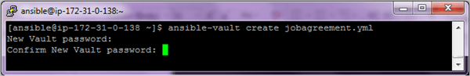
After confirming password an editing window will open to add contents to the file.
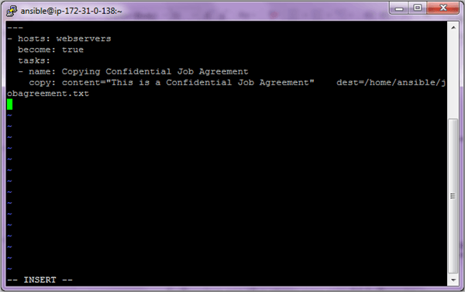
Ansible will encrypt the contents when you close the file. Instead of seeing the actual contents you will see encrypted blocks.
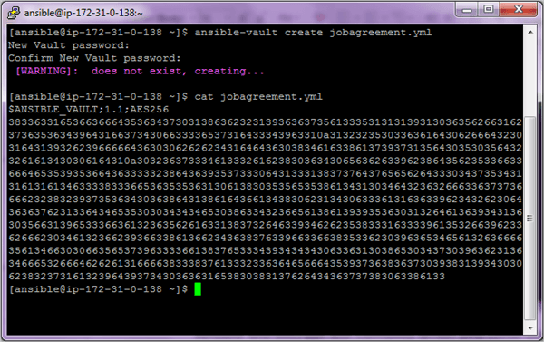
#2) To encrypt an existing yml file use the following
$ ansible-vault encrypt existingfile.yml
Password will again be asked for encryption.
#3) Viewing encrypted file
Use the command ansible-vault view to look at the actual contents of the file.
$ ansible-vault view jobagreement.yml
You will be asked for the password again to look at the contents of the file.
#4) Editing encrypted files
If you need to edit the file use the command ansible-vault edit
$ ansible-vault edit users.yml
Enter the password to edit the file.
#5) Changing password of the encrypted files
Use the command ansible-vault rekey to change the password of the file.
$ ansible-vault rekey jobagreement.yml
#6) Run an encrypted Ansible playbook file
Use the option –ask-vault-pass with the ansible-playbook command.
$ ansible-playbook users.yml --ask-vault-pass
#7) Manually decrypting the encrypted files
Use the command ansible-vault decrypt command.
$ ansible-vault decrypt jobagreement.yml

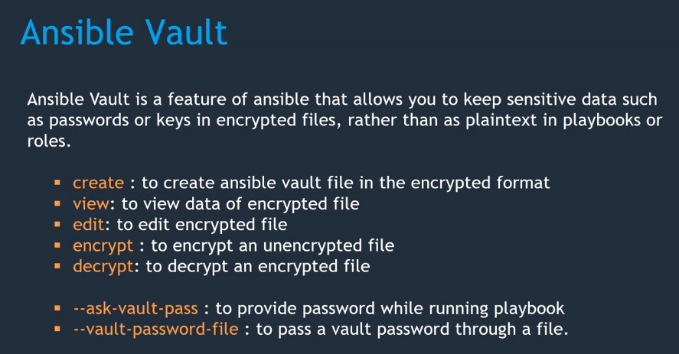

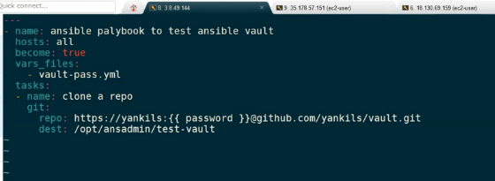

How to copy files between two nodes using ansible
hosts: machine2
user: user2
tasks:
- name: Copy file from machine1 to machine2
shell: scp user1@machine1:/path-of-file/file1 /home/user2/file1

Ansible roles
In Ansible, the role is the primary mechanism for breaking a playbook into multiple files. This simplifies writing complex playbooks, and it makes them easier to reuse. The breaking of playbook allows you to logically break the playbook into reusable components.
Each role is basically limited to a particular functionality or desired output, with all the necessary steps to provide that result either within that role itself or in other roles listed as dependencies.
Roles are not playbooks. Roles are small functionality which can be independently used but have to be used within playbooks. There is no way to directly execute a role. Roles have no explicit setting for which host the role will apply to.

A role directory structure contains directories: defaults, vars, tasks, files, templates, meta, handlers. Each directory must contain a main.yml file which contains relevant content. Let’s look little closer to each directory.

- defaults: contains default variables for the role. Variables in default have the lowest priority so they are easy to override.
- vars: contains variables for the role. Variables in vars have higher priority than variables in defaults directory.
- tasks: contains the main list of steps to be executed by the role.
- files: contains files which we want to be copied to the remote host. We don’t need to specify a path of resources stored in this directory.
- templates: contains file template which supports modifications from the role. We use the Jinja2 templating language for creating templates.
- meta: contains metadata of role like an author, support platforms, dependencies.
- handlers: contains handlers which can be invoked by “notify” directives and are associated with service.
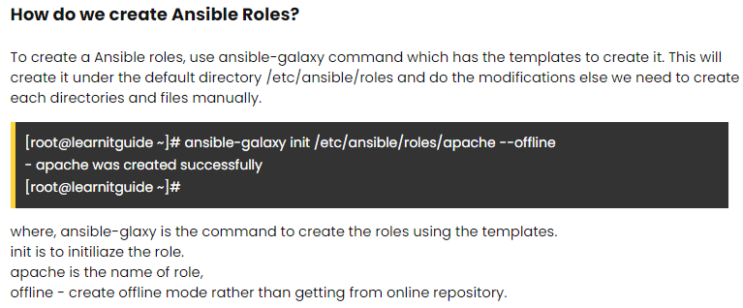
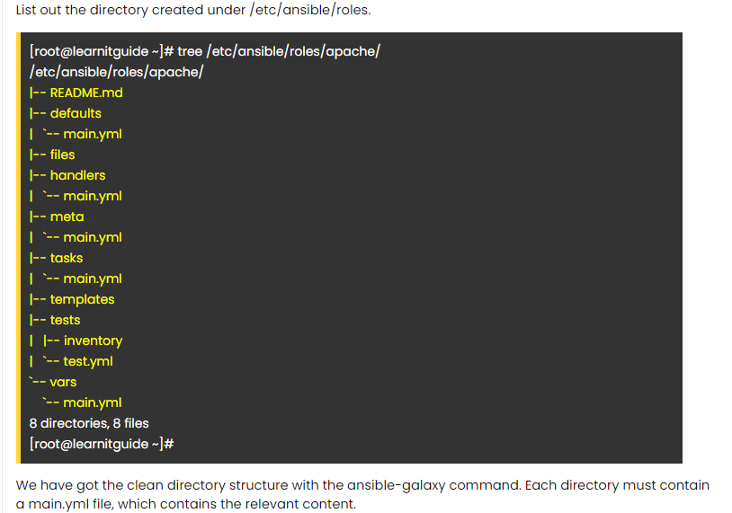
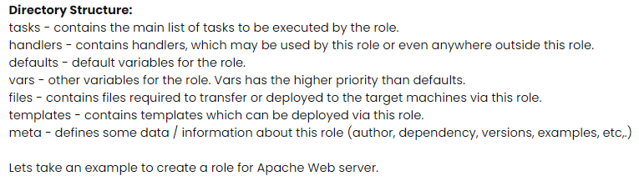
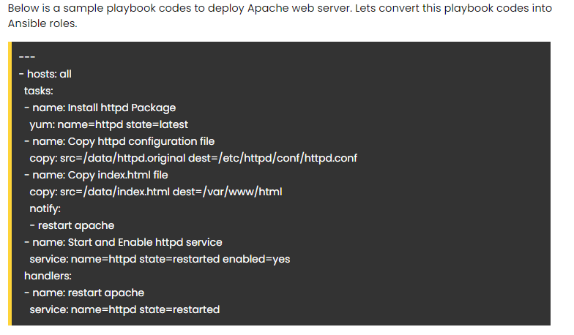

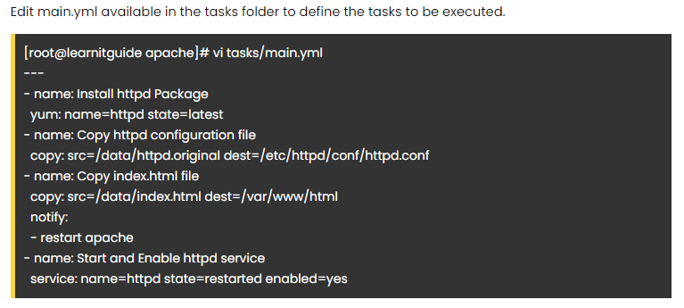
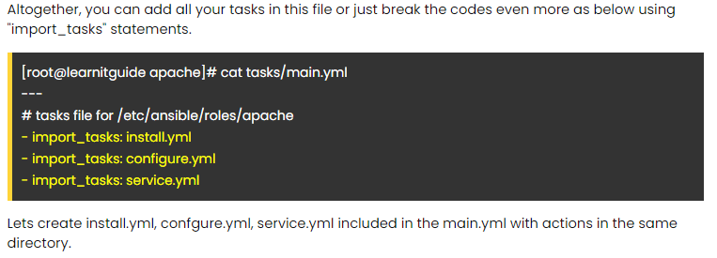
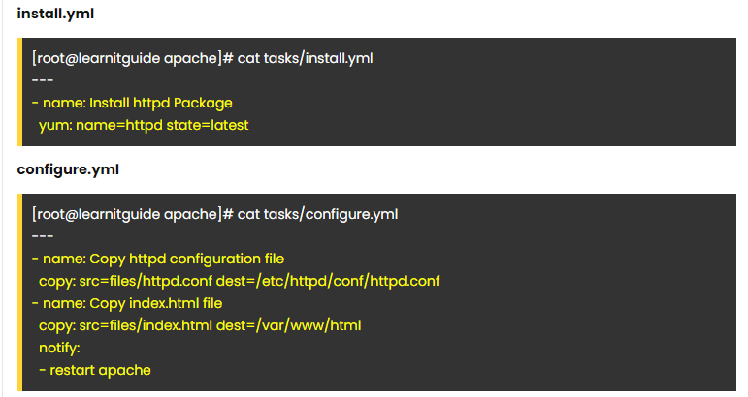


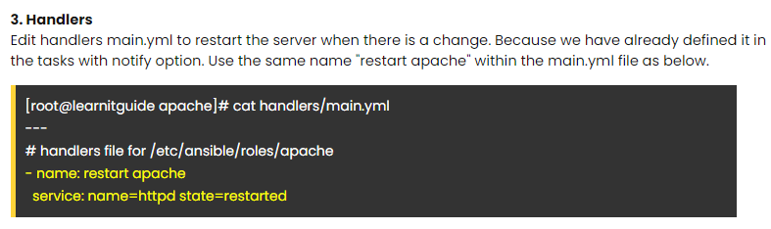
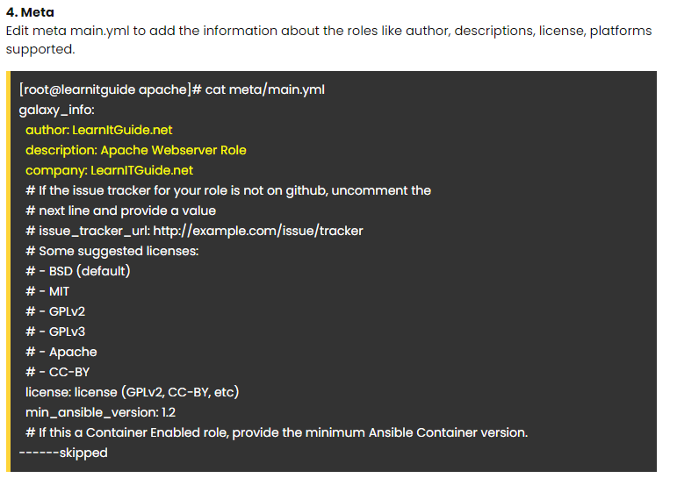
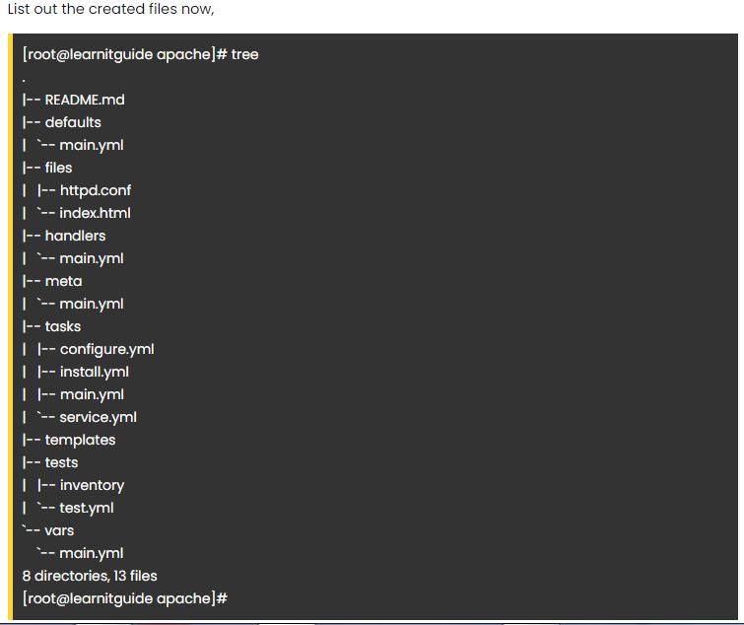
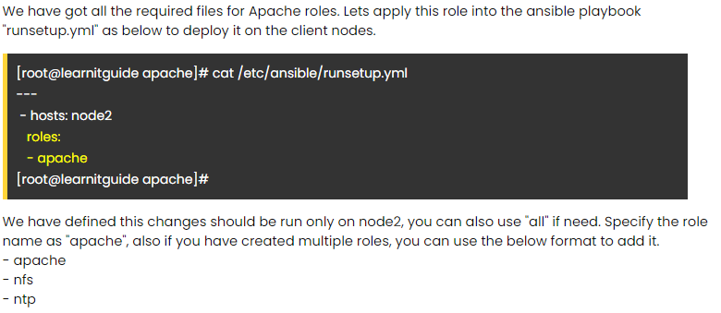

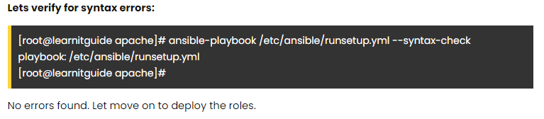
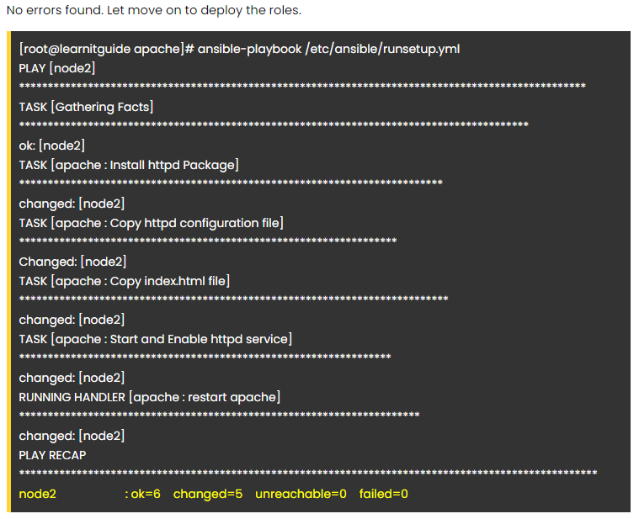

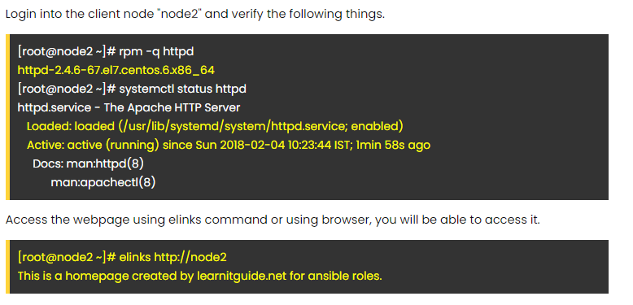

How to run multiple playbooks in order with Ansible

Build many sub-playbooks and aggregate them via include statements.
- include: playbook-one.yml
- include: playbook-two.yml

For newer versions of Ansible, you can build many sub-playbooks and aggregate them via import_playbook statements:
---
- import_playbook: A-systemd-networkd.yml
- import_playbook: B-fail2ban-ssh.yml
- import_playbook: C-enable-watchdog.yml

- hosts: localhost
tasks:
- debug:
msg: play1

- name: Include a play after another play
import_playbook: otherplays.yaml

Ansible block and rescue for error handling with examples

Blocks in Ansible allow you to logically group a set of tasks together, primarily for one of two purposes. One might be to apply conditional logic to an entire set of tasks. We can use ansible block, rescue and always to perform different kinds of error handling where with the rescue block we can perform cleanup action. We will learn more about this in detail with examples in this section.

Example-1: Why we should use blocks
I have written a small playbook ansible-blocks-1.yml which will help you understand how ansible blocks can be useful and why it should be used. In this playbook we have 4 tasks wherein 3 tasks requires root level privilege while one of the task can be executed without root level privilege.
Now I have used become: yes 3 times which is just increasing the number of lines in the playbook.
[ansible@controller ~]$ vim ansible-blocks-1.yml
---
- name: Ansible Blocks
hosts: server1
gather_facts: false

tasks:
- name: List usr directory content
command: "ls -l /usr/"
become: yes

- name: List root partition content
command: "ls -l /root/"
become: yes

- name: List ansible user's home directory content
command: "ls -l ~/"

- name: List bin diretcory content
command: "ls -l /bin/"
become: yes

We could have added become: yes in the starting of the play but then that variable will be applied to the entire play wherein we don’t want this permission for task 3. To overcome this we have block level solution wherein we can place all the common tasks under single block.

This is how the playbook would look with blocks. Here we have combined all the tasks which requires root level privilege into single block and instead of using become 3 times, we have applied this to the entire block.

---
- name: Ansible Blocks
hosts: server1
gather_facts: false

tasks:
- block:
- name: List usr directory content
command: "ls -l /usr/"

- name: List root partition content
command: "ls -l /root/"

- name: List bin directory content
command: "ls -l /bin/"
become: yes

- name: List ansible user's home directory content
command: "ls -l ~/"

Now we can execute the playbook:
[ansible@controller ~]$ ansible-playbook ansible-blocks-1.yml

PLAY [Ansible Blocks] ************************************************************************************************

TASK [List usr directory content] ************************************************************************************
changed: [server1]

TASK [List root partition content] ***********************************************************************************
changed: [server1]

TASK [List bin directory content] ************************************************************************************
changed: [server1]

TASK [List ansible user's home directory content] ********************************************************************
changed: [server1]

PLAY RECAP ***********************************************************************************************************
server1 : ok=4 changed=4 unreachable=0 failed=0 sk

Example-2: Perform error recovery with rescue block
We have additional benefit while using ansible blocks to perform recovery operation i.e. if any of the tasks within a block fails then in a ideal scenario the playbook would exit (unless you are using ignore_errors: yes). But with blocks we can assign a rescue block which can again contain a bunch of tasks. So if any of the tasks within block fails then automatically the tasks from recovery block will be executed which can perform any clean up activity which you would want to do in case of failure.
Lastly we also have an always block which will be called independent of the task execution status which can be used to give something like SUMMARY or anything as per your requirement.
In this sample playbook ansible-blocks-2.yml we have created two tasks inside the block wherein one task will pass while the other is expected to fail. In which case the rescue block will be executed followed by the always block.
---
- name: Ansible Blocks
hosts: server1
gather_facts: false

tasks:
- block:
- name: List home directory content
command: "ls -l ~/"

- name: Failing intentionally
command: "ls -l /tmp/does-not-exist"

rescue:
- name: Rescue block (perform recovery)
debug:
msg: "Something went wrong, cleaning up.."

always:
- name: This will execute always
debug:
msg: "I will execute even in failure scenario"
Let us execute this playbook:
[ansible@controller ~]$ ansible-playbook ansible-blocks-2.yml

PLAY [Ansible Blocks] ************************************************************************************************

TASK [List home directory content] ***********************************************************************************
changed: [server1]

TASK [Failing intentionally] *****************************************************************************************
fatal: [server1]: FAILED! => {"changed": true, "cmd": ["ls", "-l", "/tmp/does-not-exist"], "delta": "0:00:00.003050", "end": "2020-09-26 10:29:13.864820", "msg": "non-zero return code", "rc": 2, "start": "2020-09-26 10:29:13.861770", "stderr": "ls: cannot access '/tmp/does-not-exist': No such file or directory", "stderr_lines": ["ls: cannot access '/tmp/does-not-exist': No such file or directory"], "stdout": "", "stdout_lines": []}

TASK [Rescue block (perform recovery)] *******************************************************************************
ok: [server1] => {
"msg": "Something went wrong, cleaning up.."
}

TASK [This will execute always] **************************************************************************************
ok: [server1] => {
"msg": "I will execute even in failure scenario"
}

PLAY RECAP ***********************************************************************************************************
server1 : ok=3 changed=1 unreachable=0 failed=0 ski

As you can see, our task1 was successful but task2 has failed after which the recovery block was executed followed by always block.

Now assuming none of the tasks failed in the block section in which case the rescue block will not be executed, but always block will be executed independent of the task status.

Example-3: Practical example of error and recovery with blocks
Now that we know the concept of block and rescue let’s use this in practical use case. I will create one playbook which will perform the following task under our block.

- Install vsftpd package
- Take a backup of /etc/vsftpd/vsftpd.conf on the same managed node
- Copy vsftpd.j2 jinja template from controller node to the managed node and replace /etc/vsftpd/vsftpd.conf
- Intentionally fail the block by trying to access incorrect location
Next I will have a rescue block so that if something goes wrong we will perform some clean up/fallback. In this I have two tasks:
- Print a message on the console for the recovery
- Restore vsftpd.conf using the backup file vsftpd.conf.bkp on the managed node
Lastly we will have always block will restart the vsftpd service independent of the task execution status
This is our playbook ansible-blocks-3.yml:
---
- name: Install vsftpd
hosts: server1
become: yes
vars:
anonymous_enable: yes
local_enable: yes
write_enable: yes
anon_upload_enable: yes
tasks:
- block:
- name: install vsftp
yum:
name: vsftpd
- name: take backup of existing config
copy:
src: /etc/vsftpd/vsftpd.conf
dest: /etc/vsftpd/vsftpd.conf.bkp
remote_src: yes
- name: use Jinja2 template to configure vsftpd
template:
src: vsftpd.j2
dest: /etc/vsftpd/vsftpd.conf
- name: This will fail
command: "ls -l /tmp/does-not-exist"

rescue:
- name: Recovery block
debug:
msg: "something failed, restoring vsftpd.conf from backup"
- name: Restoring vsftpd.conf
copy:
src: /etc/vsftpd/vsftpd.conf.bkp
dest: /etc/vsftpd/vsftpd.conf
remote_src: yes

always:
- name: Restarting vsftpd
service:
name: vsftpd
state: restarted

Let us execute this playbook and verify the steps:
[ansible@controller ~]$ ansible-playbook ansible-blocks-3.yml

PLAY [Install vsftpd] ************************************************************************************************

TASK [Gathering Facts] ***********************************************************************************************
ok: [server1]

TASK [install vsftp] *************************************************************************************************
ok: [server1]

TASK [take backup of existing config] ********************************************************************************
changed: [server1]

TASK [use Jinja2 template to configure vsftpd] ***********************************************************************
changed: [server1]

TASK [This will fail] ************************************************************************************************
fatal: [server1]: FAILED! => {"changed": true, "cmd": ["ls", "-l", "/tmp/does-not-exist"], "delta": "0:00:00.003701", "end": "2020-09-26 10:56:49.076834", "msg": "non-zero return code", "rc": 2, "start": "2020-09-26 10:56:49.073133", "s tderr": "ls: cannot access '/tmp/does-not-exist': No such file or directory", "stderr_lines": ["ls: cannot access '/tm p/does-not-exist': No such file or directory"], "stdout": "", "stdout_lines": []}

TASK [Recovery block] ************************************************************************************************
ok: [server1] => {
"msg": "something failed, restoring vsftpd.conf from backup"
}

TASK [Restoring vsftpd.conf] *****************************************************************************************
changed: [server1]

TASK [Restarting vsftpd] *********************************************************************************************
changed: [server1]

PLAY RECAP ***********************************************************************************************************
server1 : ok=7 changed=4 unreachable=0 failed=0

As expected TASK 1 and TASK 2 have successfully executed while TASK 3 has failed. Since one of the task in our block has failed, the rescue block is executed which will restore our vsftpd.conf file. Lastly the always block is executed to restart the vsftpd service.
We can also connect to server1 and check if vsftpd.conf.bkp is created:

[ansible@server-1 ~]$ sudo ls -l /etc/vsftpd/vsftpd.conf*
-rw------- 1 root root 5098 May 14 2019 /etc/vsftpd/vsftpd.conf
-rw-r--r-- 1 root root 5098 May 14 2019 /etc/vsftpd/vsftpd.conf.bkp

deploy.yml

The tasks inside the loop will be grouped inside a block (doc). Whenever a failure takes place inside the block, the rescue section will get executed.

The block has a defined condition (when:) so it will only be executed when the tasks_status variable value is OK .
Whenever a task fails, the rescue section will set the task_status variable to ERROR and that will prevent further executions of the loop because of the condition not being satisfied anymore.

---
- name: deploying
block:
- debug:
msg: "on {{ clusters[index] }} status: {{ task_status }}"
# forcing failure on server03
- command: /bin/false
when: clusters[index] == 'server03' rescue:
- debug:
msg: "error on {{ clusters[index] }} "
- set_fact:
task_status: "ERROR"when: task_status == 'OK'

https://vmnet8.github.io/2020/06/21/Ansible-part12-block-rescure-and-always/

