- Q - Install WordPress inside the machine using Ansible/Shell script
Step 1 - Install Apache and PHP
~/ansible/roles/apache.yaml

- name: install apache & php
remote_user: ubuntu
hosts: all
become: true
become_user: root
gather_facts: true
tasks:
- name: "Install apache2"
package: name=apache2 state=present
- name: "Install apache2-php5"
package: name=libapache2-mod-php state=present
- name: "Install php-cli"
package: name=php-cli state=present
- name: "Install php-mcrypt"
package: name=php-mcrypt state=present
- name: "Install php-gd"
package: name=php-gd state=present
- name: Install php-fpm
package: name=php-fpm state=present
- name: Install php-common
package: name=php-common state=present
- name: Install php-mbstring
package: name=php-mbstring state=present
- name: Install php-xmlrpc
package: name=php-xmlrpc state=present
- name: Install php-xml
package: name=php-xml state=present
- name: Install php-mysql
package: name=php-mysql state=present
- name: Install php zip
package: name=php-zip state=present
- name: Install php-curl
package: name=php-curl state=present
------------------------------------------------------------------
Step 2 - Install MYSQL

~/ansible/roles/mysql.yaml

- name: Install MySQL for production ready server
user: ubuntu
hosts: all
become: True
become_user: root
vars:
MySQL_root_pass: ReplaceWithYourPassword
tasks:
- name: Set MySQL root password before installing
debconf: name="mysql-server" question="mysql-server/root_password" value="" vtype="password"
- name: Confirm MySQL root password before installing
debconf: name="mysql-server" question="mysql-server/root_password_again" value="" vtype="password"
- name: test1
apt:
package:
- mysql-server
- mysql-client
- python-mysqldb
state: present
force: yes
update_cache: yes
cache_valid_time: 3600
when: ansible_os_family == "Debian"
- name: Deletes anonymous MySQL server user for localhost
mysql_user: user="" state="absent" login_password="" login_user=root
- name: Secures the MySQL root user
mysql_user: user="root" password="" host="{{item}}" login_password="" login_user=root
with_items:
- 127.0.0.1
- localhost
- ::1
- ""
- name: Removes the MySQL test database
mysql_db: db=test state=absent login_password="" login_user=root

- name: Create a new database called wordpress
mysql_db:
login_user: root
login_password: ""
name: wordpress
state: present

- name: Configure new MySQL user called wpuser
mysql_user:
login_user: root
login_password: ""
name: wpuser
password: wpuser_password_replace_with_your_own
priv: 'wordpress.*:ALL'

------------------------------------------------------------------
Step 3 - Install wordpress

~/ansible/roles/wordpress.yaml

- name: Install WordPress
remote_user: ubuntu
hosts: all
become: true
become_user: root
gather_facts: true
tasks:
- name: Download and Extract WorPress
unarchive:
src: https://wordpress.org/latest.tar.gz
dest: /var/www/
remote_src: yes

- name: Update default Apache site
lineinfile:
path: /etc/apache2/sites-enabled/000-default.conf
state: present
regexp: '(.)+DocumentRoot /var/www/html'
line: 'DocumentRoot /var/www/wordpress'

- name: Restart Apache
service:
name: apache2
state: restarted

- name: Copy sample config file
command: mv /var/www/wordpress/wp-config-sample.php /var/www/wordpress/wp-config.php

- name: Update Wordpress config file
lineinfile:
path: /var/www/wordpress/wp-config.php
regexp: "{{item.regexp}}"
line: "{{item.line}}"
with_items:
- {'regexp': "define\\( 'DB_NAME', '(.)+' \\);", 'line': "define( 'DB_NAME', 'wordpress' );"}
- {'regexp': "define\\( 'DB_USER', '(.)+' \\);", 'line': "define( 'DB_USER', 'wpuser' );"}
- {'regexp': "define\\( 'DB_PASSWORD', '(.)+' \\);", 'line': "define( 'DB_PASSWORD', 'wpuser_password_replace_with_your_own' );"}

- name: Update ownership to Apache user
file:
path: /var/www/wordpress/
state: directory
recurse: yes
owner: www-data

- name: Set the correct permissions on Wordpress directories
command: find /var/www/wordpress/ -type d -exec chmod 750 {} \;

- name: Set the correct permissions for Wordpress files
command: find /var/www/wordpress/ -type f -exec chmod 640 {} \;

-------------------------------------------------------------------------------------------------------

Step 4 - Include above 3 YAML files in below and run the playbook.

editor ~/ansible/roles/lamp.yaml

- name: install LAMP Stack
hosts: all
remote_user: ubuntu
become: true
become_user: root
gather_facts: true

- name: Include Apache
import_playbook: apache.yaml

- name: Include MySQL
import_playbook: mysql.yaml

- name: Include MySQL
import_playbook: wordpress.yaml

Install JDK
---
- hosts: webservers
become: true
vars:
download_url: http://download.oracle.com/otn-pub/java/jdk/8u171-b11/512cd62ec5174c3487ac17c61aaa89e8/jdk-8u171-linux-x64.rpm

tasks:
- name: Download JDK 8 RPM file
command: "wget --no-check-certificate --no-cookies --header 'Cookie: oraclelicense=accept-securebackup-cookie' {{download_url}} "
- name: Install JDK 8
command: "rpm -ivh jdk-8u171-linux-x64.rpm"

Install Maven
---
- hosts: webservers
become: true
tasks:
- name: Download Maven
get_url: url=http://www-us.apache.org/dist/maven/maven-3/3.5.3/binaries/apache-maven-3.5.3-bin.tar.gz dest=/opt/niranjan/apache-maven-3.5.3-bin.tar.gz
- name: Extract Maven
command: tar xvf /opt/niranjan/apache-maven-3.5.3-bin.tar.gz -C /opt/niranjan
- name: Move to a smaller directory
command: mv /opt/niranjan/apache-maven-3.5.3 /opt/niranjan/maven
- name: Update Profile
copy: content="export M2_HOME=/opt/niranjan/maven \n" dest=/etc/profile.d/maven.sh
# lineinfile is used to add additional or append lines to existing files.
- lineinfile:
path: /etc/profile.d/maven.sh
line: 'export PATH=${M2_HOME}/bin:${PATH}'
- name: Source profile
shell: source /etc/profile.d/maven.sh

Install Tomcat
---
- hosts: webservers
become: true
gather_facts: no
tasks:
- name: Download Tomcat
get_url: url=http://www-us.apache.org/dist/tomcat/tomcat-8/v8.5.32/bin/apache-tomcat-8.5.32.tar.gz dest=/home/ansible

- name: Extract the file downloaded tomcat file
command: tar xvf apache-tomcat-8.5.32.tar.gz

- name: Move the Tomcat directory to a smaller one
command: mv apache-tomcat-8.5.32 tomcat

- name: Change Ownership and group of the Tomcat directory
file: path=/home/ansible/tomcat owner=ansible group=ansible mode=775 state=directory recurse=yes

- name: Start Tomcat
command: nohup /home/ansible/tomcat/bin/startup.sh # Execute command even after you have exited from the shell prompt
become: true
become_user: ansible

Install Apache:-
---
- hosts: apache
sudo: yes
tasks:
- name: install apache2
apt: name=apache2 update_cache=yes state=latest

- name: enabled mod_rewrite
apache2_module: name=rewrite state=present
notify:
- restart apache2

handlers:
- name: restart apache2
service: name=apache2 state=restarted

- hosts: webservers
become: true
tasks:
- name: Install httpd package
yum: name=httpd state=latest
- name: Copy the httpd configuration file
copy: src=/home/ansible/httpd.final dest=/etc/httpd/conf/httpd.conf
- name: Copy index.html file
copy: src=/home/ansible/index.html dest=/var/www/html
notify:
- restart httpd
- name: Start httpd service
service: name=httpd state=started enabled=yes
handlers:
- name: restart httpd
service: name=httpd state=restarted
-------------------------------------------------------------------------------------------------------------------------------
- hosts: webservers
remote_user: root

tasks:
- name: ensure apache is at the latest version
yum: name=httpd state=latest

Install vsftpd:-
- name: Install FTP package on RHEL
yum:
name: vsftpd
state: present
when: ansible_distribution == "RedHat"
- name: Install FTP package on Ubuntu
apt:
name: vsftpd
state: present
when: ansible_distribution == "Ubuntu"
- name: Install Firewalld package on RHEL
yum:
name: firewalld
state: present
when: ansible_distribution == "RedHat"
Install Jenkins :-
---
- name: Install Jenkins
hosts: linux
gather_facts: false
become: true
tasks:
- name: Install yum
yum:
name:
- wget
- java-1.8.0-openjdk

- name: Download jenkins.repo
get_url:
url: http://pkg.jenkins-ci.org/redhat-stable/jenkins.repo
dest: /etc/yum.repos.d/jenkins.repo

- name: Import Jenkins Key
rpm_key:
state: present
key: https://jenkins-ci.org/redhat/jenkins-ci.org.key

- name: Install Jenkins
yum:
name: jenkins
state: present

- name: Start & Enable Jenkins
systemd:
name: jenkins
state: started
enabled: true

- name: Sleep for 30 seconds and continue with play
wait_for: timeout=30

- name: Get init password Jenkins
shell: cat /var/lib/jenkins/secrets/initialAdminPassword
changed_when: false
register: result
- name: Print init password Jenkins
debug:
var: result.stdout

Ansible Vault

Ansible Vault is a feature of Ansible that allows you to keep sensitive data, such as passwords or keys in encrypted files, rather than as plaintext in playbooks or roles. These vault files can then be distributed or placed in source control.
To enable this feature, a command-line tool — ansible-vault — is used to edit files, and a command-line flag (--ask-vault-pass or --vault-password-file) is used.

#1) Creating new encrypted files
To create new encrypted files with vault use the ansible-vault create command.
$ ansible-vault create jobagreement.yml
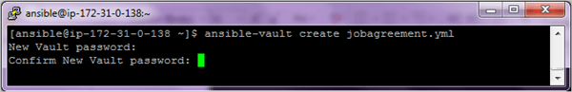
After confirming password an editing window will open to add contents to the file.
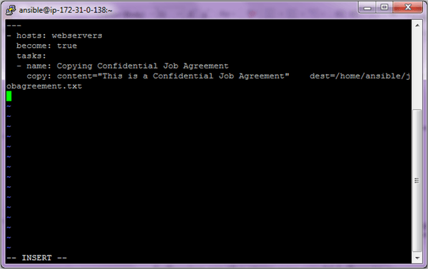
Ansible will encrypt the contents when you close the file. Instead of seeing the actual contents you will see encrypted blocks.
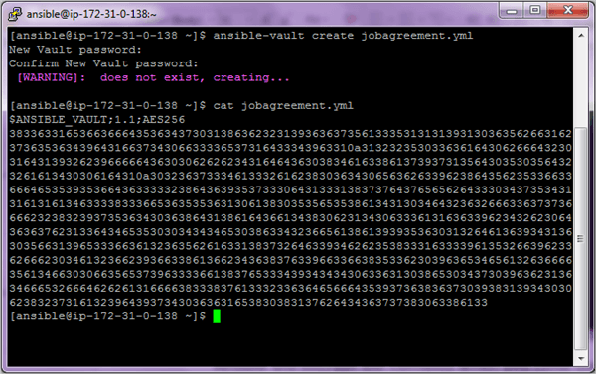
#2) To encrypt an existing yml file use the following
$ ansible-vault encrypt existingfile.yml
Password will again be asked for encryption.
#3) Viewing encrypted file
Use the command ansible-vault view to look at the actual contents of the file.
$ ansible-vault view jobagreement.yml
You will be asked for the password again to look at the contents of the file.
#4) Editing encrypted files
If you need to edit the file use the command ansible-vault edit
$ ansible-vault edit users.yml
Enter the password to edit the file.
#5) Changing password of the encrypted files
Use the command ansible-vault rekey to change the password of the file.
$ ansible-vault rekey jobagreement.yml
#6) Run an encrypted Ansible playbook file
Use the option –ask-vault-pass with the ansible-playbook command.
$ ansible-playbook users.yml --ask-vault-pass
#7) Manually decrypting the encrypted files
Use the command ansible-vault decrypt command.
$ ansible-vault decrypt jobagreement.yml

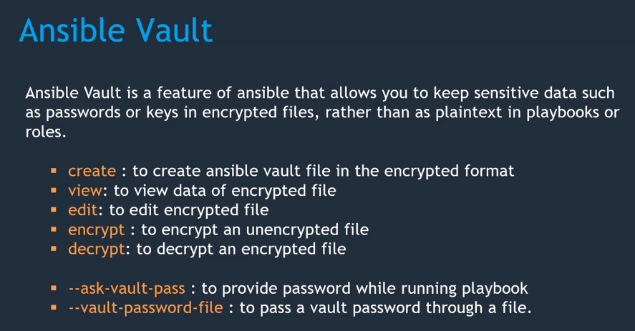

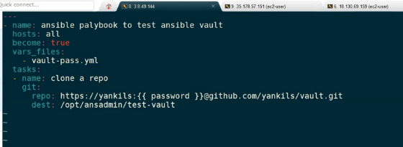

How to copy files between two nodes using ansible
hosts: machine2
user: user2
tasks:
- name: Copy file from machine1 to machine2
shell: scp user1@machine1:/path-of-file/file1 /home/user2/file1

Ansible roles
In Ansible, the role is the primary mechanism for breaking a playbook into multiple files. This simplifies writing complex playbooks, and it makes them easier to reuse. The breaking of playbook allows you to logically break the playbook into reusable components.
Each role is basically limited to a particular functionality or desired output, with all the necessary steps to provide that result either within that role itself or in other roles listed as dependencies.
Roles are not playbooks. Roles are small functionality which can be independently used but have to be used within playbooks. There is no way to directly execute a role. Roles have no explicit setting for which host the role will apply to.

A role directory structure contains directories: defaults, vars, tasks, files, templates, meta, handlers. Each directory must contain a main.yml file which contains relevant content. Let’s look little closer to each directory.

- defaults: contains default variables for the role. Variables in default have the lowest priority so they are easy to override.
- vars: contains variables for the role. Variables in vars have higher priority than variables in defaults directory.
- tasks: contains the main list of steps to be executed by the role.
- files: contains files which we want to be copied to the remote host. We don’t need to specify a path of resources stored in this directory.
- templates: contains file template which supports modifications from the role. We use the Jinja2 templating language for creating templates.
- meta: contains metadata of role like an author, support platforms, dependencies.
- handlers: contains handlers which can be invoked by “notify” directives and are associated with service.

