Types of Pod
There are two types of Pods −
- Single container pod
- Multi container pod

Single Container Pod
They can be simply created with the kubctl run command, where you have a defined image on the Docker registry which we will pull while creating a pod.
$ kubectl run <name of pod> --image=<name of the image from registry>
Example − We will create a pod with a tomcat image which is available on the Docker hub.
$ kubectl run tomcat --image = tomcat:8.0
This can also be done by creating the yaml file and then running the kubectl create command.
apiVersion: v1
kind: Pod
metadata:
name: Tomcat
spec:
containers:
- name: Tomcat
image: tomcat: 8.0
ports:
containerPort: 7500
imagePullPolicy: Always

Once the above yaml file is created, we will save the file with the name of tomcat.yml and run the create command to run the document.
$ kubectl create –f tomcat.yml
It will create a pod with the name of tomcat. We can use the describe command along with kubectl to describe the pod.

Multi Container Pod
Multi container pods are created using yaml mail with the definition of the containers.
apiVersion: v1
kind: Pod
metadata:
name: Tomcat
spec:
containers:
- name: Tomcat
image: tomcat: 8.0
ports:
containerPort: 7500
imagePullPolicy: Always
-name: Database
Image: mongoDB
Ports:
containerPort: 7501
imagePullPolicy: Always

In the above code, we have created one pod with two containers inside it, one for tomcat and the other for MongoDB

Run a Stateless Application Using a Deployment:-

Creating and exploring an nginx deployment

apiVersion: apps/v1 # for versions before 1.9.0 use apps/v1beta2
kind: Deployment
metadata:
name: nginx-deployment
spec:
selector:
matchLabels:
app: nginx
replicas: 2 # tells deployment to run 2 pods matching the template
template:
metadata:
labels:
app: nginx
spec:
containers:
- name: nginx
image: nginx:1.14.2
ports:
- containerPort: 80

kubectl apply -f https://k8s.io/examples/application/deployment.yaml

kubectl describe deployment nginx-deployment

kubectl get pods -l app=nginx

kubectl describe pod <pod-name>

For example, suppose you have a set of Pods that each listen on TCP port 9376 and carry a label app=MyApp:
apiVersion: v1
kind: Service
metadata:
name: my-service
spec:
selector:
app: MyApp
ports:
- protocol: TCP
port: 80
targetPort: 9376
This specification creates a new Service object named "my-service", which targets TCP port 9376 on any Pod with the app=MyApp label.

- Services are how pods communicate, either with either other or with the outside world. They do this by specifying a port for the caller to use, and a targetPort, which is the port on which the Pod itself receives the message.
- Services know which pods to target based on labels specified in the selector.

apiVersion: v1
kind: Service
metadata:
name: nginx
labels:
app: nginx
spec:
selector:
app: nginx
ports:
- port: 80
name: http
targetPort: 80
- port: 443
name: https
targetPort: 80

kubectl apply -f test.yaml

kubectl get svc

kubectl describe svc nginx

kubernetes
apiVersion: v1
kind: Service
metadata:
name: elasticsearch
namespace: elk
labels:
component: elasticsearch
spec:
type: LoadBalancer
selector:
component: elasticsearch
ports:
- name: http
port: 9200
protocol: TCP
- name: transport
port: 9300
protocol: TCP
—
apiVersion: v1
kind: Pod
metadata:
name: rss-site
labels:
app: web
spec:
containers:
– name: front-end
image: nginx
ports:
– containerPort: 80
– name: rss-reader
image: nickchase/rss-php-nginx:v1
ports:
– containerPort: 88

apiVersion: apps/v1
kind: Deployment
metadata:
name: rss-site
labels:
app: web
spec:
replicas: 2
selector:
matchLabels:
app: web
template:
metadata:
labels:
app: web
spec:
containers:
- name: front-end
image: nginx
ports:
- containerPort: 80
- name: rss-reader
image: nickchase/rss-php-nginx:v1
ports:
- containerPort: 88

create a deployment:-

kubectl run hello-world –replicas=2 –labels=”run=load-balancer-example” –image=gcr.io/google-samples/node-hello:1.0 –port=8080”

To see that the deployment is running

$ kubectl get deployments hello-world
NAME DESIRED CURRENT UP-TO-DATE AVAILABLE AGE
hello-world 2 2 2 2 56s

With the applications running, we want to access one. So, let’s create a ClusterIP type of service. We can:
- Create a yaml manifest for the service and apply it, or
- Use the “kubectl expose” command, which is the easier option. This expose command creates a service without creating a yaml file.
- $ kubectl expose deployment hello-world --type=ClusterIP --name=example-service
- service "example-service" exposed

To access our application, run “kubectl get service example-service” to get our port number. Then, run a special command called port-forward. Because our service type is Cluster IP, which can only be accessed from within the cluster, we must access our app by forwarding the port to a local port.

$ kubectl get service example-service
NAME TYPE CLUSTER-IP EXTERNAL-IP PORT(S) AGE
example-service ClusterIP 100.20.149.98 <none> 8080/TCP 1h

$ kubectl port-forward service/example-service 8080:8080
Forwarding from 127.0.0.1:8080 -> 8080

Now we can browse http://localhost:8080 from our workstation and we should see:
Hello Kubernetes!
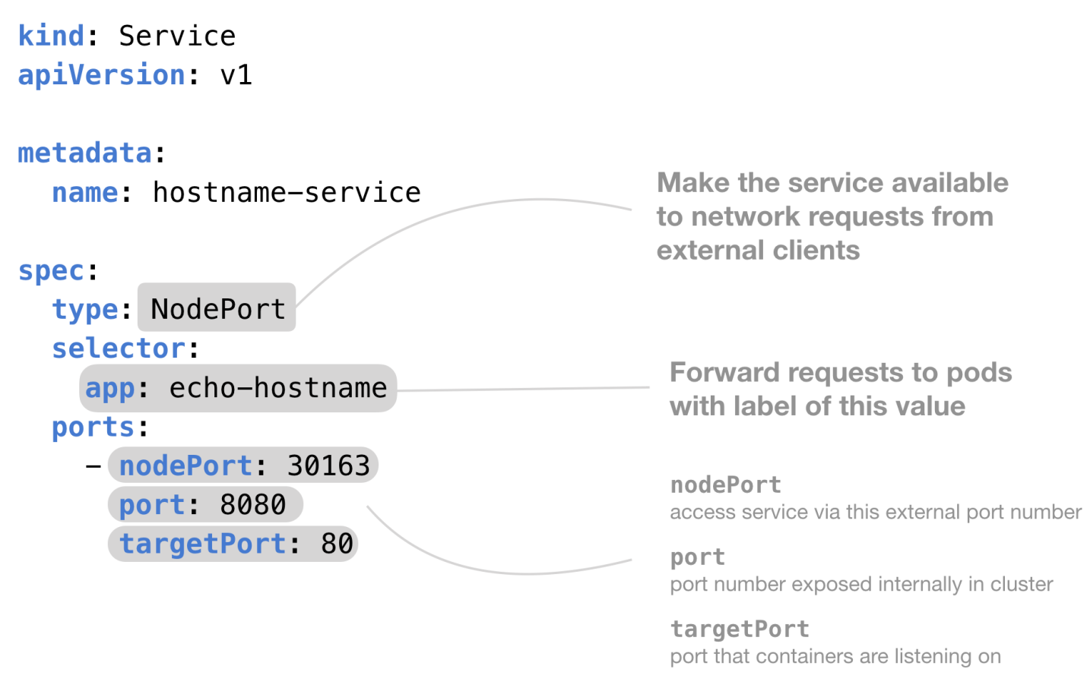

- ClusterIP – The default value. The service is only accessible from within the Kubernetes cluster
- NodePort – This makes the service accessible on a static port on each Node in the cluster.
- LoadBalancer – The service becomes accessible externally through a cloud provider's load balancer functionality. GCP, AWS, Azure, and OpenStack offer this functionality.

Running Automated Tasks with a CronJob
The main function of a job is to create one or more pod and tracks about the success of pods. They ensure that the specified number of pods are completed successfully. When a specified number of successful run of pods is completed, then the job is considered complete.

Cron jobs are useful for creating periodic and recurring tasks, like running backups or sending emails. Cron jobs can also schedule individual tasks for a specific time, such as if you want to schedule a job for a low activity period.

You need to have a Kubernetes cluster, and the kubectl command-line tool must be configured to communicate with your cluster.

Creating a Cron Job
Cron jobs require a config file. This example cron job config .spec file prints the current time and a hello message every minute:
apiVersion: batch/v1beta1
kind: CronJob
metadata:
name: hello
spec:
schedule: "*/1 * * * *"
jobTemplate:
spec:
template:
spec:
containers:
- name: hello
image: busybox
args:
- /bin/sh
- -c
- date; echo Hello from the Kubernetes cluster
restartPolicy: OnFailure

Run the above example CronJob by using this command:
kubectl create -f https://k8s.io/examples/application/job/cronjob.yaml
The output is similar to this:
cronjob.batch/hello created

After creating the cron job, get its status using this command:
kubectl get cronjob hello
The output is similar to this:
NAME SCHEDULE SUSPEND ACTIVE LAST SCHEDULE AGE
hello */1 * * * * False 0 <none> 10s

As you can see from the results of the command, the cron job has not scheduled or run any jobs yet.
Watch for the job to be created in around one minute:
kubectl get jobs --watch
The output is similar to this:
NAME COMPLETIONS DURATION AGE
hello-4111706356 0/1 0s
hello-4111706356 0/1 0s 0s
hello-4111706356 1/1 5s 5s

Now you've seen one running job scheduled by the "hello" cron job. You can stop watching the job and view the cron job again to see that it scheduled the job:
kubectl get cronjob hello
The output is similar to this:
NAME SCHEDULE SUSPEND ACTIVE LAST SCHEDULE AGE
hello */1 * * * * False 0 50s 75s

You should see that the cron job hello successfully scheduled a job at the time specified in LAST SCHEDULE. There are currently 0 active jobs, meaning that the job has completed or failed.

This cronjob will run one job every 5 minutes (using a cron format for scheduling) and display “Hello world”

apiVersion:batch/v1beta1
kind: CronJob
metadata:
name: test
spec:
schedule: "*/5 * * * *"
jobTemplate:
spec:
template:
spec:
containers:
- name: hello
image: bash
command: ["echo", "Hello world"]
restartPolicy: OnFailure
To launch this job - kubectl apply -f most_basic_cronjob.yaml

To check that the cronjob was created - kubectl get cronjob

If we check the status of our scheduled jobs after 5 minutes, here’s what we’ll see.

To check the job in detail - kubectl get job

To get the details of the job - kubectl describe cronjob test

To edit the cronjob on the fly - kubectl edit cronjob test

Deleting a Cron Job - kubectl delete cronjob hello

How to create the YAML file
The first thing we must do is create a YAML file for the task. Remember, this is a very basic task, so our YAML file won't contain too much information. Let's break it down.
The first section defines the API version and the kind of job we're creating. That section looks like:
apiVersion: batch/v1beta1
kind: CronJob

The next section details the metadata for the job. That section looks like:
metadata:
name: cron-hello

Next, we have the specs for the job. This section contains our parameters for cron and is defined by way of the schedule option, which will run the task every 15 minutes. This section looks like:
spec:
schedule: "0,15,30,45 * * * *"

Now we have the job template section, some of which will remain blank (for simplicity). This section defines the image used for the container to be deployed--in this case, busybox. It also includes a few arguments, one of which is the output to be printed for the job (remember, this is a simple task). The output will be the date and a text message printed every 15 minutes, as defined by the schedule option.
This section looks like:
jobTemplate:
spec:
template:
spec:
containers:
- name: cron-hello
image: busybox
args:
- /bin/sh
- -c
- date; echo Hello, TechRepublic!
restartPolicy: OnFailure

Create the new file with the command:
nano cron.yaml
In that file, paste the entire contents of the manifest shown below:
apiVersion: batch/v1beta1
kind: CronJob
metadata:
name: cron-hello
spec:
schedule: "0,15,30,45 * * * *"
jobTemplate:
spec:
template:
spec:
containers:
- name: cron-hello
image: busybox
args:
- /bin/sh
- -c
- date; echo Hello, TechRepublic!
restartPolicy: OnFailure

Save and close the file.

How to deploy the job
Now we're going to deploy the job that includes the scheduled task. To do that, issue the command:
kubectl create -f cron.yaml
Once the job runs, it'll report that cron-hello has been created (Figure A).
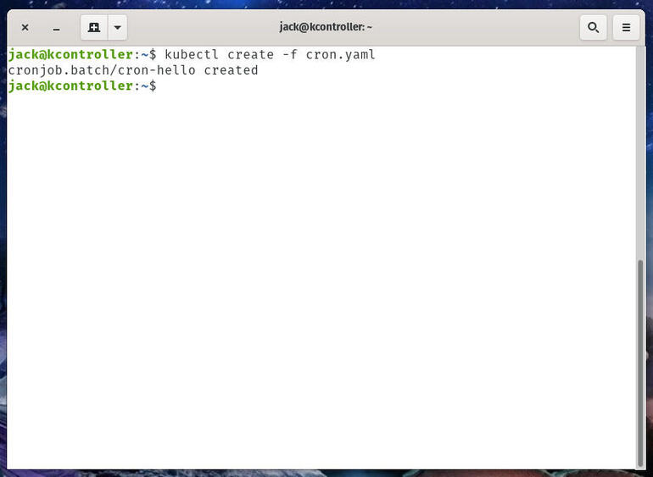
Our scheduled task deployment was successful.
You can ensure the cronjob task is running with the command:
kubeclt get cronjobs
This will list out every cronjob task on your cluster (Figure B).
Figure B
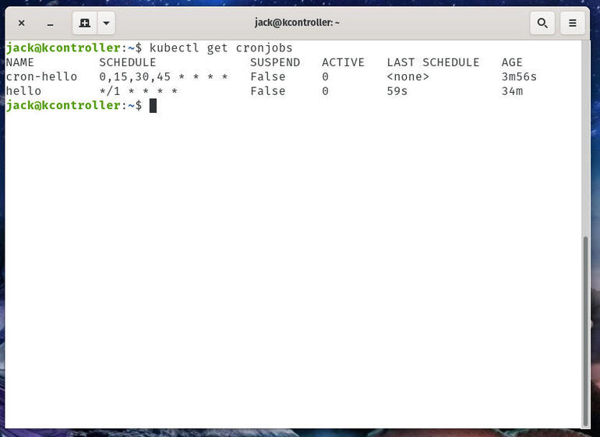
I have two containers that include cronjobs on my Kubernetes cluster.

How to watch for the cronjob
Let's say you've deployed a container with an associated cronjob and you want to watch for it. To do that, you'd issue the command:
kubectl get jobs --watch
The output of that command will include a running list of every deployed job (Figure C).
Figure C
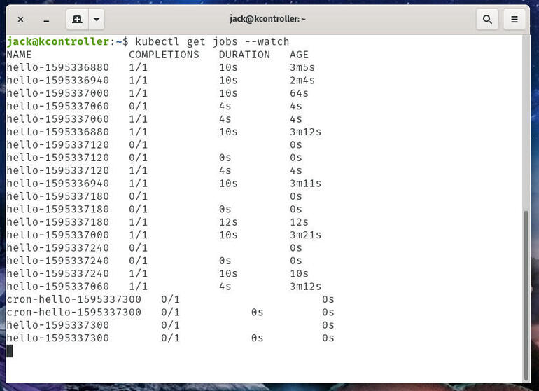
I have a number of created jobs that have run, thanks to cronjob.
To end that watch, use the Ctrl+C combination.

How to delete the cronjob
Deleting a cron-scheduled job is quite simple. To do this, issue the command:
kubectl delete cronjob NAME
Where NAME is the name used in the metadata section of the YAML file.
Alternatively, use kubectl run to create a cron job without writing full config:

$ kubectl run hello --schedule="*/1 * * * *" --restart=OnFailure --image=busybox -- /bin/sh -c "date; echo Hello from the Kubernetes cluster"

cronjob "hello" created

After creating the cron job, get its status using this command:
$ kubectl get cronjob hello
NAME SCHEDULE SUSPEND ACTIVE LAST-SCHEDULE
hello */1 * * * * False 0 <none>

As you can see above, there's no active job yet, and no job has been scheduled, either.
Watch for the job to be created in around one minute:
$ kubectl get jobs --watch
NAME DESIRED SUCCESSFUL AGE
hello-4111706356 1 1 2s
Now you've seen one running job scheduled by "hello". We can stop watching it and get the cron job again:
$ kubectl get cronjob hello
NAME SCHEDULE SUSPEND ACTIVE LAST-SCHEDULE
hello */1 * * * * False 0 Mon, 29 Aug 2016 14:34:00 -0700
You should see that "hello" successfully scheduled a job at the time specified in LAST-SCHEDULE. There are currently 0 active jobs, meaning that the job that's scheduled is completed or failed.
Now, find the pods created by the job last scheduled and view the standard output of one of the pods. Note that your job name and pod name would be different.
# Replace "hello-4111706356" with the job name in your system
$ pods=$(kubectl get pods --selector=job-name=hello-4111706356 --output=jsonpath={.items..metadata.name})

$ echo $pods
hello-4111706356-o9qcm

$ kubectl logs $pods
Mon Aug 29 21:34:09 UTC 2016
Hello from the Kubernetes cluster

Deleting a Cron Job
Once you don't need a cron job anymore, simply delete it with kubectl:
$ kubectl delete cronjob hello
cronjob "hello" deleted
This stops new jobs from being created. However, running jobs won't be stopped, and no jobs or their pods will be deleted. To clean up those jobs and pods, you need to list all jobs created by the cron job, and delete them all:
$ kubectl get jobs
NAME DESIRED SUCCESSFUL AGE
hello-1201907962 1 1 11m
hello-1202039034 1 1 8m
...

$ kubectl delete jobs hello-1201907962 hello-1202039034 ...

job "hello-1201907962" deleted
job "hello-1202039034" deleted
...
Once the jobs are deleted, the pods created by them are deleted as well. Note that all jobs created by cron job "hello" will be prefixed "hello-". You can delete them at once with kubectl delete jobs --all, if you want to delete all jobs in the current namespace (not just the ones created by "hello".)

Kubernetes Networking

- Communication between containers in the same pod
- Communication between pods on the same node
- Communication between pods on different nodes
- Communication between pods and services

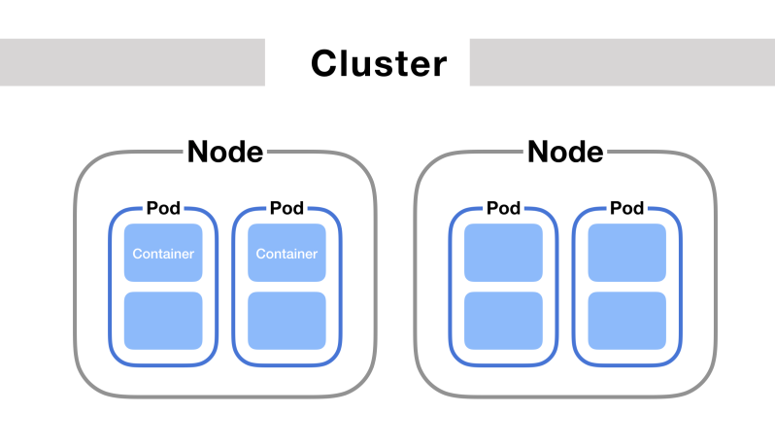
Communication between containers in the same pod
First, if you've got two containers running in the same pod, how do they talk to each other?
This happens via localhost and port numbers. Just like when you’re running multiple servers on your own laptop.
This is possible because containers in the same pod are in the same network namespace – they share networking resources.

What is a network namespace?
It’s a collection of network interfaces (connections between two pieces of equipment on a network) and routing tables (instructions for where to send network packets).
Namespaces are helpful because you can have many network namespaces on the same virtual machine without collisions or interference.
(You wouldn’t want all your pods to run containers that listen on port 3000 in the same namespace – they’d all collide!)
There’s a secret container that runs on every pod in Kubernetes. This container’s #1 job is to keep the namespace open in case all the other containers on the pod die. It’s called the pause container.
So, each pod gets its own network namespace. Containers in the same pod are in the same network namespace. This is why you can talk between containers via localhost and why you need to watch out for port conflicts when you’ve got multiple containers in the same pod.
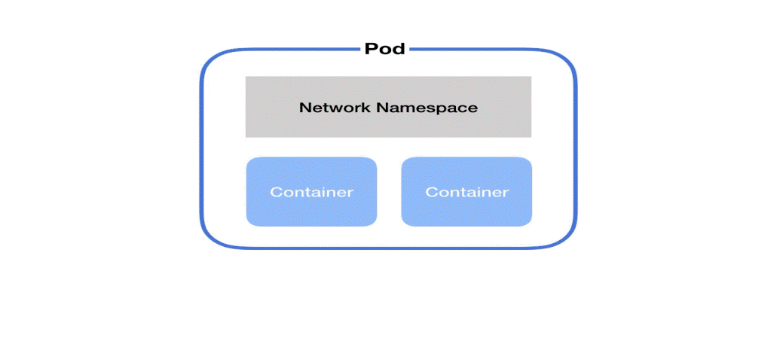

Communication between pods on the same node
Each pod on a node has its own network namespace. Each pod has its own IP address.
And each pod thinks it has a totally normal ethernet device called eth0 to make network requests through. But Kubernetes is faking it – it’s just a virtual ethernet connection.
Each pod’s eth0 device is actually connected to a virtual ethernet device in the node.
A virtual ethernet device is a tunnel that connects the pod’s network with the node. This connection has two sides – on the pod’s side, it’s named eth0, and on the node’s side, it’s named vethX.
Why the X? There’s a vethX connection for every pod on the node. (So they’d be veth1, veth2, veth3, etc.)
When a pod makes a request to the IP address of another node, it makes that request through its own eth0 interface. This tunnels to the node’s respective virtual vethX interface.
But then how does the request get to the other pod?
The node uses a network bridge.

What is a Network Bridge?
A network bridge connects two networks together. When a request hits the bridge, the bridge asks all the connected devices (i.e. pods) if they have the right IP address to handle the original request.
(Remember that each pod has its own IP address and it knows its own IP address.)
If one of the devices does, the bridge will store this information and also forward data to the original back so that its network request is completed.
In Kubernetes, this bridge is called cbr0. Every pod on a node is part of the bridge, and the bridge connects all pods on the same node together.
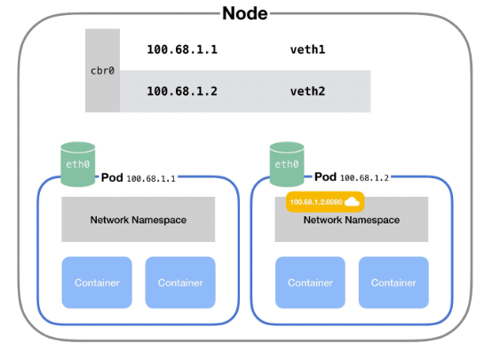

Communication between pods on different nodes
But what if pods are on different nodes?
Well, when the network bridge asks all the connected devices (i.e. pods) if they have the right IP address, none of them will say yes.
(Note that this part can vary based on the cloud provider and networking plugins.)
After that, the bridge falls back to the default gateway. This goes up to the cluster level and looks for the IP address.
At the cluster level, there’s a table that maps IP address ranges to various nodes. Pods on those nodes will have been assigned IP addresses from those ranges.
For example, Kubernetes might give pods on node 1 addresses like 100.96.1.1, 100.96.1.2, etc. And Kubernetes gives pods on node 2 addresses like 100.96.2.1, 100.96.2.2, and so on.
Then this table will store the fact that IP addresses that look like 100.96.1.xxx should go to node 1, and addresses like 100.96.2.xxx need to go to node 2.
After we’ve figured out which node to send the request to, the process proceeds the roughly same as if the pods had been on the same node all along.
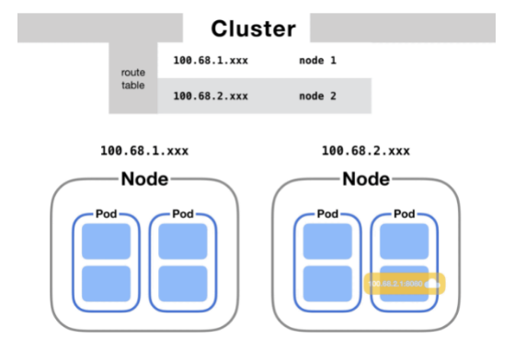

Communication between pods and services
One last communication pattern is important in Kubernetes.
In Kubernetes, a service lets you map a single IP address to a set of pods. You make requests to one endpoint (domain name/IP address) and the service proxies requests to a pod in that service.
This happens via kube-proxy a small process that Kubernetes runs inside every node.
This process maps virtual IP addresses to a group of actual pod IP addresses.
Once kube-proxy has mapped the service virtual IP to an actual pod IP, the request proceeds as in the above sections.

How does DNS work? How do we discover IP addresses?
DNS is the system for converting domain names to IP addresses.
Kubernetes clusters have a service responsible for DNS resolution.
Every service in a cluster is assigned a domain name like my-service.my-namespace.svc.cluster.local.
Pods are automatically given a DNS name, and can also specify their own using the hostname and subdomain properties in their YAML config.
So when a request is made to a service via its domain name, the DNS service resolves it to the IP address of the service.
Then kube-proxy converts that service's IP address into a pod IP address. After that, based on whether the pods are on the same node or on different nodes, the request follows one of the paths explained above.

Creating Namespaces
Don’t be afraid to create namespaces. They don’t add a performance penalty, and in many cases can actually improve performance as the Kubernetes API will have a smaller set of objects to work with.
Creating a Namespace can be done with a single command. If you wanted to create a Namespace called ‘test’ you would run:

kubectl create namespace test

Or you can create a YAML file and apply it just like any other Kubernetes resource.
test.yaml:
apiVersion: v1
kind: Namespace
metadata:
name: test
labels:
name: test
kubectl apply -f test.yaml

Viewing Namespaces
You can see all the Namespaces with the following command:
kubectl get namespace
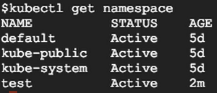

Creating Resources in the Namespace
Let’s take a look at a simple YAML to create a Pod:
apiVersion: v1
kind: Pod
metadata:
name: mypod
labels:
name: mypod
spec:
containers:
- name: mypod
image: nginx

You might notice that there is no mention of namespaces anywhere. If you run a `kubectl apply` on this file, it will create the Pod in the current active namespace. This will be the “default” namespace unless you change it.
There are two ways to explicitly tell Kubernetes in which Namespace you want to create your resources.
One way is to set the “namespace” flag when creating the resource:
kubectl apply -f pod.yaml --namespace=test
You can also specify a Namespace in the YAML declaration.
apiVersion: v1
kind: Pod
metadata:
name: mypod
namespace: test
labels:
name: mypod
spec:
containers:
- name: mypod
image: nginx
If you specify a namespace in the YAML declaration, the resource will always be created in that namespace. If you try to use the “namespace” flag to set another namespace, the command will fail.

Viewing resources in the Namespace
If you try to find your Pod, you might notice you can’t!
$ kubectl get pods
No resources found.
This is because all commands are run against the currently active Namespace. To find your Pod, you need to use the “namespace” flag.
$ kubectl get pods --namespace=test
NAME READY STATUS RESTARTS AGE
mypod 1/1 Running 0 10s
This can get annoying quickly, especially if you are a developer working on a team that uses its own Namespace for everything and don’t want to use the “namespace” flag for every command. Let’s see how we can fix that.

Managing your active Namespace
Out of the box, your active namespace is the “default” namespace. Unless you specify a Namespace in the YAML, all Kubernetes commands will use the active Namespace.
Unfortunately, trying to manage your active Namespace with kubectl can be a pain. Fortunately, there is a really good tool called kubens (created by the wonderful Ahmet Alp Balkan) that makes it a breeze!
When you run the ‘kubens’ command, you should see all the namespaces, with the active namespace highlighted:
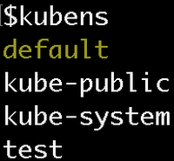
To switch your active namespace to the ‘test’ Namespace, run:
kubens test
Now you can see that the ‘test’ Namespace is active:
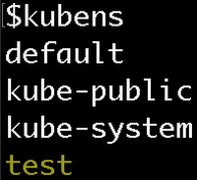
Now, if you run kubectl commands, the Namespace will be ‘test’ instead of ‘default’! This means you don’t need the namespace flag to see the pod in the test namespace.
$ kubectl get pods
NAME READY STATUS RESTARTS AGE
mypod 1/1 Running 0 10m

Creating a new namespace
- Create a new YAML file called my-namespace.yaml with the contents:

- apiVersion: v1
- kind: Namespace
- metadata:
- name: <insert-namespace-name-here>
Then run:
kubectl create -f ./my-namespace.yaml
- Alternatively, you can create namespace using below command:
- kubectl create namespace <insert-namespace-name-here>

The name of your namespace must be a valid DNS label.

Subdividing your cluster using Kubernetes namespaces

In a scenario where an organization is using a shared Kubernetes cluster for development and production use cases:
The development team would like to maintain a space in the cluster where they can get a view on the list of Pods, Services, and Deployments they use to build and run their application. In this space, Kubernetes resources come and go, and the restrictions on who can or cannot modify resources are relaxed to enable agile development.
The operations team would like to maintain a space in the cluster where they can enforce strict procedures on who can or cannot manipulate the set of Pods, Services, and Deployments that run the production site.
One pattern this organization could follow is to partition the Kubernetes cluster into two namespaces: development and production.
Let's create two new namespaces to hold our work.
Create the development namespace using kubectl:
kubectl create -f https://k8s.io/examples/admin/namespace-dev.json
or
kubectl create –f ./namespace-dev.yml

And then let's create the production namespace using kubectl:
kubectl create -f https://k8s.io/examples/admin/namespace-prod.json
or
kubectl create –f ./namespace-prod.yml

To be sure things are right, list all of the namespaces in our cluster.
kubectl get namespaces --show-labels

NAME STATUS AGE LABELS
default Active 32m <none>
development Active 29s name=development
production Active 23s name=production

namespace-dev.yml
apiVersion: v1
kind: Namespace
metadata:
name: development
labels:
name: development

namespace-prod.yml
apiVersion: v1
kind: Namespace
metadata:
name: production
labels:
name: production

A Kubernetes namespace provides the scope for Pods, Services, and Deployments in the cluster.

To demonstrate this, let's spin up a simple Deployment and Pods in the development namespace.

kubectl create deployment snowflake --image=k8s.gcr.io/serve_hostname -n=development --replicas=2

We have created a deployment whose replica size is 2 that is running the pod called snowflake with a basic container that serves the hostname.
kubectl get deployment -n=development
NAME READY UP-TO-DATE AVAILABLE AGE
snowflake 2/2 2 2 2m

kubectl get pods -l app=snowflake -n=development
NAME READY STATUS RESTARTS AGE
snowflake-3968820950-9dgr8 1/1 Running 0 2m
snowflake-3968820950-vgc4n 1/1 Running 0 2m

And this is great, developers are able to do what they want, and they do not have to worry about affecting content in the production namespace.
Let's switch to the production namespace and show how resources in one namespace are hidden from the other.The production namespace should be empty, and the following commands should return nothing.
kubectl get deployment -n=production
kubectl get pods -n=production

Production likes to run cattle, so let's create some cattle pods.

kubectl create deployment cattle --image=k8s.gcr.io/serve_hostname -n=production
kubectl scale deployment cattle --replicas=5 -n=production

kubectl get deployment -n=production

NAME READY UP-TO-DATE AVAILABLE AGE
cattle 5/5 5 5 10s

kubectl get pods -l app=cattle -n=production

NAME READY STATUS RESTARTS AGE
cattle-2263376956-41xy6 1/1 Running 0 34s
cattle-2263376956-kw466 1/1 Running 0 34s
cattle-2263376956-n4v97 1/1 Running 0 34s
cattle-2263376956-p5p3i 1/1 Running 0 34s
cattle-2263376956-sxpth 1/1 Running 0 34s

At this point, it should be clear that the resources users create in one namespace are hidden from the other namespace.

Create Horizontal Pod Autoscaler:
Now that the server is running, we will create the autoscaler using kubectl autoscale. The following command will create a Horizontal Pod Autoscaler that maintains between 1 and 10 replicas of the Pods controlled by the php-apache deployment we created in the first step of these instructions. Roughly speaking, HPA will increase and decrease the number of replicas (via the deployment) to maintain an average CPU utilization across all Pods of 50% (since each pod requests 200 milli-cores by kubectl run), this means average CPU usage of 100 milli-cores). See here for more details on the algorithm.
kubectl autoscale deployment php-apache --cpu-percent=50 --min=1 --max=10
horizontalpodautoscaler.autoscaling/php-apache autoscaled
We may check the current status of autoscaler by running:
kubectl get hpa
NAME REFERENCE TARGET MINPODS MAXPODS REPLICAS AGE
php-apache Deployment/php-apache/scale 0% / 50% 1 10 1 18s

Please note that the current CPU consumption is 0% as we are not sending any requests to the server (the TARGET column shows the average across all the pods controlled by the corresponding deployment).

Increase load
Now, we will see how the autoscaler reacts to increased load. We will start a container, and send an infinite loop of queries to the php-apache service (please run it in a different terminal):
kubectl run -it --rm load-generator --image=busybox /bin/sh

Hit enter for command prompt

while true; do wget -q -O- http://php-apache; done
Within a minute or so, we should see the higher CPU load by executing:
kubectl get hpa
NAME REFERENCE TARGET MINPODS MAXPODS REPLICAS AGE
php-apache Deployment/php-apache/scale 305% / 50% 1 10 1 3m

Here, CPU consumption has increased to 305% of the request. As a result, the deployment was resized to 7 replicas:
kubectl get deployment php-apache
NAME READY UP-TO-DATE AVAILABLE AGE
php-apache 7/7 7 7 19m
Note: It may take a few minutes to stabilize the number of replicas. Since the amount of load is not controlled in any way it may happen that the final number of replicas will differ from this example.

Stop load
We will finish our example by stopping the user load.
In the terminal where we created the container with busybox image, terminate the load generation by typing <Ctrl> + C.
Then we will verify the result state (after a minute or so):
kubectl get hpa
NAME REFERENCE TARGET MINPODS MAXPODS REPLICAS AGE
php-apache Deployment/php-apache/scale 0% / 50% 1 10 1 11m
kubectl get deployment php-apache
NAME READY UP-TO-DATE AVAILABLE AGE
php-apache 1/1 1 1 27m

To get the yaml for a deployment (service, pod, secret, etc):
kubectl get deploy deploymentname -o yaml --export
Bash script exporting yaml to sub-folders:
for n in $(kubectl get -o=name pvc,configmap,serviceaccount,secret,ingress,service,deployment,statefulset,hpa,job,cronjob)
do
mkdir -p $(dirname $n)
kubectl get -o=yaml --export $n > $n.yaml
done

