fTerminology:
Jenkins
Jenkins is an open source Continuous Integration system. It is a process in which developers puts their code in a shared repository and every time the automated cycle is performed from Build, Test and Deploy, etc.
SonarQube
SonarQube is an open source platform used for continuous analysis of your source code quality by performing analysis of your code to detect duplications, bugs, security vulnerabilities and code smells.
Why should Integrating SonarQube and Jenkins Useful:
When you are working on a project and if are doing SonarQube analysis sometimes then you can do that easily but if the scenario changes to that SonarQube analysis will be performed after completion of each and every task or say deployment then the manual action would become hard to rely on. So, to overcome the problem of manual analysis with it,
SonarQube is integrated with Jenkins which performs automated tasks. Now, you have to only add your sonar script for analysis in Jenkins job to perform SonarQube analysis and you can perform this action as your requirements and also get a quality report of your code in SonarQube.
Pre-requisites:
- Install Java 8 from the Oracle website.
- Install any database from following
Must be configured to use UTF8 charset
Database | Version
PostgreSQL | 8.x  9.x
Microsoft SQL Server | 2014 (MSSQL Server 12.0)  2016 (MSSQL Server 13.0)
Oracle | 11G  12C  XE Editions are supported
MySQL | 5.6  5.7
Let’s start, We have explained an integration process of SonarQube and Jenkins in three simple steps as below:
- Jenkins Installation
- SonarQube Installation
- Integration of SonarQube in Jenkins
1. Jenkins Installation
- Download OS based file for setup or war file from Jenkins Downloads.
- On the restart system, Jenkins will start automatically if you had installed it with OS installer package. It also generates WAR file but in Linux, it is in /usr/share/jenkins directory.
If you had downloaded the WAR file, you can put it any folder as your requirement.
- Jenkins will start on port 8080 by default.
To start Jenkins on a different port you can use the following command (You can change port here) and you can find Jenkins password in logs of terminal or in the log file of Jenkins from /var/log/jenkins/jenkins.log.
java -jar jenkins.war --httpPort=8080
2. SonarQube Installation
SonarQube is used to analyze the source code of our project.
- Download SonarQube from SonarQube Downloads.
- Unzip the file in a directory which can be accessed without root permissions. Because SonarQube also contains the ElasticSearch which will be in SonarQube directory.So, basically, when you start SonarQube instance with root permissions it will generate an error in the start-up of ElasticSearch.
- Before starting the server you have to set database connection with sonar. And you can find it in sonar.properties in sonarqube/conf
- sonar.jdbc.url
- sonar.jdbc.username
sonar.jdbc.password
- SonarQuber server will start on port 9000. You can alter it in sonar.properties file
sonar.web.port=9000
- To start SonarQube Server from its directory /bin/[OS directory]
sh sonar.sh console
3. Integration of SonarQube in Jenkins
For the integration of SonarQube in Jenkins, you have performed the following steps.
- Login into Jenkins and install SonarQube scanner plugin
Go to Manage Jenkins –> Manage Plugins > Available –> SonarQube scanner
And also add credentials plugins to store your credentials in Jenkins
- Configure SonarQube home path
Go to Manage Jenkins –> Global Tool Configuration –> SonarQube Scanner
  - Name : sonar_scanner
  - SONAR_RUNNER_HOME : /opt/sonarqube (Your directory path of SonarQube)
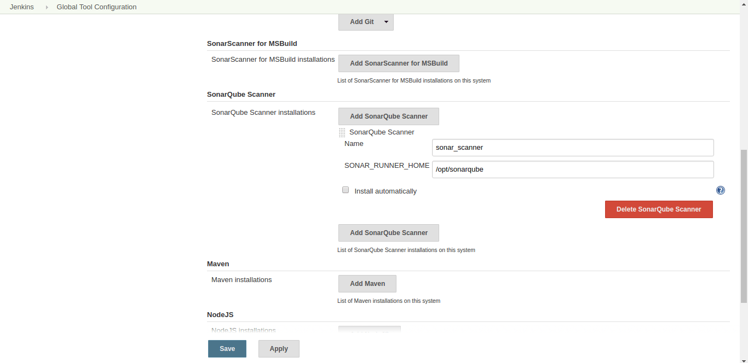
- Now, Configure SonarQube server in Jenkins
  - For integration, you need SonarQube Server authentication token in Jenkins
i. Log in into your SonarQube Server and find following under user bar
Go to My Account –> Security –> Generate Token
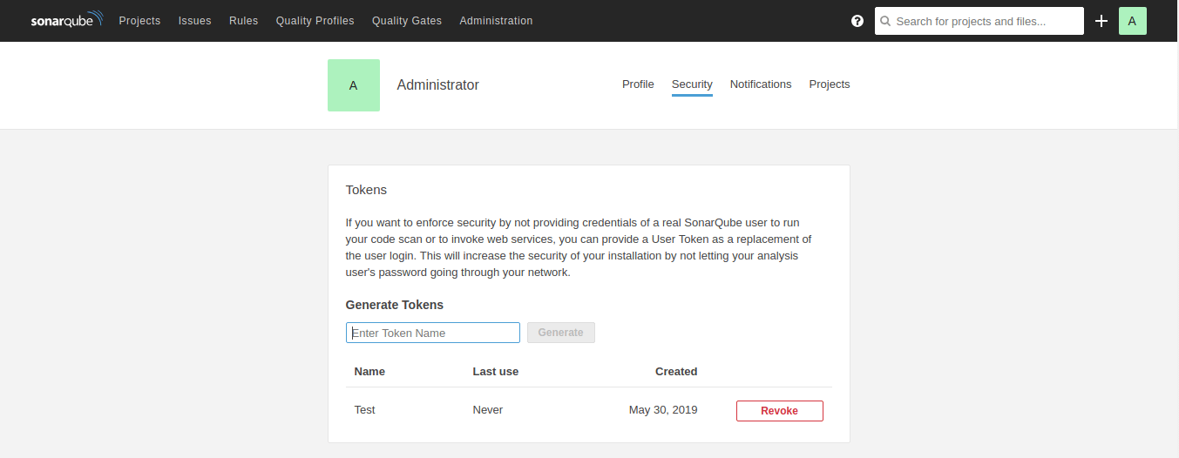
  - Go to Manage Jenkins –> Configure Systems –> SonarQube Servers
Name : SonarQube
Server URL : Not Required is same as default
Server authentication token :
i. Add server authentication token as following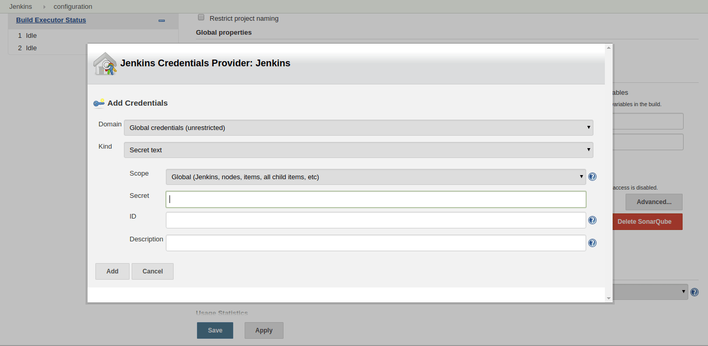
ii. Select it as a server authentication token
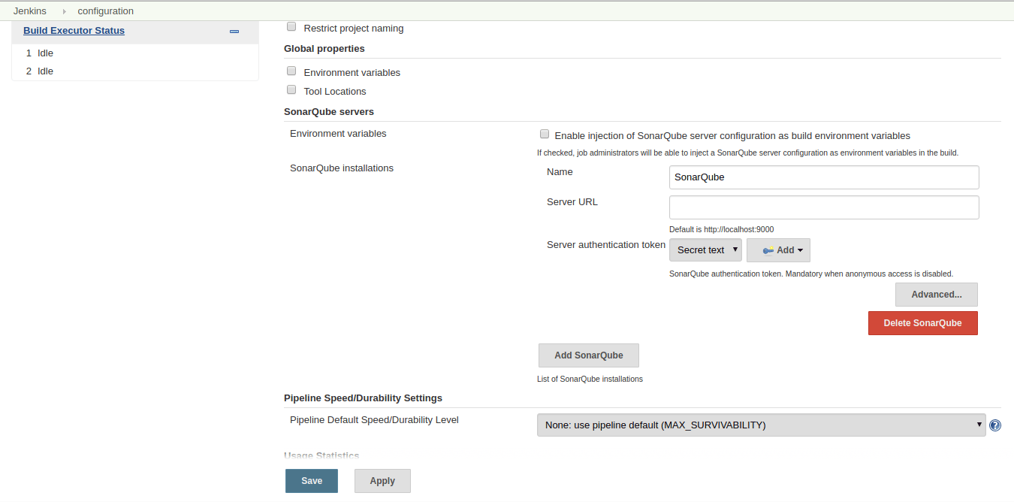
- Save it. Now, your SonarQube integration is completed with Jenkins. Create a job (Follow Jenkins – Continuous Integration System) to test SonarQube and to generate a report of your project.
Following is an example of Jenkins Pipeline integrated with SonarQube. Last stage “Quality Analysis” will perform SonarQube quality analysis execution.
- 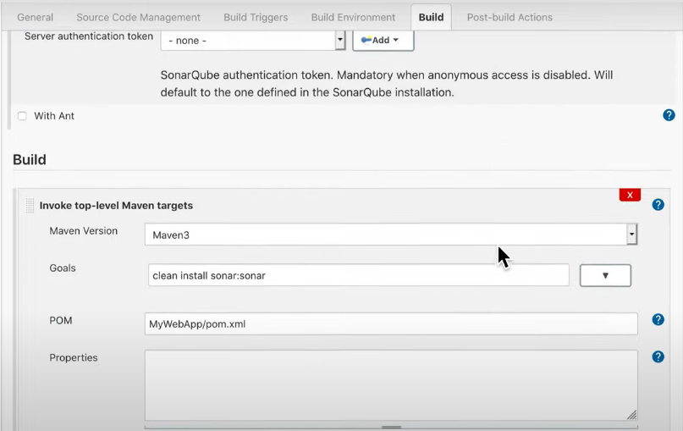
- 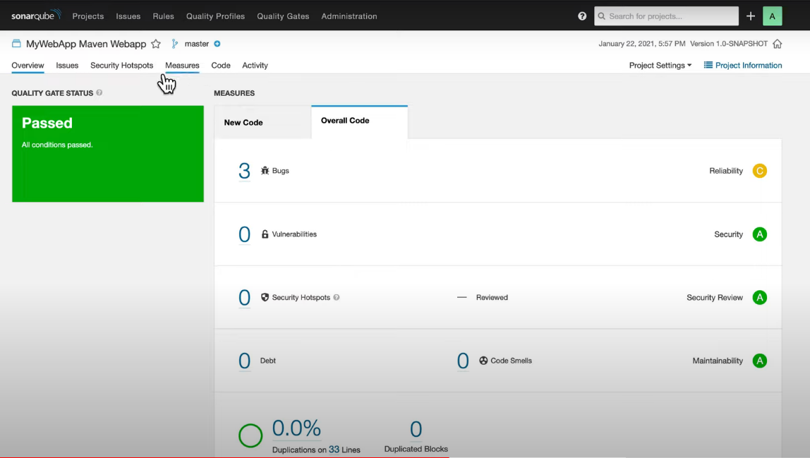
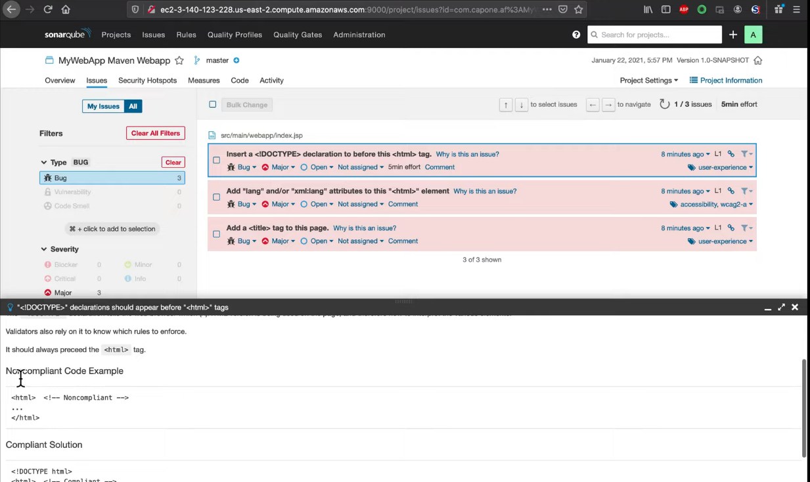
- 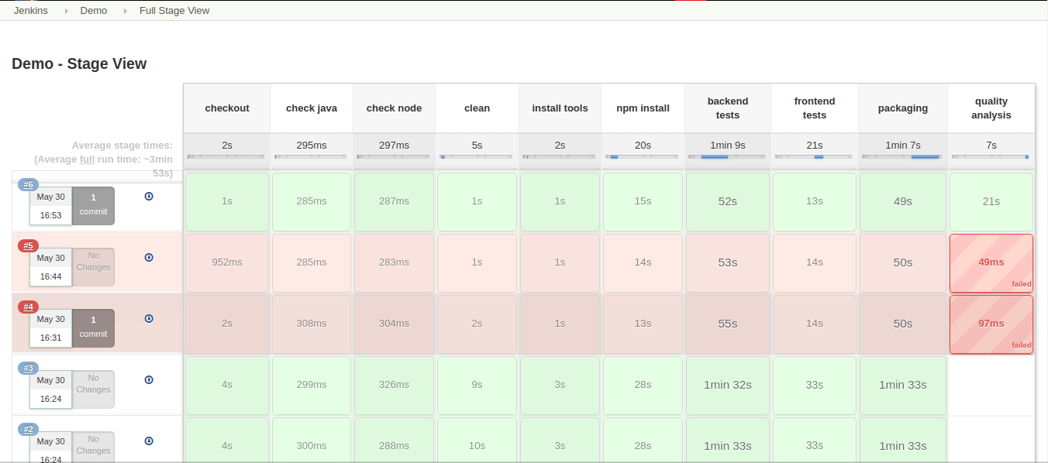
When you login into SonarQube server using, you will get analysis report of your code.
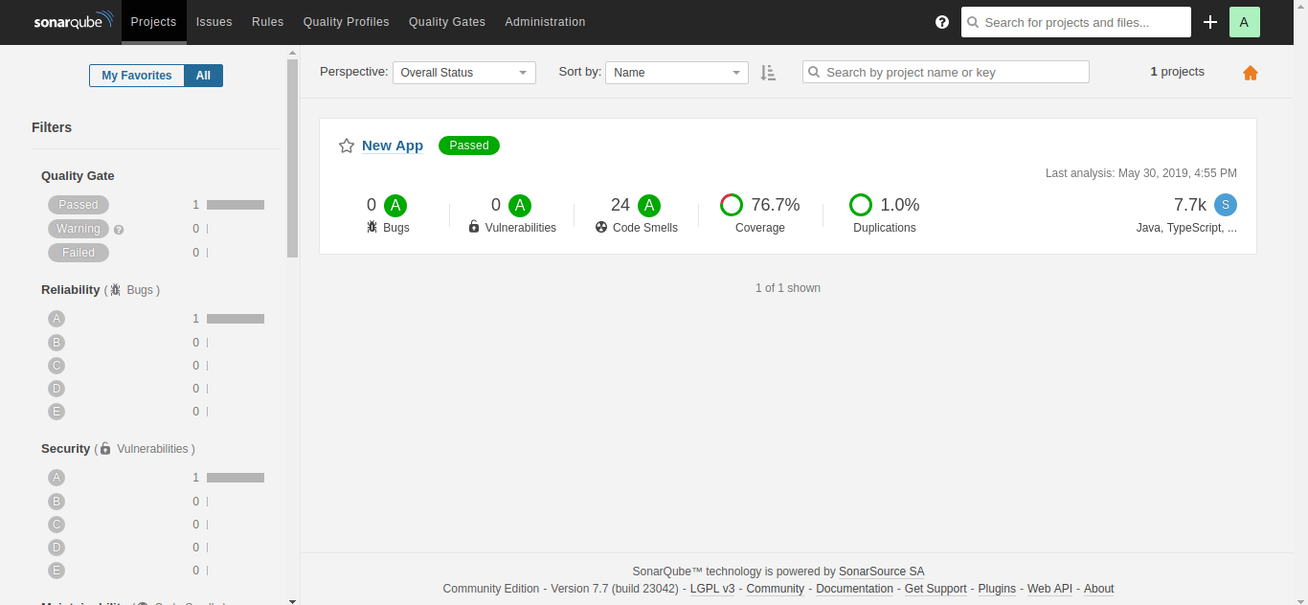
Jenkins Master Slave
Jenkins Master
Your main Jenkins server is the master machine. The tasks performed by the master are :
- Scheduling build jobs.
- Dispatching builds to the slaves for the execution.
- Monitor the slaves.
- Recording and presenting the build results.
- Can also execute build jobs directly.
Jenkins Slave
A slave is a Java executable that runs on a remote machine. The characteristics of the slave are :
- It hears requests from the Jenkins Master instance.
- Slaves can run on a variety of operating systems.
- The job of a Slave is to do as they are told to, which involves executing build jobs dispatched by the Master.
- We can configure a project to always run on a particular Slave machine or a particular type of Slave machine, or simply let Jenkins pick the next available Slave.

Advantages of Jenkins include:
- It is an open-source tool with great community support.
- Too easy to install.
- It has 1000+ plugins to ease your work. If a plugin does not exist, you can code it and share it with the community.
- It is free of cost.
- It is built with Java and hence, it is portable to all the major platforms.

Jenkins Architecture
Let us have a look at the Jenkins Architecture below diagram depicts the same.
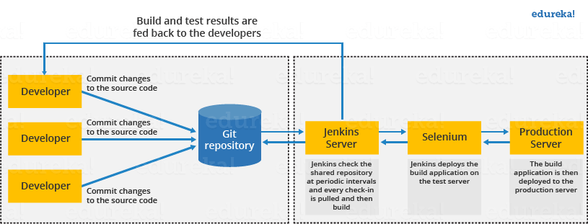
This single Jenkins server was not enough to meet certain requirements like:
- Sometimes you might need several different environments to test your builds. This cannot be done by a single Jenkins server.
- If larger and heavier projects get built on a regular basis then a single Jenkins server cannot simply handle the entire load.
To address the above-stated needs, Jenkins distributed architecture came into the picture.

Jenkins Distributed Architecture
Jenkins uses a Master-Slave architecture to manage distributed builds. In this architecture, Master and Slave communicate through TCP/IP protocol.

Jenkins Master
Your main Jenkins server is the Master. The Master’s job is to handle:
- Scheduling build jobs.
- Dispatching builds to the slaves for the actual execution.
- Monitor the slaves (possibly taking them online and offline as required).
- Recording and presenting the build results.
- A Master instance of Jenkins can also execute build jobs directly.

Jenkins Slave
A Slave is a Java executable that runs on a remote machine. Following are the characteristics of Jenkins Slaves:
- It hears requests from the Jenkins Master instance.
- Slaves can run on a variety of operating systems.
- The job of a Slave is to do as they are told to, which involves executing build jobs dispatched by the Master.
- You can configure a project to always run on a particular Slave machine or a particular type of Slave machine, or simply let Jenkins pick the next available Slave.
The diagram below is self-explanatory. It consists of a Jenkins Master which is managing three Jenkins Slave.
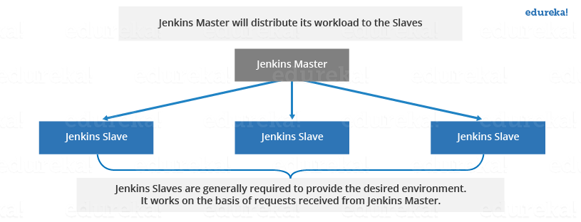

How Jenkins Master and Slave Architecture works?
Now let us look at an example in which we use Jenkins for testing in different environments like Ubuntu, MAC, Windows, etc.
The diagram below represents the same:
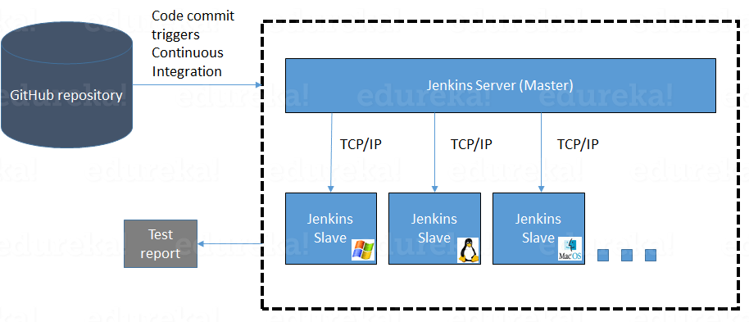
The above image represents the following functions:
- Jenkins checks the Git repository at periodic intervals for any changes made in the source code.
- Each builds requires a different testing environment which is not possible for a single Jenkins server. In order to perform testing in different environments, Jenkins uses various Slaves as shown in the diagram.
- Jenkins Master requests these Slaves to perform testing and to generate test reports.

How to setup Jenkins Master and Slaves?
- Go to the Manage Jenkins section and scroll down to the section of Manage Nodes.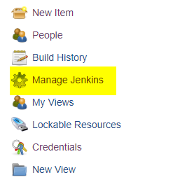

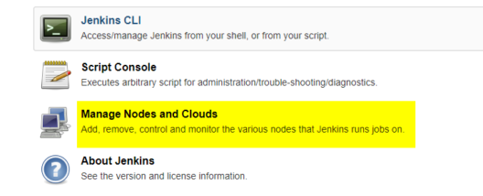

2. Click on New Node
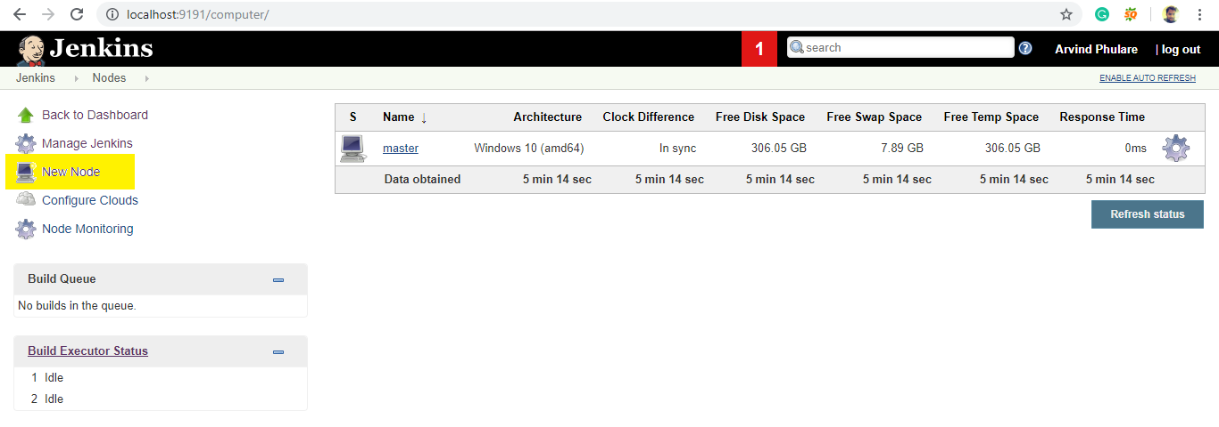3. Give a name for the node, choose the Permanent Agent option and click on Ok.
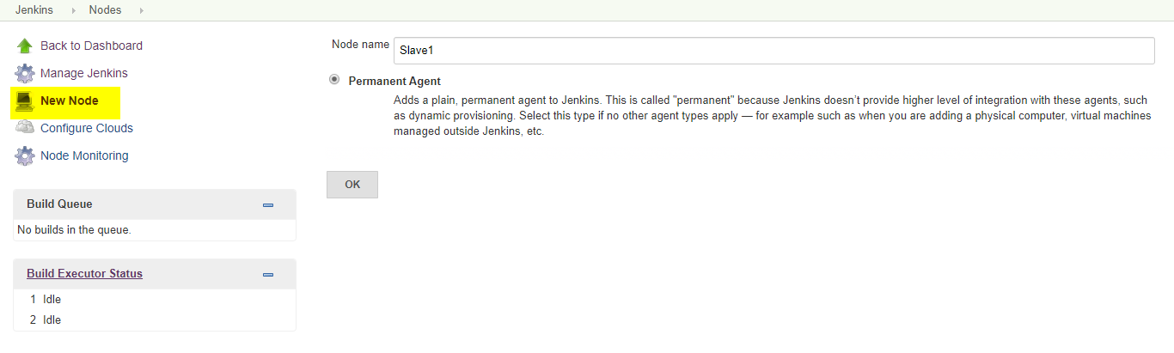4. Enter the details of the node slave machine. Here no. of executers in nothing but no. of jobs that this slave can run parallely. Here we have kept it to 2. The Labels for which the name is entered as “Slave1” is what can be used to configure jobs to use this slave machine.Select Usage to Use this node as much as possible. For launch method we select the option of “Launch agent by connecting it to the master”. If this option is not visible then go to Jenkins home page -> Manage Jenkins -> Configure Global Security. Here in the Agents section click on Random and Save it. Now you will find the required option. Enter Custom WorkDir path as the workspace of your slave node. In Availability select “Keep this agent online as much as possible”.Click on Save.
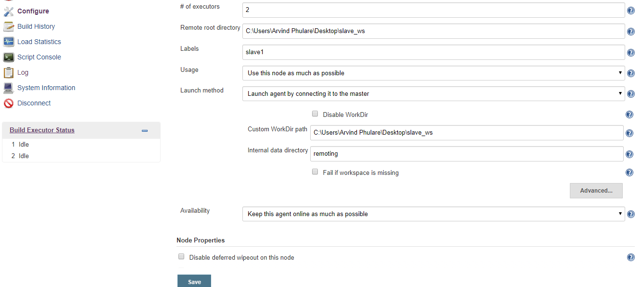
Once you complete the above steps, the new node machine will initially be in an offline state but will come online if all the settings in the previous screen were entered correctly. One can at any time make the node slave machine offline if required.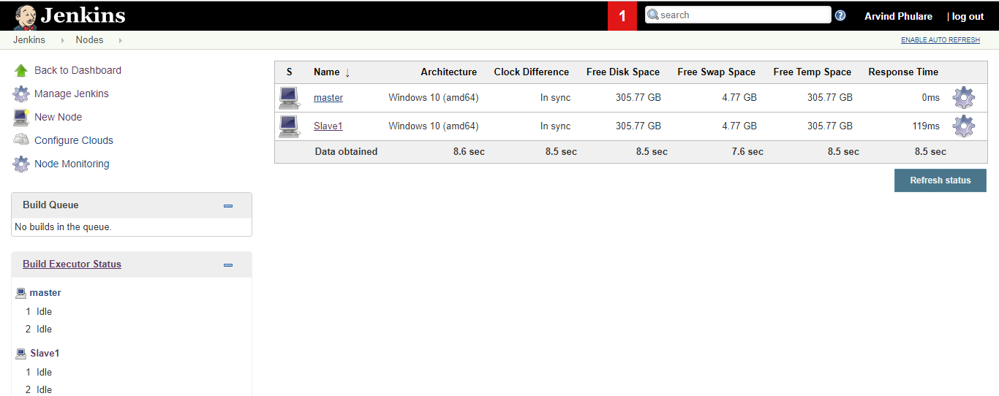
5. Now since your slave is up and running, lets execute a job on slave. For that I already have an existing job and I will run this job on this slave. Open this job and click on configure. Now here in the General section, click on “Restrict where this project can be run”. Here in Label Expression, enter the name of the slave and save it. Now click on Build now and see the output of this job. Everything is correct you will see the output as Success.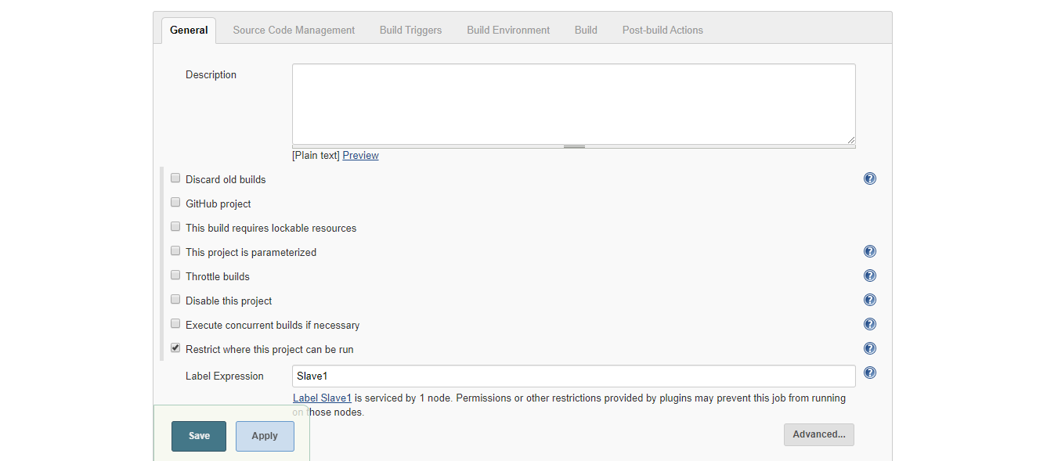

Steps to Configure Jenkins Master and Slave Nodes
- Click on Manage Jenkins in the left corner on the Jenkins dashboard.
- Click on Manage Nodes.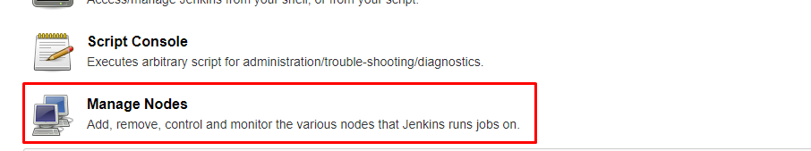
- Select New Node and enter the name of the node in the Node Name field.
- Select Permanent Agent and click the OK button. Initially, you will get only one option, "Permanent Agent." Once you have one or more slaves you will get the "Copy Existing Node" option.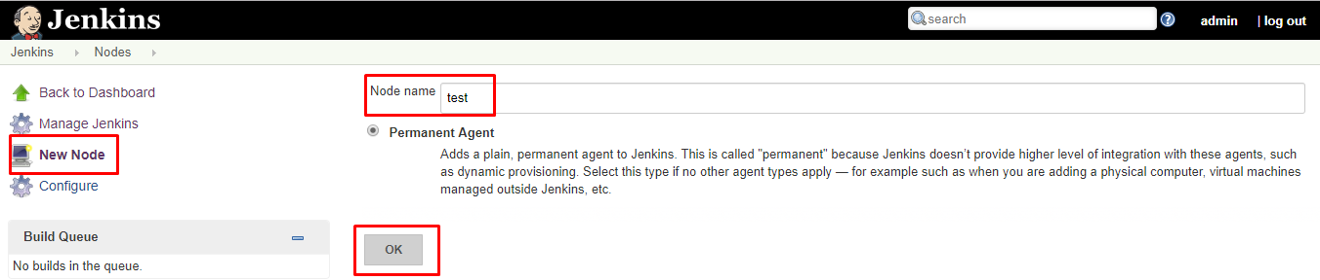
- Enter the required information.
Some required fields include:
1
Name: Name of the Slave. e.g: Test
2
​
3
Description: Description for this slave (optional). e.g: testing slave
4
​
5
# of Executors: Maximum number of Parallel builds Jenkins master perform on this slave. e.g: #2
6
​
7
Remote root directory: A slave needs to have a directory dedicated to Jenkins. Specify the path to this directory on the agent. e.g: /home/
8
​
9
Usage: Controls how Jenkins schedules builds on this node. e.g: Only build jobs with label expressions matching this node.
10
​
11
Launch method: Controls how Jenkins starts this agent. e.g: Launch agent agents via SSH
6. Enter the Hostname in the Host field.
7. Select the Add button to add credentials. and click Jenkins.
8. Enter Username, Password, ID, and Description.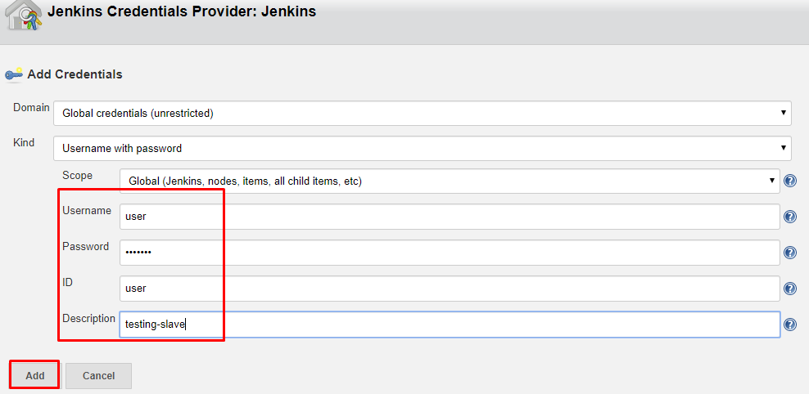
9. Select the dropdown menu to add credentials in the Credentials field.
10. Select the next dropdown to add the Host Key Verification Strategy under Non verifying Verification Strategy.
11. Select Keep this agent online as much as possible in the Availability field.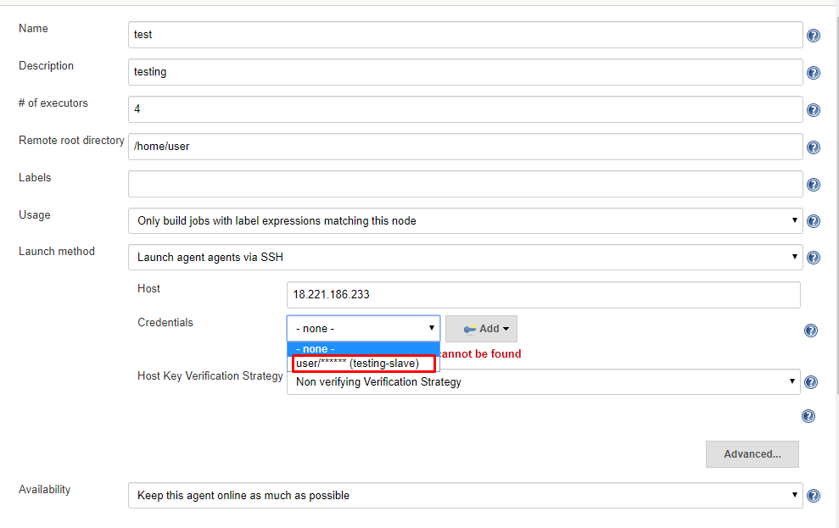
12. Click the Save button.
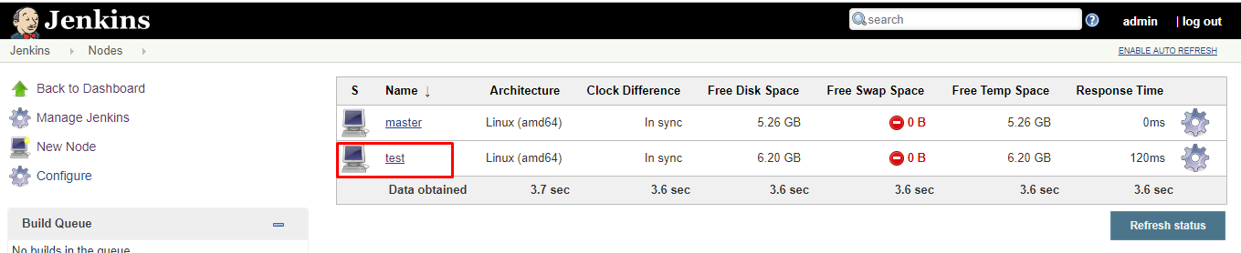

Creating a Freestyle Project and Running on The Slave Machine
- Click on Save and it will redirect to job's view page
- On the left pane, click the Build Now button to execute your Pipeline.
- We can verify the history of the executed build under the Build History by clicking the build number.
- Click on the build number and select Console Output. Here you can see the executed job in the remote host and output.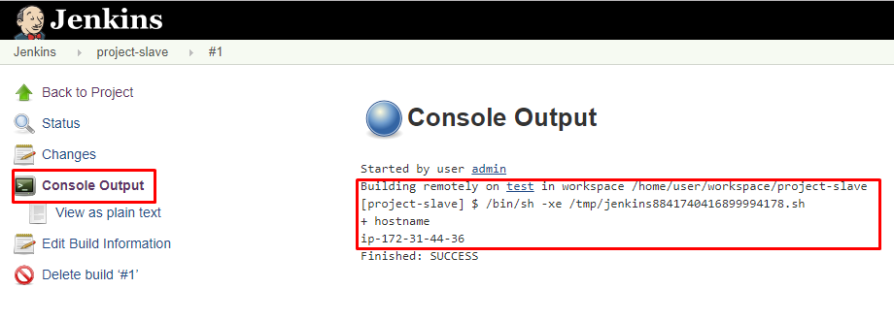

Creating a Pipeline and Running on The Slave Machine
- Click New Item in the top left corner on the dashboard.
- Enter the name of your project in the Enter an item name field, and select the Pipeline project, and click OK button.
- Enter Description (optional).
- Go to the Pipeline section, make sure the Definition field has the Pipeline script option selected.
- Copy and paste the following declarative Pipeline script into a script field.
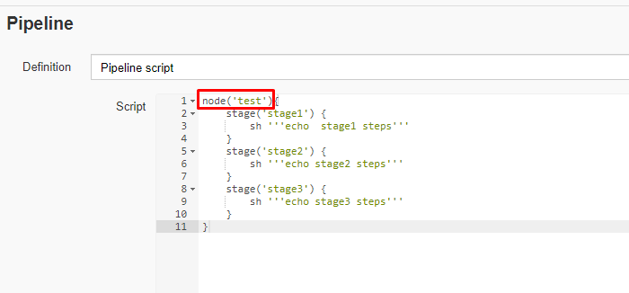
6. Click on Save, it will redirect to the Pipeline view page.
7. On the left pane, click the Build Now button to execute your Pipeline.
8. After Pipeline execution is completed, the Pipeline view will be as shown below.
9. We can verify the history of executed build under the Build History by clicking the build number.
10. Click on build number and select Console Output. Here you can see that the pipeline ran on a slave machine.
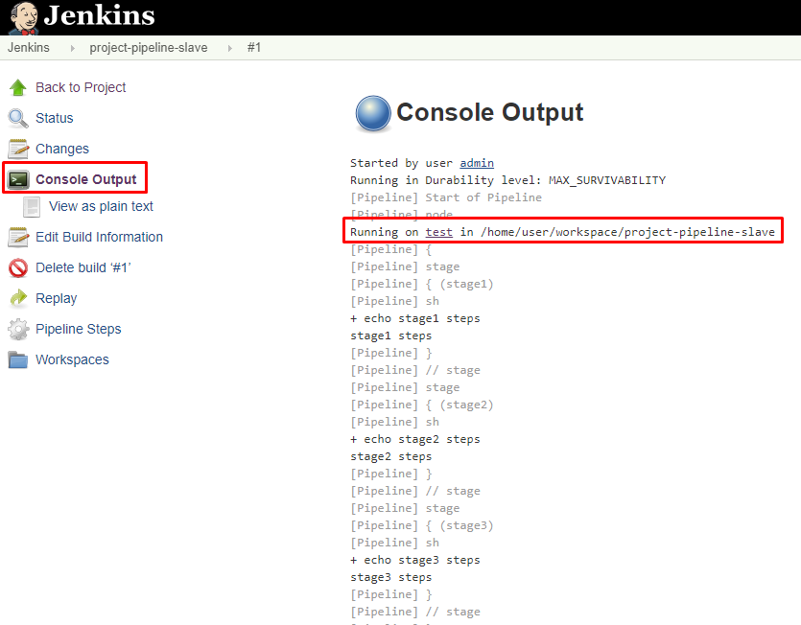

Adding a slave node in Jenkins Master

Step 1 – Go to manage Jenkins – click on new node

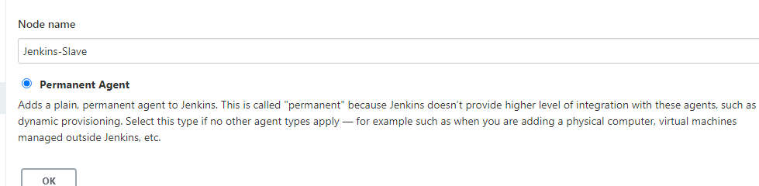

Fill all the details as below

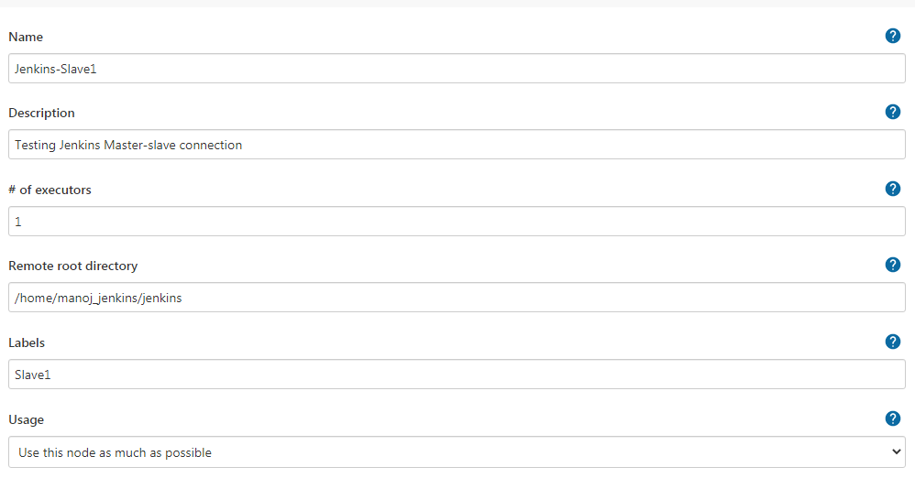

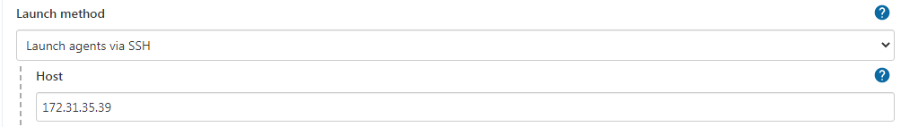

Add credentials of the agent

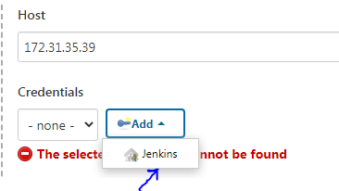

A new window will appear where you have to provide details

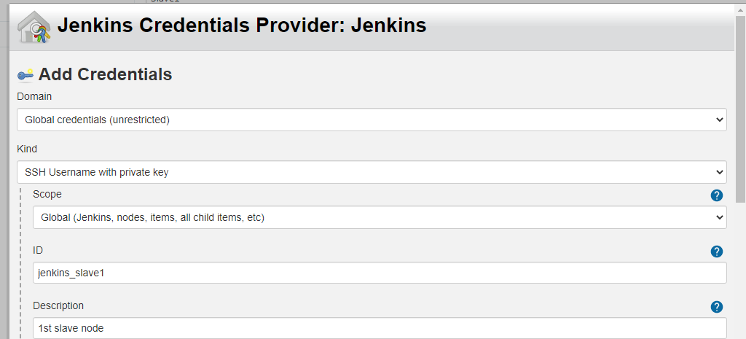

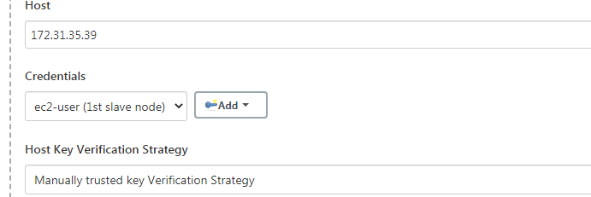

You can see node is added

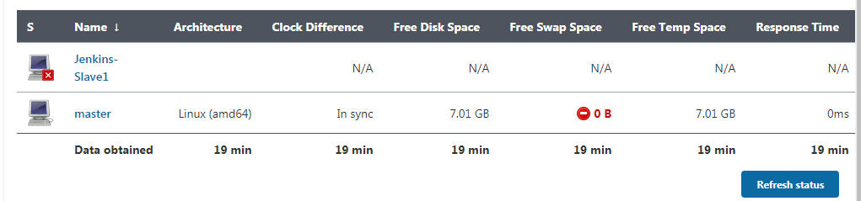

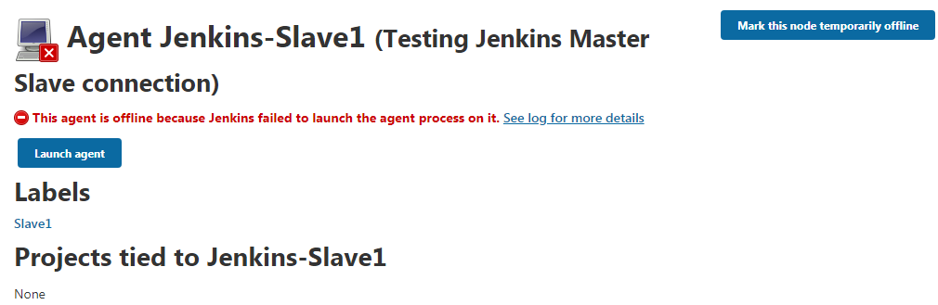

Step 2 - Click on the Launch agent button on the slave node.
- The key difference between Declarative pipeline and Scripted pipeline would be with respect to their syntaxes and their flexibility.
- Declarative pipeline is a relatively new feature that supports the pipeline as code concept. It makes the pipeline code easier to read and write. This code is written in a Jenkinsfile which can be checked into a source control management system such as Git.
- Whereas, the scripted pipeline is a traditional way of writing the code. In this pipeline, the Jenkinsfile is written on the Jenkins UI instance.
- Though both these pipelines are based on the groovy DSL, the scripted pipeline uses stricter groovy based syntaxes because it was the first pipeline to be built on the groovy foundation. Since this Groovy script was not typically desirable to all the users, the declarative pipeline was introduced to offer a simpler and more optioned Groovy syntax.
- The declarative pipeline is defined within a block labelled ‘pipeline’ whereas the scripted pipeline is defined within a ‘node’.

https://www.edureka.co/community/54705/difference-between-declarative-pipeline-scripted-pipeliine

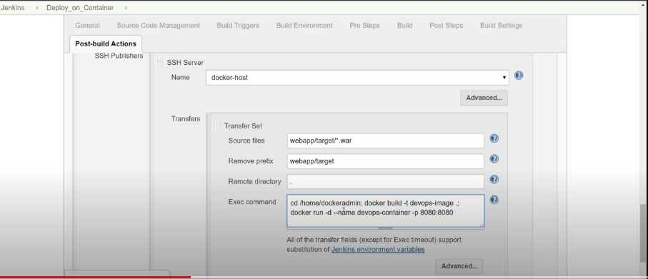

Trigger Jenkins Jobs using Github Webhooks
