Create a VPC:
Resources:
# First, a VPC:
VPC:
Type: AWS::EC2::VPC
Properties:
CidrBlock: 10.1.0.0/16
EnableDnsSupport: true
EnableDnsHostnames: true
Tags:
- Key: Name
Value: !Join ['', [!Ref "AWS::StackName", "-VPC" ]]

Defining a parameter in a template
The following example declares a parameter named InstanceTypeParameter. This parameter lets you specify the Amazon EC2 instance type for the stack to use when you create or update the stack.
Note that InstanceTypeParameter has a default value of t2.micro. This is the value that AWS CloudFormation uses to provision the stack unless another value is provided
"Parameters" : {
"InstanceTypeParameter" : {
"Type" : "String",
"Default" : "t2.micro",
"AllowedValues" : ["t2.micro", "m1.small", "m1.large"],
"Description" : "Enter t2.micro, m1.small, or m1.large. Default is t2.micro."
}
}

Parameters:
InstanceTypeParameter:
Type: String
Default: t2.micro
AllowedValues:
- t2.micro
- m1.small
- m1.large
Description: Enter t2.micro, m1.small, or m1.large. Default is t2.micro.

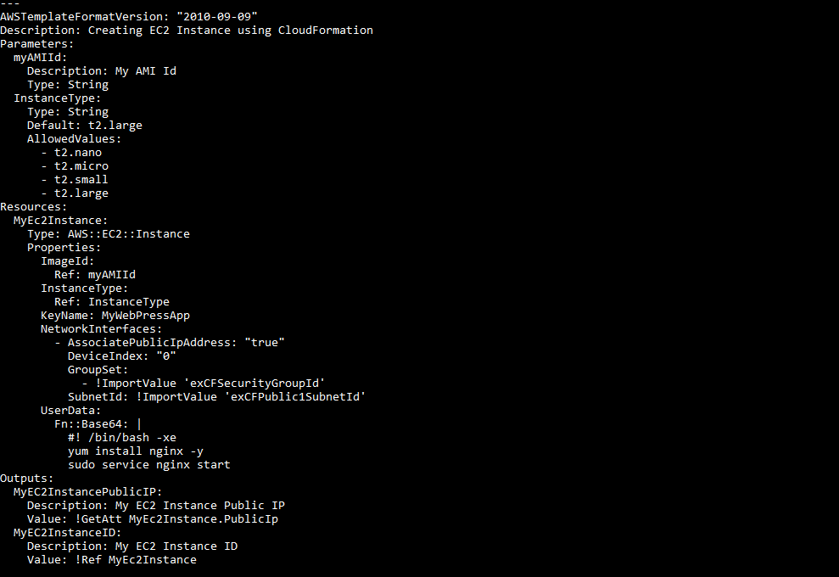

Resources:
Ec2Instance:
Type: AWS::EC2::Instance
Properties:
InstanceType: t2.micro
ImageId: ami-063dd30adbb186909 # Amazon Linux AMI in N.California
Tags:
- Key: test
Value: My EC2 Instance
- Key: Type
Value: Worker Instance

Q - Create a VPC
Resources:
# First, a VPC:
VPC:
Type: AWS::EC2::VPC
Properties:
CidrBlock: 10.1.0.0/16
EnableDnsSupport: true
EnableDnsHostnames: true
Tags:
- Key: Name
Value: myVP

-----------------------------------------------------------------------------------------
Q - Two Public Subnet with 64 IPS
Resources:
VPC:
Type: AWS::EC2::VPC
Properties:
CidrBlock: 10.0.0.0/16
EnableDnsHostnames: true
Tags:
- Key: Name
Value: myVPC

InternetGateway:
Type: AWS::EC2::InternetGateway
Properties:
Tags:
- Key: Name
Value: myVPC Internet Gateway

AttachGateway:
Type: AWS::EC2::VPCGatewayAttachment
Properties:
VpcId: !Ref VPC
InternetGatewayId: !Ref InternetGateway

PublicSubnet1:
Type: AWS::EC2::Subnet
Properties:
VpcId: !Ref VPC
Ipv6CidrBlock: 2001:db8:2234:1a00::/64
AvailabilityZone: ap-south-1a
Tags:
- Key: Name
Value: Public Subnet 1

PublicSubnet2:
Type: AWS::EC2::Subnet
Properties:
VpcId: !Ref VPC
Ipv6CidrBlock: 2001:db8:2235:1a00::/64
AvailabilityZone: ap-south-1a
Tags:
- Key: Name
Value: Public Subnet 2

Q - Two Private Subnet 64 Ips

Resources:
VPC:
Type: AWS::EC2::VPC
Properties:
CidrBlock: 10.0.0.0/16
EnableDnsHostnames: true
Tags:
- Key: Name
Value: myVPC

InternetGateway:
Type: AWS::EC2::InternetGateway
Properties:
Tags:
- Key: Name
Value: myVPC Internet Gateway

AttachGateway:
Type: AWS::EC2::VPCGatewayAttachment
Properties:
VpcId: !Ref VPC
InternetGatewayId: !Ref InternetGateway

PrivateSubnet1:
Type: AWS::EC2::Subnet
Properties:
VpcId: !Ref VPC
Ipv6CidrBlock: 2001:db8:2234:1a00::/64
AvailabilityZone: !Select
- '0'
- !GetAZs ''
Tags:
- Key: Name
Value: Private Subnet 1

PrivateSubnet2:
Type: AWS::EC2::Subnet
Properties:
VpcId: !Ref VPC
Ipv6CidrBlock: 2001:db8:2234:1a00::/64
AvailabilityZone: !Select
- '0'
- !GetAZs ''
Tags:
- Key: Name
Value: Private Subnet 2

-----------------------------------------------------------------------------------------------------------------------------------------
- Q - Private Subnet have S3 VPC endpoint
Description: 'Add VPC Endpoint to S3 from private subnets'
Parameters:
VpcId:
Description: The VPC ID of the VPC that this endpoint will be attached to
Type: AWS::EC2::VPC::Id
AllowedPattern: "[a-z0-9-]*"
RouteTableId:
Description: The Routing Table ID of the Routing Table that this endpoint will be added to
Type: String
AllowedPattern: "[a-z0-9-]*"
Resources:
S3Endpoint:
Type: "AWS::EC2::VPCEndpoint"
Properties:
PolicyDocument:
Version: 2012-10-17
Statement:
- Effect: Allow
Principal: '*'
Action:
- 's3:GetObject'
- 's3:PutObject'
- 's3:DeleteObject'
Resource:
- 'arn:aws:s3:::aws-allow-ec2-vpc-endpoint/*'
RouteTableIds:
- !Ref RouteTableId
ServiceName: !Join
- ''
- - com.amazonaws.
- !Ref 'AWS::Region'
- .s3
VpcId: !Ref VpcId
Outputs:
StackName:
Description: 'Stack name'
Value: !Sub '${AWS::StackName}'
Endpoint:
Description: 'The VPC endpoint to S3.'
Value: !Ref S3Endpoint

- Q - Allow only Ports 80,443,22 between private Subnet
Resources:
#Create a VPC:
VPC:
Type: AWS::EC2::VPC
Properties:
CidrBlock: 10.1.0.0/16
EnableDnsSupport: true
EnableDnsHostnames: true
Tags:
- Key: Name
Value: !Join ['', [!Ref "AWS::StackName", "-VPC" ]]

ALBSecurityGroup:
Type: 'AWS::EC2::SecurityGroup'
Properties:
VpcId: !Ref VPC
GroupDescription: Enable SSH/HTTP/HTTPS access
SecurityGroupIngress:
- IpProtocol: 'tcp'
FromPort: '80'
ToPort: '80'
CidrIp: !Ref ALBAccessCIDR
- IpProtocol: 'tcp'
FromPort: '443'
ToPort: '443'
CidrIp: !Ref ALBAccessCIDR
- IpProtocol: 'tcp'
FromPort: '22'
ToPort: '22'
CidrIp: !Ref ALBAccessCIDR
Tags:
- Key: Name
Value: SecurityGroup

- Q - Create a VM in Public Subnet

- name: Ansible test
hosts: localhost
tasks:
- name: launching AWS instance using Ansible
ec2:
key_name: aws_instance_Ansible
instance_type: t2.micro
image: ami-0dacb0c129b49f529
region: us-east-2
wait: yes
group: Ansible
count: 1
vpc_subnet_id: default
assign_public_ip: yes
aws_access_key: ***********xxxxxxxx
Aws_secret_key: ***********xxxxxxxx

- Q - Use the AMI and Create an Autoscaling group in Private subnet
Resources:
Type: AWS::AutoScaling::AutoScalingGroup
Properties:
AvailabilityZones:
Fn::GetAZs: ""
LaunchConfigurationName:
Ref: "myLaunchConfig"
MinSize: "1"
MaxSize: "4"
LoadBalancerNames:
- Ref: "myLoadBalancer"
MetricsCollection:
- Granularity: "1Minute"
Metrics:
- "GroupMinSize"
- "GroupMaxSize"
Tags:
- Key: Environment
Value: Production
PropagateAtLaunch: "true"
- Key: Purpose
Value: WebServerGroup
PropagateAtLaunch: "false"

Q - Create Load balancer in Public Subnet

MyLoadBalancer:
Type: AWS::ElasticLoadBalancing::LoadBalancer
Properties:
AvailabilityZones:
- "us-east-1a"
Instances:
- Ref: logical name of AWS::EC2::Instance resource 1
- Ref: logical name of AWS::EC2::Instance resource 2
Listeners:
- LoadBalancerPort: '80'
InstancePort: '80'
Protocol: HTTP
HealthCheck:
Target: HTTP:80/
HealthyThreshold: '3'
UnhealthyThreshold: '5'
Interval: '30'
Timeout: '5'

Create NAT Gateway
Configure NAT Gateway for private subnets in your VPC:
- Navigate to the AWS console -> Services.
- Go to the Networking & Content Delivery section and click VPC.
- Navigate to Virtual Private Cloud -> NAT Gateways -> Create NAT Gateway.
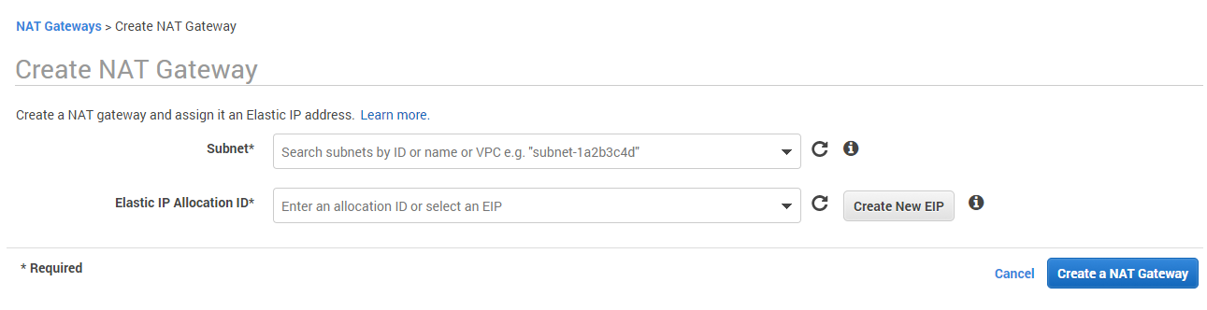
- On the newly opened page select a public subnet from the Subnet drop-down list in which to create the NAT gateway.
- Assign an Elastic IP Address to the NAT Gateway.
- Click Create a NAT Gateway.
Now you need to configure the routing for your private subnets. Enable traffic from your private subnets to Internet by using the NAT Gateway you have created.

Configure private subnets route table
- Navigate to VPC Dashboard -> Subnets.
- Select one of your private subnets from the list and navigate to its Summary section.
- Click on the name of the Route Table of the subnet.
- You are then redirected to your Route Table in the Virtual Private Cloud -> Route Tables subsection.
- Add a new rule and for destination type 0.0.0.0/0 (all packets for the internet) and for target choose the NAT Gateway you created as in the previous subtopic.
- Save the rules and now the traffic from instances in the private subnets destined to the Internet will be redirected to the NAT Gateway.
- 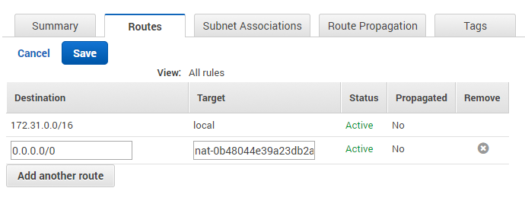
- Save the rules.
- Navigate to the Subnet Associations tab and associate your private subnets with the route table and save the changes.
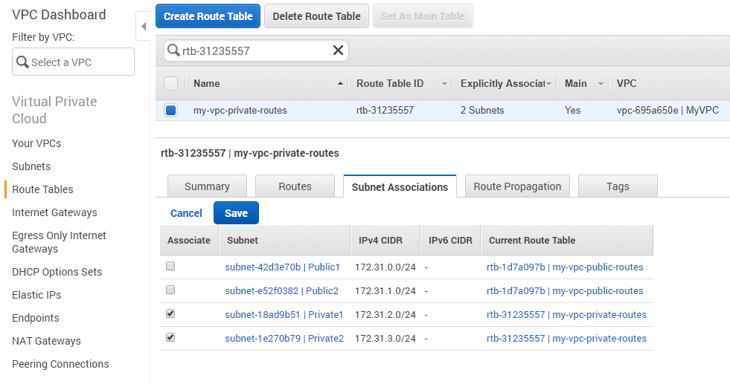
Now traffic from instances in the private subnets destined for the Internet will be redirected to the NAT Gateway.

aws s3 ls s3://mybucket --recursive --human-readable –summarize – check size of a S3 bucket

aws s3 ls -r s3://bucket_name | wc –l – Check the number of objects in a bucket

aws s3 ls --summarize --human-readable --recursive s3://my-docs
It prints output like this one:

2019-03-07 12:11:24 69.7 KiB 2019/01/file1.pdf
2019-03-07 12:11:20 921.4 KiB 2019/01/file2.pdf
2019-03-07 12:11:16 130.9 KiB 2019/01/file3.pdf

Total Objects: 310
Total Size: 121.7 MiB

