Install Apache:
FROM ubuntu
RUN apt-get update
RUN apt-get install –y apache2
RUN apt-get install –y apache2-utils
RUN apt-get clean
EXPOSE 80 CMD [“apache2ctl”, “-D”, “FOREGROUND”]

FROM ubuntu:18.10
LABEL maintainer="egidio.docile@linuxconfig.org"

RUN apt-get update && apt-get -y install apache2
EXPOSE 80

ENTRYPOINT ["/usr/sbin/apachectl"]
CMD ["-D", "FOREGROUND"]

COPY index.html /var/www/html/index.html

CMD ["/usr/sbin/apachectl", "-D", "FOREGROUND"] –- Exec form
CMD /usr/sbin/apachectl -D FOREGROUND -- Shell form

Install Ngnix:

FROM ubuntu:16.04

MAINTAINER Chris Fidao

RUN apt-get update \
&& apt-get install -y nginx \
&& apt-get clean \
&& rm -rf /var/lib/apt/lists/* /tmp/* /var/tmp/* \
&& echo "daemon off;" >> /etc/nginx/nginx.conf

ADD default /etc/nginx/sites-available/default

EXPOSE 80
CMD ["nginx"]

docker build -t shippingdocker/nginx:1.0 -t shippingdocker/nginx:latest
sudo docker run –p 8080:80 –d nginx
Install Tomcat:

FROM centos

MAINTAINER aksarav@middlewareinventory.com

RUN mkdir /opt/tomcat/

WORKDIR /opt/tomcat
RUN curl -O https://www-eu.apache.org/dist/tomcat/tomcat-8/v8.5.40/bin/apache-tomcat-8.5.40.tar.gz
RUN tar xvfz apache*.tar.gz
RUN mv apache-tomcat-8.5.40/* /opt/tomcat/.
RUN yum -y install java
RUN java -version

WORKDIR /opt/tomcat/webapps
RUN curl -O -L https://github.com/AKSarav/SampleWebApp/raw/master/dist/SampleWebApp.war

EXPOSE 8080

CMD ["/opt/tomcat/bin/catalina.sh", "run"]

FROM tomcat:8.5.35-jre10
ADD sample.war /usr/local/tomcat/webapps/
EXPOSE 8080
CMD chmod +x /usr/local/tomcat/bin/catalina.sh
CMD ["catalina.sh", "run"]

$ docker build -t bogo_tomcat .

$ docker run -it -p 8787:8080 bogo_tomcat

Install Python:

FROM python:3

ADD my_script.py /

RUN pip install pystrich

CMD [ "python", "./my_script.py" ]

FROM ubuntu
MAINTAINER Prashansa Kulshrestha
RUN apt-get update
RUN apt-get install -y python
ADD hello.py /home/hello.py
ADD a.py /home/a.py
CMD ["/home/hello.py"]
ENTRYPOINT ["python"]

Install Jenkins:

FROM jenkins/jenkins
LABEL maintainer="hitjethva@gmail.com"
USER root
RUN mkdir /var/log/jenkins
RUN mkdir /var/cache/jenkins
RUN chown -R jenkins:jenkins /var/log/jenkins
RUN chown -R jenkins:jenkins /var/cache/jenkins
USER jenkins
ENV JAVA_OPTS="-Xmx8192m"
ENV JENKINS_OPTS="--handlerCountMax=300 --logfile=/var/log/jenkins/jenkins.log
--webroot=/var/cache/jenkins/war"

docker build -t myjenkins .

docker run -p 8080:8080 -p 50000:50000 --name=jenkins-master --mount source=jenkins-log,
target=/var/log/jenkins --mount source=jenkins-data,target=/var/jenkins_home -d myjenkins

CONTAINER ID IMAGE COMMAND CREATED STATUS
3dec02a7077c myjenkins "/sbin/tini -- /usr/…" 6 minutes ago Up 6 minutes
PORTS NAMES
0.0.0.0:8080->8080/tcp, 0.0.0.0:50000->50000/tcp jenkins-master

FROM jenkins/jenkins:lts
USER root
RUN apt-get update && \
apt-get -y install apt-transport-https \
ca-certificates \
curl \
gnupg2 \
software-properties-common && \
curl -fsSL https://download.docker.com/linux/$(. /etc/os-release;
echo "$ID")/gpg > /tmp/dkey; apt-key add /tmp/dkey && \
add-apt-repository \
"deb [arch=amd64] https://download.docker.com/linux/$(. /etc/os-release; echo "$ID") \
$(lsb_release -cs) \
stable" && \
apt-get update && \
apt-get -y install docker-ce
RUN apt-get install -y docker-ce
RUN usermod -a -G docker jenkins
USER Jenkins

Docker Volume

Volumes are special directories in a container
Volumes can be declared in two different ways.

- Within a Dockerfile, with a VOLUME instruction.
VOLUME /uploads

- On the command-line, with the -v flag for docker run.

$ docker run -d -v /uploads myapp

In both cases, /uploads (inside the container) will be a volume.

Create a file with name volume and paste the following content to it:
FROM ubuntu:latest
RUN mkdir /data
WORKDIR /data
RUN echo "Hello from Volume" > test
VOLUME /data

Execute the following commands:
docker build -f volume -t collabnix/volume:1 .

docker run collabnix/volume:1

docker volume ls

cd /var/lib/docker/volumes

ls -ltr

cd ./<FOLDER_NAME_WITH_RANDOM_NUMBERS_&_CHARACTERS>

cd ./_data

cat test

Docker volumes can be used to share files between a host system and the Docker container. For example, let’s say you wanted to use the official Docker Nginx image and keep a permanent copy of Nginx’s log files to analyze later. By default, the nginx Docker image will log to the /var/log/nginx directory inside the Docker Nginx container. Normally it’s not reachable from the host filesystem.

Step 1 — Bindmounting a Volume
The following command will create a directory called nginxlogs in your current user’s home directory and bindmount it to /var/log/nginx in the container:
- docker run --name=nginx -d -v ~/nginxlogs:/var/log/nginx -p 5000:80 nginx

Let’s take a moment to examine this command in detail:
- --name=nginx names the container so we can refer to it more easily.
- -d detaches the process and runs it in the background. Otherwise, we would just be watching an empty Nginx prompt and wouldn’t be able to use this terminal until we killed Nginx.
- -v ~/nginxlogs:/var/log/nginx sets up a bindmount volume that links the /var/log/nginx directory from inside the Nginx container to the ~/nginxlogs directory on the host machine. Docker uses a : to split the host’s path from the container path, and the host path always comes first.
- -p 5000:80 sets up a port forward. The Nginx container is listening on port 80 by default. This flag maps the container’s port 80 to port 5000 on the host system.
- nginx specifies that the container should be built from the Nginx image, which issues the command nginx -g "daemon off" to start Nginx.
Note: The -v flag is very flexible. It can bindmount or name a volume with just a slight adjustment in syntax. If the first argument begins with a / or ~/, you’re creating a bindmount. Remove that, and you’re naming the volume.
- -v /path:/path/in/container mounts the host directory, /path at the /path/in/container
- -v path:/path/in/container creates a volume named path with no relationship to the host.
For more on named volumes, see How to Share Data Between Docker Containers

Step 2 — Accessing Data on the Host
We now have a copy of Nginx running inside a Docker container on our machine, and our host machine’s port 5000 maps directly to that copy of Nginx’s port 80.
Load the address in a web browser, using the IP address or hostname of your server and the port number: http://your_server_ip:5000. You should see:

More interestingly, if we look in the ~/nginxlogs directory on the host, we’ll see the access.log created by the container’s nginx which will show our request:

The docker-compose.yml file
version: '3'
services:
web:
image: nginx
db:
image: mysql
ports:
- "3306:3306"
environment:
- MYSQL_ROOT_PASSWORD=password
- MYSQL_USER=user
- MYSQL_PASSWORD=password
- MYSQL_DATABASE=demodb

Deploy the file docker-compose up

HOW TO CREATE A DOCKER IMAGE FROM A CONTAINER

Step 1: Create a Base Container
Let’s get started by creating a running container. So that we don’t get bogged down in the details of any particular container, we can use nginx.
The Docker create command will create a new container for us from the command line:
Here we have requested a new container named nginx_base with port 80 exposed to localhost. We are using nginx:alpine as a base image for the container.
If you don’t have the nginx:alpine image in your local docker image repository, it will download automatically. When this happens, you will see something like this:
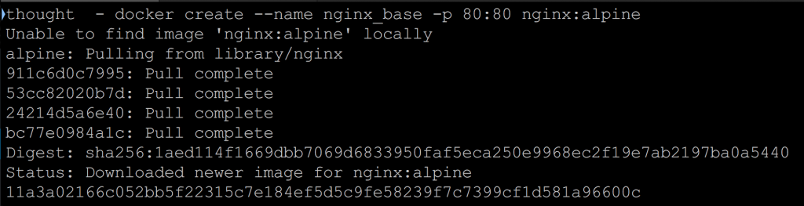

Step 2: Inspect Images
If you look at the list of images on your system, you will now see the nginx:alpine image:
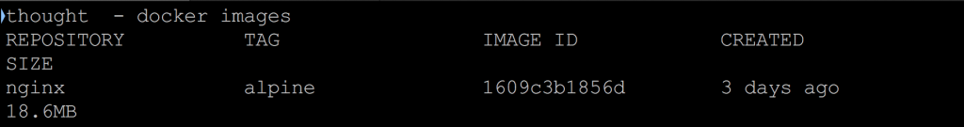

Step 3: Inspect Containers
Note here that the container is not running, so you won’t see it in the container list unless you use the -a flag (-a is for all).
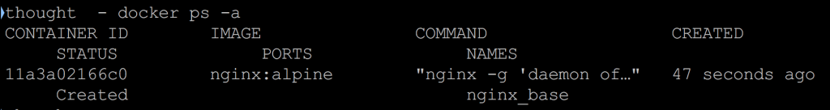

Step 4: Start the Container
Let’s start the container and see what happens.
Now visit http://localhost with your browser. You will see the default “Welcome to nginx!” page. We are now running an nginx container.
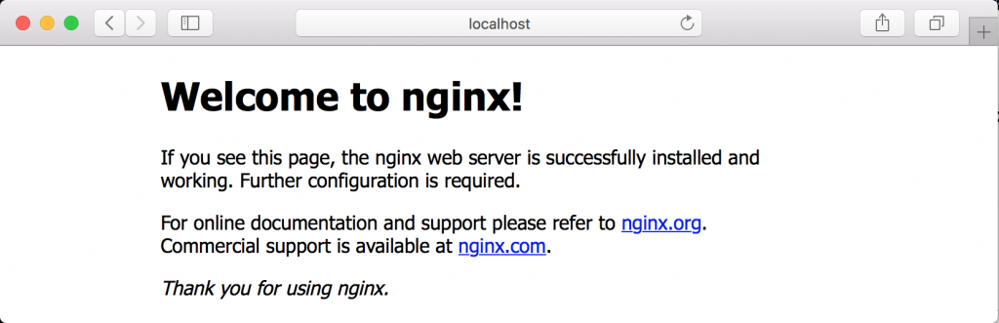

Step 5: Modify the Running Container
So if you wanted to modify this running container so that it behaves in a specific way, there are a variety of ways to do that.
In order to keep things as simple as possible, we are just going to copy a new index.html file onto the server. You could do practically anything you wanted here.
Let’s create a new index.html file and copy it onto the running container. Using an editor on your machine, create an index.html file in the same directory that you have been running Docker commands from.
Then paste the following HTML into it:
<html>
<head>
<title>Hi Mom</title>
</head>
<body>
<h1>Hi Mom!</h1>
</body>
Then save the file and return to the command line. We will use the docker cp command to copy this file onto the running container.
Now reload your browser or revisit http://localhost. You will see the message “Hi Mom!” in place of the default nginx welcome page.
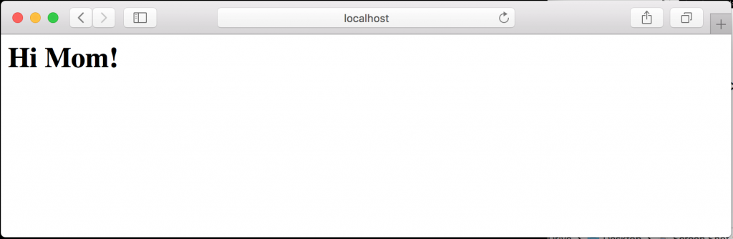

Step 6: Create an Image From a Container
So at this point, we’ve updated the contents of a running container and as long as we keep that container around, we don’t need to do anything.
However, we want to know how to save this container as an image so we can make other containers based on this one. The Docker commands to do this are quite simple.
To save a Docker container, we just need to use the docker commit command like this:
Now look at the docker images list:
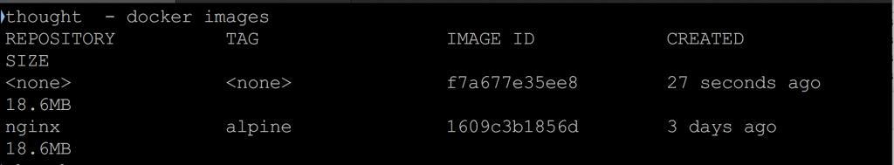
You can see there is a new image there. It does not have a repository or tag, but it exists. This is an image created from the running container. Let’s tag it so it will be easier to find later.

Step 7: Tag the Image
Using docker tag, we can name the image we just created. We need the image ID for the command, so given that the image ID listed above is f7a677e35ee8, our command will be:
And if we look at the index of images again, we can see that the <None>s were replaced:
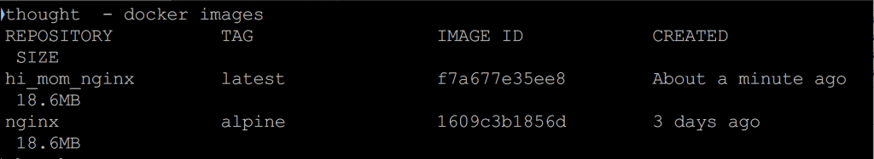
We can actually use complicated tags here with version numbers and all the other fixings of a tag command, but for our example, we’ll just create an image with a meaningful name.

Step 8: Create Images With Tags
You can also tag the image as it is created by adding another argument to the end of the command like this:
This command effectively commits and tags at the same time, which is helpful but not required.

Step 9: Delete the Original Container
Earlier we started a Docker container. We can see that it is still running using the docker ps command.
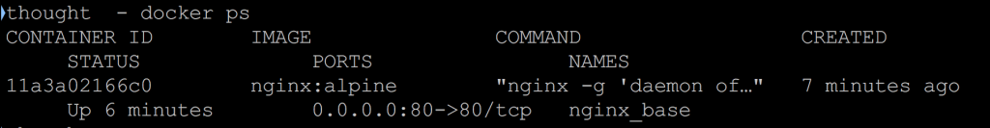
Let’s stop the Docker container that is currently running and delete it.
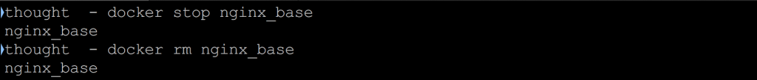
If we list all of the Docker containers, we should have none:
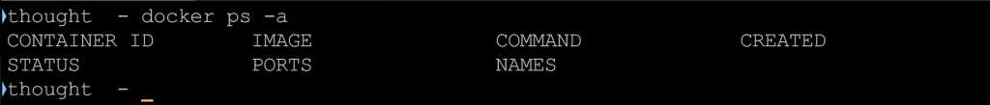
Now, let’s create a new container based on the image we just created and start it.
Note that docker run is the equivalent of executing docker create followed by docker start; we are just saving a step here.
The -d option tells Docker to run the container detached so we get our command prompt back.

Step 10: Look at Running Containers
If you look at the running containers now, you will see we have one called hi_mom:
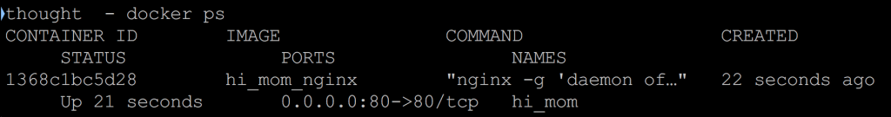
Now go look at http://localhost.
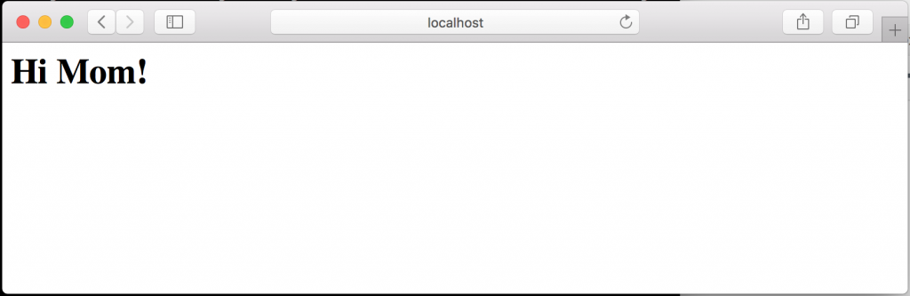
As you can see, the index.html page now shows the “Hi Mom!” message just like we wanted.
Stop the container hi_mom before moving on to the next section.

