Difference Between Git Fetch and Git Pull

One such example is the difference between git fetch and git pull. At first glance the name of the commands don't give much hint as to how they differ, so in this article I'll be explaining the difference between the git fetch and git pull commands.

Git Fetch
The fetch command retrieves any commits, references (like tags), branches and files from a remote repository, along with any other corresponding objects. However, not all tags are retrieved as this command only takes the ones that point to commits that you are retrieving. Basically this command fetches anything needed to reconstruct the history of the particular branch you're interested in.
The basic syntax is the following:

$ git fetch <remote-repo> <remote-branch>

Specifying <remote-branch> will only fetch changes from that branch. If this parameter is omitted then changes from all branches are retrieved.
The interesting thing about the fetch command is that it doesn't actually affect anything in your local repo. No working changes will be lost, and you'll see no direct affect on your local branches. This is because Git keeps fetched content separate from your own repo's content until it is merged in.
So, let's say you want to view changes for the "master" branch from the "origin" remote repo before deciding to merge them in to your repo. To do this you could use the following commands:
$ git fetch origin master
Now that you have the changes in your repository, you'll likely want to actually view them, which you can do by just checking out the branch:
$ git checkout origin/master
This will allow you to see the changes, and it still isn't merged in to any of your own branches.
A quicker way to view these changes would be to just look at the commit logs, which you can do with:
$ git log master..origin/master
Note that this is considered a "safer" method than pull since it does not actually make any changes to your local branches.
Now that we've seen what fetch does and a bit about how it works, let's take a look at pull.

Git Pull
The git pull command is what I'd call a "high level" command. By that I mean that it performs the actions of a few other Git commands in sequence, which I'll explain more about below. In this section, after I describe the difference between fetch and pull, I'll also briefly talk about the numerous different ways the command can be used.
The general syntax is the following:
$ git pull <remote-repo> <remote-branch>
Both the <remote-repo> and <remote-branch> parameters are optional, as long as your current branch is tracking a remote one.
Probably the simplest way to explain this command, and how it's different from fetch, is that it's an alias for two other Git commands, when used in its default mode: fetch and merge. So by running git pull you are essentially running these two commands in sequence:
$ git fetch <remote-repo>
$ git merge FETCH_HEAD
Here FETCH_HEAD is a reference to tip of the last fetch, which is being merged in to your current branch.

git fetch gathers any commits from the target branch that do not exist in your current branch and stores them in your local repository. But it does not merge them with your current branch. If you type git pull origin <your branch name> you will see the changes but you will notice that it still isn’t merged into your local branches. The interesting thing about git fetch is that it will not affect to your local branch. Commits, tags, files which are updated to the remote branch, it will retrieve that from the remote branch only and make your local repository updated. But it won’t merge.

On the contrary, git pull is the combination of git fetch and git merge . It will fetch from the remote to local and automatically merge them to your current branch. So, now if you type git log you will see the changes and also you will notice that it merged into your local branches. After a git pull operation, your working copy should be fully synchronized, barring any local modifications you have made. So, no need to type git checkout origin <your branch name> .
Here is the workflow of git fetch and git pull

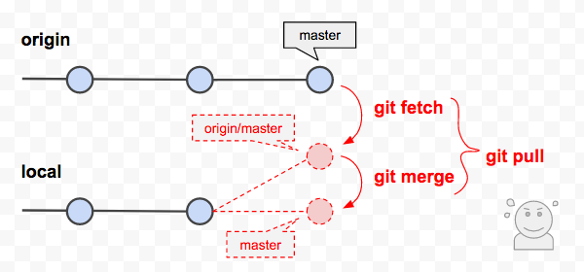Git fetch vs git pull

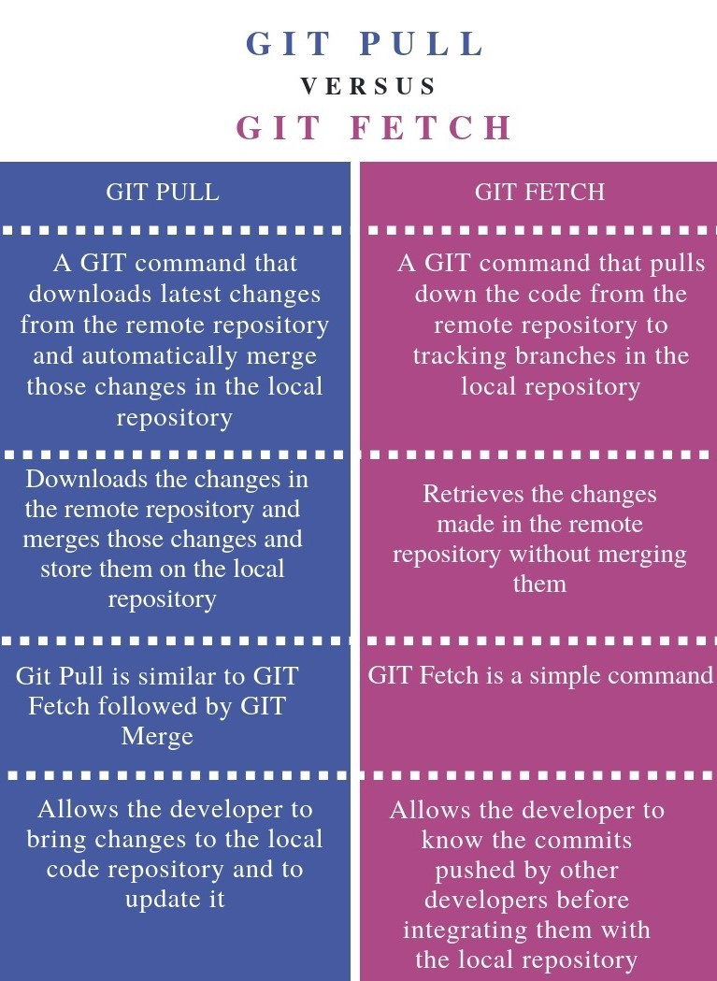

How to Change a Git Commit Message

Changing the Most Recent Commit
The git commit --amend command allows you to change the most recent commit message.

Not pushed commit
To change the message of the most recent commit that has not been pushed to the remote repository, commit it again using the --amend flag.
- Navigate to the repository directory in your terminal.
- Run the following command to amend (change) the message of the latest commit:
git commit --amend -m "New commit message."
What the command does is overwriting the most recent commit with the new one.
The -m option allows you to write the new message on the command line without opening an editor session.
Before changing the commit message, you can also add other changes you previously forgot:
git add .git commit --amend -m "New commit message."

Pushed commit
The amended (changed) commit is a new entity with a different SHA-1. The previous commit will no longer exist in the current branch.
Generally, you should avoid amending a commit that is already pushed as it may cause issues to people who based their work on this commit. It is a good idea to consult your fellow developers before changing a pushed commit.
If you changed the message of most recently pushed commit, you would have to force push it.
- Navigate to the repository.
- Amend the message of the latest pushed commit:
git commit --amend -m "New commit message."
- Force push to update the history of the remote repository:
git push --force branch-name

git reset vs git revert

When maintaining code using version control systems such as git, it is unavoidable that we need to rollback some wrong commits either due to bugs or temp code revert. In this case, rookie developers would be very nervous because they may get lost on what they should do to rollback their changes without affecting others, but to veteran developers, this is their routine work and they can show you different ways of doing that.
In this post, we will introduce two major ones used frequently by developers.
- git reset
- git revert
What are their differences and corresponding use cases? We will discuss them in detail below.

git reset
Assuming we have below few commits.
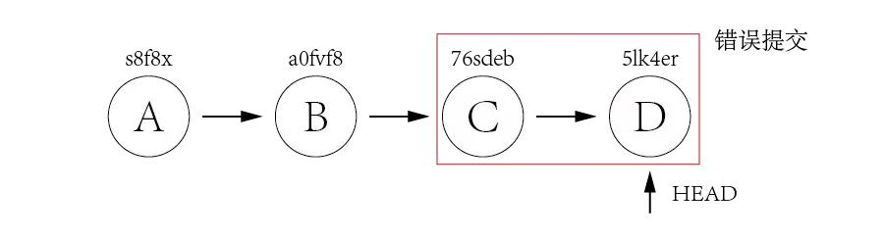
Commit A and B are working commits, but commit C and D are bad commits. Now we want to rollback to commit B and drop commit C and D. Currently HEAD is pointing to commit D 5lk4er, we just need to point HEAD to commit B a0fvf8 to achieve what we want.
It's easy to use git reset command.
git reset --hard a0fvf8
After executing above command, the HEAD will point to commit B.
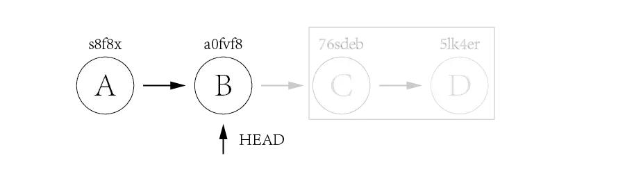
But now the remote origin still has HEAD point to commit D, if we directly use git push to push the changes, it will not update the remote repo, we need to add a -f option to force pushing the changes.
git push -f
The drawback of this method is that all the commits after HEAD will be gone once the reset is done. In case one day we found that some of the commits ate good ones and want to keep them, it is too late. Because of this, many companies forbid to use this method to rollback changes.

git revert
The use of git revert is to create a new commit which reverts a previous commit. The HEAD will point to the new reverting commit.
For the example of git reset above, what we need to do is just reverting commit D and then reverting commit C.
git revert 5lk4er
git revert 76sdeb
Now it creates two new commit D' and C',
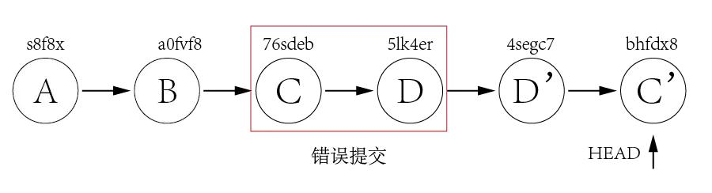
In above example, we have only two commits to revert, so we can revert one by one. But what if there are lots of commits to revert? We can revert a range indeed.
git revert OLDER_COMMIT^..NEWER_COMMIT
This method would not have the disadvantage of git reset, it would point HEAD to newly created reverting commit and it is ok to directly push the changes to remote without using the -f option.
Now let's take a look at a more difficult example. Assuming we have three commits but the bad commit is the second commit.

It's not a good idea to use git reset to rollback the commit B since we need to keep commit C as it is a good commit. Now we can revert commit C and B and then use cherry-pick to commit C again.
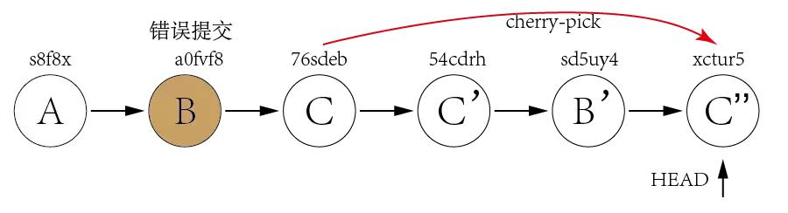
From above explanation, we can find out that the biggest difference between git reset and git revert is that git reset will reset the state of the branch to a previous state by dropping all the changes post the desired commit while git revert will reset to a previous state by creating new reverting commits and keep the original commits. It's recommended to use git revert instead of git reset in enterprise environment.

What are Git hooks?
Git hooks are scripts that Git executes before or after events such as: commit, push, and receive. Git hooks are a built-in feature - no need to download anything. Git hooks are run locally.
These hook scripts are only limited by a developer's imagination. Some example hook scripts include:
- pre-commit: Check the commit message for spelling errors.
- pre-receive: Enforce project coding standards.
- post-commit: Email/SMS team members of a new commit.
- post-receive: Push the code to production.

How do git hooks work?
Every Git repository has a .git/hooks folder with a script for each hook you can bind to. You're free to change or update these scripts as necessary, and Git will execute them when those events occur.
Here's a full list of hooks you can attach scripts to:
- applypatch-msg
- pre-applypatch
- post-applypatch
- pre-commit
- prepare-commit-msg
- commit-msg
- post-commit
- pre-rebase
- post-checkout
- post-merge
- pre-receive
- update
- post-receive
- post-update
- pre-auto-gc
- post-rewrite
- pre-push
Git Stash
Suppose you are implementing a new feature for your product. Your code is in progress and suddenly a customer escalation comes. Because of this, you have to keep aside your new feature work for a few hours. You cannot commit your partial code and also cannot throw away your changes. So you need some temporary space, where you can store your partial changes and later on commit it.
- In Git, the stash operation takes your modified tracked files, stages changes, and saves them on a stack of unfinished changes that you can reapply at any time.
- [jerry@CentOS project]$ git status -s
- M string.c
- ?? string
- Now, you want to switch branches for customer escalation, but you don’t want to commit what you’ve been working on yet; so you’ll stash the changes. To push a new stash onto your stack, run the git stash command.
- [jerry@CentOS project]$ git stash
- Saved working directory and index state WIP on master: e86f062 Added my_strcpy function
- HEAD is now at e86f062 Added my_strcpy function
- Now, your working directory is clean and all the changes are saved on a stack. Let us verify it with the git status command.
- [jerry@CentOS project]$ git status -s
- ?? string
- Now you can safely switch the branch and work elsewhere. We can view a list of stashed changes by using the git stash list command.
- [jerry@CentOS project]$ git stash list
- stash@{0}: WIP on master: e86f062 Added my_strcpy function
- Suppose you have resolved the customer escalation and you are back on your new feature looking for your half-done code, just execute the git stash pop command, to remove the changes from the stack and place them in the current working directory.
- [jerry@CentOS project]$ git status -s
- ?? string

- [jerry@CentOS project]$ git stash pop
- The above command will produce the following result:
- # On branch master
- # Changed but not updated:
- # (use "git add ..." to update what will be committed)
- # (use "git checkout -- ..." to discard changes in working directory)

Centralized Version Control System
- In centralized source control, there is a server and a client. The server is the master repository which contains all of the versions of the code. To work on any project, firstly user or client needs to get the code from the master repository or server. So the client communicates with the server and pulls all the code or current version of the code from the server to their local machine. In other terms we can say, you need to take an update from the master repository and then you get the local copy of the code in your system. So once you get the latest version of the code, you start making your own changes in the code and after that, you simply need to commit those changes straight forward into the master repository. Committing a change simply means merging your own code into the master repository or making a new version off the source code. So everything is centralized in this model.
There will be just one repository and that will contain all the history or version of the code and different branches of the code. So the basic workflow involves in the centralized source control is getting the latest version of the code from a central repository that will contain other people code as well, making your own changes in the code and then committing or merging those changes into the central repository.

Distributed Version Control System
- In distributed version control most of the mechanism or model applies the same as centralized. The only major difference you will find here is, instead of one single repository which is the server, here every single developer or client has their own server and they will have a copy of the entire history or version of the code and all of its branches in their local server or machine. Basically, every client or user can work locally and disconnected which is more convenient than centralized source control and that’s why it is called distributed.
You don’t need to rely on the central server, you can clone the entire history or copy of the code to your hard drive. So when you start working on a project, you clone the code from the master repository in your own hard drive, then you get the code from your own repository to make changes and after doing changes, you commit your changes to your local repository and at this point your local repository will have ‘change sets‘ but it is still disconnected with master repository (master repository will have different ‘sets of changes‘ from each and every individual developer’s repository), so to communicate with it, you issue a request to the master repository and push your local repository code to the master repository. Getting the new change from a repository is called “pulling” and merging your local repository ‘set of changes’ is called “pushing“.
It doesn’t follow the way of communicating or merging the code straight forward to the master repository after making changes. Firstly you commit all the changes in your own server or repository and then the ‘set of changes’ will merge to the master repository.

Clone
Clone operation creates the instance of the repository. Clone operation not only checks out the working copy, but it also mirrors the complete repository. Users can perform many operations with this local repository. The only time networking gets involved is when the repository instances are being synchronized.

Pull
Pull operation copies the changes from a remote repository instance to a local one. The pull operation is used for synchronization between two repository instances. This is same as the update operation in Subversion.

Push
Push operation copies changes from a local repository instance to a remote one. This is used to store the changes permanently into the Git repository. This is same as the commit operation in Subversion.

HEAD
HEAD is a pointer, which always points to the latest commit in the branch. Whenever you make a commit, HEAD is updated with the latest commit. The heads of the branches are stored in .git/refs/heads/ directory.
[CentOS]$ ls -1 .git/refs/heads/
master
[CentOS]$ cat .git/refs/heads/master
570837e7d58fa4bccd86cb575d884502188b0c49

git clean
This is builtin command to cleanup the untracked files. Be careful with this one, it deletes files permanently!
Always add -n or --dry-run options to preview the damage you'll do! (source)
- If you just clean untracked files, run git clean -f
- If you want to also remove directories, run git clean -f -d
- If you just want to remove ignored files, run git clean -f -X
- If you want to remove ignored as well as non-ignored files, run git clean -f -x
Note, that there is -f / --force option in each example, this is because of default configuration of git: If the git configuration variable clean.requireForce is not set to false, git clean will refuse to run unless given -f or -n.

git trash
Soft alternative to git clean. Moves all unstaged files to the .trash directory for later review.
First to have this command work you need to add .trash directory to the local or global .gitignore. If you don't do that git trash will try to remove the .trash folder as well.
echo ".trash" >> .gitignore

Now add the trash git shortcut to your global aliases list:
git config --global alias.trash '!mkdir -p .trash && git ls-files --others --exclude-standard | xargs mv -f -t .trash'

And you're done. Now you can run git trash in your root of git repository and all unstaged files will be moved to the .trash subdirectory.

