Firewall decides fate of packets incoming and outgoing in system. IPTables is a rule based firewall and it is pre-installed on most of Linux operating system. By default it runs without any rules. IPTables was included in Kernel 2.4

IPTables is a front-end tool to talk to the kernel and decides the packets to filter.

Different services is used for different protocols as:
- iptables applies to IPv4.
- ip6tables applies to IPv6.
- arptables applies to ARP.
- ebtables applies to Ethernet frames..
IPTables main files are:
- /etc/init.d/iptables – init script to start|stop|restart and save rulesets.
- /etc/sysconfig/iptables – where Rulesets are saved.
- /sbin/iptables – binary.

- ables is the name for a set of chains.
- Chain is a collection of rules.
- Rule is condition used to match packet.
- Target is action taken when a possible rule matches. Examples of the target are ACCEPT, DROP, QUEUE.
- Policy is the default action taken in case of no match with the inbuilt chains and can be ACCEPT or DROP.
Syntax:
iptables --table TABLE -A/-C/-D... CHAIN rule --jump Target
TABLE
There are five possible tables:
- filter: Default used table for packet filtering. It includes chains like INPUT, OUTPUT and FORWARD.
- nat : Related to Network Address Translation. It includes PREROUTING and POSTROUTING chains.
- mangle : For specialised packet alteration. Inbuilt chains include PREROUTING and OUTPUT.
- raw : Configures exemptions from connection tracking. Built-in chains are PREROUTING and OUTPUT.
- security : Used for Mandatory Access Control
CHAINS
There are few built-in chains that are included in tables. They are:
- INPUT :set of rules for packets destined to localhost sockets.
- FORWARD :for packets routed through the device.
- OUTPUT :for locally generated packets, meant to be transmitted outside.
- PREROUTING :for modifying packets as they arrive.
- POSTROUTING :for modifying packets as they are leaving.
Start/Stop/Restart Iptables Firewall

------------ On Cent/RHEL 7 and Fedora 22+ ------------
# systemctl start iptables
# systemctl stop iptables
# systemctl restart iptables

------------ On Cent/RHEL 6/5 and Fedora ------------
# /etc/init.d/iptables start
# /etc/init.d/iptables stop
# /etc/init.d/iptables restart

Check all IPtables Firewall Rules
iptables -L -n -v
- While trying out the commands, you can remove all filtering rules and user created chains.
- sudo iptables --flush
- To save the iptables configuration use:
sudo iptables-save
- Restoring iptables config can be done with:
sudo iptables-restore

Block Specific IP Address in IPtables Firewall
iptables -A INPUT -s xxx.xxx.xxx.xxx -j DROP
In case you only want to block TCP traffic from that IP address, you can use the -p option that specifies the protocol

# iptables -A INPUT -p tcp -s xxx.xxx.xxx.xxx -j DROP
Unblock IP Address in IPtables Firewall
iptables -D INPUT -s xxx.xxx.xxx.xxx -j DROP
To block outgoing connections on a specific port use:
# iptables -A OUTPUT -p tcp --dport xxx -j DROP
To allow incoming connections use:
# iptables -A INPUT -p tcp --dport xxx -j ACCEPT

Allow Multiple Ports on IPtables using Multiport

# iptables -A INPUT -p tcp -m multiport --dports 22,80,443 -j ACCEPT
# iptables -A OUTPUT -p tcp -m multiport --sports 22,80,443 -j ACCEPT
You may want to limit certain connections on specific port to a given network. Let’s say you want to allow outgoing connections on port 22 to network 192.168.100.0/24.
You can do it with this command:
# iptables -A OUTPUT -p tcp -d 192.168.100.0/24 --dport 22 -j ACCEPT

- RUN executes command(s) in a new layer and creates a new image. E.g., it is often used for installing software packages.
- CMD sets default command and/or parameters, which can be overwritten from command line when docker container runs.
- ENTRYPOINT configures a container that will run as an executable

In short, CMD defines default commands and/or parameters for a container. CMD is an instruction that is best to use if you need a default command which users can easily override. If a Dockerfile has multiple CMDs, it only applies the instructions from the last one.

On the other hand, ENTRYPOINT is preferred when you want to define a container with a specific executable. You cannot override an ENTRYPOINT when starting a container unless you add the --entrypoint flag.
Combine ENTRYPOINT with CMD if you need a container with a specified executable and a default parameter that can be modified easily. For example, when containerizing an application use ENTRYPOINT and CMD to set environment-specific variables.

Shell and Exec Form
Before we begin, it is important to discus the forms of instructions. Docker ENTRYPOINT and CMD can have two forms:

  - Shell form
  - Exec form
The syntax for any command in shell form is:
<instruction> <command>
The syntax for instructions in exec form is:
<instruction> [“executable”, “parameter”]
You can write Docker CMD/ENTRYPOINT instructions in both forms:
- CMD echo “Hello World” (shell form)
- CMD ["echo", "Hello World"] (exec form)
- ENTRYPOINT echo "Hello World" (shell form)
- ENTRYPOINT ["echo", "Hello World"] (exec form)

- ADD copies the files from a source on the host into the container’s own filesystem at the set destination.
- CMD can be used for executing a specific command within the container.
- ENTRYPOINT sets a default application to be used every time a container is created with the image.
- ENV sets environment variables.
- EXPOSE associates a specific port to enable networking between the container and the outside world.
- FROM defines the base image used to start the build process.
- MAINTAINER defines a full name and email address of the image creator.
- RUN is the central executing directive for Dockerfiles.
- USER sets the UID (or username) which is to run the container.
- VOLUME is used to enable access from the container to a directory on the host machine.
- WORKDIR sets the path where the command, defined with CMD, is to be executed.
- LABEL allows you to add a label to your docker imag

Four basic Docker CLI comes into action:
- The docker export - Export a container’s filesystem as a tar archive
- The docker import - Import the contents from a tarball to create a filesystem image
- The docker save - Save one or more images to a tar archive (streamed to STDOUT by default)
- The docker load - Load an image from a tar archive or STDIN

Tested Infrastructure
Platform | Number of Instance | Reading Time
Play with Docker | 1 | 5 min

Pre-requisite
- Create an account with DockerHub
- Open PWD Platform on your browser
- Click on Add New Instance on the left side of the screen to bring up Alpine OS instance on the right side

Create Nginx Container
$ docker run -d -p 80:80 nginx
Unable to find image 'nginx:latest' locally
latest: Pulling from library/nginx
a5a6f2f73cd8: Pull complete
1ba02017c4b2: Pull complete
33b176c904de: Pull complete
Digest: sha256:5d32f60db294b5deb55d078cd4feb410ad88e6fe77500c87d3970eca97f54dba
Status: Downloaded newer image for nginx:latest
df2caf9283e84a15bb2321a17aabe84e3e0762ec82fc180e2a4c15fcf0f96588
[node1] (local) root@192.168.0.33 ~

Displaying Running Container
$ docker ps -a
CONTAINER ID IMAGE COMMAND CREATED STATUS PORTS NAMES
df2caf9283e8 nginx "nginx -g 'daemon of…" 35 seconds ago Up 34 seconds 0.0.0.0:80->80/tcp vigorous_jang
$ docker export df2 > nginx.tar
You could commit this container as a new image locally, but you could also use the Docker import command:
$ docker import - mynginx < nginx.tar
sha256:aaaed50d250a671042e8dc383c6e05012e245f5eaf555d10c40be63f6028ee7b
$ docker images
REPOSITORY TAG IMAGE ID CREATED SIZE
mynginx latest aaaed50d250a 25 seconds ago 107MB
nginx latest 568c4670fa80 2 weeks ago 109MB
If you wanted to share this image with one of your collaborators, you could upload the tar file on a web server and let your collaborator download it and use the import command on his Docker host.
If you would rather deal with images that you have already committed, you can use the load and save commands:
$ docker save -o mynginx1.tar nginx
$ ls -l
total 218756
-rw------- 1 root root 112844800 Dec 18 02:53 mynginx1.tar
-rw-r--r-- 1 root root 111158784 Dec 18 02:50 nginx.tar
$ docker rmi mynginx
Untagged: mynginx:latest
Deleted: sha256:aaaed50d250a671042e8dc383c6e05012e245f5eaf555d10c40be63f6028ee7b
Deleted: sha256:41135ad184eaac0f5c4f46e4768555738303d30ab161a7431d28a5ccf1778a0f
Now delete all images and containers running and try to run the below command to load Docker image into your system:
$ docker images
REPOSITORY TAG IMAGE ID CREATED SIZE
$ docker load < mynginx1.tar
Loaded image: nginx:latest
[node1] (local) root@192.168.0.33 ~$ docker images
REPOSITORY TAG IMAGE ID CREATED SIZE
nginx latest 568c4670fa80 2 weeks ago 109MB
[node1] (local) root@192.168.0.33 ~
$

A Handler is exactly the same as a Task (it can do anything a Task can), but it will run when called by another Task. You can think of it as part of an Event system; A Handler will take an action when called by an event it listens for.
This is useful for "secondary" actions that might be required after running a Task, such as starting a new service after installation or reloading a service after a configuration change.

Orchestrating Databases Inside Kubernetes: StatefulSets vs DaemonSets
Kubernetes provides two solutions to run databases inside Kubernetes. These solutions are StatefulSets and DaemonSets.

StatefulSets
StatefulSets are a group of pods with unique stable hostnames and persistent identities. StatefulSets are designed to run replicated and stateful Kubernetes services. Kubernetes maintains these pods regardless of whether pods are scheduled. The state information and other resilient data for any given StatefulSet pod are stored in the persistent disks of the StatefulSet.
The local persistent volumes feature reached general availability in Kubernetes 1.14. A local persistent volume serves as a local disk directly attached to a single Kubernetes node. This means you do not need remote services to attach and detach the same disk to multiple machines.
StatefulSets use a unique persistent ID for each pod to enable Kubernetes run a replicated database. IDs persist even when the pod is rescheduled to another machine. The persistent ID allows you to attach a specific volume to the pod. As a result, the state of the pod is retained even when Kubernetes moves it across your datacenter.

Performance implications
The database and Kubernetes itself run on the same machines. They both consume resources and can affect overall performance. Additionally, StatefulSets enables you to reschedule database pods to other nodes. As a result, sometimes other Kubernetes services compete with the stateful service over available resources.

DaemonSets
A DaemonSet is a Kubernetes service that ensures a pod is running on every node. For example, if you create a DaemonSet on a cluster with six nodes, the DaemonSet schedules six pods total. This enables you to run your database on a particular set of nodes. Kubernetes makes sure that the database always remains available. This is perfect for stateful services because you do not have to run anything else on your database nodes.
Moreover, DaemonSets use local disks in a more reliable way since you don’t have to reschedule database pods and worry about losing a disk. Keep in mind, however, that local disks are more prone to failure since they rarely have any redundancy or replication.

Performance Implications
DaemonSet databases occupy entire sets of nodes. As a result, the number of connections between other applications and your database is limited. This improves database security and reduces resource dependencies.

DaemonSets vs StatefulSets
You can reschedule Kubernetes StatefulSets onto the same machine just like all other pods. You just need to ensure that your database pods have sufficient resources by setting appropriate limits. In addition, StatefulSets have potentially greater performance implications than DaemonSets due to the reliance on remote services.
On the other hand, DaemonSets represent a more natural abstraction for database orchestration on dedicated nodes. The biggest downside of DaemonSets is the limited ability of Kubernetes to help your cluster recover from failures. For instance, Kubernetes cannot replace a node that is about to fail with a new node because it’s currently running a database pod on all the associated nodes. This resembles running a database directly on physical machines that are manually replaced.

A pod is a collection of containers and its storage inside a node of a Kubernetes cluster. It is possible to create a pod with multiple containers inside it. For example, keeping a database container and data container in the same pod.
.

Horizontal Scaling
Horizontal Scaling is the act of changing the number of nodes in a computing system without changing the size of any individual node.
Vertical Scaling
Vertical Scaling is increasing the size and computing power of a single instance or node without increasing the number of nodes or instances.
Load Balancer
A load balancer is a computing architecture component that is responsible for distributing load across a cluster of nodes.
Horizontal scaling means that you scale by adding more machines into your pool of resources whereas Vertical scaling means that you scale by adding more power (CPU, RAM) to an existing machine.
An easy way to remember this is to think of a machine on a server rack, we add more machines across the horizontal direction and add more resources to a machine in the vertical direction.
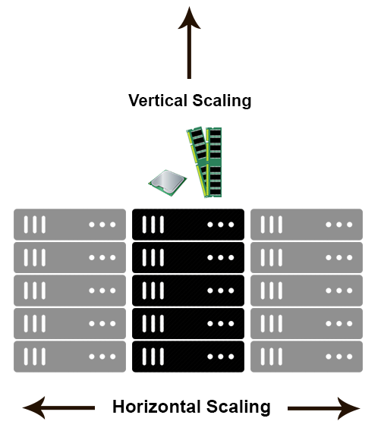
In the database world, horizontal-scaling is often based on the partitioning of the data i.e. each node contains only part of the data, in vertical-scaling the data resides on a single node and scaling is done through multi-core i.e. spreading the load between the CPU and RAM resources of that machine.
With horizontal-scaling it is often easier to scale dynamically by adding more machines into the existing pool - Vertical-scaling is often limited to the capacity of a single machine, scaling beyond that capacity often involves downtime and comes with an upper limit.
Good examples of horizontal scaling are Cassandra, MongoDB, Google Cloud Spanner .. and a good example of vertical scaling is MySQL - Amazon RDS (The cloud version of MySQL). It provides an easy way to scale vertically by switching from small to bigger machines. This process often involves downtime.
In-Memory Data Grids such as GigaSpaces XAP, Coherence etc.. are often optimized for both horizontal and vertical scaling simply because they're not bound to disk. Horizontal-scaling through partitioning and vertical-scaling through multi-core support.

Create Horizontal Pod Autoscaler:
Now that the server is running, we will create the autoscaler using kubectl autoscale. The following command will create a Horizontal Pod Autoscaler that maintains between 1 and 10 replicas of the Pods controlled by the php-apache deployment we created in the first step of these instructions. Roughly speaking, HPA will increase and decrease the number of replicas (via the deployment) to maintain an average CPU utilization across all Pods of 50% (since each pod requests 200 milli-cores by kubectl run), this means average CPU usage of 100 milli-cores). See here for more details on the algorithm.
kubectl autoscale deployment php-apache --cpu-percent=50 --min=1 --max=10
horizontalpodautoscaler.autoscaling/php-apache autoscaled
We may check the current status of autoscaler by running:
kubectl get hpa
NAME REFERENCE TARGET MINPODS MAXPODS REPLICAS AGE
php-apache Deployment/php-apache/scale 0% / 50% 1 10 1 18s

Please note that the current CPU consumption is 0% as we are not sending any requests to the server (the TARGET column shows the average across all the pods controlled by the corresponding deployment).

Increase load
Now, we will see how the autoscaler reacts to increased load. We will start a container, and send an infinite loop of queries to the php-apache service (please run it in a different terminal):
kubectl run -it --rm load-generator --image=busybox /bin/sh

Hit enter for command prompt

while true; do wget -q -O- http://php-apache; done
Within a minute or so, we should see the higher CPU load by executing:
kubectl get hpa
NAME REFERENCE TARGET MINPODS MAXPODS REPLICAS AGE
php-apache Deployment/php-apache/scale 305% / 50% 1 10 1 3m

Here, CPU consumption has increased to 305% of the request. As a result, the deployment was resized to 7 replicas:
kubectl get deployment php-apache
NAME READY UP-TO-DATE AVAILABLE AGE
php-apache 7/7 7 7 19m
Note: It may take a few minutes to stabilize the number of replicas. Since the amount of load is not controlled in any way it may happen that the final number of replicas will differ from this example.

Stop load
We will finish our example by stopping the user load.
In the terminal where we created the container with busybox image, terminate the load generation by typing <Ctrl> + C.
Then we will verify the result state (after a minute or so):
kubectl get hpa
NAME REFERENCE TARGET MINPODS MAXPODS REPLICAS AGE
php-apache Deployment/php-apache/scale 0% / 50% 1 10 1 11m
kubectl get deployment php-apache
NAME READY UP-TO-DATE AVAILABLE AGE
php-apache 1/1 1 1 27m

To get the yaml for a deployment (service, pod, secret, etc):
kubectl get deploy deploymentname -o yaml --export
Bash script exporting yaml to sub-folders:
for n in $(kubectl get -o=name pvc,configmap,serviceaccount,secret,ingress,service,deployment,statefulset,hpa,job,cronjob)
do
mkdir -p $(dirname $n)
kubectl get -o=yaml --export $n > $n.yaml
done

A PersistentVolume (PV) is a piece of storage in the cluster that has been provisioned by an administrator. It is a resource in the cluster just like a node is a cluster resource. PVs are volume plugins like Volumes but have a lifecycle independent of any individual pod that uses the PV. This API object captures the details of the implementation of the storage, be that NFS, iSCSI, or a cloud-provider-specific storage system.
A PersistentVolumeClaim (PVC) is a request for storage by a user. It is similar to a pod. Pods consume node resources and PVCs consume PV resources. Pods can request specific levels of resources (CPU and Memory). Claims can request specific size and access modes (e.g., can be mounted once read/write or many times read-only).

OSI stands for Open Systems Interconnection. It has been developed by ISO – ‘International Organization of Standardization‘, in the year 1984. It is a 7 layer architecture with each layer having specific functionality to perform. All these 7 layers work collaboratively to transmit the data from one person to another across the globe.
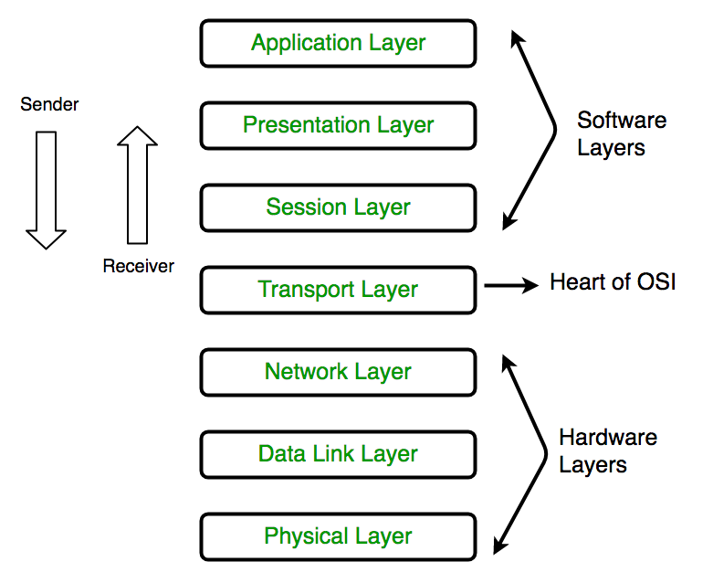

Difference between Apache Tomcat server and Apache web server
Apache Tomcat server: Apache Tomcat is a web container. It allows the users to run Servlet and JAVA Server Pages that are based on the web-applications. It can be used as the HTTP server. The performance of the Tomcat server is not as good as the designated web server. It can be used as separate product with its own internal Web-server. It can also be used as mutually with the others Web-servers which include Apache, Microsoft Internet Information Server, and Microsoft Personal Web-server.
Apache Web server: Apache web-server is designed to create the web-servers. It can host one or more HTTP based web-servers. It is used by the various web-hosting companies for the mutual web-hosting. It is the oldest web-server.
Difference between the Apache Tomcat server and Apache web server:
APACHE TOMCAT SERVER | APACHE WEB SERVER
This server is a JSP/Servlet container. | This server is a HTTP server. It serves the files through the HTTP protocol.
It can handle both static pages and dynamic pages. The static pages are generated using HTML. The dynamic pages are generated using Servlet and JSP. | It can handle static pages which are generated using HTML. It can handle dynamic content which are coded in PHP, Ruby or other languages only through add-on modules offered by Apache or any other client.
It can be used only for hosting JAVA based code. | It can be used to host applications written in any programming language.
It is not capable for the requests/response processing. It is the container that can manage the entire lifecycle of the pages which are generated hrough the Servlet & JSP. | It is capable of request/ response & load balancing.
It can be coded in pure JAVA. | It is only coded in C programming language.

A VPC peering connection is a networking connection between two VPCs that enables you to route traffic between them using private IPv4 addresses or IPv6 addresses. Instances in either VPC can communicate with each other as if they are within the same network. You can create a VPC peering connection between your own VPCs, or with a VPC in another AWS account. The VPCs can be in different regions (also known as an inter-region VPC peering connection).
