Types of Pod
There are two types of Pods −
- Single container pod
- Multi container pod

Single Container Pod
They can be simply created with the kubctl run command, where you have a defined image on the Docker registry which we will pull while creating a pod.
$ kubectl run <name of pod> --image=<name of the image from registry>
Example − We will create a pod with a tomcat image which is available on the Docker hub.
$ kubectl run tomcat --image = tomcat:8.0
This can also be done by creating the yaml file and then running the kubectl create command.
apiVersion: v1
kind: Pod
metadata:
name: Tomcat
spec:
containers:
- name: Tomcat
image: tomcat: 8.0
ports:
containerPort: 7500
imagePullPolicy: Always

Once the above yaml file is created, we will save the file with the name of tomcat.yml and run the create command to run the document.
$ kubectl create –f tomcat.yml
It will create a pod with the name of tomcat. We can use the describe command along with kubectl to describe the pod.

Multi Container Pod
Multi container pods are created using yaml mail with the definition of the containers.
apiVersion: v1
kind: Pod
metadata:
name: Tomcat
spec:
containers:
- name: Tomcat
image: tomcat: 8.0
ports:
containerPort: 7500
imagePullPolicy: Always
-name: Database
Image: mongoDB
Ports:
containerPort: 7501
imagePullPolicy: Always

In the above code, we have created one pod with two containers inside it, one for tomcat and the other for MongoDB

Run a Stateless Application Using a Deployment:-

Creating and exploring an nginx deployment

apiVersion: apps/v1 # for versions before 1.9.0 use apps/v1beta2
kind: Deployment
metadata:
name: nginx-deployment
spec:
selector:
matchLabels:
app: nginx
replicas: 2 # tells deployment to run 2 pods matching the template
template:
metadata:
labels:
app: nginx
spec:
containers:
- name: nginx
image: nginx:1.14.2
ports:
- containerPort: 80

kubectl apply -f https://k8s.io/examples/application/deployment.yaml

kubectl describe deployment nginx-deployment

kubectl get pods -l app=nginx

kubectl describe pod <pod-name>

For example, suppose you have a set of Pods that each listen on TCP port 9376 and carry a label app=MyApp:
apiVersion: v1
kind: Service
metadata:
name: my-service
spec:
selector:
app: MyApp
ports:
- protocol: TCP
port: 80
targetPort: 9376
This specification creates a new Service object named "my-service", which targets TCP port 9376 on any Pod with the app=MyApp label.

- Services are how pods communicate, either with either other or with the outside world. They do this by specifying a port for the caller to use, and a targetPort, which is the port on which the Pod itself receives the message.
- Services know which pods to target based on labels specified in the selector.

apiVersion: v1
kind: Service
metadata:
name: nginx
labels:
app: nginx
spec:
selector:
app: nginx
ports:
- port: 80
name: http
targetPort: 80
- port: 443
name: https
targetPort: 80

kubectl apply -f test.yaml

kubectl get svc

kubectl describe svc nginx

kubernetes
apiVersion: v1
kind: Service
metadata:
name: elasticsearch
namespace: elk
labels:
component: elasticsearch
spec:
type: LoadBalancer
selector:
component: elasticsearch
ports:
- name: http
port: 9200
protocol: TCP
- name: transport
port: 9300
protocol: TCP
—
apiVersion: v1
kind: Pod
metadata:
name: rss-site
labels:
app: web
spec:
containers:
– name: front-end
image: nginx
ports:
– containerPort: 80
– name: rss-reader
image: nickchase/rss-php-nginx:v1
ports:
– containerPort: 88

apiVersion: apps/v1
kind: Deployment
metadata:
name: rss-site
labels:
app: web
spec:
replicas: 2
selector:
matchLabels:
app: web
template:
metadata:
labels:
app: web
spec:
containers:
- name: front-end
image: nginx
ports:
- containerPort: 80
- name: rss-reader
image: nickchase/rss-php-nginx:v1
ports:
- containerPort: 88

Types of Services
ClusterIP − This helps in restricting the service within the cluster. It exposes the service within the defined Kubernetes cluster.
spec:
type: NodePort
ports:
- port: 8080
nodePort: 31999
name: NodeportService
NodePort − It will expose the service on a static port on the deployed node. A ClusterIP service, to which NodePort service will route, is automatically created. The service can be accessed from outside the cluster using the NodeIP:nodePort.
spec:
ports:
- port: 8080
nodePort: 31999
name: NodeportService
clusterIP: 10.20.30.40
Load Balancer − It uses cloud providers’ load balancer. NodePort and ClusterIP services are created automatically to which the external load balancer will route.
A full service yaml file with service type as Node Port. Try to create one yourself.
apiVersion: v1
kind: Service
metadata:
name: appname
labels:
k8s-app: appname
spec:
type: NodePort
ports:
- port: 8080
nodePort: 31999
name: omninginx
selector:
k8s-app: appname
component: nginx
env: env_name

create a deployment:-

kubectl run hello-world –replicas=2 –labels=”run=load-balancer-example” –image=gcr.io/google-samples/node-hello:1.0 –port=8080”

To see that the deployment is running

$ kubectl get deployments hello-world
NAME DESIRED CURRENT UP-TO-DATE AVAILABLE AGE
hello-world 2 2 2 2 56s

With the applications running, we want to access one. So, let’s create a ClusterIP type of service. We can:
- Create a yaml manifest for the service and apply it, or
- Use the “kubectl expose” command, which is the easier option. This expose command creates a service without creating a yaml file.
- $ kubectl expose deployment hello-world --type=ClusterIP --name=example-service
- service "example-service" exposed

To access our application, run “kubectl get service example-service” to get our port number. Then, run a special command called port-forward. Because our service type is Cluster IP, which can only be accessed from within the cluster, we must access our app by forwarding the port to a local port.

$ kubectl get service example-service
NAME TYPE CLUSTER-IP EXTERNAL-IP PORT(S) AGE
example-service ClusterIP 100.20.149.98 <none> 8080/TCP 1h

$ kubectl port-forward service/example-service 8080:8080
Forwarding from 127.0.0.1:8080 -> 8080

Now we can browse http://localhost:8080 from our workstation and we should see:
Hello Kubernetes!
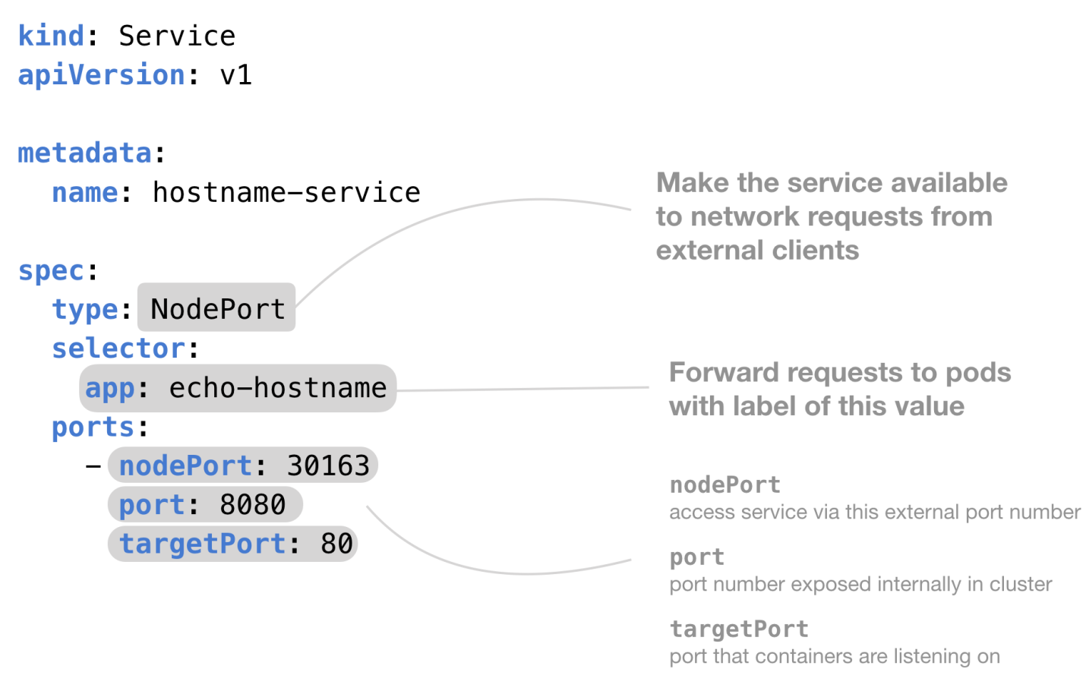

- ClusterIP – The default value. The service is only accessible from within the Kubernetes cluster
- NodePort – This makes the service accessible on a static port on each Node in the cluster.
- LoadBalancer – The service becomes accessible externally through a cloud provider's load balancer functionality. GCP, AWS, Azure, and OpenStack offer this functionality.

Running Automated Tasks with a CronJob
The main function of a job is to create one or more pod and tracks about the success of pods. They ensure that the specified number of pods are completed successfully. When a specified number of successful run of pods is completed, then the job is considered complete.

Cron jobs are useful for creating periodic and recurring tasks, like running backups or sending emails. Cron jobs can also schedule individual tasks for a specific time, such as if you want to schedule a job for a low activity period.

You need to have a Kubernetes cluster, and the kubectl command-line tool must be configured to communicate with your cluster.

Creating a Cron Job
Cron jobs require a config file. This example cron job config .spec file prints the current time and a hello message every minute:
apiVersion: batch/v1beta1
kind: CronJob
metadata:
name: hello
spec:
schedule: "*/1 * * * *"
jobTemplate:
spec:
template:
spec:
containers:
- name: hello
image: busybox
args:
- /bin/sh
- -c
- date; echo Hello from the Kubernetes cluster
restartPolicy: OnFailure

Run the above example CronJob by using this command:
kubectl create -f https://k8s.io/examples/application/job/cronjob.yaml
The output is similar to this:
cronjob.batch/hello created

After creating the cron job, get its status using this command:
kubectl get cronjob hello
The output is similar to this:
NAME SCHEDULE SUSPEND ACTIVE LAST SCHEDULE AGE
hello */1 * * * * False 0 <none> 10s

As you can see from the results of the command, the cron job has not scheduled or run any jobs yet.
Watch for the job to be created in around one minute:
kubectl get jobs --watch
The output is similar to this:
NAME COMPLETIONS DURATION AGE
hello-4111706356 0/1 0s
hello-4111706356 0/1 0s 0s
hello-4111706356 1/1 5s 5s

Now you've seen one running job scheduled by the "hello" cron job. You can stop watching the job and view the cron job again to see that it scheduled the job:
kubectl get cronjob hello
The output is similar to this:
NAME SCHEDULE SUSPEND ACTIVE LAST SCHEDULE AGE
hello */1 * * * * False 0 50s 75s

You should see that the cron job hello successfully scheduled a job at the time specified in LAST SCHEDULE. There are currently 0 active jobs, meaning that the job has completed or failed.

This cronjob will run one job every 5 minutes (using a cron format for scheduling) and display “Hello world”

apiVersion:batch/v1beta1
kind: CronJob
metadata:
name: test
spec:
schedule: "*/5 * * * *"
jobTemplate:
spec:
template:
spec:
containers:
- name: hello
image: bash
command: ["echo", "Hello world"]
restartPolicy: OnFailure
To launch this job - kubectl apply -f most_basic_cronjob.yaml

To check that the cronjob was created - kubectl get cronjob

If we check the status of our scheduled jobs after 5 minutes, here’s what we’ll see.

To check the job in detail - kubectl get job

To get the details of the job - kubectl describe cronjob test

To edit the cronjob on the fly - kubectl edit cronjob test

Deleting a Cron Job - kubectl delete cronjob hello

How to create the YAML file
The first thing we must do is create a YAML file for the task. Remember, this is a very basic task, so our YAML file won't contain too much information. Let's break it down.
The first section defines the API version and the kind of job we're creating. That section looks like:
apiVersion: batch/v1beta1
kind: CronJob

The next section details the metadata for the job. That section looks like:
metadata:
name: cron-hello

Next, we have the specs for the job. This section contains our parameters for cron and is defined by way of the schedule option, which will run the task every 15 minutes. This section looks like:
spec:
schedule: "0,15,30,45 * * * *"

Now we have the job template section, some of which will remain blank (for simplicity). This section defines the image used for the container to be deployed--in this case, busybox. It also includes a few arguments, one of which is the output to be printed for the job (remember, this is a simple task). The output will be the date and a text message printed every 15 minutes, as defined by the schedule option.
This section looks like:
jobTemplate:
spec:
template:
spec:
containers:
- name: cron-hello
image: busybox
args:
- /bin/sh
- -c
- date; echo Hello, TechRepublic!
restartPolicy: OnFailure

Create the new file with the command:
nano cron.yaml
In that file, paste the entire contents of the manifest shown below:
apiVersion: batch/v1beta1
kind: CronJob
metadata:
name: cron-hello
spec:
schedule: "0,15,30,45 * * * *"
jobTemplate:
spec:
template:
spec:
containers:
- name: cron-hello
image: busybox
args:
- /bin/sh
- -c
- date; echo Hello, TechRepublic!
restartPolicy: OnFailure

Save and close the file.

How to deploy the job
Now we're going to deploy the job that includes the scheduled task. To do that, issue the command:
kubectl create -f cron.yaml
Once the job runs, it'll report that cron-hello has been created (Figure A).
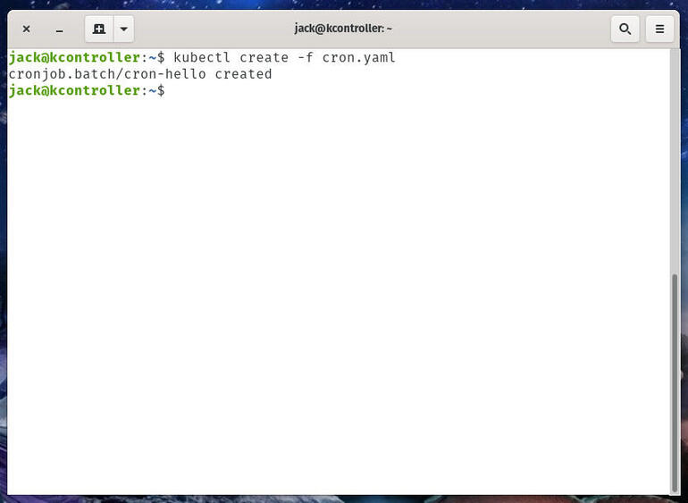
Our scheduled task deployment was successful.
You can ensure the cronjob task is running with the command:
kubeclt get cronjobs
This will list out every cronjob task on your cluster (Figure B).
Figure B
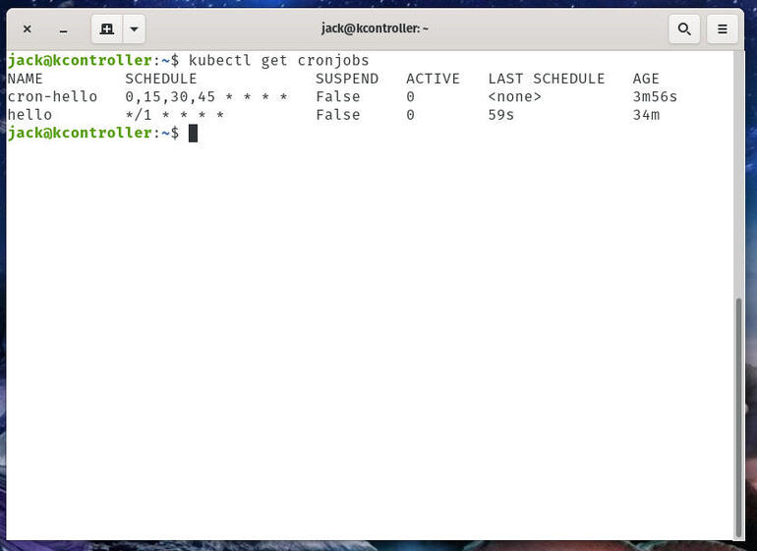
I have two containers that include cronjobs on my Kubernetes cluster.

How to watch for the cronjob
Let's say you've deployed a container with an associated cronjob and you want to watch for it. To do that, you'd issue the command:
kubectl get jobs --watch
The output of that command will include a running list of every deployed job (Figure C).
Figure C
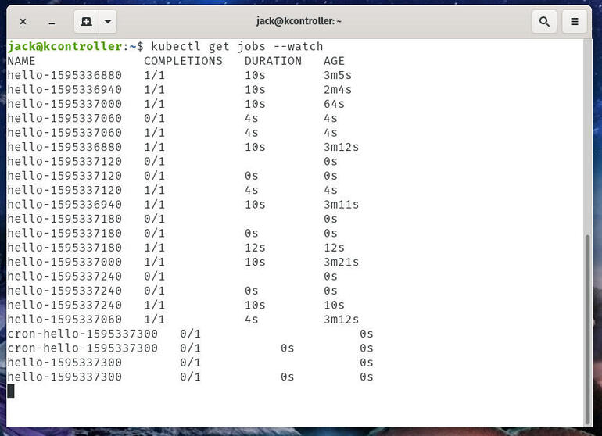
I have a number of created jobs that have run, thanks to cronjob.
To end that watch, use the Ctrl+C combination.

How to delete the cronjob
Deleting a cron-scheduled job is quite simple. To do this, issue the command:
kubectl delete cronjob NAME
Where NAME is the name used in the metadata section of the YAML file.
Alternatively, use kubectl run to create a cron job without writing full config:

$ kubectl run hello --schedule="*/1 * * * *" --restart=OnFailure --image=busybox -- /bin/sh -c "date; echo Hello from the Kubernetes cluster"

cronjob "hello" created

After creating the cron job, get its status using this command:
$ kubectl get cronjob hello
NAME SCHEDULE SUSPEND ACTIVE LAST-SCHEDULE
hello */1 * * * * False 0 <none>

As you can see above, there's no active job yet, and no job has been scheduled, either.
Watch for the job to be created in around one minute:
$ kubectl get jobs --watch
NAME DESIRED SUCCESSFUL AGE
hello-4111706356 1 1 2s
Now you've seen one running job scheduled by "hello". We can stop watching it and get the cron job again:
$ kubectl get cronjob hello
NAME SCHEDULE SUSPEND ACTIVE LAST-SCHEDULE
hello */1 * * * * False 0 Mon, 29 Aug 2016 14:34:00 -0700
You should see that "hello" successfully scheduled a job at the time specified in LAST-SCHEDULE. There are currently 0 active jobs, meaning that the job that's scheduled is completed or failed.
Now, find the pods created by the job last scheduled and view the standard output of one of the pods. Note that your job name and pod name would be different.
# Replace "hello-4111706356" with the job name in your system
$ pods=$(kubectl get pods --selector=job-name=hello-4111706356 --output=jsonpath={.items..metadata.name})

$ echo $pods
hello-4111706356-o9qcm

$ kubectl logs $pods
Mon Aug 29 21:34:09 UTC 2016
Hello from the Kubernetes cluster

Deleting a Cron Job
Once you don't need a cron job anymore, simply delete it with kubectl:
$ kubectl delete cronjob hello
cronjob "hello" deleted
This stops new jobs from being created. However, running jobs won't be stopped, and no jobs or their pods will be deleted. To clean up those jobs and pods, you need to list all jobs created by the cron job, and delete them all:
$ kubectl get jobs
NAME DESIRED SUCCESSFUL AGE
hello-1201907962 1 1 11m
hello-1202039034 1 1 8m
...

$ kubectl delete jobs hello-1201907962 hello-1202039034 ...

job "hello-1201907962" deleted
job "hello-1202039034" deleted
...
Once the jobs are deleted, the pods created by them are deleted as well. Note that all jobs created by cron job "hello" will be prefixed "hello-". You can delete them at once with kubectl delete jobs --all, if you want to delete all jobs in the current namespace (not just the ones created by "hello".)

What is Ingress
Kubernetes ingress is a collection of routing rules that govern how external users access services running in a Kubernetes cluster. However, in real-world Kubernetes deployments, there are frequently additional considerations beyond routing for managing ingress.
Ingress exposes HTTP and HTTPS routes from outside the cluster to services within the cluster. Traffic routing is controlled by rules defined on the Ingress resource.
Here is a simple example where an Ingress sends all its traffic to one Service:
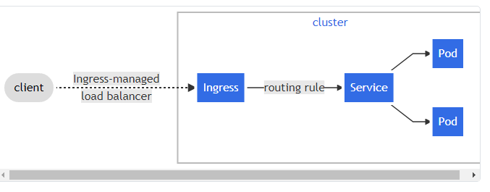
An Ingress may be configured to give Services externally-reachable URLs, load balance traffic, terminate SSL / TLS, and offer name-based virtual hosting. An Ingress controller is responsible for fulfilling the Ingress, usually with a load balancer, though it may also configure your edge router or additional frontends to help handle the traffic.
An Ingress does not expose arbitrary ports or protocols. Exposing services other than HTTP and HTTPS to the internet typically uses a service of type Service.Type=NodePort or Service.Type=LoadBalancer.
In Kubernetes, there are three general approaches to exposing your application.
- Using a Kubernetes service of type NodePort, which exposes the application on a port across each of your nodes
- Use a Kubernetes service of type LoadBalancer, which creates an external load balancer that points to a Kubernetes service in your cluster
- Use a Kubernetes Ingress Resource
An Ingress provides the following:
- Externally reachable URLs for applications deployed in Kubernetes clusters
- Name-based virtual host and URI-based routing support
- Load balancing rules and traffic, as well as SSL termination

What is the Ingress Controller?
If Kubernetes Ingress is the API object that provides routing rules to manage external access to services, Ingress Controller is the actual implementation of the Ingress API. The Ingress Controller is usually a load balancer for routing external traffic to your Kubernetes cluster and is responsible for L4-L7 Network Services.
Layer 4 (L4) refers to the connection level of the OSI network stack—external connections load-balanced in a round-robin manner across pods. Layer 7 (L7) refers to the application level of the OSI stack—external connections load-balanced across pods, based on requests. Layer 7 is often preferred, but you should select an Ingress Controller that meets your load balancing and routing requirements.
Ingress Controller is responsible for reading the Ingress Resource information and processing that data accordingly. The following is a sample Ingress Resource:
As an analogy, if Kubernetes Ingress is a computer, then Ingress Controller is a programmer using the computer and taking action. Furthermore, Ingress Rules act as the manager who directs the programmer to do the work using the computer. Ingress Rules are a set of rules for processing inbound HTTP traffic. An Ingress with no rules sends all traffic to a single default backend service.
Looking deeper, the Ingress Controller is an application that runs in a Kubernetes cluster and configures an HTTP load balancer according to Ingress Resources. The load balancer can be a software load balancer running in the cluster or a hardware or cloud load balancer running externally. Different load balancers require different Ingress Controller implementations.
