In this guide, we are going to use Docker to configure Jenkins and Tomcat to achieve Continuous Integration/Continuous Deployment.
We will install and set up Tomcat and Jenkins using Docker, and thereafter we are going to create a Jenkins Job to deploy your Java application over the Tomcat server.
This guide is assuming that you already have basic knowledge of Docker and Docker is up and running on your host machine. So let’s begin with the guide.

Jenkins Set up
You can spin up a Docker container using the Jenkins image.
$ docker container run -dit -p 8080:8080 -v /var/run/docker.sock:/var/run/docker.sock -v /data/jenkins/jenkins_home:/var/jenkins_home --name jenkins_container jenkins/jenkins
We are running Jenkins on port 8080. You can see the running container here:
$ docker ps
CONTAINER ID IMAGE COMMAND CREATED STATUS PORTS NAMES
ce46107c9f83 jenkins/jenkins:lts "/sbin/tini” Up 1 minutes Up 1 minutes 0.0.0.0:8080->8080/tcp jenkins_container
To extract the Jenkins password from Jenkins’s container, you can run below-mentioned command:
$ docker exec -it jenkins_container cat /var/jenkins_home/secrets/initialAdminPassword
gSzHTGfbtXSpcBXMyJ6gzmNfNH7BjhK23
Copy the admin password from your terminal and open http://your-ip-addr:8080 in your preferred browser. Next, run the initial setup wizard and select Recommended Plugins. Jenkins will install all the necessary plugins.
If everything goes well, you will land on the Jenkins’ dashboard area, which looks something like this:

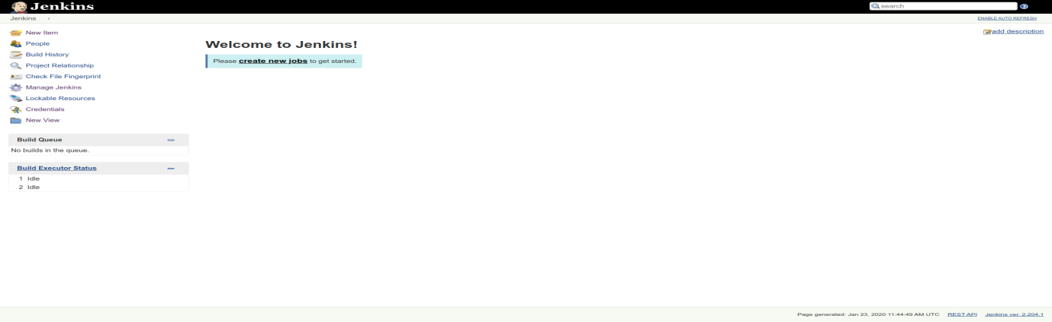

Tomcat Set up
Now, it’s time to spin the Tomcat container. For this, we are going to use CentOS, which will enable us to set up a customized Tomcat server. You can also use tomcat image as per your choice, however for this guide we are going to stick to the plan. So let’s start by pulling the latest Centos image from Docker Hub:
$ docker pull centos
Using default tag: latest
latest: Pulling from library/centos
8a29a15cefae: Pull complete
Digest: sha256:fe8d824220415eed5477b63addf40fb06c3b049404242b31982106ac204f6700
Status: Downloaded newer image for centos:latest
docker.io/library/centos:latest
To run the container from the pulled image in detached mode, use the command below:
$ docker run -dit --name tomcat_container -p 8888:8080 centos
As Jenkins has already occupied port 8080 on the machine, here we have opened port 8888 for Tomcat in spite the default port being 8080.
To install Tomcat in your Centos container, follow the steps:
$ docker exec -it eca291a36127 /bin/bash
Go to /opt directory, in your tomcat_container:
[root@eca291a36127 /]# cd opt/
Open https://tomcat.apache.org/download-80.cgi on your browser. Find “Core” and download the Tomcat binary. At the time of writing this article, the current version is 8.5.50.
[root@eca291a36127 /]# yum install wget
[root@eca291a36127 /]# wget http://apachemirror.wuchna.com/tomcat/tomcat-8/v8.5.50/bin/apache-tomcat-8.5.50.tar.gz
Extract the tar file:
[root@eca291a36127 /]# tar -xvzf apache-tomcat-8.5.50.tar.gz
[root@eca291a36127 /]# cd apache-tomcat-8.5.50/bin/
Here you are going to find two shell script files named startup.sh and shutdown.sh, assign “execute” permission to both. Both these files allow us to start and stop the Tomcat server, within our container:
[root@eca291a36127 bin]# chmod +x shutdown.sh
[root@eca291a36127 bin]# chmod +x startup.sh
To run the Tomcat server, Java is required. In order to do so, run following command to satisfy the requirement. Here we are going to install OpenJDK 7 using Yum:
[root@eca291a36127 /]# yum install java-1.7.0-openjdk-devel
It’s time to run our Tomcat server; use startup.sh file to do so:
[root@eca291a36127 /]# ./startup.sh
Using CATALINA_BASE: /opt/apache-tomcat-8.5.50
Using CATALINA_HOME: /opt/apache-tomcat-8.5.50
Using CATALINA_TMPDIR: /opt/apache-tomcat-8.5.50/temp
Using JRE_HOME: /usr
Using CLASSPATH: /opt/apache-tomcat-8.5.50/bin/bootstrap.jar:/opt/apache-tomcat-8.5.50/bin/tomcat-juli.jar
Tomcat started.
In your terminal, you can see the message Tomcat started. Now, go to your browser; Tomcat should be accessible at http://your-ip-addr:8888.

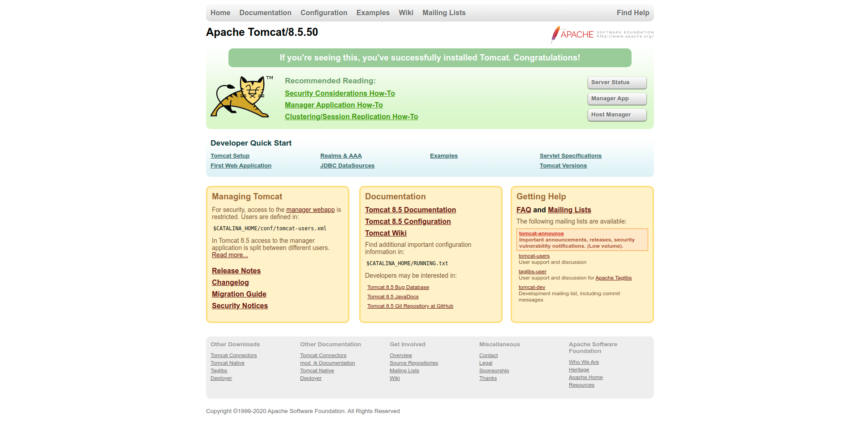
In case you want to access the Manage App, you will have to do some additional settings, as by default, the Manager App section can only be accessed from the local system (i.e., 127.0.0.1).
To overcome this, you will need to make some changes to context.xml file. To do so follow the below-mentioned steps:
$ docker exec -it tomcat_container /bin/bash
Now, find the context.xml file:
$ find / -name context.xml
/opt/apache-tomcat-8.5.50/conf/context.xml
/opt/apache-tomcat-8.5.50/webapps/host-manager/META-INF/context.xml
/opt/apache-tomcat-8.5.50/webapps/manager/META-INF/context.xml
Edit the file that resides in webapps directory i.e. /opt/apache-tomcat-8.5.50/webapps/host-manager/META-INF/context.xml, find the Value class name org.apache.catalina.valves.RemoteAddrValve and comment it:
...
<!-- <Valve className="org.apache.catalina.valves.RemoteAddrValve"
allow="127\.\d+\.\d+\.\d+|::1|0:0:0:0:0:0:0:1" /> -->
...
Let’s do the same thing on the other file as well, i.e., /opt/apache-tomcat-8.5.50/webapps/manager/META-INF/context.xml.
To access the default username and password through the Manager App section, go to conf/tomcat-users.xml and make the following changes:
$ /opt/apache-tomcat-8.5.50/conf && nano tomcat-users.xml
Now, as part of your pipeline, you will have to add a user and define roles on your Tomcat server. To copy the file from the remote machine (in our case, the Jenkins server), you will need to define the role Manager Script, copy the lines and add it to the end of the file just before the closing tag </tomcat-users>:
...
<role rolename="manager-gui"/>
<role rolename="manager-script"/>
<role rolename="manager-jmx"/>
<role rolename="manager-status"/>
<user username="admin" password="admin" roles="manager-gui, manager-script, manager-jmx, manager-status"/>
<user username="deployer" password="deployer" roles="manager-script"/>
<user username="tomcat" password="s3cret" roles="manager-gui"/>
</tomcat-users>
...
Since you have made configuration changes in the Tomcat server, you will need to restart the server for the changes to take effect.
$ cd /opt/apache-tomcat-8.5.50/bin/
$ ./shutdown.sh
$ ./startup.sh
Using CATALINA_BASE: /opt/apache-tomcat-8.5.50
Using CATALINA_HOME: /opt/apache-tomcat-8.5.50
Using CATALINA_TMPDIR: /opt/apache-tomcat-8.5.50/temp
Using JRE_HOME: /usr
Using CLASSPATH: /opt/apache-tomcat-8.5.50/bin/bootstrap.jar:/opt/apache-tomcat-8.5.50/bin/tomcat-juli.jar
Tomcat started.
You can now access the Tomcat Web Application Manager dashboard; username and password are tomcat and s3cret, respectively.
Let us move to the next part of the tutorial.

Configure Jenkins
It’s time to set up Maven and an additional plugin so that Jenkins can connect to Tomcat container over SSH. For this, we are going to install Maven Integration and Publish over SSH plugin in Jenkins.
Login to your Jenkins environment and go to Dashboard > Manage Jenkins > Manage Plugins > Available, as shown below:
For Maven Integration:

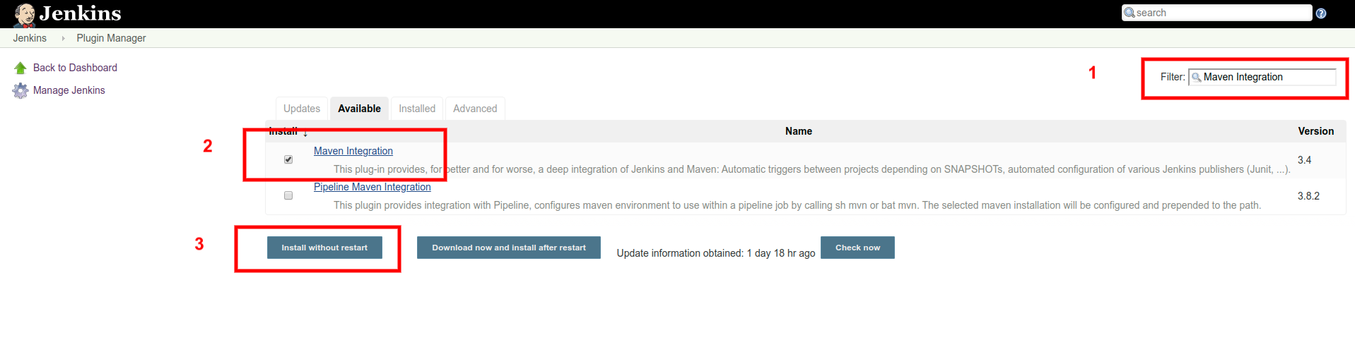
For Publish over SSH: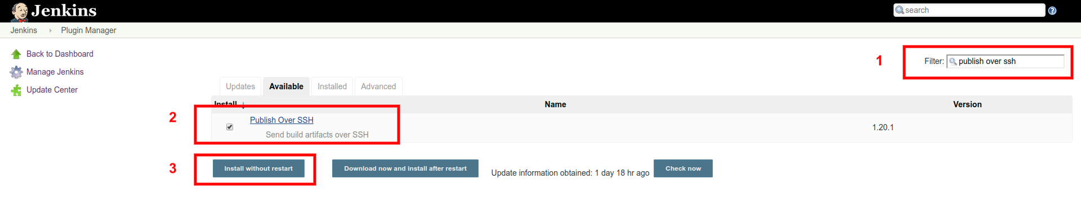
Post-installation, you need to configure SSH server details so that Jenkins can connect the Tomcat container. In Jenkins, go to Dashboard > Manage Jenkins > Configure System and find SSH Servers. Enter details as shown below:

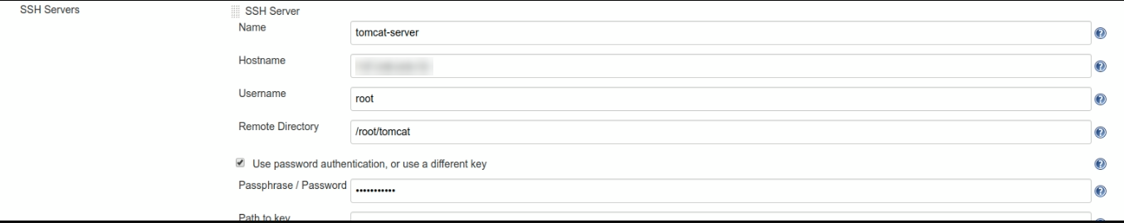
Test your connection before saving the details. For the sake of this article, we have used the password authentication method, however, it is not recommended in a production environment. We recommend you use a SSH key instead.

Deploying WAR file on Tomcat Server using Jenkins
As you are through with the configuration part, now you can proceed to create a Jenkins Job.
For this simple job, you would need to use Freestyle Project. Create a new item, as shown below:

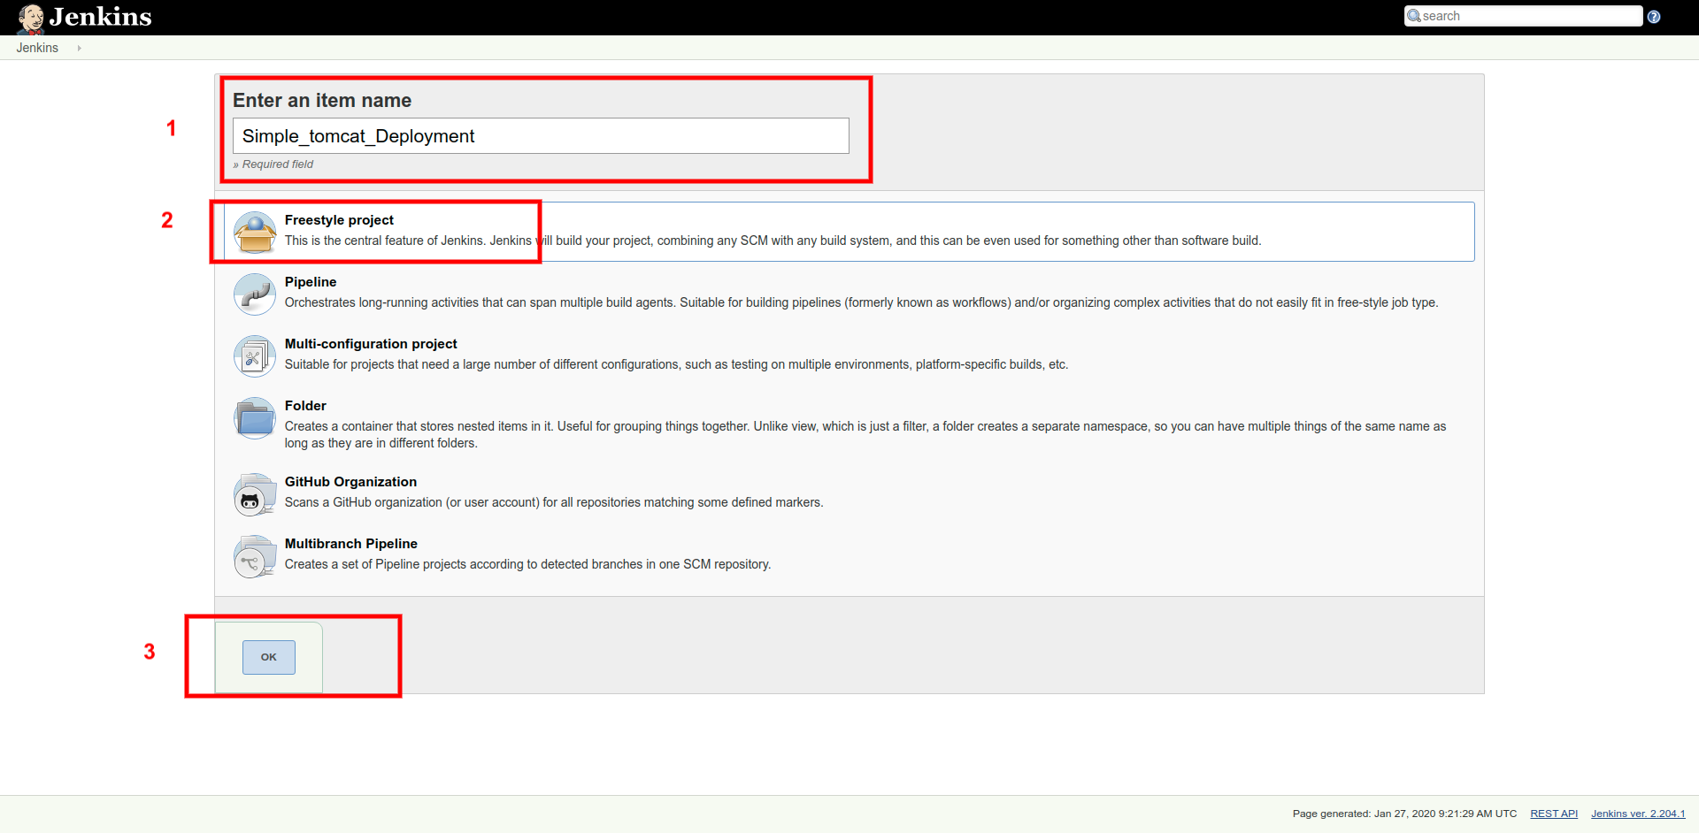
SCM
Go to the Source Code Management (also known as SCM), and select Git. Add your Github or GitLab URL in Repository URL field:

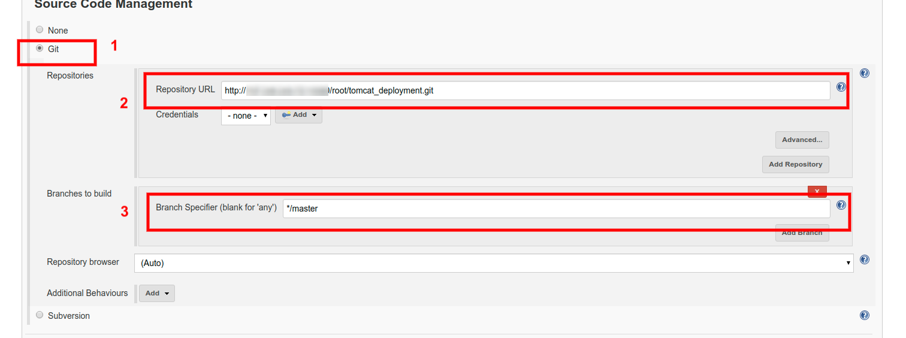
Poll SCM
In the Build Triggers section, select Poll SCM. It periodically polls the VCS to check if any changes were made. During the poll, if any changes were detected in repo since the last build, a new build is initiated.
Let’s say you want to poll SCM every 30 minutes, then in the text field, add H/30 * * * * (i.e., every 30 minutes, every hour, every day, every month, and every day of the week).

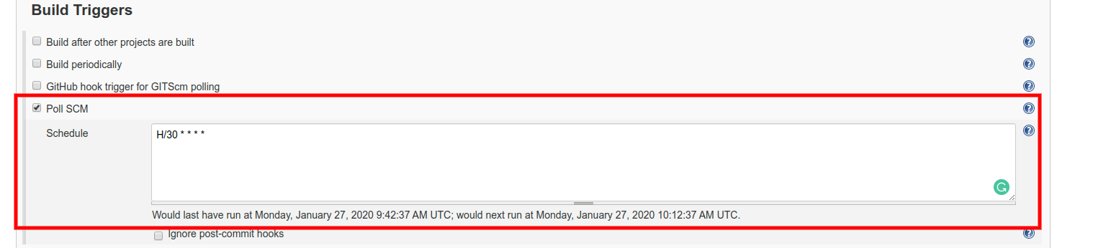
Post-Build Step
Go to Post-build Actions section and from the drop-down menu, select Send build artifacts over SSH, as shown below:

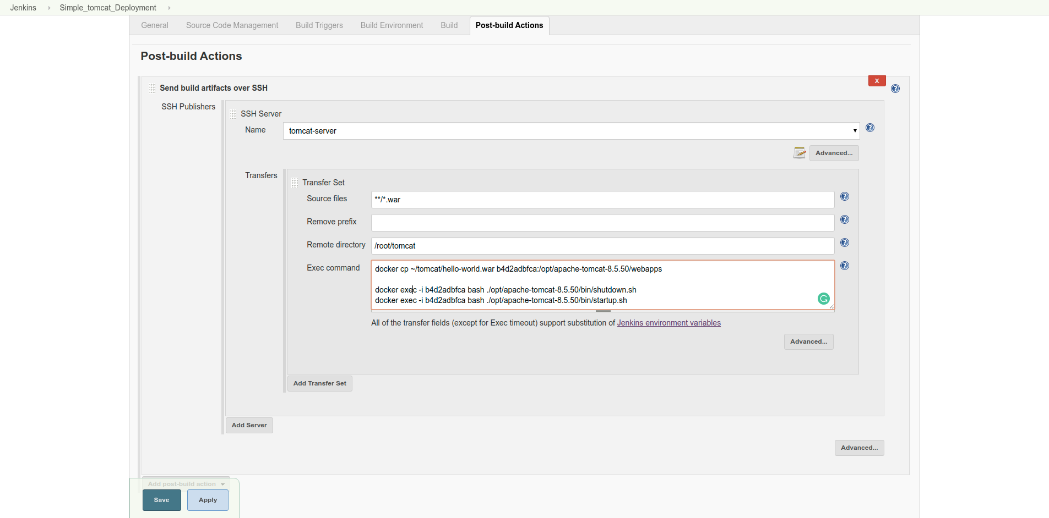
In the Source files field, mention the file name that is going to be uploaded to the server. In case you are not sure about the file name, you can use the pattern as mentioned above **/*.war.
Other than this, make sure that you mention the Remote Directory; in our case, it is /root/tomcat. Whereas, for Exec command, as you are using Docker for your Tomcat server, use the below-mentioned commands:
docker cp ~/tomcat/hello-world.war tomcat_container:/opt/apache-tomcat-8.5.50/webapps
docker exec -i tomcat_container bash ./opt/apache-tomcat-8.5.50/bin/shutdown.sh
docker exec -i tomcat_container bash ./opt/apache-tomcat-8.5.50/bin/startup.sh
The above will copy hello-world.war file to your dockerized tomcat container in /opt/apache-tomcat-8.5.50/webapps. Plus, you are making sure that you restart Tomcat to see the changes.
Build Now
Initiate the build process from the Project’s Jenkins Page, and go to the console log output to see if the build was a success or if there is any error/exception.
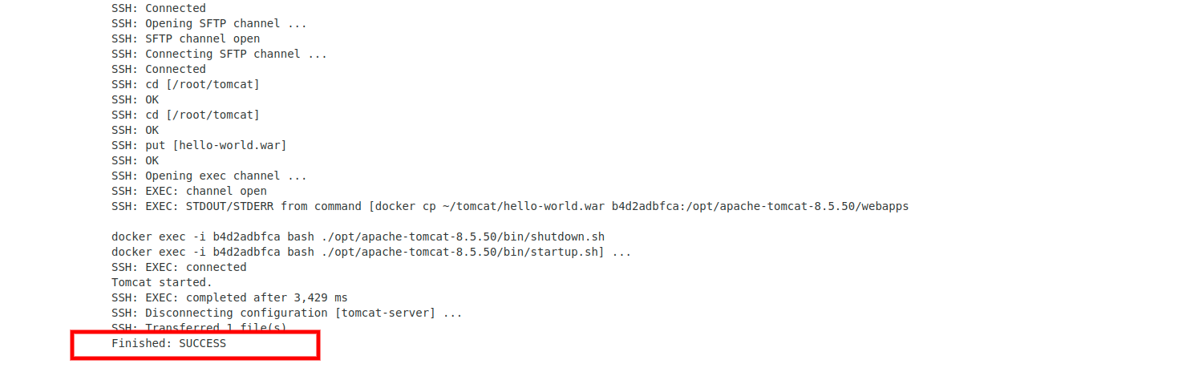
Your build finished with a SUCCESS message. Now go to your web browser and open http://your-ip-addr:8888/hello-world. You will see your application index page content. In our case, output is:


Voila!You have successfully deployed a sample application over Tomcat Server running on Docker with the help of Jenkins Jobs.

Ingress vs. ClusterIP vs. NodePort vs. LoadBalancer
Ingress, ClusterIP, NodePort, and LoadBalancer are all ways to get external traffic into your cluster, and they each do it differently. Let’s take a look at how each works and where you would use them.

ClusterIP
ClusterIP is the preferred option for internal service access and uses an internal IP address to access the service. Some examples of where ClusterIP might be the best option include service debugging during development and testing, internal traffic, and dashboards.
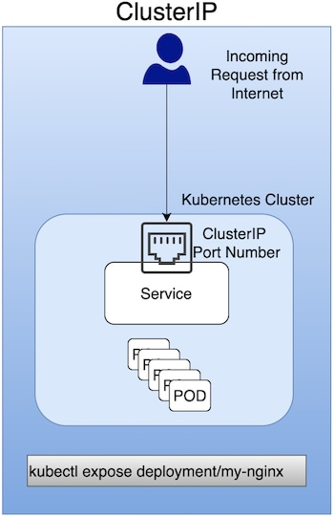

NodePort
A NodePort is a virtual machine (VM) used to expose a service on a Static Port number. It's primarily used for exposing services in a non-production environment (in fact, production use is not recommended). As an example, a NodePort would be used to expose a single service (with no load-balancing requirements for multiple services).
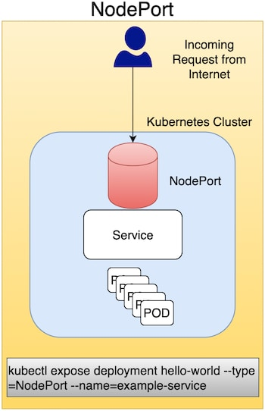

LoadBalancer
This method uses an external LoadBalancer to expose services to the Internet. You can use LoadBalancer in a production environment, but Ingress is often preferred.
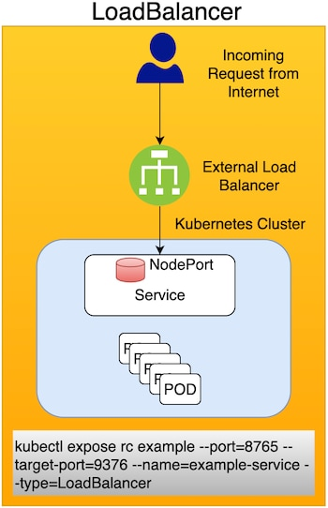

Ingress
Ingress enables you to consolidate the traffic-routing rules into a single resource and runs as part of a Kubernetes cluster. Some reasons Kubernetes Ingress is the preferred option for exposing a service in a production environment include the following:
- Traffic routing is controlled by rules defined on the Ingress Resource.
- Ingress is part of the Kubernetes cluster and runs as pods.
- An external Load Balancer is expensive, and you need to manage this outside the Kubernetes cluster. Kubernetes Ingress is managed from inside the cluster.
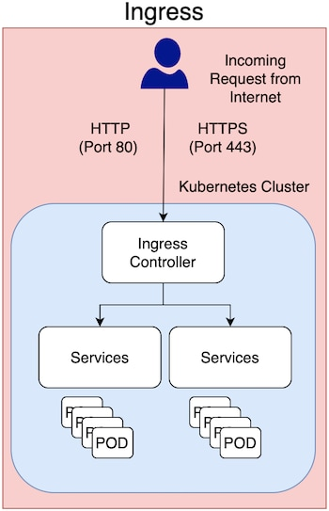
In production environments, you typically use Ingress to expose applications to the Internet. An application is accessed from the Internet via Port 80 (HTTP) or Port 443 (HTTPS), and Ingress is an object that allows access to your Kubernetes services from outside the Kubernetes cluster.

[ec2-user@ip-172-31-3-12 ~]$ nc -zv test-database2.cgiq2yxatjot.ap-south-1.rds.amazonaws.com 3306
Ncat: Version 7.50 ( https://nmap.org/ncat )
Ncat: Connected to 172.31.5.175:3306.
Ncat: 0 bytes sent, 0 bytes received in 0.04 seconds.
[ec2-user@ip-172-31-3-12 ~]$
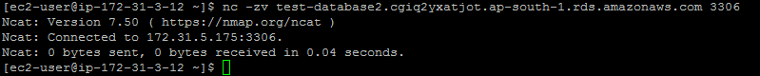
[ec2-user@ip-172-31-3-12 ~]$ mysql -h test-database2.cgiq2yxatjot.ap-south-1.rds.amazonaws.com -u admin -p
Enter password:
Welcome to the MariaDB monitor. Commands end with ; or \g.
Your MySQL connection id is 1480
Server version: 5.7.26-log Source distribution

Copyright (c) 2000, 2018, Oracle, MariaDB Corporation Ab and others.

Type 'help;' or '\h' for help. Type '\c' to clear the current input statement.

MySQL [(none)]>
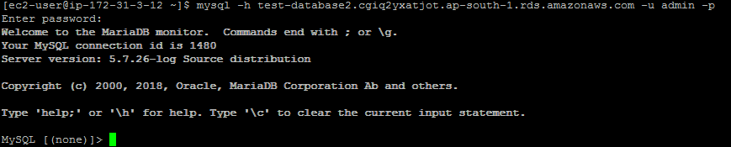
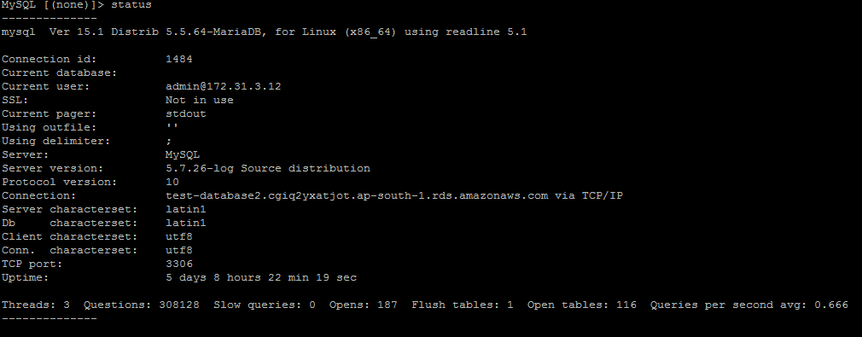

What is CIDR?
CIDR stands for Classless Inter-Domain Routing and is used for IP addressing and routing. It allocates IP addresses in a more flexible manner as compared to the original system of Internet Protocol (IP) address classes. In this way, it increases the number of available IP addresses with extensive use of NAT (Network Address Translation).
For example, consider the following CIDR Notation
182.0.1.2/28
Here, the prefix is – 182.0.1.2, and
The total number of bits in this address is 28.
For example, a CIDR block is shown below
10.0.1.0/24

Here /24 signifies the total number of 1’s bits in the routing mask (network mask).
This IP address can be shown as below in the binary format:

11111111.11111111.11111111.00000000

Here the first 24 bits are marked as 1.
It would be equivalent to a network mask of 255.255.255.0

Calculating the Number of Subnets and Hosts
Now based on a CIDR block, let’s say we need to calculate the number of subnets and hosts possible. We can do this with the following equations.
- Number of Networks possible in a CIDR network, use 2^{n} where n is the number of 1s in the subnet mask
- Number of hosts possible in a CIDR network, use 2^{n}-2 where n is the number of 0s in the host mask
- Every network needs 2 addresses, 1 for network and 1 for broadcast
Let’s consider the following example,
There is a given CIDR block of IP address 192.168.1.0/28
So first let’s get the decimal format in place
11111111.11111111.11111111.11110000
Now, here the first 3 octets are dedicated to the Network
11111111.11111111.11111111.11110000
The first 4 bits of 1’s of the 4th octet is what gives us the possibility of the subnets. So the value of n is 4.
11111111.11111111.11111111.11110000
So the number of subnets is (2*2*2*2) = 16
Next, we need to calculate the number of hosts
Since the number of host bits is 4, hence the value of n is also 4
11111111.11111111.11111111.11110000
So the number of hosts is (2*2*2*2) – 2 = 14

