Redis

Introduction to Redis:

- Redis, developed in 2009, is a flexible, open-source (BSD licensed), in-memory data structure store, used as database, cache, and message broker.
- Redis stands for REmote DIctionary Server.
- Redis is written in ANSI C and works in most POSIX systems like Linux, *BSD, and OS X, without external dependencies.
- Linux and OS X are the two operating systems where Redis is developed and tested the most, and we recommend using Linux for deployment.There is no official support for Windows builds.
- Redis is a No SQL database which works on the concept of key-value pair. Following in the footsteps of other NoSQL databases, such as Cassandra, CouchDB, and MongoDB, Redis allows the user to store vast amounts of data without the limits of a relational database.
- It is often referred to as a data structure server, since the keys can contain strings, hashes, lists, sets and sorted sets.
- Redis has three main peculiarities that sets it apart.
- Redis holds its database entirely in the memory, using the disk only for persistence.
- Redis has a relatively rich set of data types when compared to many key-value data stores.
- Redis can replicate data to any number of slaves

Redis vs RDBMS

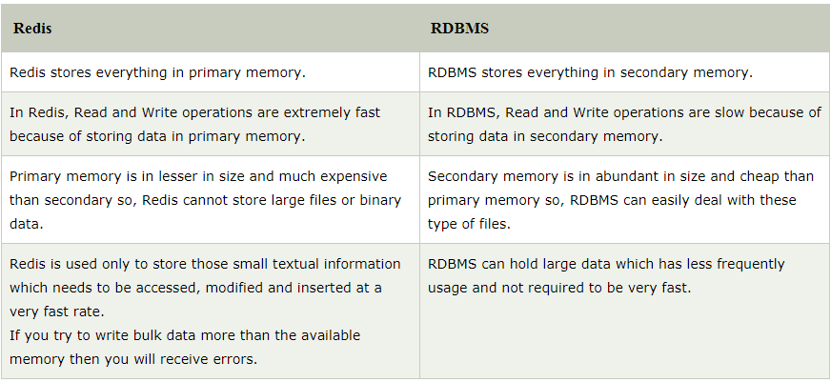

Redis Advantages
Following are certain advantages of Redis.
- Exceptionally fast − Redis is very fast and can perform about 110000 SETs per second, about 81000 GETs per second.
- Supports rich data types − Redis natively supports most of the datatypes that developers already know such as list, set, sorted set, and hashes. This makes it easy to solve a variety of problems as we know which problem can be handled better by which data type.
- Operations are atomic − All Redis operations are atomic, which ensures that if two clients concurrently access, Redis server will receive the updated value.
- Multi-utility tool − Redis is a multi-utility tool and can be used in a number of use cases such as caching, messaging-queues (Redis natively supports Publish/Subscribe), any short-lived data in your application, such as web application sessions, web page hit counts, etc.

Redis vs Other Key-Value Stores

Key-value store is a special type of database storage system where data is stored in form of key and value pairs.
Redis is different compared to other key-value stores because of the following:
- Redis is a different evolution path in the key-value databases where values can contain more complex data types, with atomic operations defined on those data types.
- Redis data types are closely related to fundamental data structures and are exposed to the programmer as such, without additional abstraction layers.
- Redis is an in-memory but persistent on disk database, so it represents a different trade off where very high write and read speed is achieved with the limitation of data sets that can't be larger than memory.
- Another advantage of in memory databases is that the memory representation of complex data structures is much simpler to manipulate compared to the same data structure on disk, so Redis can do a lot, with little internal complexity.
- At the same time the two on-disk storage formats (RDB and AOF) don't need to be suitable for random access, so they are compact and always generated in an append-only fashion.
What happens if Redis runs out of memory?
- Redis will either be killed by the Linux kernel OOM killer, crash with an error or will start to slow down. With modern operating systems malloc() returning NULL is not common, usually the server will start swapping, and Redis performance will degrade, so you'll probably notice there is something wrong.
The INFO command will report the amount of memory Redis is using so you can write scripts that monitor your Redis servers checking for critical conditions.
Redis has built-in protections allowing the user to set a max limit to memory usage, using the maxmemory option in the config file to put a limit to the memory Redis can use. If this limit is reached Redis will start to reply with an error to write commands, or you can configure it to evict keys when the max memory limit is reached in the case you are using Redis for caching.

Use cases of Redis
- User defined indexing schemes
- Message queues with real time new element notification
- Directed and undirected graph stores for following or friending systems
- Real-time publish/subscribe notification systems
- Real-time analytics backends
- Bloom filter servers
- Task queues and job systems
- High score leaderboards
- User ranking systems
- Hierarchical/tree structured storage systems
- Individual personalized news or data feeds for your users
Differences between SQL and NoSQL
Sr. No. | Key | SQL | NoSQL
1 | Type | SQL database is generally classified as a Relational database i.e. RDBMS. | While NOSQL database is known as non-relational or distributed database.
2 | Language | As we already know SQL uses structured query language for its CRUD operation which is defined as SQL. This makes SQL database to store data in more structured form and also preferred for more complex operations which could get completed with complex SQL queries. | NoSQL database on other hand has dynamic schema for unstructured data.Data stored in this type of database is not structured and could be stored in either of forms such as document-oriented, column-oriented, graph-based or organized as a KeyValue store. This syntax can be varied from DB to DB.
3 | Scalability | SQL database can extends its capacity on single server by increasing things like RAM, CPU or SSD i.e we can say that SQL dbs could be scalable in vertical as their storage could be increase for the same server by enhancing its storage components. | In order to increase the capacity of NOSQL dbs we required to install new servers parallel to the parent server i.e NOSQL dbs could be scalable in horizontal and this made them more preferable choice for large or ever-changing data sets.
4 | Internal implementation | SQL follows ACID properties for its operations which is abbreviation of Atomicity, Consistency, Isolation and Durability. | On other hand NOSQL is based on Brewers CAP theorem which maily focus on Consistency, Availability and Partition tolerance.
5 | Performance and suited for | SQL databases are best suited for complex queries but are not preferred for hierarchical large data storage. | NoSQL databases are not so good for complex queries because these are not as powerful as SQL queries but are best suited for hierarchical large data storage.
6 | Examples | SQL dbs is implemented in both open source and commercial Database such as like Postgres & MySQL as open source and Oracle and Sqlite as commercial. | On other hand NOSQL is purely open source and MongoDB, BigTable, Redis, RavenDB, Cassandra, Hbase, Neo4j, CouchDB are the main implementation of it.

Install Redis on Ubuntu
o install Redis on Ubuntu, go to the terminal and type the following commands −
$sudo apt-get update
$sudo apt-get install redis-server
This will install Redis on your machine.

Start Redis
$redis-server

Check If Redis is Working
$redis-cli
This will open a redis prompt.
redis 127.0.0.1:6379>
In the above prompt, 127.0.0.1 is your machine's IP address and 6379 is the port on which Redis server is running. Now type the following PING command.
redis 127.0.0.1:6379> ping
PONG
This shows that Redis is successfully installed on your machine.

