Why use Docker?

Open source Software development platform for virtualization with multiple OS.
Separate infrastructure and applications in order to deliver software quickly.
Develop, Ship and Run your application anywhere using Docker Containers.
Streamlines the development lifecycle by allowing developers to work in standardized environments using local Containers.

Docker architecture

Docker uses a client-server architecture where Docker client talks to the Docker daemon.

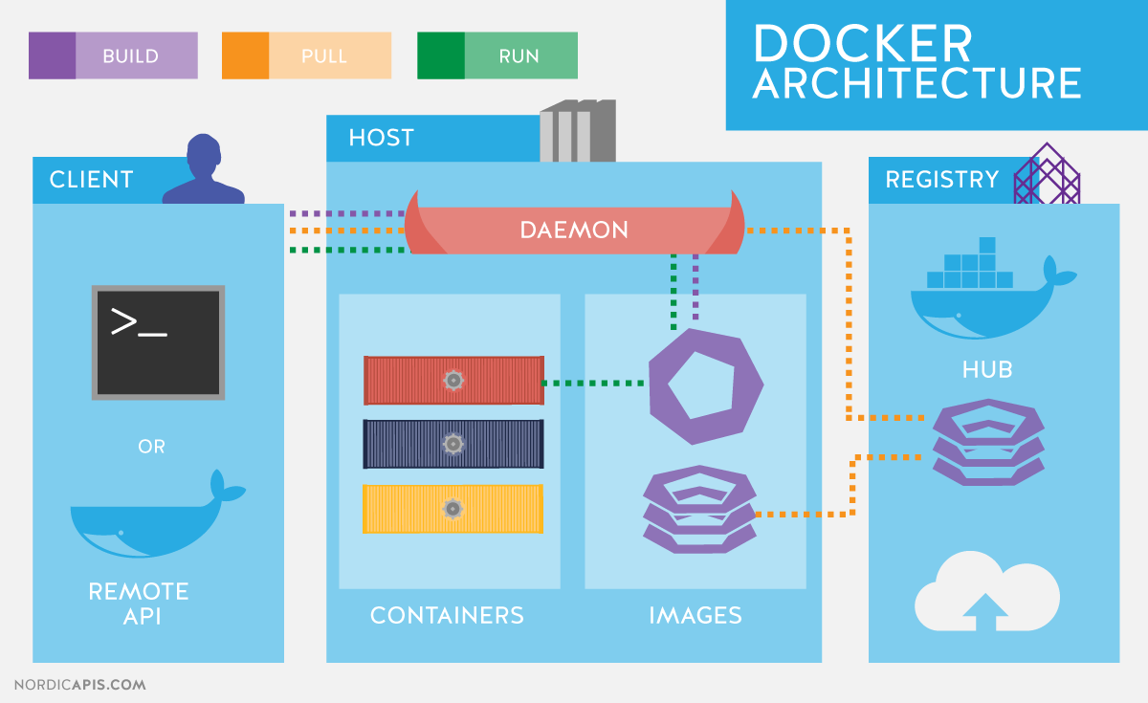

Key terms in Docker:

Docker Engine – Allows you to develop, assemble, ship, and run applications.

Docker Daemon - A persistent background process that manages Docker images, containers, networks, and storage volumes.

Docker Client – Enables users to interact with Docker.

Docker Host – It provides a complete environment to execute and run applications.

Docker Image - Docker images are the "source code" to build containers.

Docker Container - A runnable instance of an image.

Docker Registries – Store the images built in hub.

VM vs Docker
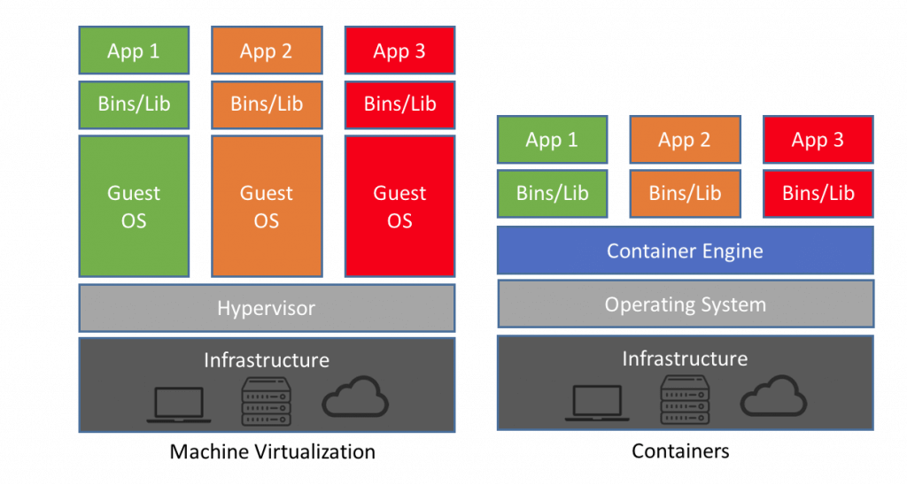
Pros and Cons of Docker:
Consistent and Isolated Environment
Cost-effectiveness with Fast Deployment
Mobility – Ability to Run Anywhere
Repeatability and Automation
Test, Roll Back and Deploy
Collaboration, Modularity and Scaling
Continuous Integration(CI)
storage is still hard to provision
Poor monitoring
Less Secure
 | Docker | Virtual Machines (VMs)

Boot-Time | Boots in a few seconds. | It takes a few minutes for VMs to boot.
Runs on | Dockers make use of the execution engine. | VMs make use of the hypervisor.
Memory Efficiency | No space is needed to virtualize, hence less memory. | Requires entire OS to be loaded before starting the surface, so less efficient.
Size | Containers are lightweight (KBs/MBs). | VMs are of few GBs.
Deployment | Deploying is easy as only a single image, containerized can be used across all platforms. | Deployment is comparatively lengthy as separate instances are responsible for execution.
Availability | Pre-built docker containers are easily available. | Ready-made VMs are difficult to find.

Vagrant Overview:

Vagrant describes itself as "a tool for building and managing virtual machine environments in a single workflow.
It’s a layer of software installed between a virtualization tool (such as VirtualBox, Docker, Hyper-V) and a VM.
open-source tool that allows you to create, configure, and manage boxes of virtual machines through an easy to use command interface.
It is often used in software development to ensure all team members are building for the same configuration.
Vagrant is essentially a wrapper to allow for repeatable virtual machine management, but it does not run VMs itself.

How Vagrant Works:
Vagrant works with a standard format for documenting an environment, called a Vagrantfile.

The primary function of the Vagrantfile is to describe the type of machine required for a project, and how to configure and provision these machines.

It provides a software development to ensure all team members are building for the same configuration. Not only does it share environments, but it also shares code as well.

Vagrant Architecture
Vagrant uses Providers and Provisioners as building blocks to manage development environments.

Provisioners are tools that allow users to customize the configuration of virtual environments.

Providers are the services that Vagrant uses to set up and create virtual environments. Docker, Hyper-V, and VirtualBox virtualization ships support Vagrant, while AWS and VMware are supported via plugins.

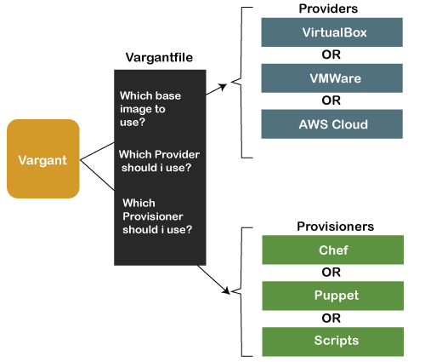

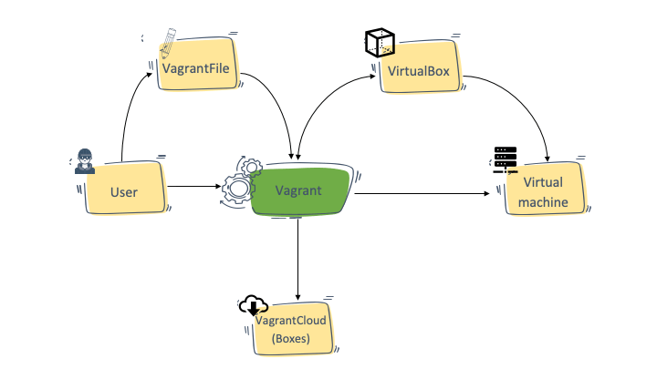
Pros and Cons of Vagrant
Open Source
Great variety of community boxes and plugins
Speed vs other VMs
Easy to set up and configure local development environment
Consistent, reliable virtual environments for development
-------------------------------------------------------------------------------
Lacks a GUI, would be useful for entry level users
Compatibility issues with some operating systems (Windows 8.1 home, Windows 10 home)
Can take up a lot of disk space if running several VMs with various configurations

PFA - Platform A

PFA in Container

It is designed as a microservice architecture style in which the application is made up of smaller services communicating with each other directly using light weight protocols like HTTP.

For each service separate containers are built running services that work together.

Overview of PFA in containers

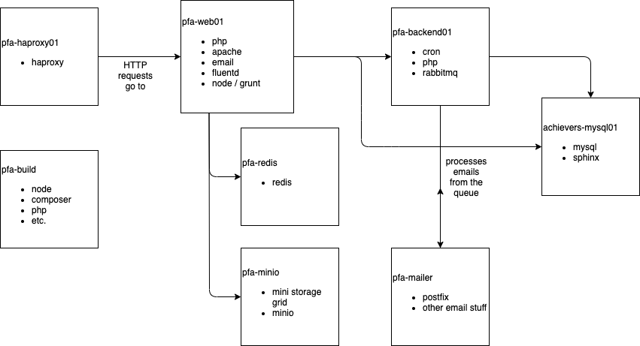
l

PFA Containers :

pfa-web01
pfa-backend01
pfa-pc-stager
pfa-haproxy
pfa-redis
pfa-mailer
achievers-mysql01
achievers-mysql-stager
platform-content.pfa-minio

https://over.localhost.achievers.com

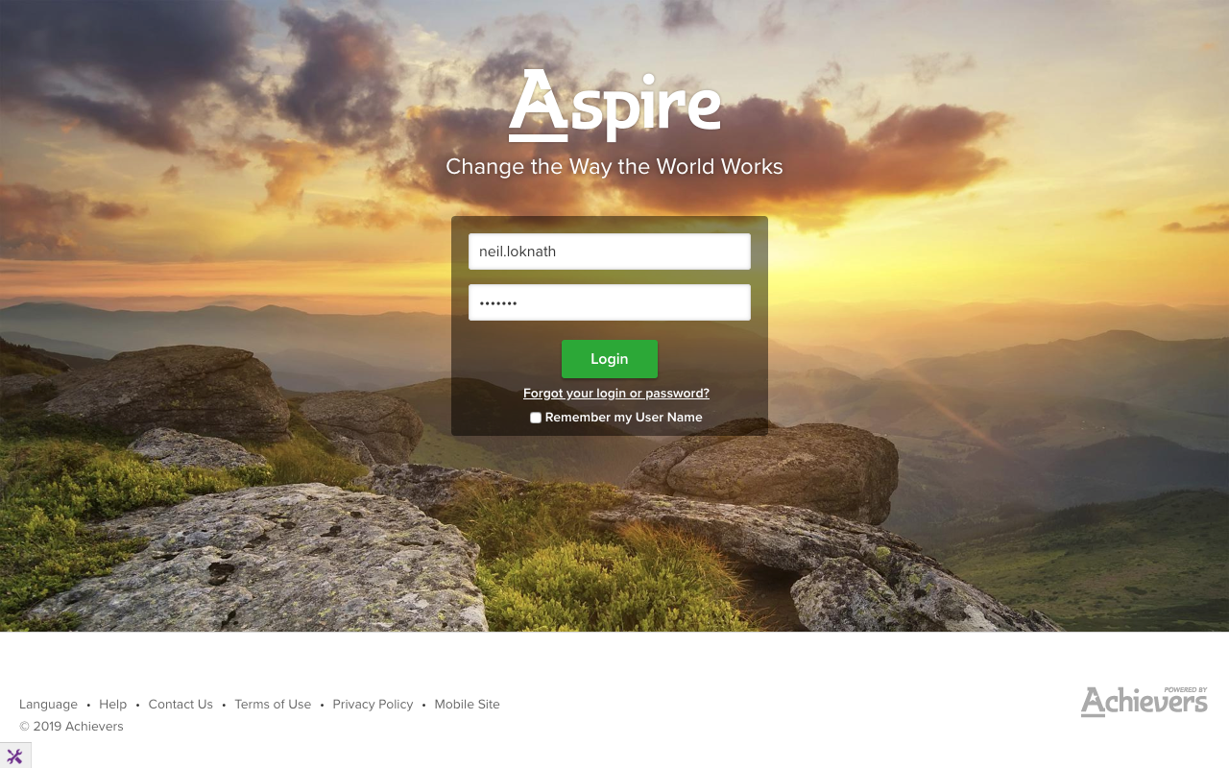
l
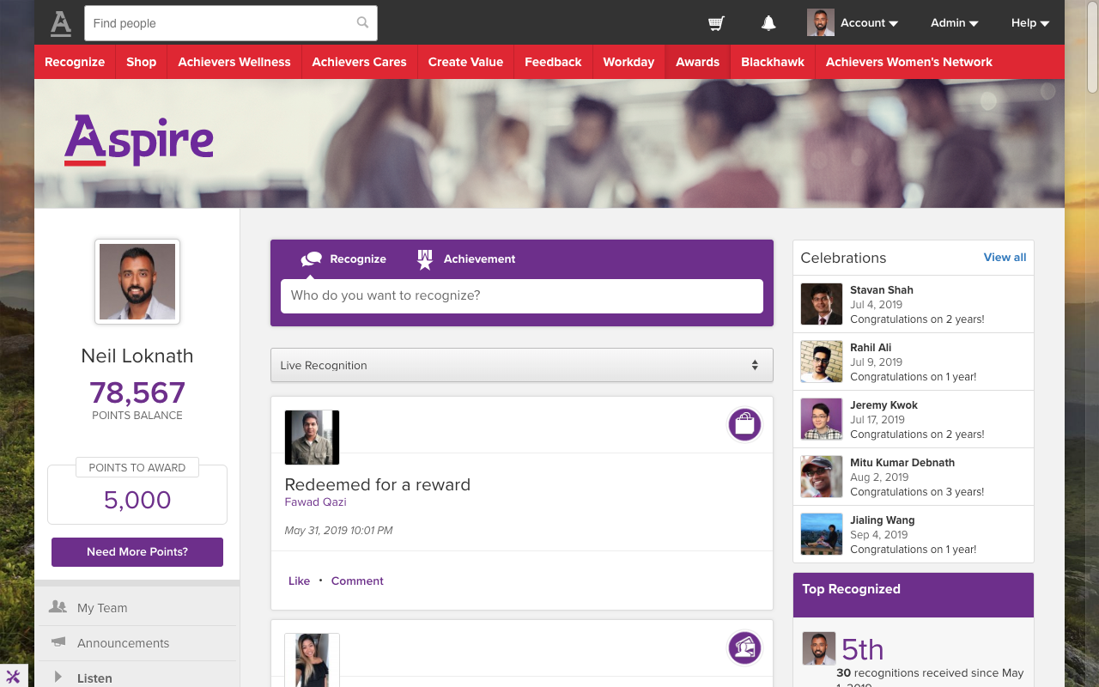
l

https://core.localhost.achievers.com

