RabbitMQ

What is RabbitMQ & When is often used :

- It is an AMQP messaging broker and is the famously easy to set up, open-source, and cross-platform message broker
  - AMQP stands for Advanced Message Queuing protocol which offers features like Message Orientation, Queuing, Routing (through Point-to-Point or Publish-and-Subscribe), Reliability and Security
- It offers an easy way to exchange different platform applications (like Java and DotNet) and offers helps in communication between different Microservices
- It is a lightweight and easy to deploy application available on-premises and cloud to meet the high scalability and availability requirements
- In the present time, a single application supports multiple tasks (i.e. sending notifications, reports, etc.). So sometimes these tasks add an extra load on the application thereby increasing the maintenance cost (such as space, memory, etc) to serve more requests. Thus, RabbitMQ in such situations acts a blessing to remove some of the heavy tasks
- RabbitMQ is one of the more popular message broker solutions in the market, offered with an open-source license (Mozilla Public License v1.1) and developed using the Erlang language.

List of releases - https://www.rabbitmq.com/changelog.html
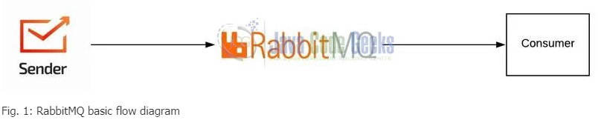

Messaging and Queues :
Messaging is a way of exchanging certain data between processes, applications, and servers (virtual and physical). These messages exchanged, helping with certain engineering needs, can consist of anything from plain text messages to blobs of binary data serving to address different needs. For this to work, an interface managed by a third party program (a middleware) is needed called message brooker.

Why use RabbitMQ :
These message brooking solutions act like a middleman for various services (e.g. your web application). They can be used to greatly reduce loads and delivery times by web application servers since tasks, which would normally take quite bit of time to process, can be delegated for a third party whose sole job is to perform them (e.g. workers). They also come in handy when a more “guaranteed” persistence is needed to pass information along from one place to another.

When to use RabbitMQ :
All put together, the core functionality explained expands to cover a multitude of areas, including-but-not-limited-to:
- Allowing web servers to respond to requests quickly instead of being forced to perform resource-heavy procedures on the spot
- Distributing a message to multiple recipients for consumption (e.g. processing)
- Letting offline parties (i.e. a disconnected user) fetch data at a later time instead of having it lost permanently
- Introducing fully asynchronous functionality to the backend systems
- Ordering and prioritising tasks
- Balancing loads between workers
- Greatly increase reliability and uptime of your application
- and much more.

RabbitMQ Features

Asynchronous Messaging
Supports multiple messaging protocols, message queuing, delivery acknowledgement, flexible routing to queues, multiple exchange type.

Developer Experience
Deploy with BOSH, Chef, Docker and Puppet. Develop cross-language messaging with favorite programming languages such as: Java, .NET, PHP, Python, JavaScript, Ruby, Go, and many others.

Distributed Deployment
Deploy as clusters for high availability and throughput; federate across multiple availability zones and regions.

Enterprise & Cloud Ready
Pluggable authentication, authorisation, supports TLS and LDAP. Lightweight and easy to deploy in public and private clouds.

Tools & Plugins
Diverse array of tools and plugins supporting continuous integration, operational metrics, and integration to other enterprise systems. Flexible plug-in approach for extending RabbitMQ functionality.

Management & Monitoring
HTTP-API, command line tool, and UI for managing and monitoring RabbitMQ.

Important RabbitMQ and Server Concepts:
- Producer: Application that sends the messages.
- Consumer: Application that receives the messages.
- Queue: Buffer that stores messages. A medium through which the messages are transferred or stored until the message is delivered to the consumer or the message time-to-live has expired
- Message: Information that is sent from the producer to a consumer through RabbitMQ.
- Connection: A TCP connection between your application and the RabbitMQ broker.
- Channel: A virtual connection inside a connection. When publishing or consuming messages from a queue - it's all done over a channel.
- Broker: Offers a storage mechanism for the data produced from one application. Usually meant to be consumed by Consumer(s) of another application(s) that connects to this broker
- Exchange: Receives messages from producers and pushes them to queues depending on rules defined by the exchange type. To receive messages, a queue needs to be bound to at least one exchange.
- Binding: A binding is a link between a queue and an exchange.
- Routing key: A key that the exchange looks at to decide how to route the message to queues. Think of the routing key like an address for the message.
- AMQP: Advanced Message Queuing Protocol is the protocol used by RabbitMQ for messaging.
- Users: It is possible to connect to RabbitMQ with a given username and password. Every user can be assigned permissions such as rights to read, write and configure privileges within the instance. Users can also be assigned permissions for specific virtual hosts.
- Vhost, virtual host: Provides a way to segregate applications using the same RabbitMQ instance. Different users can have different permissions to different vhost and queues and exchanges can be created, so they only exist in one vhost.

RabbitMQ Example
- A message broker acts as a middleman for various services (e.g. a web application, as in this example). They can be used to reduce loads and delivery times of web application servers by delegating tasks that would normally take up a lot of time or resources to a third party that has no other job.
- In this guide, we follow a scenario where a web application allows users to upload information to a website. The site will handle this information, generate a PDF, and email it back to the user. Handling the information, generating the PDF, and sending the email will, in this example case, take several seconds. That is one of the reasons why a message queue will be used to perform the task.
- When the user has entered user information into the web interface, the web application will create a "PDF processing" message that includes all of the important information the user needs into a message and place it onto a queue defined in RabbitMQ.

The basic architecture of a message queue is simple - there are client applications called producers that create messages and deliver them to the broker (the message queue). Other applications, called consumers, connect to the queue and subscribe to the messages to be processed. Software may act as a producer, or consumer, or both a consumer and a producer of messages. Messages placed onto the queue are stored until the consumer retrieves them.

The consumer takes a message off the queue and starts processing the PDF. At the same time, the producer is queuing up new messages. The consumer can be on a totally different server than the producer or they can be located on the same server. The request can be created in one programming language and handled in another programming language. The point is, the two applications will only communicate through the messages they are sending to each other, which means the sender and receiver have low coupling.

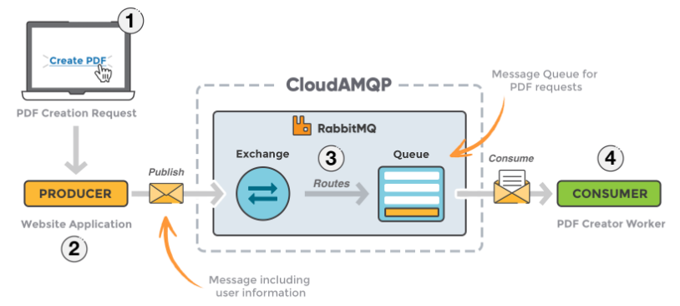
- The user sends a PDF creation request to the web application.
- The web application (the producer) sends a message to RabbitMQ that includes data from the request such as name and email.
- An exchange accepts the messages from the producer and routes them to correct message queues for PDF creation.
- The PDF processing worker (the consumer) receives the task message and starts processing the PDF.
EXCHANGES

Messages are not published directly to a queue; instead, the producer sends messages to an exchange. An exchange is responsible for routing the messages to different queues with the help of bindings and routing keys. A binding is a link between a queue and an exchange.

Message flow in RabbitMQ
- The producer publishes a message to an exchange. When creating an exchange, the type must be specified. This topic will be covered later on.
- The exchange receives the message and is now responsible for routing the message. The exchange takes different message attributes into account, such as the routing key, depending on the exchange type.
- Bindings must be created from the exchange to queues. In this case, there are two bindings to two different queues from the exchange. The exchange routes the message into the queues depending on message attributes.
- The messages stay in the queue until they are handled by a consumer
- The consumer handles the message.
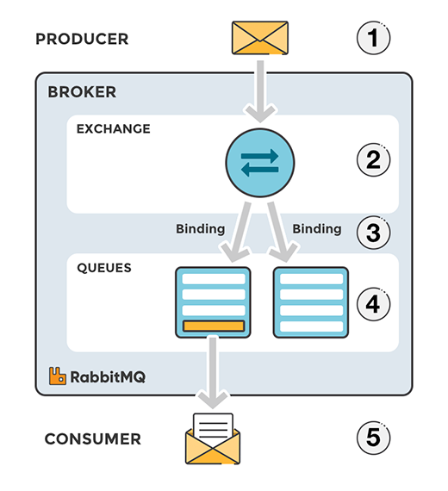

TYPES OF EXCHANGES
- Direct: The message is routed to the queues whose binding key exactly matches the routing key of the message. For example, if the queue is bound to the exchange with the binding key pdfprocess, a message published to the exchange with a routing key pdfprocess is routed to that queue.
- Fanout: A fanout exchange routes messages to all of the queues bound to it.
- Topic: The topic exchange does a wildcard match between the routing key and the routing pattern specified in the binding.
- Headers: Headers exchanges use the message header attributes for routing.

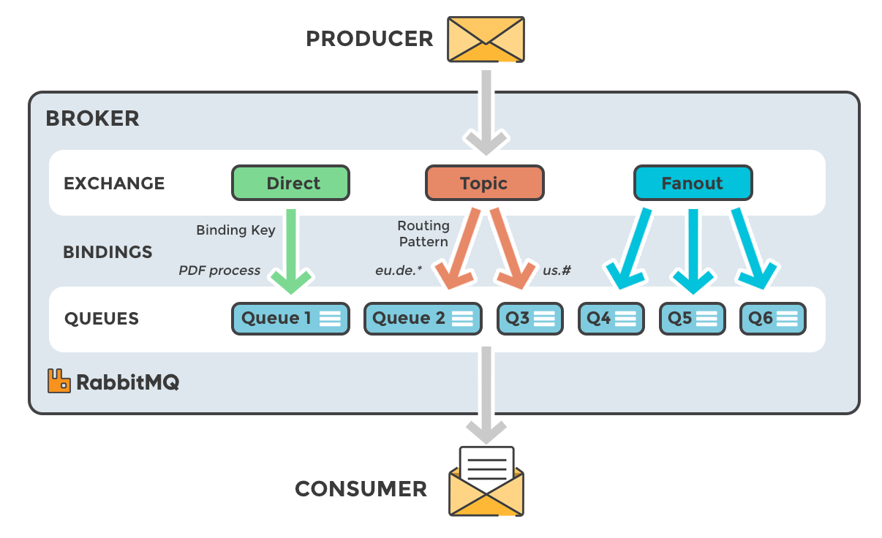

RabbitMQ Installation

Ususually installing the RabbitMq is a tedious task where one must first install the Erlang and then proceed with the RabbitMq installation. But with the technology advancements, this process has become simple with the help of Docker. Readers can watch the video available at this link to understand the Docker installation on Windows OS. Open the terminal and fire the following commands to get the RabbitMQ up and running on the local machine.

1  2  3  4  5  6 | // To download the RabbitMQ from Docker Hub  docker pull rabbitmq:3-management  // To start the RabbitMQ image on the Docker container  // Note: We will keep the container and application port as same for this tutorial  docker run -d -p 15672:15672 -p 5672:5672 --name myrabbitmq rabbitmq:3-management

If everything goes well the RabbitMQ console would be up and running as shown in the below image. Users can log in via the default username/password (i.e. guest/guest).

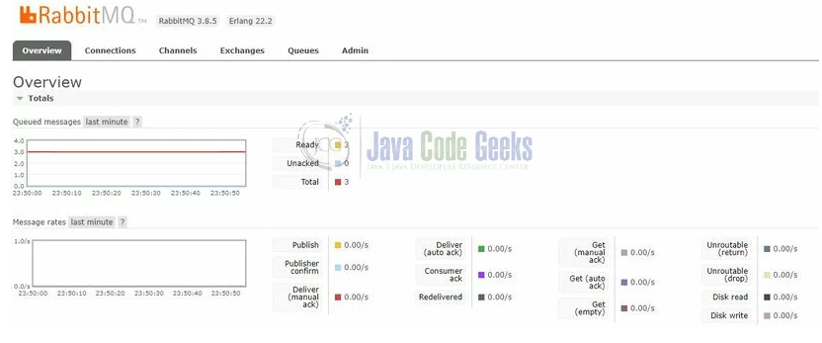
Instruction to use RabbitMQ docker image -- https://hub.docker.com/_/rabbitmq

RabbitMQ Installation on Windows

https://www.tutlane.com/tutorial/rabbitmq/rabbitmq-installation

Installing on CentOS 6 / RHEL Based Systems

Before installing RabbitMQ, we need to get its main dependencies such as Erlang. However, first and foremost we should update our system and its default applications.
Run the following to update our droplet:
yum -y update
And let’s use the below commands to get Erlang on our system:
# Add and enable relevant application repositories:
# Note: We are also enabling third party remi package repositories.
wget http://dl.fedoraproject.org/pub/epel/6/x86_64/epel-release-6-8.noarch.rpm
wget http://rpms.famillecollet.com/enterprise/remi-release-6.rpm
sudo rpm -Uvh remi-release-6*.rpm epel-release-6*.rpm

# Finally, download and install Erlang:
yum install -y erlang
Once we have Erlang, we can continue with installing RabbitMQ:
# Download the latest RabbitMQ package using wget:
wget http://www.rabbitmq.com/releases/rabbitmq-server/v3.2.2/rabbitmq-server-3.2.2-1.noarch.rpm

# Add the necessary keys for verification:
rpm --import http://www.rabbitmq.com/rabbitmq-signing-key-public.asc

# Install the .RPM package using YUM:
yum install rabbitmq-server-3.2.2-1.noarch.rpm

Managing on CentOS / RHEL Based Systems
Upon installing the application, RabbitMQ is not set to start at system boot by default.
To have RabbitMQ start as a daemon by default, run the following:

chkconfig rabbitmq-server on

To start, stop, restart and check the application status, use the following:
# To start the service:
/sbin/service rabbitmq-server start

# To stop the service:
/sbin/service rabbitmq-server stop

# To restart the service:
/sbin/service rabbitmq-server restart

# To check the status:
/sbin/service rabbitmq-server status

Installing on Ubuntu 13 / Debian 7 Based Systems

The process for downloading and installing RabbitMQ on Ubuntu and Debian will be similar to CentOS due to our desire of having a more recent version.
Let’s begin with updating our system’s default application toolset:
apt-get update
apt-get -y upgrade

Enable RabbitMQ application repository:
echo "deb http://www.rabbitmq.com/debian/ testing main" >> /etc/apt/sources.list

Add the verification key for the package:
curl http://www.rabbitmq.com/rabbitmq-signing-key-public.asc | sudo apt-key add –

Update the sources with our new addition from above:
apt-get update

And finally, download and install RabbitMQ:
sudo apt-get install rabbitmq-server

In order to manage the maximum amount of connections upon launch, open up and edit the following configuration file using nano:
sudo nano /etc/default/rabbitmq-server

Uncomment the limit line (i.e. remove #) before saving and exit by pressing CTRL+X followed with Y.

Managing on Ubuntu / Debian Based Systems

To start, stop, restart and check the application status on Ubuntu and Debian, use the following:
# To start the service:
service rabbitmq-server start

# To stop the service:
service rabbitmq-server stop

# To restart the service:
service rabbitmq-server restart

# To check the status:
service rabbitmq-server status

RabbitMQ Exchange Types
In rabbitmq, we have a four type of Exchanges are available to route the message in different ways.

Following are the different type of exchanges available in rabbitmq.

- Direct
- Fanout
- Topic
- Headers

RabbitMQ Direct Exchange
In rabbitmq, direct exchange will deliver a messages to the queues based on the message routing key. In direct exchange, the message is routed to the queues whose binding key exactly matches with the routing key of the message.

Following is the pictorial representation of message flow in rabbit direct exchange.

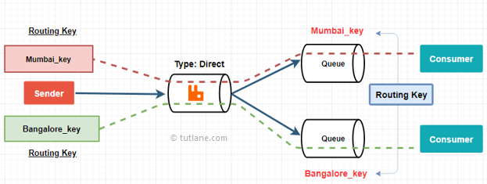

RabbitMQ Fanout Exchange
In rabbitmq, fanout exchange will route messages to all of the queues that are bound to it.

Following is the pictorial representation of message flow in rabbitmq fanout exchange.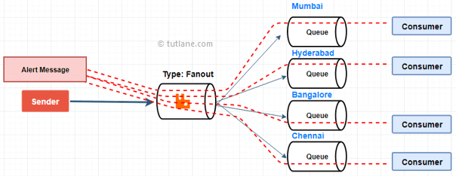

RabbitMQ Topic Exchange
In rabbitmq, topic exchange will perform a wildcard match between the routing key and the routing pattern specified in the binding to publish a messages to queue.

Following is the pictorial representation of message flow in rabbitmq topic exchange.

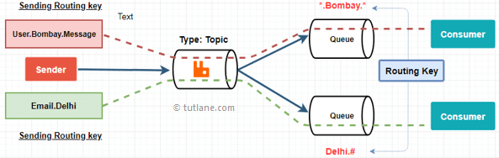

RabbitMQ Headers Exchange
In rabbitmq, headers exchanges will use the message header attributes for routing.

Following is the pictorial representation of message flow in rabbitmq headers exchange.

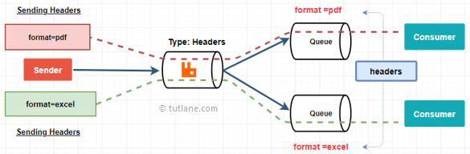
Now we will see how to add exchanges in rabbitmq using web management plugin.

RabbitMQ Create Exchange
To create new exchanges, first open rabbtimq web management portal, enter a default credentials to login and then choose Exchanges tab.
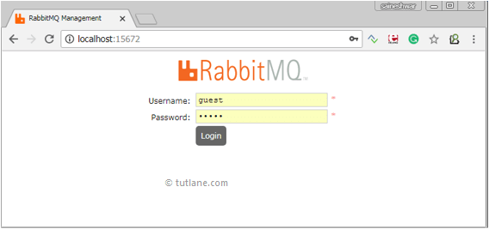

After navigate to Exchanges tab, you will see “Add a new exchange panel” just click on that panel to expand and that will contain a different properties to create a new exchange like as shown below.

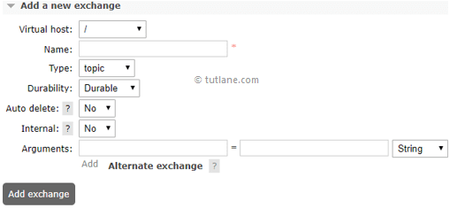

RabbitMQ Exchange Properties
Following are the different type of properties which we need to fill to create a new exchange in rabbitmq.

Property | Description
Name | The name will be an exchange name which you will set and it must be unique.
Type | You can select required exchange type either topic or fanout, etc. based on your requirements.
Durability | By using durability (Durable, Transient) properties, we can make the message to survive even after server restarts. If we select Durable, then the message will survive even after server restart. In case, if we select Tansient, then message will not service after server restart.
Auto Delete | By using auto delete property, we can set whether an exchange can delete if we unbind assigned queue.
Internal | If we set this property yes, then the exchange may not be used directly by publishers, but only when bound to other exchanges.
Alternate-exchange | If there is an issue in publishing message to exchange, then by using this property, we can specify an alternate exchange to send a message to queue.

Once we enter all required details, then click Add exchange button to create a new exchange like as shown below.

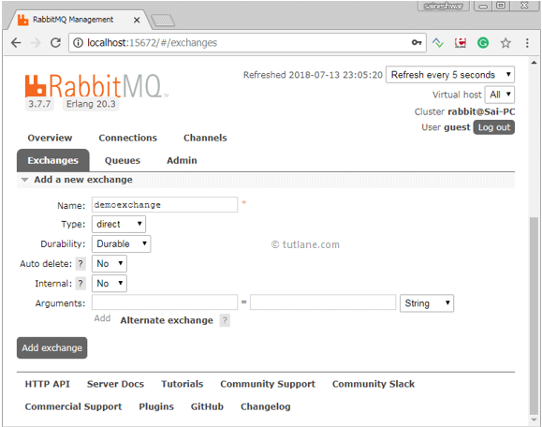

After creating the exchange, we can see our newly created exchange under exchanges tab like as shown below.

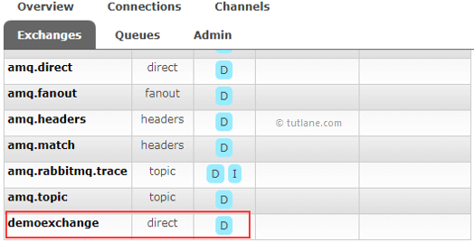

Creating the First Exchange
Once the RabbitMQ console is up and running, head over to the Exchanges tab and click on the Add a new exchange link and add the details as detailed in Section 1.4.1.

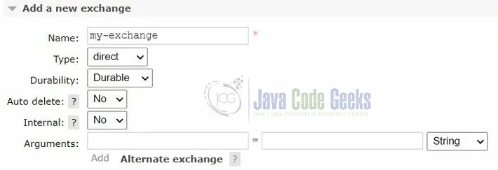

Creating a Queue
Login to the RabbitMQ head over to the Queues tab and click on the Add a new queue link and add the details.
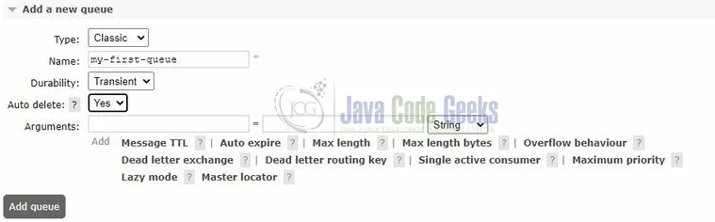
Once the queue is successfully created, click on the newly created queue and navigate to the Bindings link to bind this queue to an exchange created in Section 1.4.2 and routing key as demo-key and click on Bind button. Once successfully bound it will be shown as in the below image.

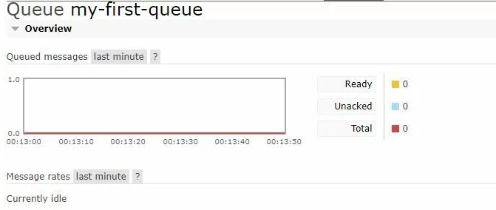

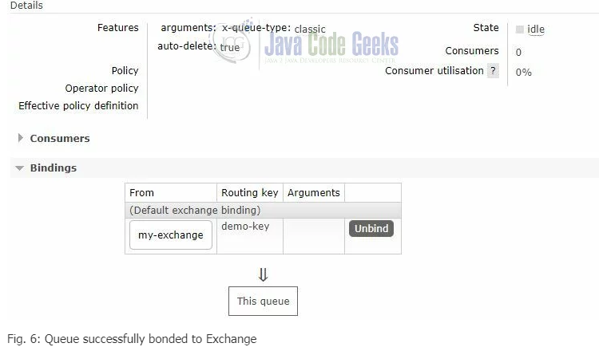

Publishing a Message to the Queue
While you’re on the my-first-queue page, navigate to the Publish message link and add the details as shown below (i.e. your message in the Payload area) and click the Publish message button.

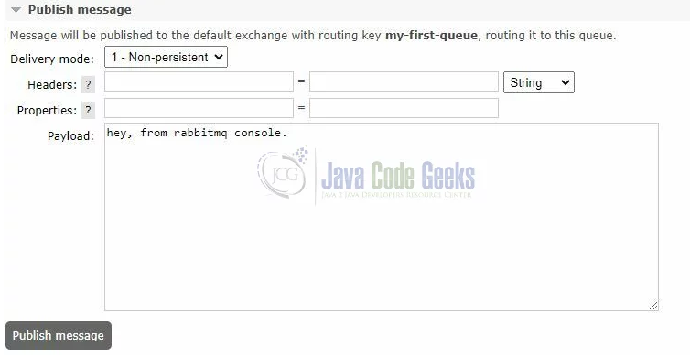
Once the message is successfully published to the queue, a successful message saying Message published. will be shown.

Consuming a Message to the Queue
While you’re on the my-first-queue page, navigate to the Get messages link and click the Get messages button. The below image will be shown in the management console after successfully reading a message from the my-first-queue.
