|  |  |  |  |  |  |  |  |  |  |
| --- | --- | --- | --- | --- | --- | --- | --- | --- | --- |
| **SCHOOL OF COMPUTER SCIENCE AND ARTIFICIAL INTELLIGENCE** | | | | | **DEPARTMENT OF COMPUTER SCIENCE ENGINEERING** | | | | |
| **ProgramName:**B. Tech | | | | **Assignment Type: Lab** | | | **AcademicYear:**2025-2026 | | |
| **CourseCoordinatorName** | | | | Venkataramana Veeramsetty | | | | | |
| **Instructor(s)Name** | | | | 1. Dr. Mohammed Ali Shaik  2. Dr. T Sampath Kumar  3. Mr. S Naresh Kumar  4. Dr. V. Rajesh  5. Dr. Brij Kishore  6. Dr Pramoda Patro  7. Dr. Venkataramana  8. Dr. Ravi Chander  9. Dr. Jagjeeth Singh | | | | | |
| **CourseCode** | | | 24CS002PC215 | **CourseTitle** | | AI Assisted Coding | | | |
| **Year/Sem** | | | II/I | **Regulation** | | R24 | | | |
| **Date and Day**  **of Assignment** | | |  | **Time(s)** | |  | | | |
| **Duration** | | | 2 Hours | **Applicableto**  **Batches** | |  | | | |
| **AssignmentNumber:3.3**(Present assignment number)/**24**(Total number of assignments) | | | | | | | | | |
|  | | | | | | | | | |
|  | **Q.No.** | **Question** | | | | | | ***ExpectedTime***  ***to complete*** |  |
|  | 1 | Lab 3: Prompt Engineering – Improving Prompts and Context Management  **Lab Objectives:**   * To understand how prompt structure and wording influence AI-generated code. * To explore how context (like comments and function names) helps AI generate relevant output. * To evaluate the quality and accuracy of code based on prompt clarity. * To develop effective prompting strategies for AI-assisted programming.   **Lab Outcomes (LOs):**  After completing this lab, students will be able to:   * Generate Python code using Google Gemini in Google Colab. * Analyze the effectiveness of code explanations and suggestions by Gemini. * Set up and use Cursor AI for AI-powered coding assistance. * Evaluate and refactor code using Cursor AI features. * Compare AI tool behavior and code quality across different platforms.   **Task Description#1**   * Try 3 different prompts to generate a factorial function.   **Expected Output#1**   * Comparison of AI-generated code styles   **Task Description#2**   * Provide a clear example input-output prompt to generate a sorting function.   **Expected Output#2**   * Functional sorting code from AI   **Task Description#3**   * Start with the vague prompt “Generate python code to calculate power bill” and improve it step-by-step   **Expected Output#3**   * Enhanced AI output with clearer prompts   **Task Description#4**   * Write structured comments to help AI generate two linked functions (e.g., login_user () and register user ()).   **Expected Output#4**   * Consistent functions with shared logic   **Task Description#5**   * Analyzing Prompt Specificity: Improving Temperature Conversion Function with Clear Instructions   **Expected Output#5**   * Code quality difference analysis for various prompts   **Note: Report should be submitted a word document for all tasks in a single document with prompts, comments & code explanation, and output and if required, screenshots**  **Evaluation Criteria:**   | **Criteria** | **Max Marks** | | --- | --- | | Factorial Function (Task#1) | 0.5 | | Sorting Function (Task#2) | 0.5 | | Vogue Vs. Specific Prompting (Task #3) | 0.5 | | Linked Functions (Task #4) | 0.5 | | Temperature Conversion Function (Task #5) | 0.5 | | **Total** | **2.5 Marks** | | | | | | | 03.08.2025 EOD |  |

**Task Description#1**

* Try 3 different prompts to generate a factorial function.

Prompt:

1. Write a Python function to take input from the user and generate a factorial.

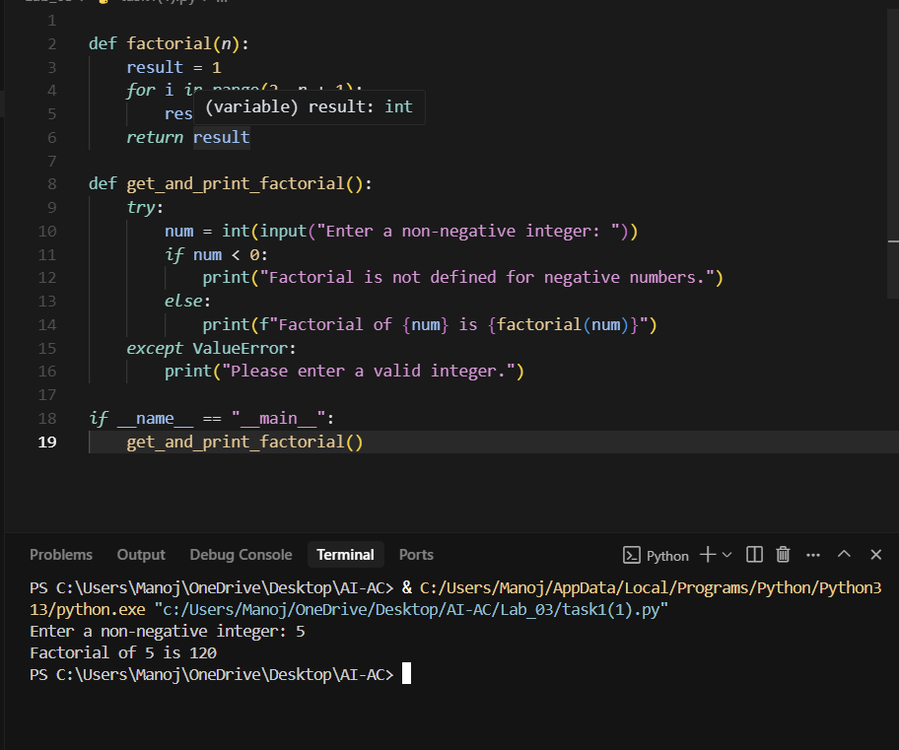

2. Write a Python function to take generate a factorial, the number should be taken from the user.

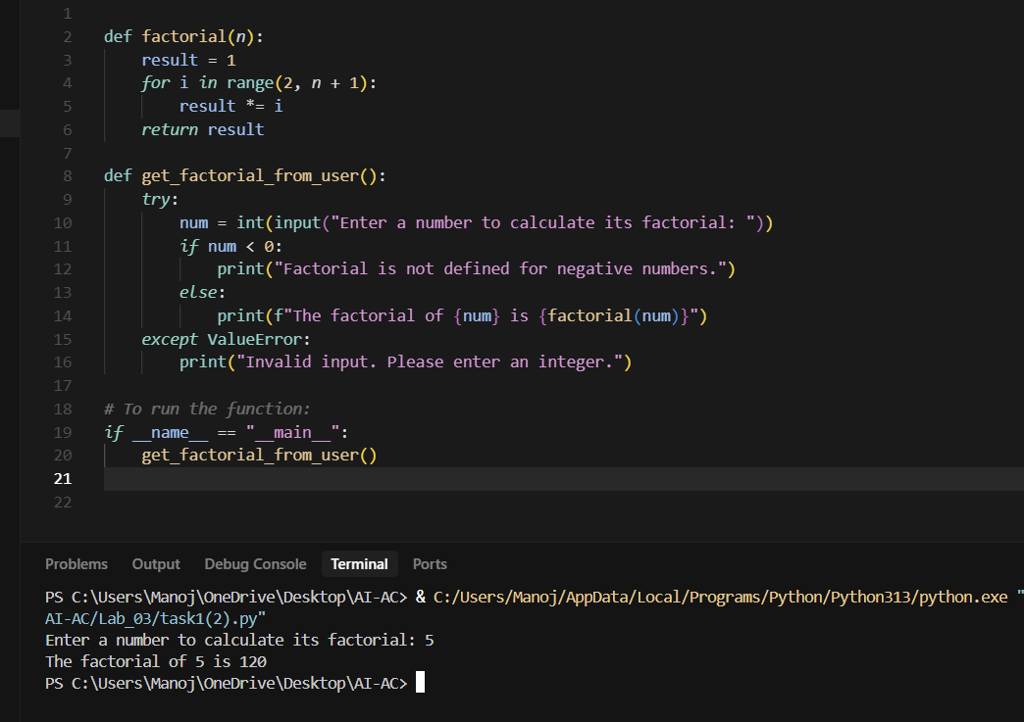

3. Write a Python function to generate factorial of a number taken from the console.

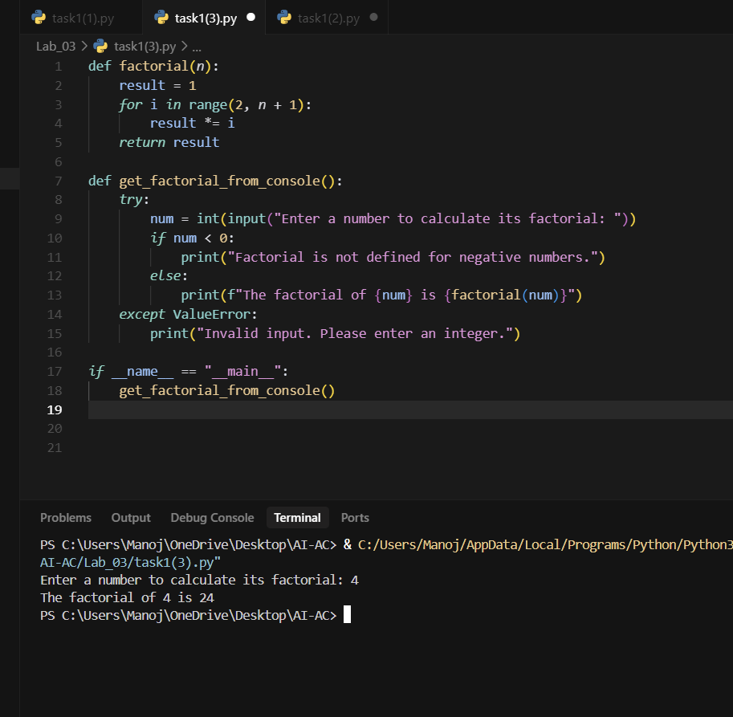

**Task Description#2**

* Provide a clear example input-output prompt to generate a sorting function.

Prompt:

1. Write a Python function that takes few numbers from the user and return numbers in sorted order and Display them on to the console.

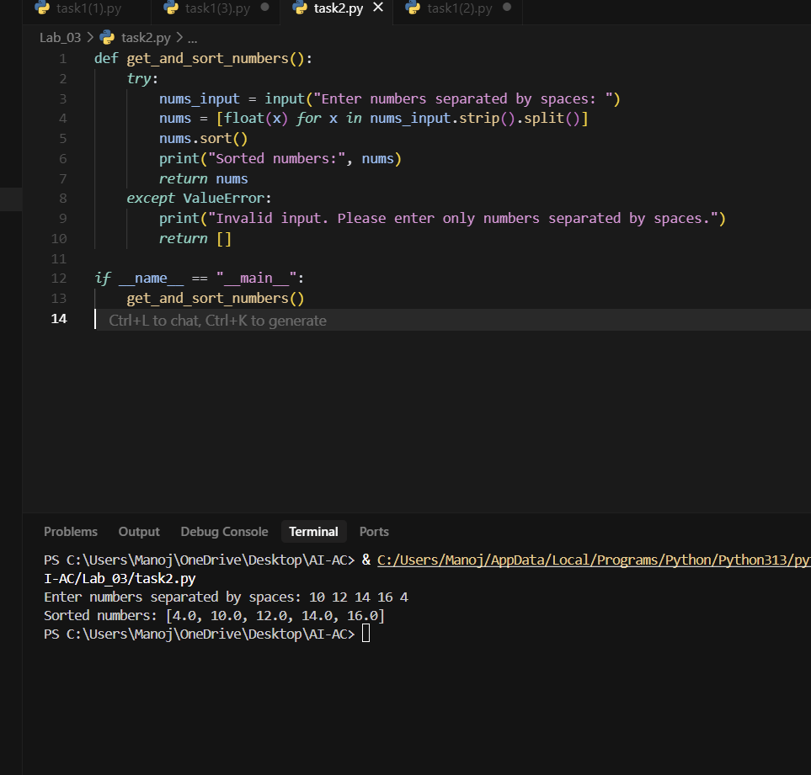

**Task Description#3**

* Start with the vague prompt “Generate python code to calculate power bill” and improve it step-by-step

Prompt:

Write a Python Program that takes previous month current readings and present month current readings. Find the difference in readings i.e. current readings and previous month readings. Now program should ask whether the current meter is residential or commercial. Cost per one reading is 2 rupees for residential and 4 for commercial. Calculate the Current bill and display it on to the screen.

* Use the concepts of structures and make it similar to real current bill.
* Update cost per units as follow if the consumed units is less than hundred (2 rupees for residential and 4 rupees for commercial), if units consumed is more than hundred and less than or equal to 250 (4 rupees for residential and 8 rupees for commercial) else (6 for residential and 12 for commercial).

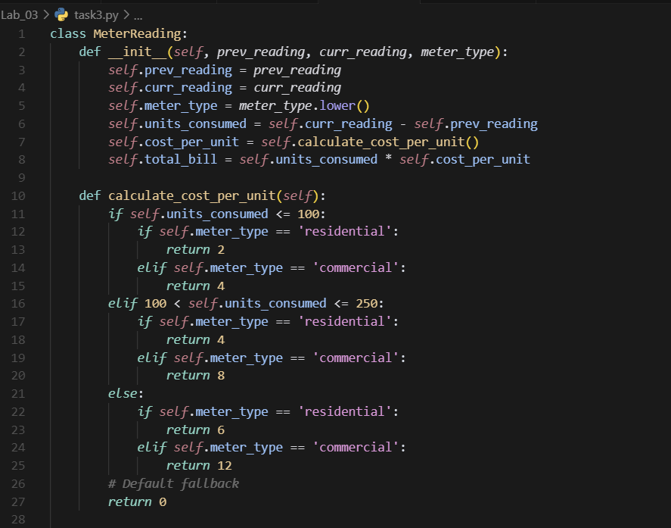

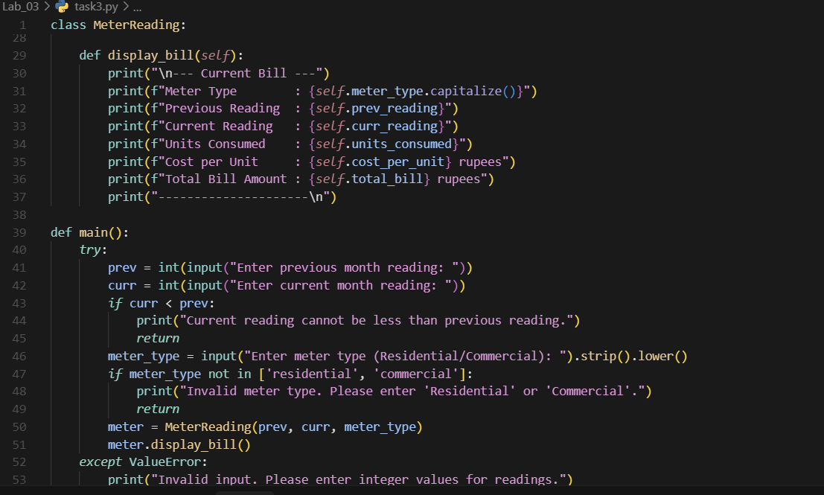

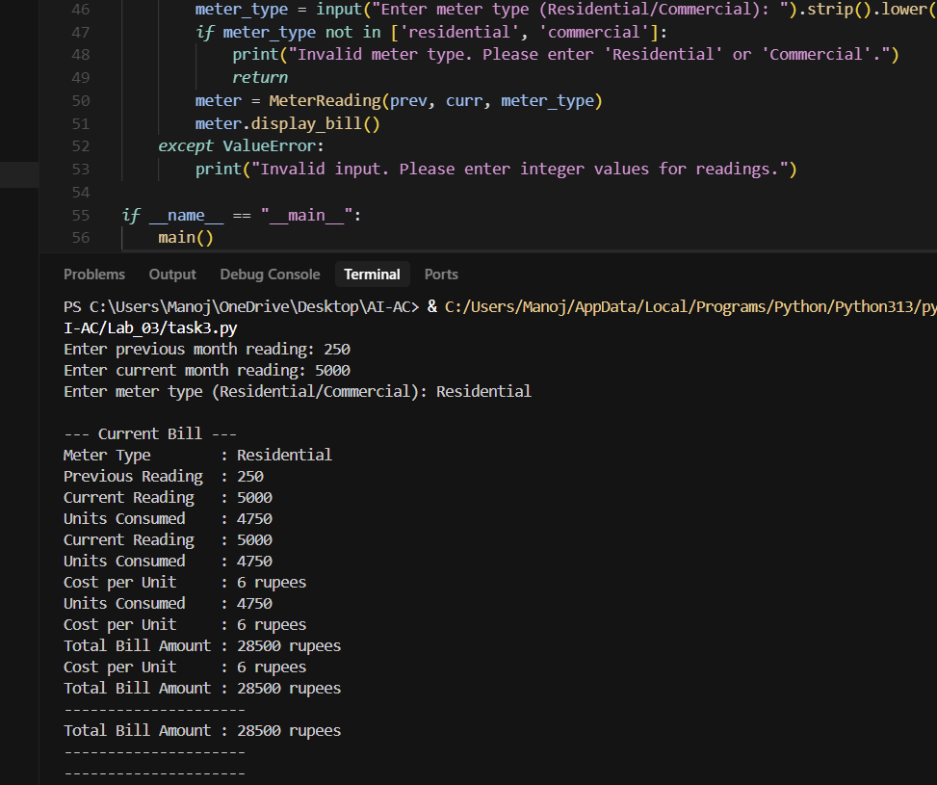

**Task Description#4**

* Write structured comments to help AI generate two linked functions (e.g., login_user () and register user ()).

**Expected Output#4**

* Consistent functions with shared logic

Prompt:

Generate a Python program that shares the data between the two functions user login and register user

And merge them.

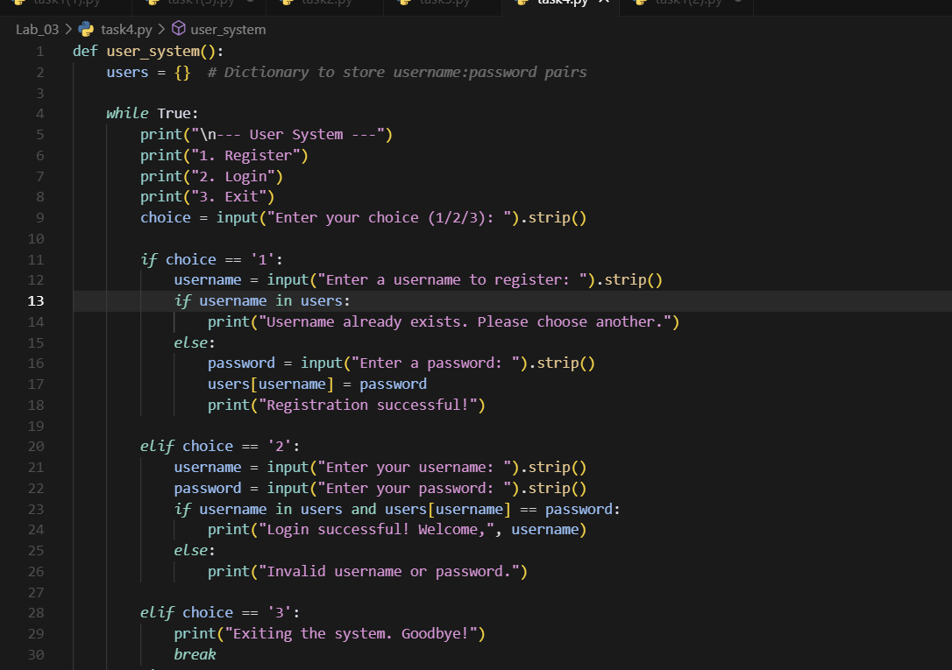

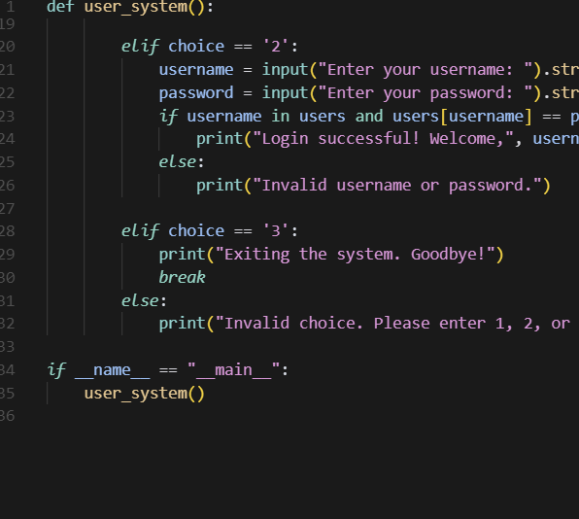

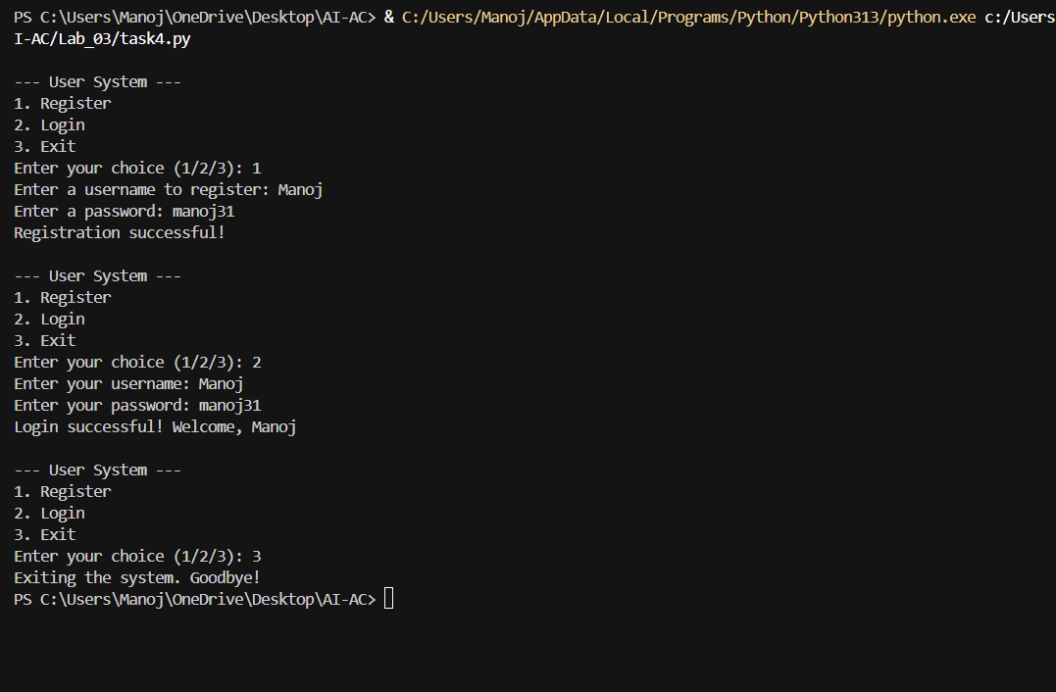

**Task Description#5**

* Analyzing Prompt Specificity: Improving Temperature Conversion Function with Clear Instructions

Prompt: Write a Python program that collects the data related to the temperature and Convert It as per the user interest. Functions should be with clear Instructions.

