Name: B.Manoj Kumar

HT.NO:2403A51060

Batch no:02

LAB_EXAM-01

Task 1: 1. Write a Python code to calculate the sum of odd and even numbers in a given list using GitHub Copilot along with VS Code. Use zero shot prompting

Prompt:Give a python code to calculate the sum of odd and even numbers in a given list.

Screen shot:

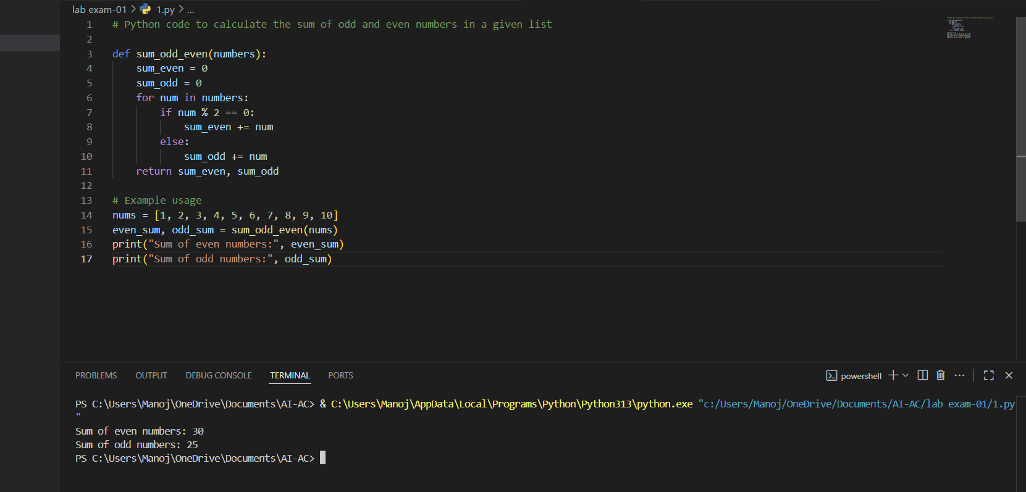

Task 2:

2. Write a Python code for given a list of integers, remove duplicates and print the sorted result. GitHub Copilot along with VS Code. Use one shot prompting.

Prompt:Give python code for given list of integers ,remove duplicates and print the sorted result.taking list as input.

Example:input list a=[1,3,3,4,5,6,6]

Output list a=[1,3,4,5,6]

Screenshot:

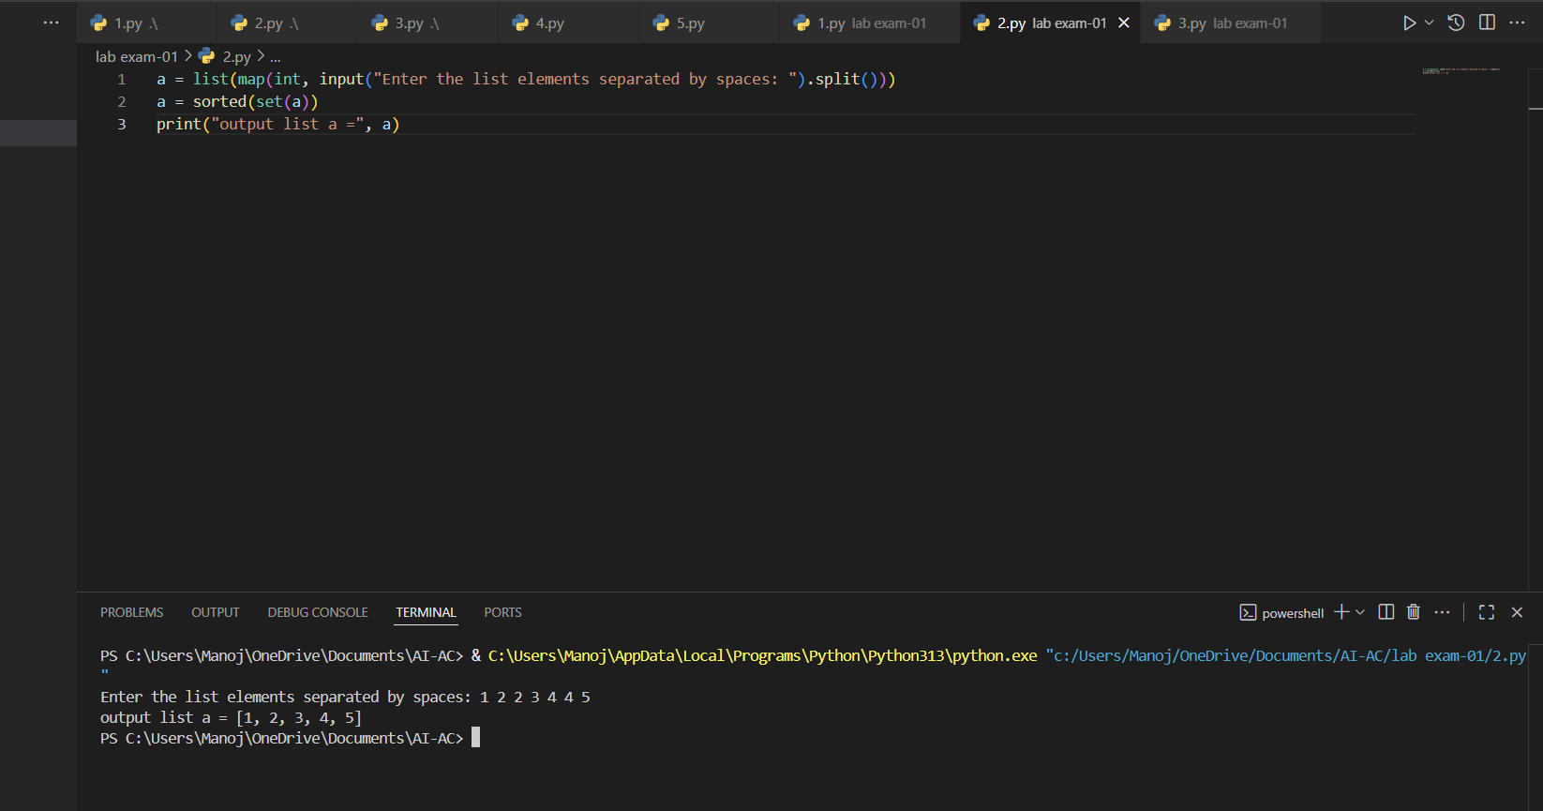

Task 3:

3. Write a Python function that converts the temperature between Celsius, Fahrenheit, and Kelvin based on user choice. Use the Cursor AI tool. Use few shot prompting.

Prompt:

Give python fun that converts temp between Celsius, Fahrenheit, and Kelvin based on my choice.

Examples:

1)temp =36,units=c ,convert unit to F,36.0 c is 96.80 F

2)temp =279,units=k,convert unit to c,279.0k is 5.85c

3)temp=94,units=F convert to c,94.0 F is 34.44C

Screenshot:

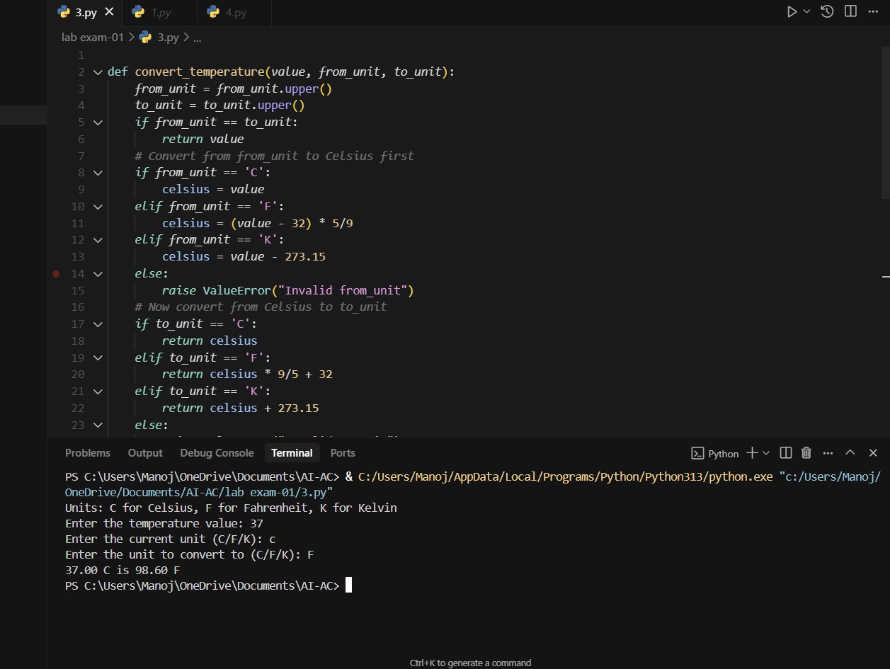

Task 4:

4. Write a Python function to remove punctuation, convert to lowercase, and remove stop words from a given text. Use the Cursor AI tool. Use zero shot prompting.

Prompt:

Give me python function to remove punctuation,convert to lowercase,remove stop words from the given text.give me output according to prompt.

Screenshot:

